1. **Business modeling**
2. business use case diagrams:

- business use case 1

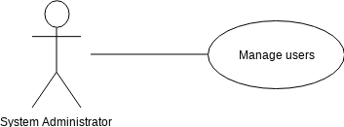

- business use case 2

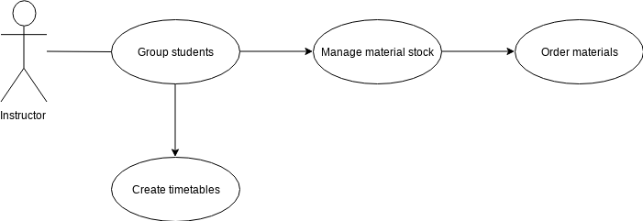

- business use case 3

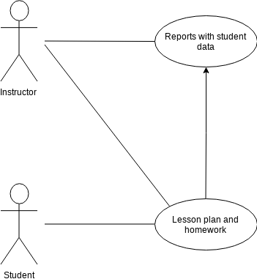

1. activity diagrams

- activity 1

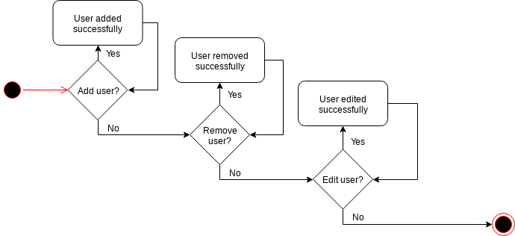

- activity 2

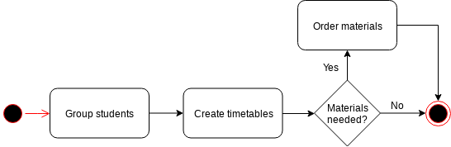

- activity 3

