Technical University of Moldova
Faculty of Computers, Informatics and Microelectronics
Department of Software Engineering and Automatics

REPORT
Laboratory Work No. 5
Course: Cryptography
Topic: Public Key Infrastructure (PKI) and Digital Signature
(version 2)

Done by: | student, group FAF-243  Zastinceanu Mihai
Checked by: | ____________________

Chișinău, 2026

1. Task
Create an internal PKI with the OpenSSL tool: generate the root private key and initialise a Certification Authority (CA) with a self-signed certificate. The system must be able to issue and revoke the users' keys/certificates; each user who obtains a certificate can sign a document/file and verify the signature.
Requirements: RSA keys; user keys of at least 2048 bits, valid 365 days; CA key of 4096 bits, self-signed CA certificate valid 3650 days (10 years). Any language is allowed — the solution is a Bash script, lab5-pki/pki.sh, run in Git Bash on Windows with OpenSSL 3.2.1.

2. Short theory
PKI (Public Key Infrastructure) is the set of roles, policies and tools that bind public keys to identities. Its central part is the Certification Authority: a trusted entity that signs X.509 certificates. A certificate contains the subject's name, its public key, the validity period, the serial number, extensions (for example CA:true/false, key usage) and the CA's signature over all of this. Anybody who trusts the CA certificate (the trust anchor) can check every certificate issued by it.
- The root CA certificate is self-signed: issuer = subject, signed with the CA's own private key. It is trusted because it is distributed out-of-band.
- A user creates a key pair and a CSR (Certificate Signing Request, PKCS#10) with his public key and name, signed with his private key (proof of possession). The CA checks it and issues the certificate.
- A certificate can be revoked before it expires (compromised key, user leaves the organisation, …). The CA publishes the list of revoked serial numbers in a signed CRL (Certificate Revocation List); relying parties must check it (alternatively OCSP).
Digital signature (RSA + SHA-256). The signer computes h = SHA-256(file) and applies the private key: s = EMSA-PKCS1-v1_5(h)^d mod n. The verifier uses the public key from the certificate: s^e mod n must give the same encoded hash. A valid signature proves integrity (the file was not changed), authenticity (only the holder of the private key could produce it) and non-repudiation — but only if the certificate that binds the public key to the signer is itself valid (issued by the trusted CA, not expired, not revoked). That is why verification in this lab has two steps.

3. Implementation
Directory layout created by ./pki.sh init (pki-data/ is ignored by git, because it contains private keys):
pki-data/ca/private/ca.key CA private key (RSA 4096)
pki-data/ca/ca.crt self-signed CA certificate (3650 days)
pki-data/ca/index.txt CA database: V = valid, R = revoked
pki-data/ca/serial, crlnumber next serial numbers
pki-data/ca/crl.pem certificate revocation list
pki-data/users/<user>/ <user>.key, <user>.csr, <user>.crt

3.1 Initialising the CA
openssl genpkey -quiet -algorithm RSA -pkeyopt rsa_keygen_bits:4096 -out "$CA_DIR/private/ca.key"
openssl req -config "$CNF" -new -x509 -sha256 -days 3650 \
-key "$CA_DIR/private/ca.key" -extensions ca_cert \
-subj "$ORG/CN=UTM Crypto Lab Root CA" -out "$CA_DIR/ca.crt"
openssl ca -config "$CNF" -gencrl -out "$CA_DIR/crl.pem"
The CA key is a 4096-bit RSA key. req -x509 creates the self-signed certificate directly (no CSR), valid 3650 days, with the ca_cert extensions: basicConstraints = critical, CA:true and keyUsage = keyCertSign, cRLSign. An empty CRL is published immediately so verification with CRL checking works from the start. The configuration file (openssl.cnf, generated by the script) describes the CA database used by openssl ca.

3.2 Issuing a user key and certificate
openssl genpkey -quiet -algorithm RSA -pkeyopt rsa_keygen_bits:2048 -out "$d/$user.key"
openssl req -new -sha256 -key "$d/$user.key" -subj "$ORG/CN=$user" -out "$d/$user.csr"
openssl ca -config "$CNF" -batch -days 365 -in "$d/$user.csr" -out "$d/$user.crt"
The user's private key is RSA 2048; the CSR is signed by the CA with openssl ca, which assigns the next serial number, records the certificate in index.txt and applies the user_cert extensions (CA:false, keyUsage = digitalSignature, nonRepudiation). Validity: 365 days. A second valid certificate for the same user is refused until the old one is revoked.

3.3 Revocation
openssl ca -config "$CNF" -revoke "$crt" -crl_reason "$reason"
openssl ca -config "$CNF" -gencrl -out "$CA_DIR/crl.pem"
The certificate is marked R in the database with the date and reason (default keyCompromise), and a new CRL signed by the CA is published.

3.4 Signing and verifying
check_certificate() {
openssl verify -crl_check -CAfile "$CA_DIR/ca.crt" -CRLfile "$CA_DIR/crl.pem" "$1"
}
# sign
check_certificate "$d/$user.crt" || die "... signing refused"
openssl dgst -sha256 -sign "$d/$user.key" -out "$file.$user.sig" "$file"
# verify
check_certificate "$crt" || { echo "RESULT: signature NOT trusted ..."; return 1; }
openssl x509 -in "$crt" -noout -pubkey > "$PKI_DIR/.pub.pem"
openssl dgst -sha256 -verify "$PKI_DIR/.pub.pem" -signature "$sig" "$file"
Signing is allowed only while the user's certificate is valid. Verification first checks the chain to the CA and the CRL, then verifies the RSA/SHA-256 signature with the public key taken from the certificate (not from a file supplied by the signer), so the signature is bound to the identity certified by the CA.

4. Results
The scenario in demo.sh was run and its output is shown below ($ lines are the commands).
1. Initialising the CA — 4096-bit key, self-signed certificate valid from 2026 to 2036 (10 years), CA:TRUE:
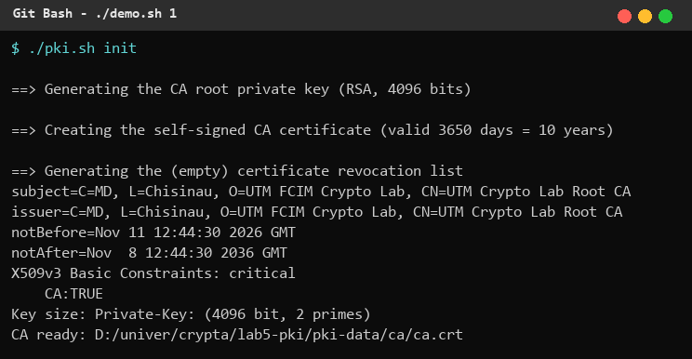
Figure 1. CA initialisation
2. Issuing keys for two users (alice, bob): 2048-bit keys, certificates valid 365 days, serial numbers 1000 and 1001, both verified against the CA:
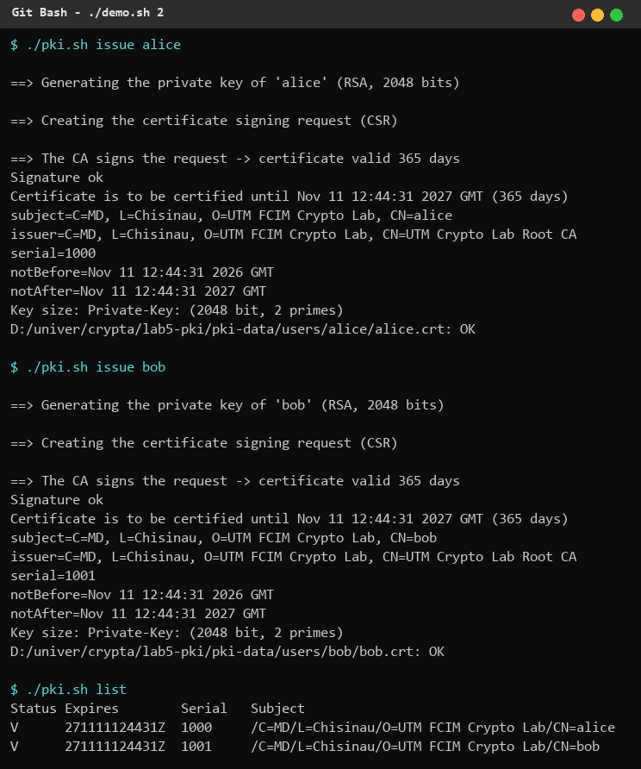
Figure 2. Issuing user certificates
3. Signing and verifying. Alice signs contract.txt → the signature is valid. Alice's signature presented as Bob's → invalid (Bob's public key does not match). After changing "500 MDL" into "5 MDL" the signature of the modified contract is invalid:
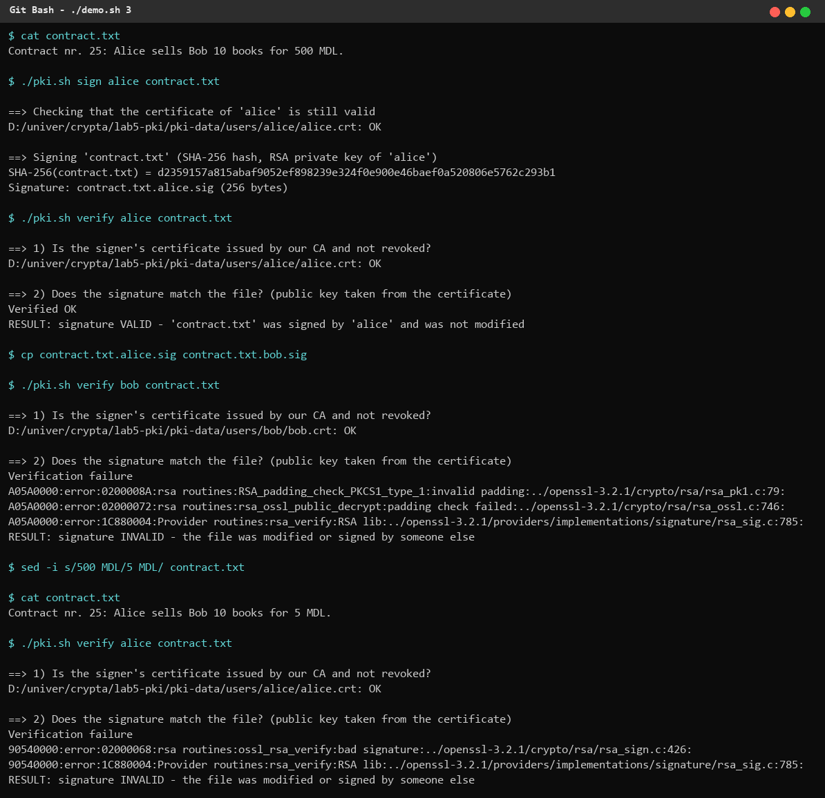
Figure 3. Signing and verifying
4. Revocation. Alice's certificate is revoked (reason Key Compromise) and the new CRL contains serial 1000. Her old signature is no longer trusted and she cannot sign any more; the database shows R for the old certificate. After a new certificate (serial 1002) is issued, she can sign again:
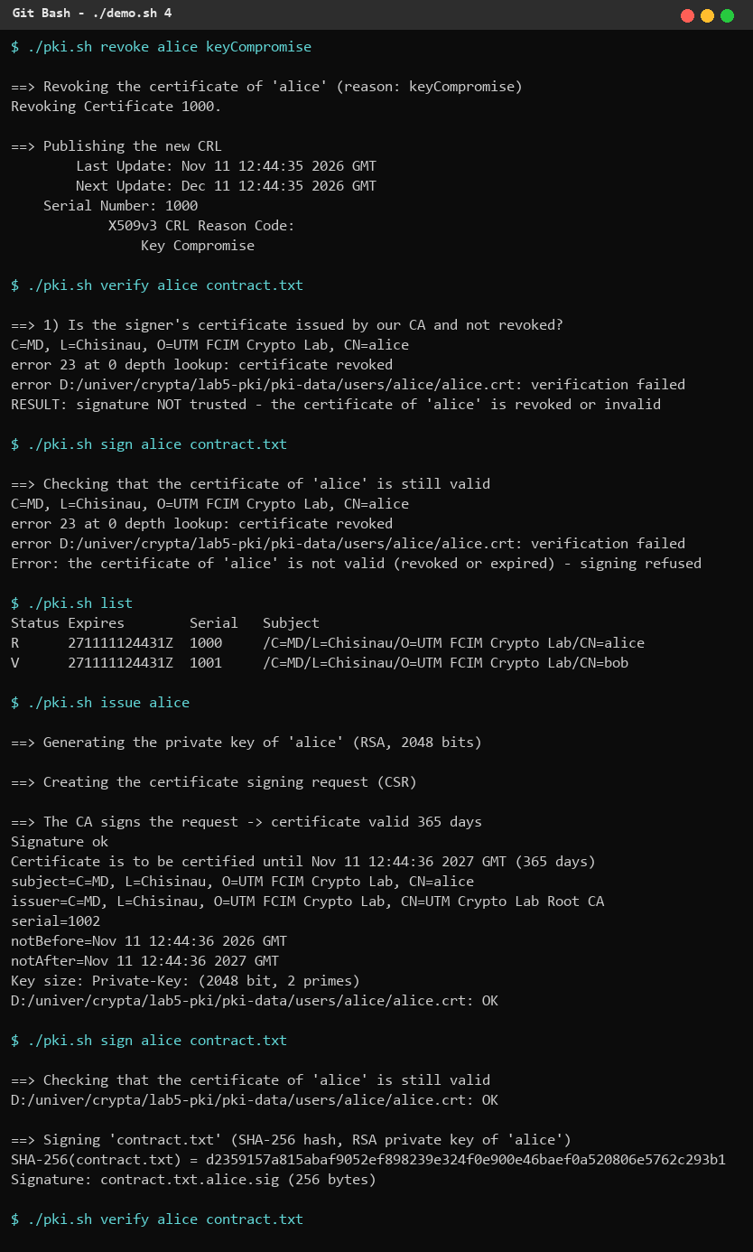
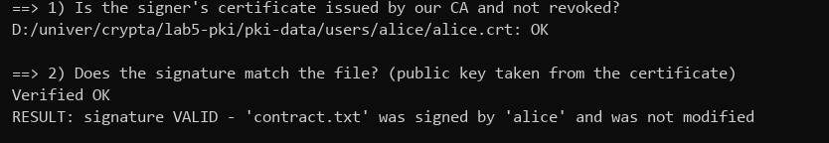
Figure 4. Revocation and re-issuing

5. Conclusions
I built a small but complete PKI with OpenSSL: a root CA with a 4096-bit RSA key and a 10-year self-signed certificate, user certificates with 2048-bit keys valid 365 days, revocation through a CRL and RSA/SHA-256 signatures of arbitrary files. The demonstration shows the three guarantees of digital signatures — a modified document and a signature attributed to another person are both rejected — and also why they depend on the PKI: once Alice's certificate is revoked, even a mathematically correct signature is no longer trusted. In a real deployment the root CA key would be kept offline and certificates would be issued by an intermediate CA; the CA private key is the most sensitive asset of the system, which is why pki-data/ is not committed to the repository.

6. Source code
GitHub repository (branch Cripto): https://github.com/mihaizastinceanu/Cripto/tree/Cripto/lab5-pki

