
MINISTRY OF EDUCATION, CULTURE AND RESEARCH
OF THE REPUBLIC OF MOLDOVA
Technical University of Moldova
Faculty of Computers, Informatics and Microelectronics
Department of Software Engineering and Automation

Zastinceanu Mihai FAF-243

Report
Laboratory Work 1&2
Operating Systems

Checked by:
Reițman Patricia, university assistant
FCIM, UTM

Chișinău – 2026
TABLE OF CONTENTS
1 THE OS AS A RESOURCE MANAGER 3
1.1 Purpose of the work 3
1.2 File management 3
1.3 Process management 5
1.4 Memory management 7
1.5 Device and storage management 8
1.6 System calls of a simple program 9
1.7 Summary of the managed resources 10
2 BUILDING AND EXTENDING XV6 12
2.1 Purpose of the work 12
2.2 Preparing the tools 12
2.3 Building and booting xv6 12
2.4 Using xv6 as a Unix system 13
2.5 Reading the source code 15
2.6 Writing the program sleep 17
2.7 Summary of the system call path 19
CONCLUSIONS 21
REFERENCES 22

1 THE OS AS A RESOURCE MANAGER

1.1 Purpose of the work
The purpose of the first laboratory work is to observe the operating system at work as the manager that stands between programs and hardware. Any operating system has four core jobs: it manages files, processes, memory and devices [2]. Each of these resources was examined on a running Linux system with standard commands, and the results were recorded together with an explanation of what they show [1].
The following tasks were set for the work:
a) to explore the file system tree, to create, copy, rename and delete files and to change their permissions;
b) to list the running processes, to start a process in the background, to inspect it through the /proc pseudo file system and to terminate it;
c) to read the total and free memory of the system and the memory used by a single process;
d) to list the disks, the mounted file systems and the device files.
All commands were run in the terminal of an Ubuntu 26.04.1 LTS virtual machine created in Oracle VirtualBox 7.2 on a Windows 11 host. The virtual machine has 4 processors, 4096 MB of memory and a 50 GB virtual disk. The first commands identify the user and the kernel (Figure 1.1). The current user is papa_bear, the kernel is Linux 7.0.0-34-generic for the x86_64 architecture, and at that moment the system had been running for 1 hour and 27 minutes with two user sessions open.
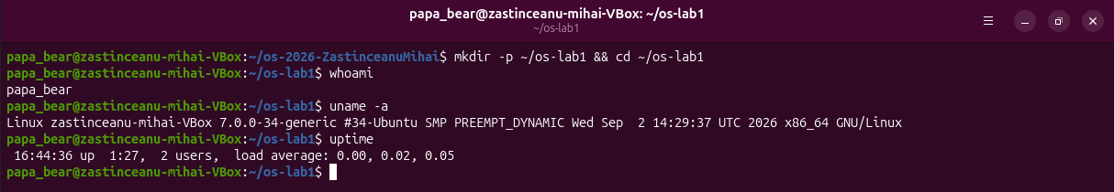
Figure 1.1 – Identification of the user, the kernel and the uptime

1.2 File management
The operating system turns the raw disk into a tree of named files and directories, and every file has an owner, a group and a set of permissions. The command ls -la / lists the root of this tree (Figure 1.2). All directories directly under / belong to the user root. Two of them show well how the tree is organised: /etc keeps the configuration files of the whole system, such as the settings of NetworkManager or adduser.conf, and /home keeps one personal directory for every user, in this case /home/papa_bear [5].
In this listing /bin, /lib, /lib64 and /sbin are not real directories but symbolic links to usr/bin, usr/lib, usr/lib64 and usr/sbin, so Ubuntu keeps all programs under /usr. The directories /proc and /sys have a size of 0 because they are not stored on the disk: the kernel generates their content at the moment it is read. The directory /tmp has the permissions drwxrwxrwt, where the final t is the sticky bit, which lets every user create files there but delete only their own. The root of the tree also holds the file swap.img of about 3.8 GB, which is the swap area of the system.
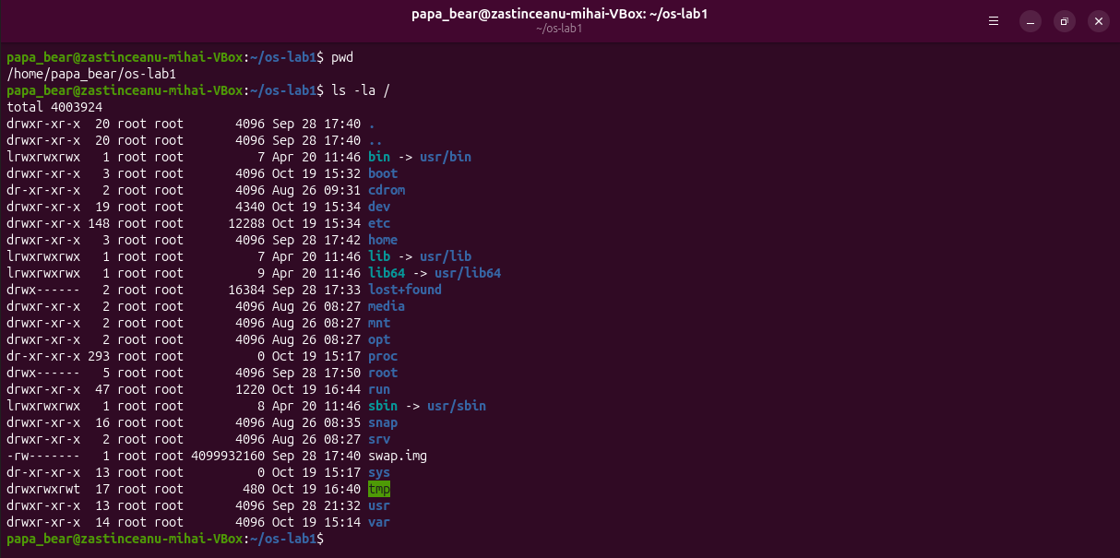
Figure 1.2 – The root of the file system tree
The home directory (Figure 1.3) has the permissions drwxr-x---, so other users cannot enter it. Besides the usual folders such as Desktop and Documents, it contains hidden configuration files whose names start with a dot, for example .bashrc and .profile. The first entries of /etc are configuration directories of system services, such as ModemManager, NetworkManager, PackageKit and X11.
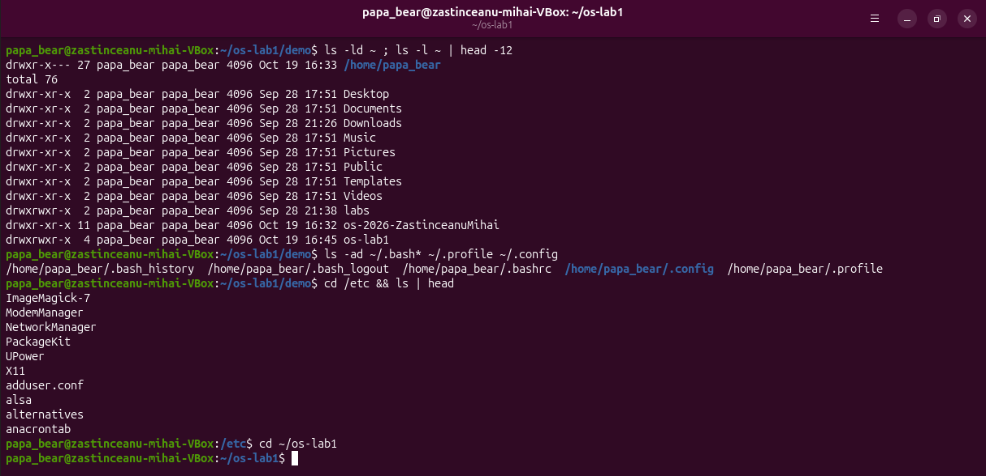
Figure 1.3 – The home directory and the first entries of /etc
In the folder ~/os-lab1/demo the file note.txt was created with echo, copied to copy.txt, renamed to renamed.txt with mv and then removed with rm (Figure 1.4). Both files have a size of 24 bytes, which is the length of the text "hello operating systems" plus the end of line character. They are owned by the user papa_bear and by the group papa_bear, because a new file takes the owner and the primary group of the process that creates it, and on Ubuntu every user has a private group with the same name; the command id confirms uid=1000(papa_bear) gid=1000(papa_bear).
The first ten characters printed by ls -l describe the type and the permissions of a file. Before the change note.txt had -rw-rw-r--, a default that comes from the umask value 0002. After chmod 600 the same line shows -rw-------. The first character means a regular file (a directory would show d). The next three characters, rw-, are the rights of the owner: read and write, but not execute. The last two groups of three are empty, so the group and the other users have no access at all. The command chmod 644 then gave read access back to the group and to the other users (-rw-r--r--).
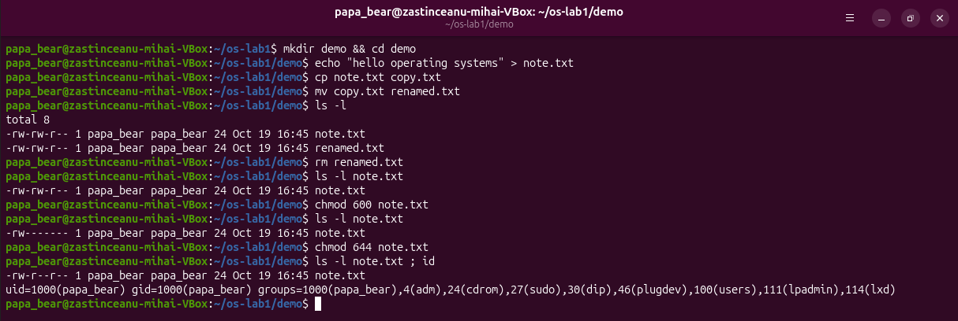
Figure 1.4 – File operations and permission changes in ~/os-lab1/demo

1.3 Process management
Every running program is a process that the kernel created, isolates from the others and schedules on the processor. The command ps aux | wc -l printed 232 lines, which means 231 processes plus the header line (Figure 1.5). The process with PID 1 is systemd, owned by root. It is the first process that the kernel starts after boot (the init process). It starts and supervises the system services and adopts every process whose parent has ended, so all user processes descend from it [3]. The process with PID 2 is kthreadd, the kernel thread that creates the other kernel threads, such as the many kworker entries in the list. They have a virtual size of 0 because they run inside the kernel and have no user memory of their own.
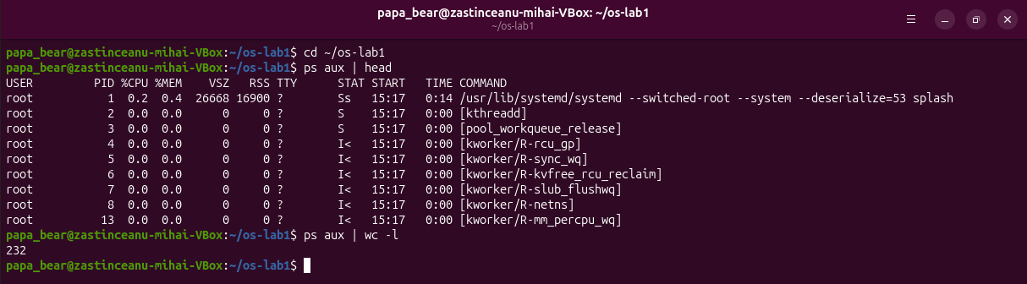
Figure 1.5 – The first processes and their number
The live view of top (Figure 1.6) showed 227 tasks on the idle virtual machine: 1 running, 226 sleeping, 0 stopped and 0 zombie, with the processor idle 92.5% of the time. Most of the processes sleep because they wait for an event, such as input, a timer or a network packet, and do not need the processor.
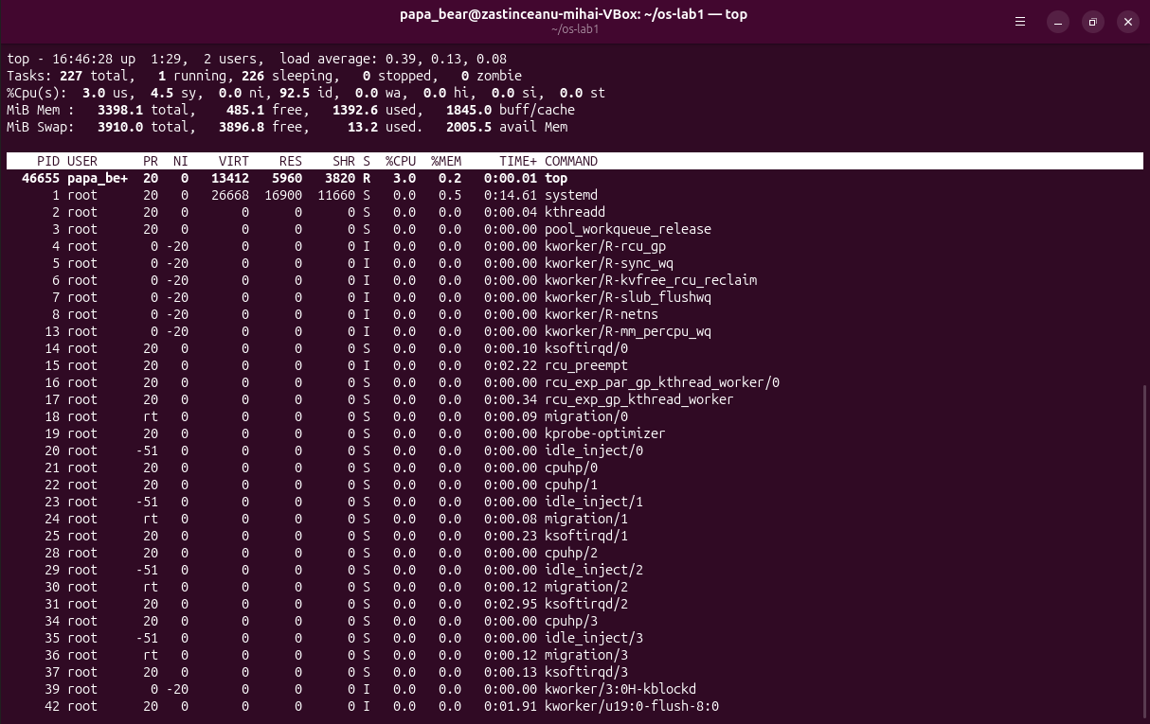
Figure 1.6 – The live process view of top
A process was then started in the background with sleep 300 &. The shell printed [1] 46710, which is the job number followed by the PID (Figure 1.7). The command jobs showed it as Running, and ps -ef | grep sleep found it with the parent PID 28913, which is the bash shell that started it. The line of grep appears as well because grep itself was a running process at that moment. The command kill asked the operating system to terminate the process, and jobs then reported it as Terminated.
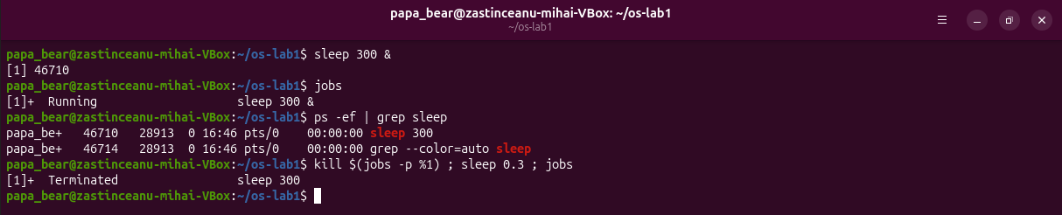
Figure 1.7 – Starting, finding and terminating a background process
The kernel also shows every process as a directory in the /proc pseudo file system [4]. For a new sleep process with PID 46558, the directory /proc/46558 contained entries such as cmdline, cwd, environ, exe, fd, maps and status (Figure 1.8). The status file reported State: S (sleeping), because sleep only waits for a timer and does not use the processor. The same file shows the parent PID 28913, the user and group id 1000 of papa_bear and a virtual memory size of 16112 kB.
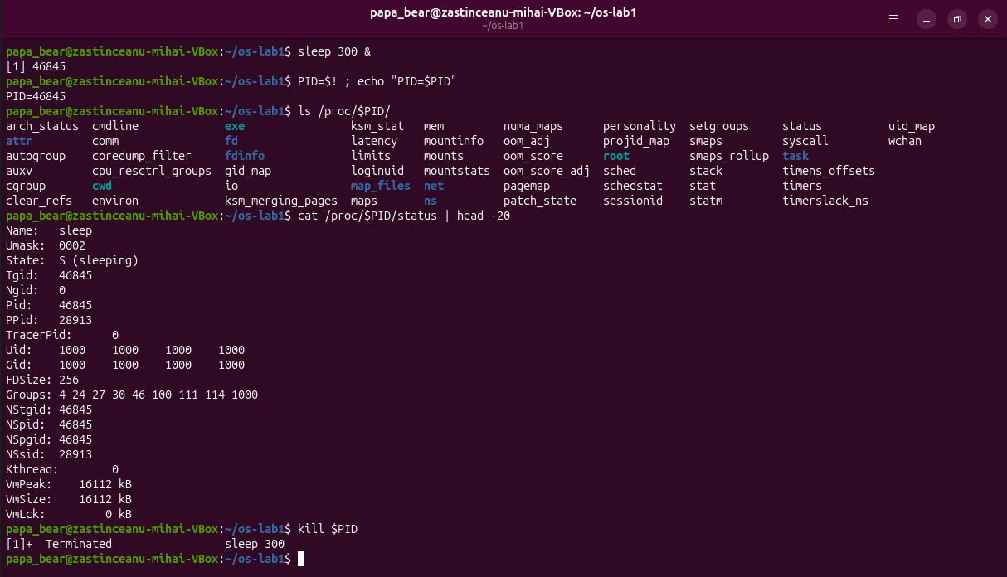
Figure 1.8 – The /proc directory of a process and its status file

1.4 Memory management
The commands free -h and cat /proc/meminfo give the memory totals of the whole machine (Figure 1.9). The virtual machine has 3.3 GiB of RAM in total (MemTotal 3479680 kB), a little less than the 4096 MB set in VirtualBox, because the memory reserved by the firmware and by the kernel at boot is not counted. At the moment of the command 611 MiB were completely free, while 2.0 GiB were available. The difference comes from the 1.7 GiB shown as buff/cache: Linux uses RAM that no program needs as a cache for disk data and gives it back as soon as a program asks for memory, so a small free value is normal on Linux.
Swap is an area on the disk to which the kernel can move memory pages that have not been used for a while when the RAM is full. It lets the system run more programs than fit in physical memory, at the cost of speed, since the disk is much slower than RAM. On this virtual machine the swap is the file /swap.img of 3.8 GiB, and only 13 MiB of it were in use.
The resident memory of a bare sleep process, read from the VmRSS line of its status file, was 7716 kB, while its virtual size is 16112 kB. The value looks large for a program that does nothing, but the breakdown explains it: only 1224 kB (RssAnon) are private memory of the process, and 6492 kB (RssFile) are pages of files, mainly the C library, which are shared by all processes that use them and exist in RAM only once. The rest of the virtual size was never touched, so because of demand paging it does not occupy RAM.
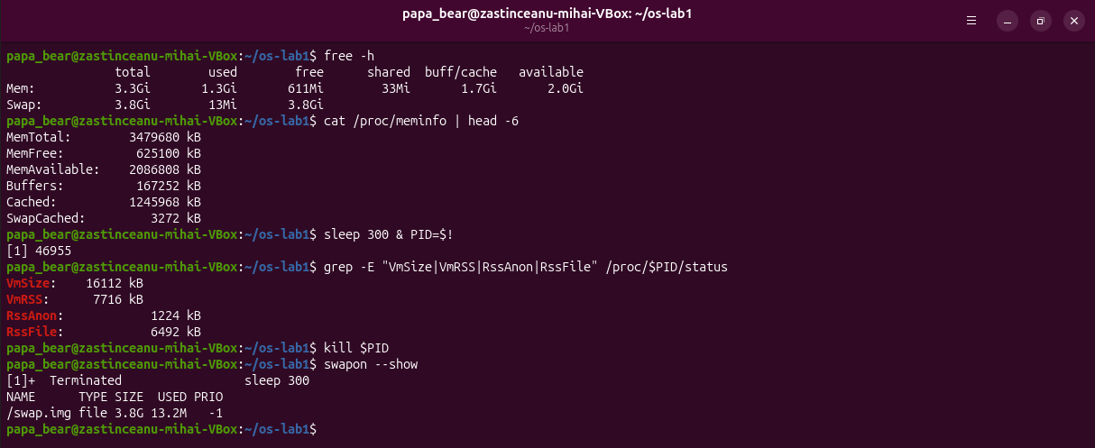
Figure 1.9 – Memory totals and the resident memory of one process

1.5 Device and storage management
The operating system hides every disk and device behind a uniform interface that looks like a file. The command lsblk lists the block devices (Figure 1.10). The virtual disk sda has 50 GB and two partitions: sda1 (1 MB), the BIOS boot partition used by the boot loader, and sda2 (50 GB) mounted on /. The output of df shows that /dev/sda2 has 49 GB, of which 14 GB (31%) are used, and the output of mount confirms that the root file system is on /dev/sda2 and uses the ext4 format. The device sr0 is the virtual optical drive. The loop devices, hidden from the listing, are the compressed images of snap packages. The command du -sh ~/os-lab1 reported 64K for the work folder.
In /dev every device appears as a file. For example, /dev/console is a character device (the line starts with c, major number 5, minor number 1) that stands for the system console, and /dev/cdrom is a link to sr0, the CD drive of the virtual machine. The output of mount also shows that /dev, /sys and /proc are themselves file systems of the types devtmpfs, sysfs and proc that the kernel fills in memory. Based on these results, "everything is a file" means that disks, terminals, kernel information and even running processes are reached through names in the same tree and are read or written with the same operations as ordinary files.
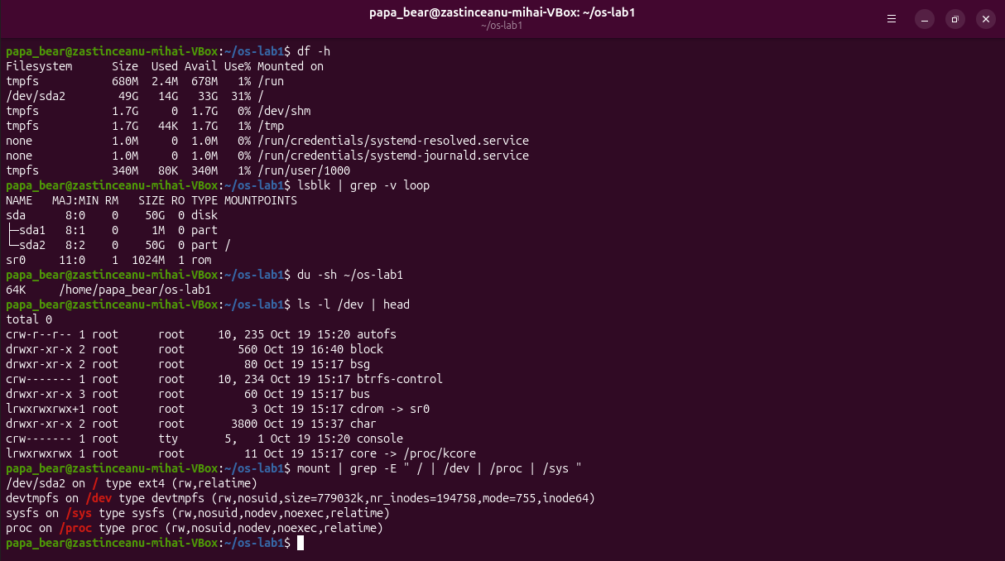
Figure 1.10 – Mounted file systems, block devices, device files and mounts

1.6 System calls of a simple program
The optional part of the work used htop and strace. htop (Figure 1.11) shows the same information as top with a load bar for each of the 4 processors, the memory use (1.06 GB of 3.32 GB) and the full command line of every process. The command strace -c ls counts the system calls that ls makes just to list a directory (Figure 1.12): 138 calls of 31 different kinds. The single execve loads the program, mmap, mprotect and brk prepare its memory, openat, read, fstat and close load the shared libraries and the locale files, getdents64 reads the entries of the directory and write prints the result. Every one of these operations is a request to the kernel, so even the simplest command depends on the operating system at every step [7].
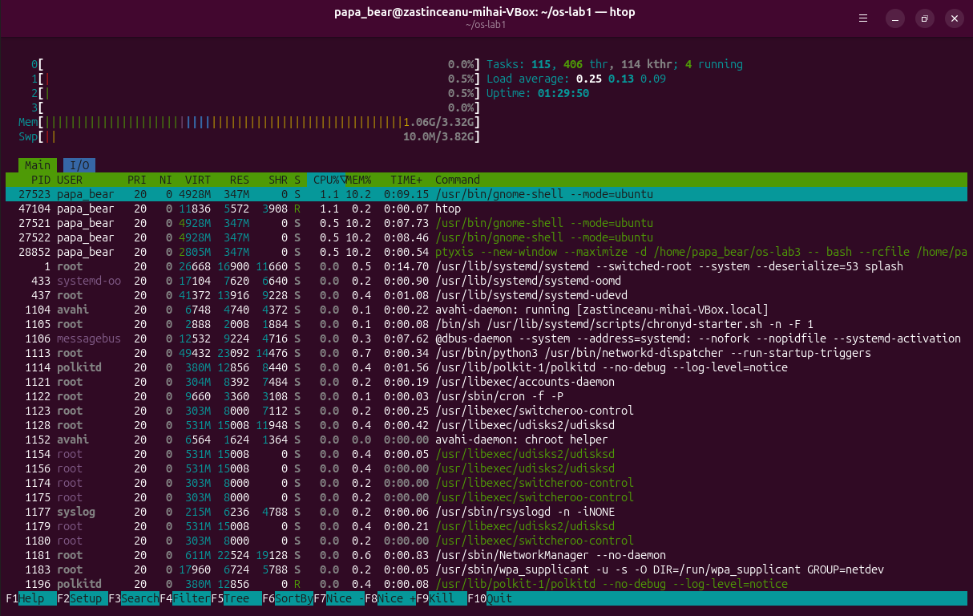
Figure 1.11 – The process view of htop
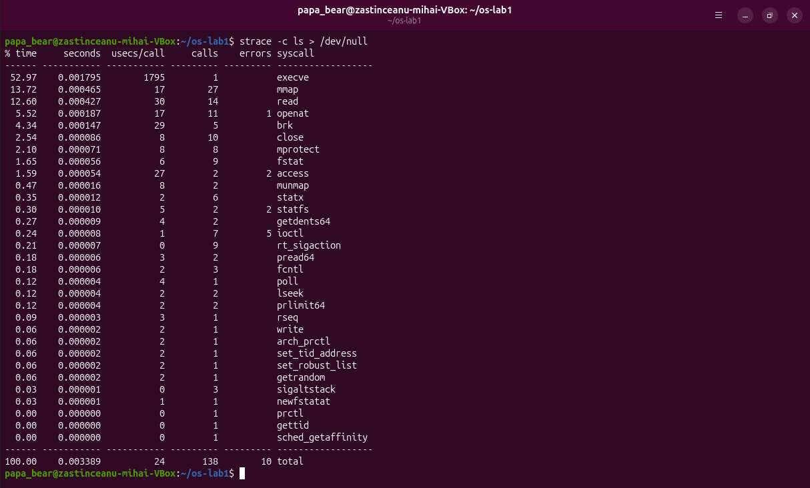
Figure 1.12 – The system calls made by ls, counted by strace

1.7 Summary of the managed resources
Table 1.1 lists the four resources that the operating system manages and the command that made each of them visible in this work.
Table 1.1 – Resources managed by the operating system
Resource | What the operating system does | Command used
Files | organises the disk into a tree of named files with owners and permissions | ls -l
Processes | creates, schedules and terminates the running programs | ps -ef, top
Memory | shares the physical RAM between the processes and uses the rest as a cache | free -h
Devices | presents disks and other hardware as files | lsblk

The operating system manages four resources: files, processes, memory and devices. The file tree and its permissions were visible with ls -l, the processes with ps -ef and top, the memory with free -h and the devices with lsblk. Each of these commands only reads information that the kernel already keeps about the resource, which shows that the operating system tracks and shares everything that programs use.

2 BUILDING AND EXTENDING XV6

2.1 Purpose of the work
The purpose of the second laboratory work is to build a real operating system from its source code, to boot it, to use it, to read its code on both sides of the system call boundary and to add a first program to it [6]. The system is xv6, a small Unix written at MIT for teaching. It reimplements Unix Version 6 in about 9,000 lines of C for the RISC-V architecture and runs under the QEMU emulator [8].
The following tasks were set for the work:
a) to build the kernel and the user programs and to boot xv6 in QEMU;
b) to use the programs that come with xv6, including a pipe;
c) to read user programs and to find where the kernel implements the system calls they use;
d) to write a new user program, sleep, that pauses for a given number of clock ticks through a system call.
The work was done on the same Ubuntu 26.04 virtual machine as the first laboratory work. The current version of xv6 was cloned from its official repository (commit 06aad25 of 26 September 2026) [9].

2.2 Preparing the tools
xv6 cannot be compiled by the usual compiler of the machine it is built on, because that compiler produces x86_64 instructions and xv6 runs on a RISC-V processor. It needs a cross compiler, which runs on one architecture and produces code for another, and an emulator of a RISC-V computer. The cross compiler riscv64-linux-gnu-gcc 15.2.0 and QEMU 10.2.1 were installed with the course setup script (Figure 2.1).
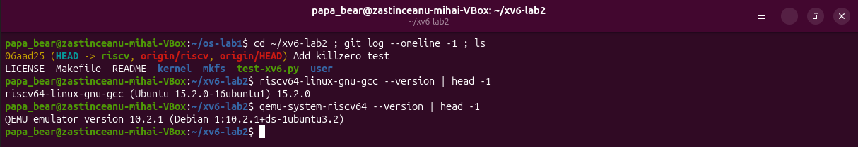
Figure 2.1 – The xv6 source tree and the versions of the cross compiler and of QEMU

2.3 Building and booting xv6
The command make qemu compiles every file of the kernel and of the user programs with the cross compiler and links each user program into a separate executable whose name starts with an underscore, for example user/_sync. Then it runs the tool mkfs, which writes these programs and the README file into the disk image fs.img (Figure 2.2). mkfs reported an image of 2000 blocks of 1024 bytes. 47 of them hold the metadata of the file system: the boot block, the superblock, 31 log blocks, 13 inode blocks and 1 bitmap block. The other 1953 blocks are for data, and after the programs were written the first 1056 blocks were in use.
QEMU then starts a virtual RISC-V computer of the type virt with 128 MB of memory and 3 processor cores, which RISC-V calls harts. The option -bios none means that no firmware runs first, so the xv6 kernel is the first code that the virtual processor executes. The kernel printed "xv6 kernel is booting", the two other cores reported "hart 1 starting" and "hart 2 starting", and the first user process, init, started the shell sh, which showed its prompt $. QEMU runs with the option -nographic, so the console of xv6 is the same terminal window, and QEMU is closed with Ctrl-A followed by X.
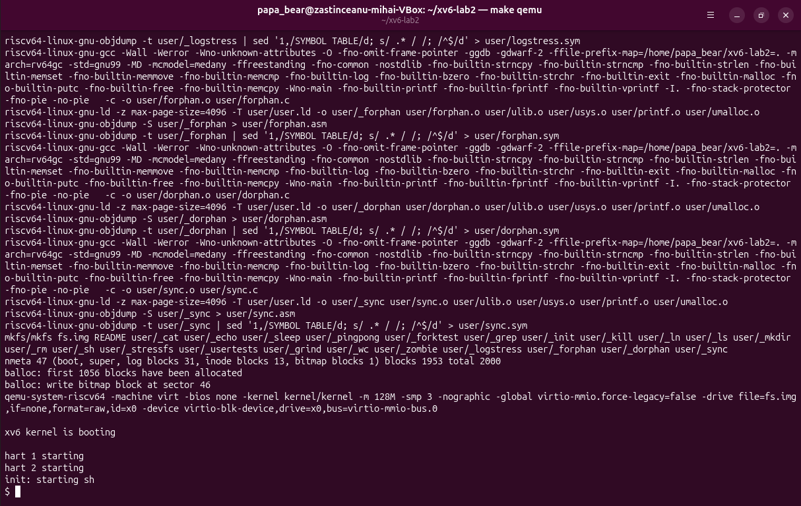
Figure 2.2 – The end of the build and the boot of xv6

2.4 Using xv6 as a Unix system
The command ls at the xv6 prompt lists the root directory (Figure 2.3). Every line shows the name, the type, the inode number and the size in bytes. The type is 1 for a directory, 2 for a file and 3 for a device, so console is a device file, just like /dev/console on Linux. Besides README and console, the disk holds 22 programs: the 20 programs of xv6 and the two added in this work, sleep and pingpong. Three of the standard programs are cat, grep and wc; the others include echo, ls, mkdir, rm, kill and the shell sh.
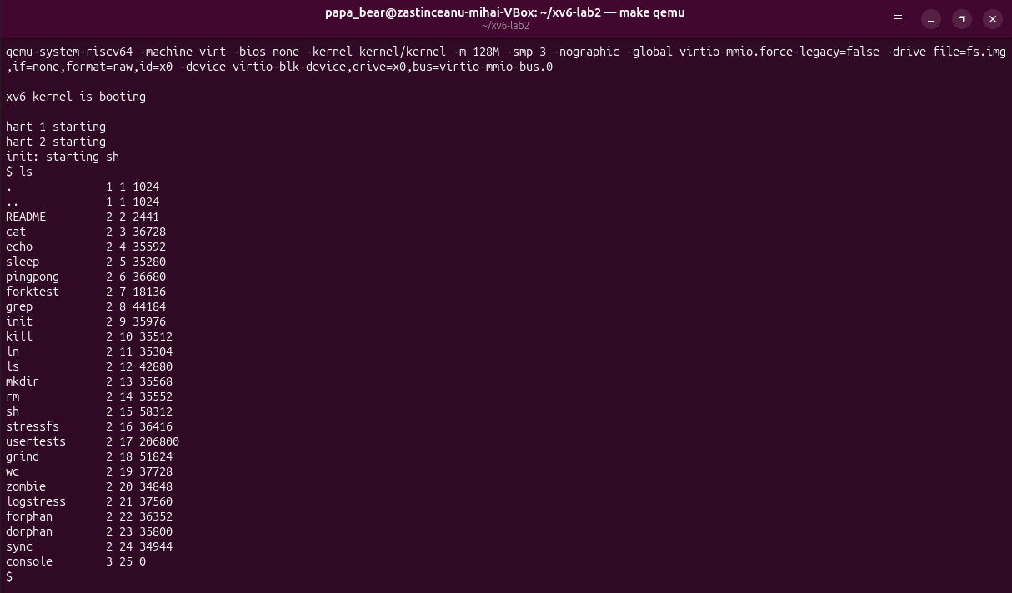
Figure 2.3 – The root directory of xv6
Then the commands cat README, echo hello xv6, ls | grep c and wc README were run (Figure 2.4). They behave like their Linux versions from the first laboratory work. The pipe ls | grep c kept only the lines of ls that contain the letter c: cat, echo, wc, sync and console. The command wc README counted 48 lines, 336 words and 2441 bytes, the same size that ls shows for README.
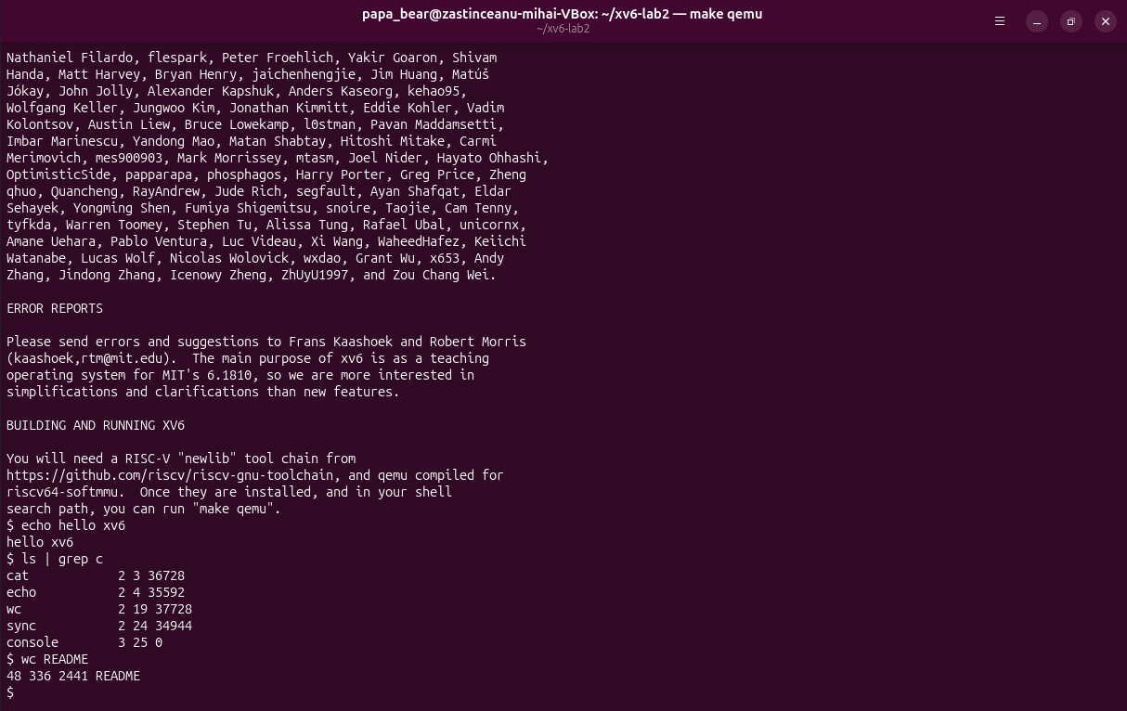
Figure 2.4 – Running the programs of xv6, including a pipe
A pipe needs two features of the operating system. The first one is processes: the shell creates a separate process for each side of the pipe with fork, loads ls into one and grep into the other with exec, and the two run at the same time. The second one is communication between processes: the system call pipe creates a buffer inside the kernel with a write end and a read end, both seen by the programs as file descriptors. The shell connects the standard output of ls to the write end and the standard input of grep to the read end with close and dup, as lines 101 to 123 of user/sh.c show. Neither program knows about the other.
The xv6 shell understands the same basic syntax as the bash shell of the first laboratory work, with commands, arguments, pipes, redirection and background jobs, but it is a single file of 499 lines, user/sh.c, without command history, tab completion, variables, wildcards or scripts.

2.5 Reading the source code
The xv6 tree is divided into two main folders, and this division is the main idea of how an operating system is organised (Figure 2.5). The folder kernel/ contains the operating system itself: the scheduler (proc.c), the memory manager (vm.c, kalloc.c), the file system (fs.c, log.c, bio.c) and the handlers of the system calls (syscall.c, sysproc.c, sysfile.c). The folder user/ contains the ordinary programs that run on top of it, such as ls, cat, echo and the shell.
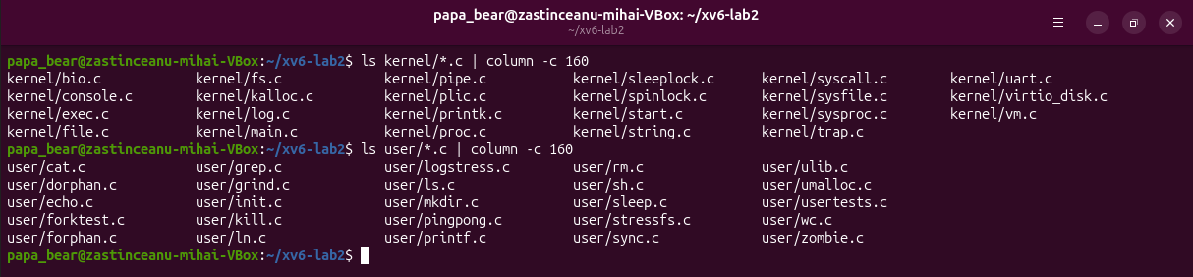
Figure 2.5 – The C files of the kernel and of the user programs
The beginnings of user/ls.c and user/cat.c were printed with sed (Figure 2.6 and Figure 2.7). They are ordinary C programs, but they include kernel/types.h and user/user.h instead of the headers of the standard C library, because xv6 has no standard library.
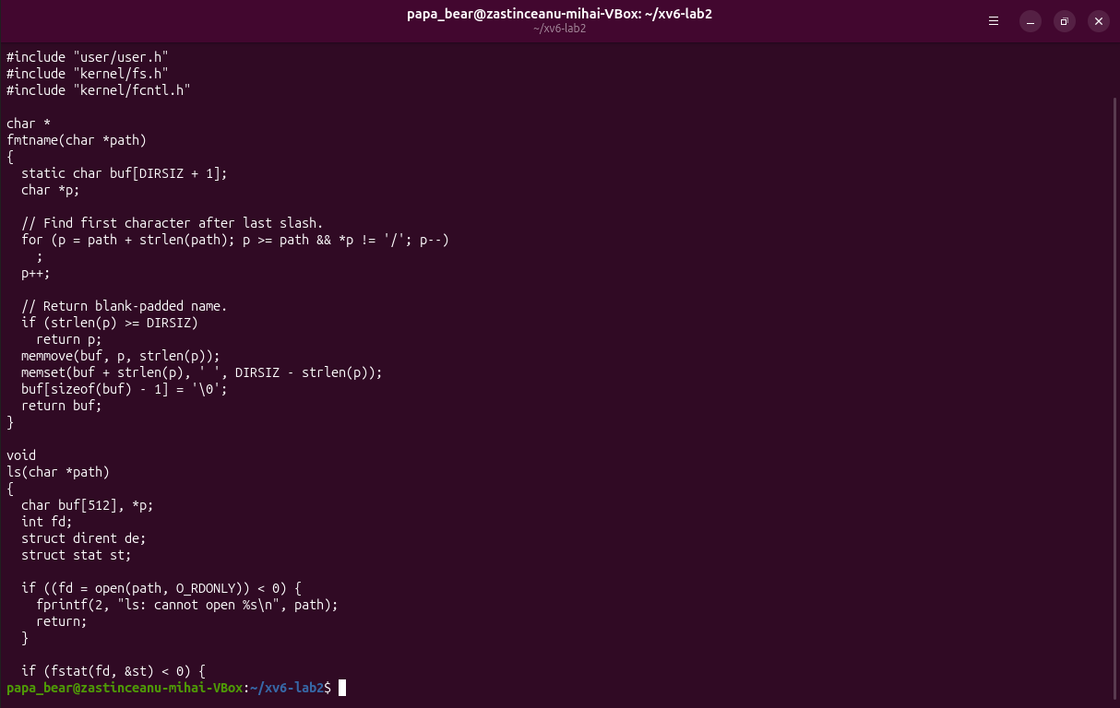
Figure 2.6 – The beginning of user/ls.c
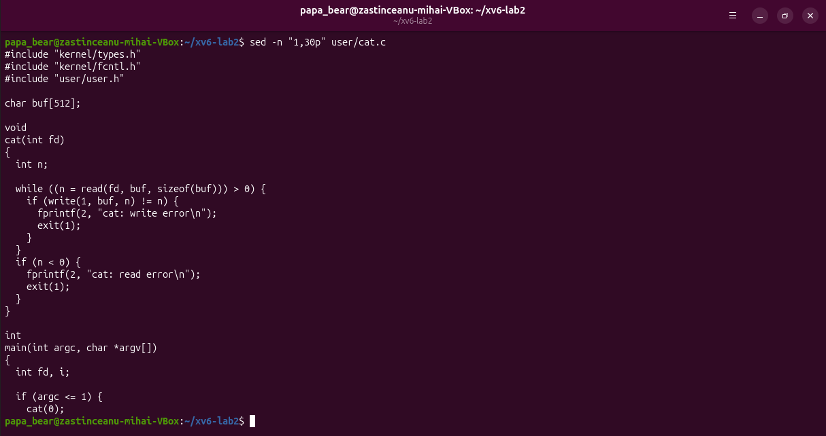
Figure 2.7 – The beginning of user/cat.c
The program cat uses five system calls. open asks the kernel to open a file named on the command line for reading and to return a file descriptor, a small number that refers to the open file. read asks the kernel to copy up to 512 bytes from the file into the buffer buf. write asks it to copy these bytes to file descriptor 1, the standard output. close releases the descriptor when the file is finished, and exit ends the process with a status, 0 for success and 1 for an error. The error messages printed with fprintf also end up as write calls on file descriptor 2. When cat gets no arguments, it calls cat(0) and reads file descriptor 0, the standard input, which is why it can stand on the right side of a pipe.
The file user/user.h lists the 22 system calls that programs can use, from fork, exit and wait to pause, uptime and sync (Figure 2.8). The command grep -n "sys_read\|sys_write" kernel/sysfile.c showed that sys_read is implemented on line 69 of kernel/sysfile.c and sys_write on line 83 of the same file.
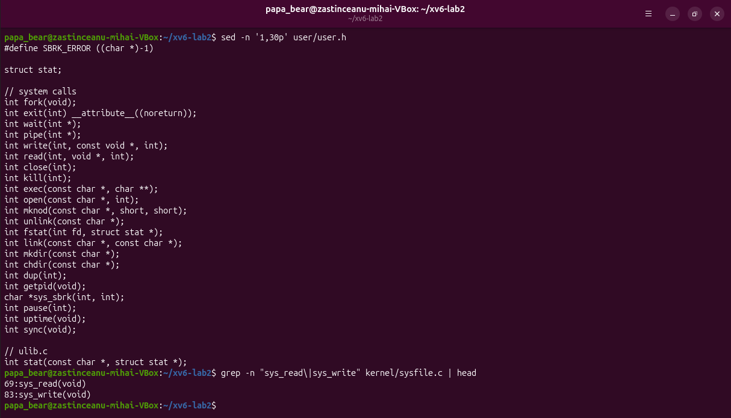
Figure 2.8 – The system calls in user/user.h and the location of sys_read and sys_write
The code in kernel/ runs in the privileged mode of the processor and controls the hardware, the memory and all the processes, while the code in user/ runs in user mode, each program isolated in its own address space, and can reach files, devices or other processes only by asking the kernel through system calls.

2.6 Writing the program sleep
The new program was written in the file user/sleep.c (Listing 2.1). It checks that it got exactly one argument. If not, it prints a usage message to file descriptor 2, the standard error, and ends with the status 1. Otherwise it converts the argument from text to a number with atoi, passes the number to the system call and ends with the status 0.
#include "kernel/types.h"
#include "user/user.h"

// sleep <ticks>: pause for the given number of clock ticks.
//
// Note: the lab sheet calls sleep(), but in current xv6 the user-level
// system call sleep() was renamed to pause() (commit f5dea58, Aug 2025,
// "user sleep() -> pause()"), because the kernel uses the name sleep()
// for its own internal sleep/wakeup mechanism. pause() is the same
// system call (SYS_pause, handled by sys_pause() in kernel/sysproc.c).
int
main(int argc, char *argv[])
{
if (argc != 2) {
fprintf(2, "usage: sleep <ticks>\n");
exit(1);
}
pause(atoi(argv[1])); // system call into the kernel
exit(0);
}
Listing 2.1 – The program user/sleep.c
The handout calls the system call sleep(), but user/user.h (Figure 2.8) contains no such name: in the current xv6 it has been renamed pause, because the kernel uses the name sleep for its internal function that blocks a process while it waits for an event. The program therefore calls pause(atoi(argv[1])) and keeps the name sleep that the task asks for.
To include the program in the build, the line $U/_sleep\ was added to the list UPROGS in the Makefile, under the line of echo, where it became line 135 (Figure 2.9). The command grep -n ... Makefile | cat -A makes invisible characters visible and confirms that the line starts with a tab, shown as ^I, and that the backslash is the last character before the end of the line, shown as $. If anything followed the backslash, the list would end on this line and the next lines of the Makefile would become invalid.
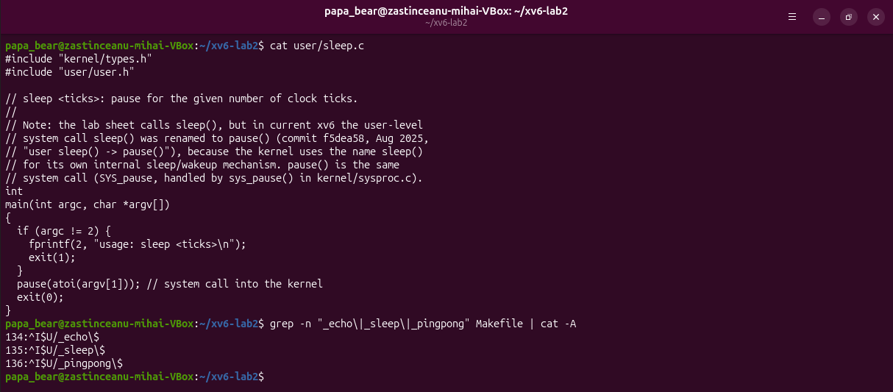
Figure 2.9 – The program user/sleep.c and the new lines in the Makefile
Inside xv6 the command ls sleep listed the program as a file with the inode number 5 and a size of 35280 bytes (Figure 2.10). The command sleep 10 paused and then returned to the prompt, and sleep without an argument printed the usage message. One tick of xv6 is the interval of the timer interrupt, which kernel/trap.c sets to 1000000 cycles of the timer, about a tenth of a second, so sleep 10 waits about one second. The optional program pingpong, which exchanges one byte between a parent and a child through two pipes, printed "7: received ping" from the child and "6: received pong" from the parent.
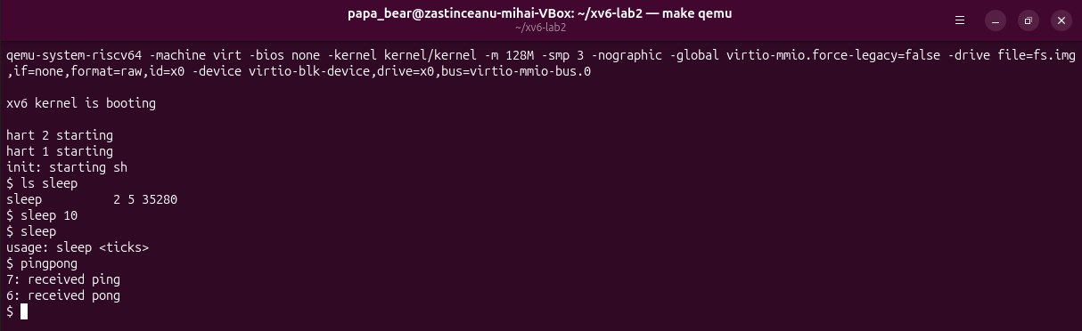
Figure 2.10 – Testing the programs sleep and pingpong inside xv6

2.7 Summary of the system call path
The call that the program sleep makes was followed from the user program down to the kernel (Figure 2.11). Table 2.1 summarises the steps.
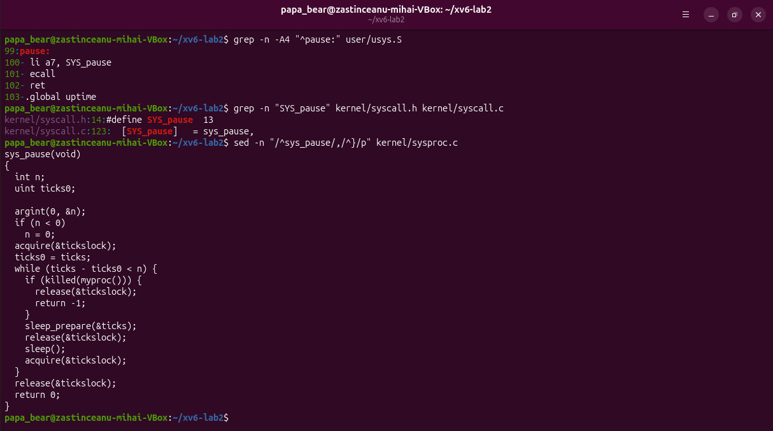
Figure 2.11 – The stub of pause, its number and the kernel function sys_pause
Table 2.1 – The path of the pause system call through xv6
Step | What happens | File
Program | main calls pause(ticks) like an ordinary function | user/sleep.c
Stub | puts 13, the number SYS_pause, into the register a7 and executes ecall | user/usys.S
Dispatch | the kernel reads a7 and calls the matching function from its table of system calls | kernel/syscall.c
Service | sys_pause sleeps until the tick counter has grown by the requested value | kernel/sysproc.c

The program sleep never touches the timer itself. It only asks, and the kernel, which owns the timer and the scheduler, does the waiting and lets other processes use the processor in the meantime.

CONCLUSIONS
The first laboratory work showed the four core jobs of an operating system on a running Ubuntu system. The file system tree, the permission bits and the owner of every file showed how the operating system controls the access to data. The commands top and ps and the /proc directory showed that even an idle desktop runs more than 220 processes and that the kernel keeps detailed information about each of them, such as its state, its parent and its memory. The output of free and /proc/meminfo showed that Linux keeps unused memory busy as a disk cache and that most of the memory of a small program like sleep is shared library code. Finally, lsblk, mount and the /dev directory showed that disks and other devices are reached through files, and strace showed that even ls needs more than a hundred system calls.
The second laboratory work moved from watching an operating system from the outside to building one. xv6 was compiled with a cross compiler, because it runs on RISC-V and not on the x86_64 processor of the host, and it was booted in QEMU on an emulated RISC-V machine. Its small set of programs behaves like the Linux commands of the first work, and its source shows both sides of every system call: the program in user/ that asks and the code in kernel/ that answers. Adding the program sleep showed the whole path of one system call, from the call in C through the ecall instruction and the table of system calls to sys_pause in the kernel. The only difference from the handout, the renaming of sleep to pause, was solved by reading user/user.h, which shows that the source code is often the fastest way to understand an error.

REFERENCES
1. The OS as a Resource Manager. Laboratory Work 1, Operating Systems course. Faculty of Computers, Informatics and Microelectronics, Technical University of Moldova, 2026.
2. SILBERSCHATZ, A., GALVIN, P. B., GAGNE, G. Operating System Concepts. 10th edition. Hoboken: Wiley, 2018.
3. systemd(1). Linux manual page [online]. Available: https://man7.org/linux/man-pages/man1/systemd.1.html
4. proc(5). Linux manual page [online]. Available: https://man7.org/linux/man-pages/man5/proc.5.html
5. Filesystem Hierarchy Standard, version 3.0. The Linux Foundation, 2015 [online]. Available: https://refspecs.linuxfoundation.org/FHS_3.0/fhs-3.0.html
6. Meet the OS You Will Build. Laboratory Work 2, Operating Systems course. Faculty of Computers, Informatics and Microelectronics, Technical University of Moldova, 2026.
7. strace(1). Linux manual page [online]. Available: https://man7.org/linux/man-pages/man1/strace.1.html
8. COX, R., KAASHOEK, F., MORRIS, R. xv6: a simple, Unix-like teaching operating system [online]. MIT, 2024. Available: https://pdos.csail.mit.edu/6.1810/2024/xv6/book-riscv-rev4.pdf
9. xv6 for RISC-V. Source code repository, MIT PDOS [online]. Available: https://github.com/mit-pdos/xv6-riscv

