
MINISTRY OF EDUCATION, CULTURE AND RESEARCH
OF THE REPUBLIC OF MOLDOVA
Technical University of Moldova
Faculty of Computers, Informatics and Microelectronics
Department of Software Engineering and Automation

Zastinceanu Mihai FAF-243

Report
Laboratory Work 3
Operating Systems
Topic: The Command Line: Shell, Pipes and Text Filters

Checked by:
Reițman Patricia, university assistant
FCIM, UTM

Chișinău – 2026
TABLE OF CONTENTS
AIM OF THE WORK 3
Purpose of the practical work 3
Problem statement 3
1 MOVING FAST AND FINDING HELP 4
1.1 Theoretical background 4
1.2 Work performed 4
1.3 Answers to the questions 6
2 WHAT THE SHELL DOES TO A COMMAND LINE 7
2.1 Theoretical background 7
2.2 Work performed 7
2.3 Answers to the questions 9
3 REDIRECTION, CHAINING AND JOBS 10
3.1 Theoretical background 10
3.2 Work performed 10
3.3 Answers to the questions 11
4 ANSWERING QUESTIONS WITH ONE-LINERS 12
4.1 Theoretical background 12
4.2 Work performed 12
4.3 Answers to the questions 15
5 THE FIRST SCRIPT 16
5.1 Theoretical background 16
5.2 Work performed 16
5.3 Answers to the questions 18
CONCLUSIONS 19
REFERENCES 20

AIM OF THE WORK

Purpose of the practical work
The purpose of the work is to acquire fluency in the Linux command line: to move quickly in the bash shell, to predict how the shell transforms a command line before the command runs, to redirect and chain the output of programs, and to answer questions about data with short pipelines of text filters [1]. The experiments were carried out in the terminal of the course virtual machine (Ubuntu 26.04.1 LTS in Oracle VirtualBox, Linux 7.0.0-34-generic, GNU bash 5.3.9), as the ordinary user papa_bear.

Problem statement
The work is divided into five parts, each of them treated in a separate chapter of the report. The following tasks have to be solved:
- to use tab completion, command history and the built-in documentation of the system;
- to predict and verify the result of globbing, quoting, brace expansion and command substitution;
- to redirect the standard streams, to chain commands with operators and to control background jobs;
- to answer eight questions about an artificial web access log of 500 lines with one-line pipelines;
- to turn the pipelines into an executable script that validates its argument and returns an exit code.
For every command marked PREDICT, the expected output was written down before execution and compared with the real output. The answers to the questions of the handout are given at the end of each chapter.

1 MOVING FAST AND FINDING HELP

1.1 Theoretical background
A command typed in the shell is either a built-in, executed by the shell process itself, or an external program, which the shell looks for in the directories listed in the PATH variable [2]. The type of a command can be checked with the built-in type and the location of an external program with which. Every command finishes with an exit status stored in the variable $?, where 0 means success and a non-zero value means failure; the status 127 is returned when the command is not found.
Interactive work is accelerated by tab completion, which completes a unique prefix or lists the candidates on the second press, and by the history search started with Ctrl+R [2]. The documentation is available without a browser through man, the option --help, the keyword search man -k and the shell built-in help.

1.2 Work performed
The behaviour of the Tab key is shown in Figure 1.1. For the prefix /usr/sh there is a single candidate, so the path is completed directly to /usr/share/. For a directory with a very large number of entries the shell asks for confirmation ("Display all 260 possibilities? (y or n)") before printing the list. The prefix /et in the command cd /et was completed to /etc/.
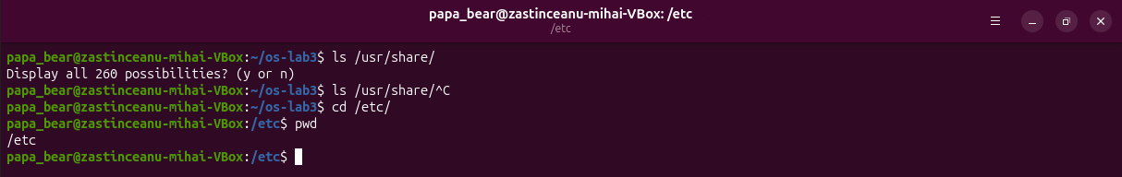
Figure 1.1 – Tab completion
After three commands (date, uname -r, whoami), the search started with Ctrl+R and the letters dat found the previous command date (Figure 1.2), and Enter executed it again.
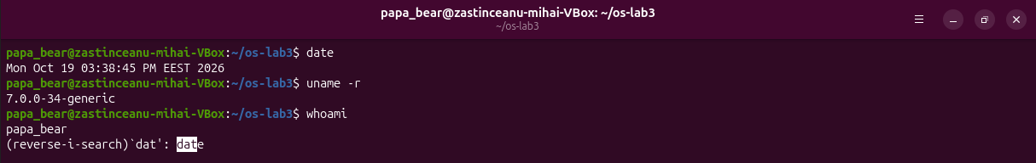
Figure 1.2 – History search with Ctrl+R
The result of the commands type and which is presented in Figure 1.3. The commands cd and echo are reported as shell builtins, ls is located in /usr/bin/ls, and type -a echo shows that an external program /usr/bin/echo exists as well, but the built-in has priority.
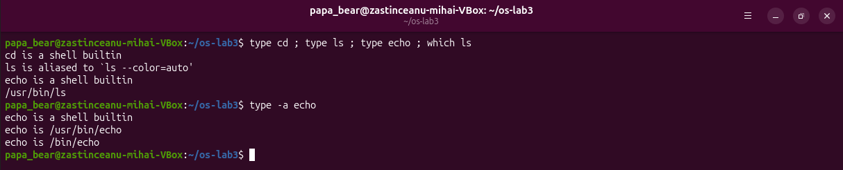
Figure 1.3 – Output of type and which
The directories searched by the shell are displayed one per line in Figure 1.4. The list contains 12 entries, counted by wc -l.
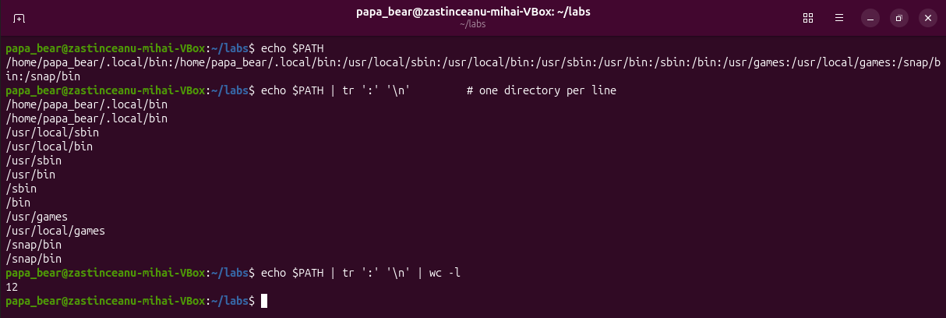
Figure 1.4 – The directories in PATH
According to Figure 1.5, the nonexistent command nosuchprog produced the message "command not found" and the exit code 127.
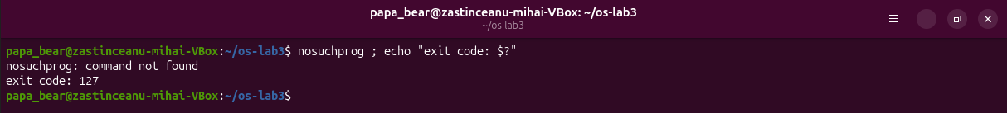
Figure 1.5 – Exit code of a missing command
Figure 1.6 shows the documentation commands. The entries rust-ls, rust-dir and rust-vdir returned by man -k and the short output of ls --help indicate that ls on this system is provided by uutils coreutils, the implementation of the core utilities in the Rust language [3], and not by the classical GNU version [4]. The manual page of ls was searched with /sort and n, and the line of the option -t was found.
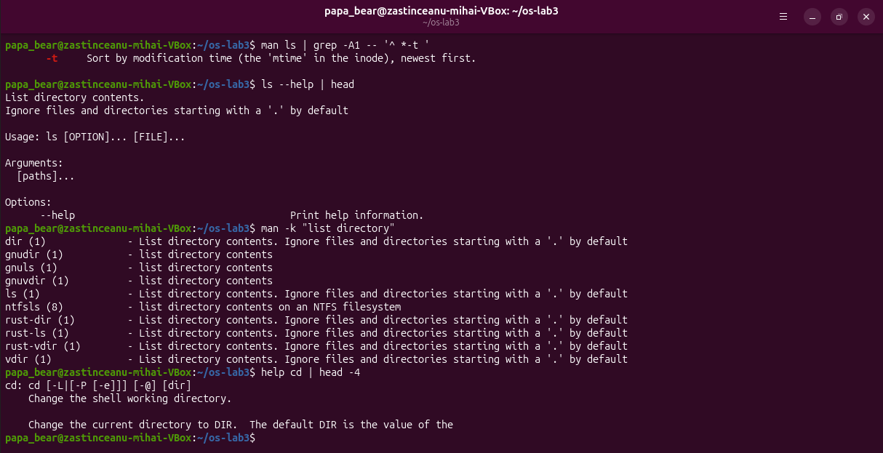
Figure 1.6 – The option -t in the manual of ls, ls --help, man -k and help cd

1.3 Answers to the questions
Question 1. The commands cd and echo are built-ins, and ls is an external program. The command cd must be a built-in because an external program runs in a child process, and a child process can change only its own working directory; the working directory of the parent shell would remain unchanged.
Question 2. The PATH variable contains 12 entries, but only 10 are distinct: /home/papa_bear/.local/bin and /snap/bin appear twice, because they are added by two configuration files of the shell. The program ls is located in /usr/bin; it is also reachable as /bin/ls because /bin is a link to usr/bin.
Question 3. A command that is not found returns the exit code 127.
Question 4. The option -t sorts the entries by modification time, the newest first: "Sort by modification time (the 'mtime' in the inode), newest first".

2 WHAT THE SHELL DOES TO A COMMAND LINE

2.1 Theoretical background
Before a command is executed, the shell transforms the typed line: it performs brace expansion, parameter expansion, command substitution and arithmetic expansion, splits the result into words, expands the patterns of file names (globbing) and removes the quotes [2], [5]. As a consequence, a program such as echo receives the already expanded list of arguments and does not know anything about the original pattern.
The pattern * matches any string, ? matches exactly one character, and [a-b] matches one character from the given range; a pattern that matches no file remains unchanged [6]. Single quotes keep every character literal, double quotes prevent word splitting and globbing but allow the expansion of variables and of $(...), and the backslash protects the next character.

2.2 Work performed
A test directory with several files was created (Figure 2.1). The name "alfa beta.txt" contains a space on purpose.
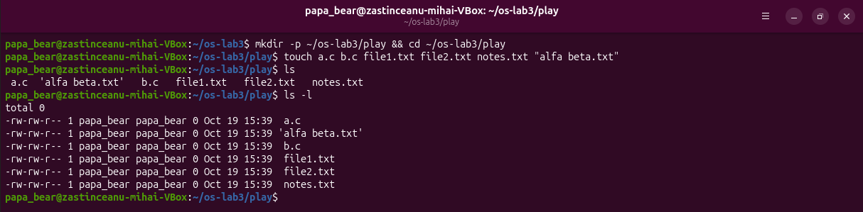
Figure 2.1 – Files created in the play directory
Ten command lines were analysed; the expected and the real output of each line are compared in Table 2.1.
Table 2.1 – Predicted and real output of the command lines
Command | Prediction | Real output | Explanation
echo *.c | a.c b.c | a.c b.c | Matches the prediction.
echo file?.txt | file1.txt file2.txt | file1.txt file2.txt | The character ? matches one character.
echo [a-b]* | a.c b.c | a.c alfa beta.txt b.c | The name "alfa beta.txt" also starts with a; it is one argument printed with its space.
echo *.xyz | an empty line | *.xyz | No file matches, so the pattern stays literal.
ls alfa beta.txt | two errors | cannot access 'alfa' and 'beta.txt' | The space splits the name into two arguments.
ls "alfa beta.txt" | alfa beta.txt | alfa beta.txt | The quotes keep one argument.
echo '$HOME' "$HOME" \$HOME | $HOME /home/papa_bear $HOME | $HOME /home/papa_bear $HOME | Only the double quotes expand the variable.
echo {1..5} ; echo $((7 * 6)) | 1 2 3 4 5 and 42 | 1 2 3 4 5 and 42 | Brace expansion and arithmetic expansion.
echo "today is $(date +%A), I am $(whoami)" | today is Monday, I am papa_bear | today is Monday, I am papa_bear | Command substitution inside double quotes.
touch log{1..3}.txt && ls log* | log1.txt log2.txt log3.txt | log1.txt log2.txt log3.txt | The files are created first, then listed.

The globbing lines are shown in Figure 2.2. The pattern [a-b]* returned "alfa beta.txt" in addition to a.c and b.c, and *.xyz was printed unchanged. Figure 2.3 shows the error of ls on a name with a space and three corrections, and Figure 2.4 shows the effect of single quotes, double quotes and the backslash.
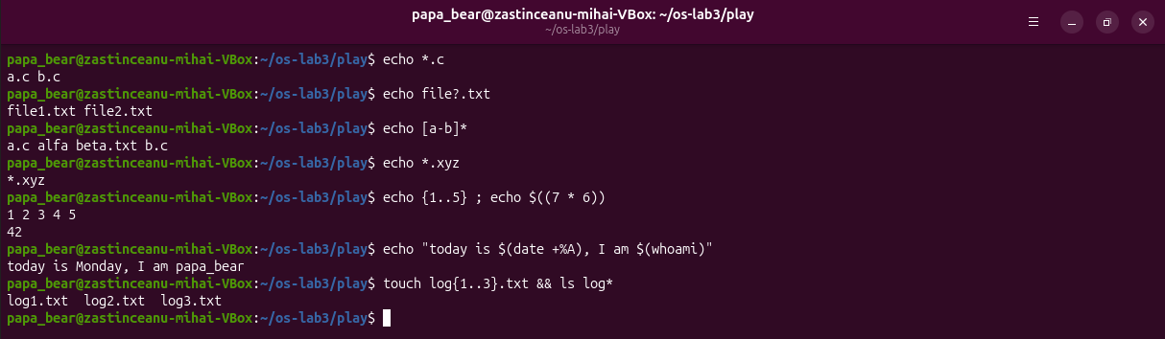
Figure 2.2 – Globbing, brace, arithmetic and command substitution results
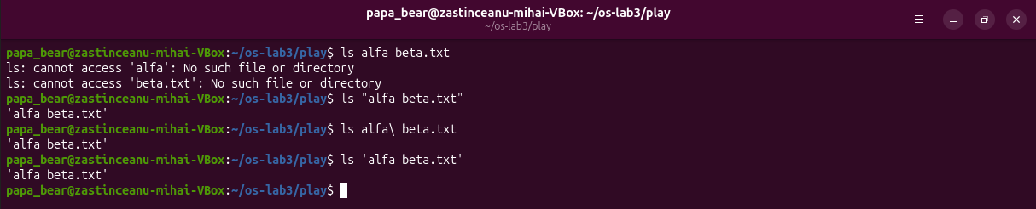
Figure 2.3 – The ls error on a name with a space, and the fix
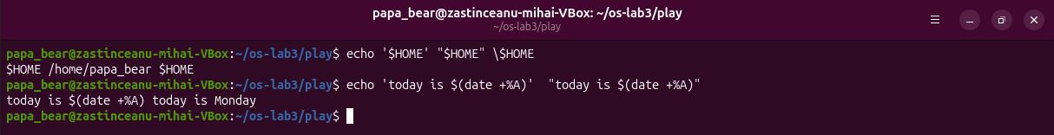
Figure 2.4 – Single quotes, double quotes and backslash

2.3 Answers to the questions
Question 1. The prediction, the real output and the explanation for each line are given in Table 2.1. Two predictions were wrong: [a-b]* also matched "alfa beta.txt", and *.xyz was printed as it is.
Question 2. The file names printed by echo *.c were produced by the shell: it expands the pattern *.c to a.c b.c before echo starts, and echo only prints the received arguments.
Question 3. The command ls alfa beta.txt failed because the shell split the line at the space, and ls received two arguments, alfa and beta.txt, none of which exists. Two ways to fix the problem are ls "alfa beta.txt" (quotes) and ls alfa\ beta.txt (backslash before the space).
Question 4. Single quotes keep everything literal, so '$HOME' remains $HOME. Double quotes prevent splitting and globbing but allow expansions, so "$HOME" becomes /home/papa_bear. The backslash removes the special meaning of the next character, so \$HOME remains $HOME.
Note. When the output goes to a terminal, ls displays a name with a space in quotes ('alfa beta.txt') in order to show where the name begins and ends and to allow it to be copied into a command; the quotes are not part of the file name, and in a pipe the name is printed without them.

3 REDIRECTION, CHAINING AND JOBS

3.1 Theoretical background
Every process has three standard streams: input (descriptor 0), output (descriptor 1) and errors (descriptor 2). The operator > writes the output to a file, >> appends to it, < reads the input from a file, and 2> redirects the error stream; the form 2>&1 makes the descriptor 2 point to the place where the descriptor 1 points at that moment, so the redirections are processed from left to right [2].
Commands can be chained in three ways: the operator ; executes them one after another, && executes the second only if the first succeeded, and || executes the second only if the first failed. The operator & starts a command in the background; the built-in jobs lists the background jobs, and kill %1 stops the job number 1.

3.2 Work performed
The first command redirects the output and the errors to different files (Figure 3.1). The listing of /etc (245 lines: the header "/etc:" and 244 names) was written to out.txt, and the error message for the nonexistent /nope was written to err.txt.
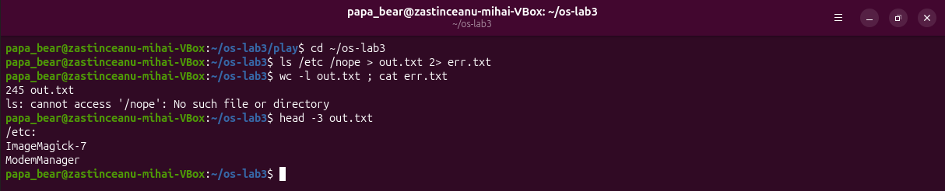
Figure 3.1 – stdout and stderr in separate files
Two versions of the redirection of both streams are compared in Figure 3.2. With > all.txt 2>&1 the error went into the file (grep counts 1 line with nope), while with 2>&1 > all.txt the error appeared on the screen and the file contains only the listing (0 lines).
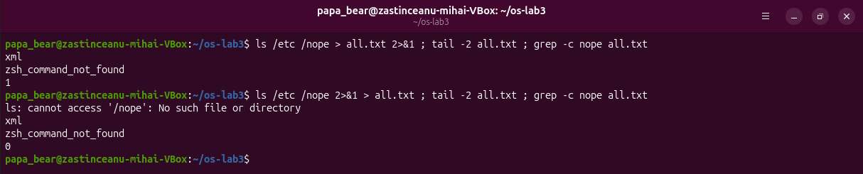
Figure 3.2 – Comparing the order of redirections
The chaining operators and the redirection of input are demonstrated in Figure 3.3. The file notes.md contains the lines first and second, wc -l < access.log printed 500, the failed command ls /nope printed the exit code 2 through the operator ||, and the operator && chained mkdir, cd and echo. A failed cd stopped the && chain, while the command after ; still ran.
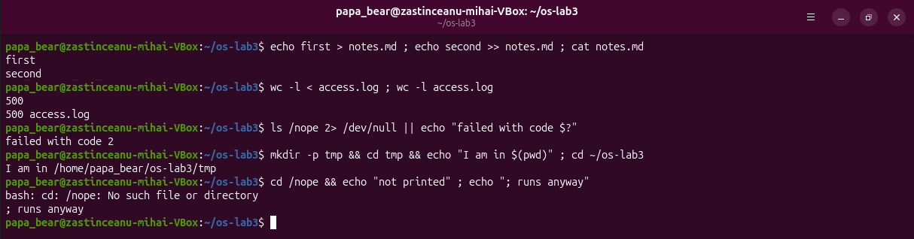
Figure 3.3 – The ; && || operators and input redirection
A background job was started, listed and stopped (Figure 3.4).
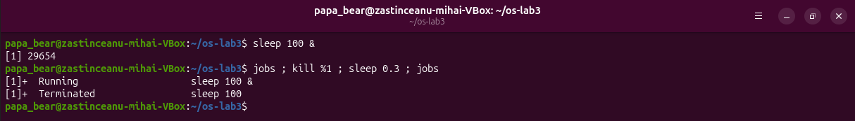
Figure 3.4 – Running a background job and stopping it

3.3 Answers to the questions
Question 1. The listing of /etc was written to out.txt, and the error message "cannot access '/nope'" was written to err.txt.
Question 2. In the form > all.txt 2>&1 the output is first redirected to the file, and then the errors are redirected to the place where the output points now, so both streams end up in all.txt. In the form 2>&1 > all.txt the errors are first redirected to the current place of the output, which is the terminal, and only afterwards the output is redirected to the file; therefore the error appears on the screen.
Question 3. With wc -l < access.log the shell opens the file and gives it to wc on the standard input, so wc does not know the file name and prints only the number. With wc -l access.log the name is received as an argument and is printed after the number.
Question 4. The operator ; executes the commands one after another regardless of the result; the operator && executes the second command only if the first one succeeded (exit code 0); the operator || executes the second command only if the first one failed (non-zero exit code).

4 ANSWERING QUESTIONS WITH ONE-LINERS

4.1 Theoretical background
A pipeline connects the standard output of a command with the standard input of the next one, so small programs can be combined into a complex query. The filters used in this part are grep (selection of lines), cut (selection of fields), sort, uniq -c (counting of adjacent equal lines), wc -l (counting of lines), head, tail and awk [4]. The typical counting scheme is sort | uniq -c | sort -rn, which counts the occurrences of each value and orders them in descending order.
The data set is an artificial access log of 500 lines. Each line has the fields date, time, user, result (OK or FAIL) and page, for example 2026-10-05 10:01 user1 OK /page1. The file was generated with the loop given in the handout [1] and checked with wc -l, which printed 500 access.log.

4.2 Work performed
Each question was solved with one command line, and all lines were saved in the file oneliners.sh with the question as a comment above the command (Listing 4.1).
# Lab 3, Part 4: answers with one command line each (run inside ~/os-lab3)

# Q1. How many requests failed?
grep -c FAIL access.log

# Q2. How many different pages were requested, and which?
cut -d' ' -f5 access.log | sort -u | cat -n

# Q3. How many requests did each page get?
cut -d' ' -f5 access.log | sort | uniq -c

# Q4. Which user or users have the most failed requests, and how many?
grep FAIL access.log | cut -d' ' -f3 | sort | uniq -c | sort -rn | awk 'NR==1{max=$1} $1==max'

# Q5. How many requests did user3 make, and how many of them failed?
echo "user3: $(grep -c ' user3 ' access.log) requests, $(grep ' user3 ' access.log | grep -c FAIL) failed"

# Q6. Print the last 3 failed requests, showing only time and user.
grep FAIL access.log | tail -3 | cut -d' ' -f2,3

# Q7. Which login shells appear in /etc/passwd, and how many accounts use each?
cut -d: -f7 /etc/passwd | sort | uniq -c | sort -rn

# Q8. Why do ls /etc | wc -l and ls -l /etc | wc -l differ by exactly one?
echo "ls: $(ls /etc | wc -l) ls -l: $(ls -l /etc | wc -l) first line of ls -l: $(ls -l /etc | head -1)"

# Bonus. Failed requests whose minute ends in 0 (10:00, 10:10, ...), and how many
grep -E '^[^ ]+ 10:[0-5]0 user[0-9] FAIL ' access.log ; grep -cE '^[^ ]+ 10:[0-5]0 user[0-9] FAIL ' access.log
Listing 4.1 – The file oneliners.sh
The results of the individual questions are presented in figures 4.1 – 4.8 and are summarised in Table 4.1. For question 4 the filter awk keeps every user whose count equals the maximum, so a tie is reported completely.
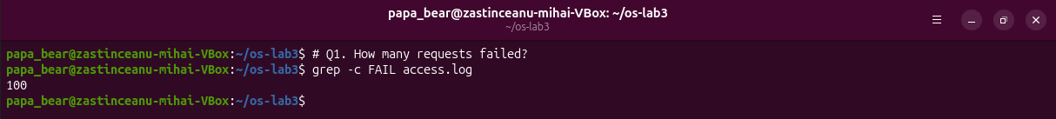
Figure 4.1 – Number of failed requests
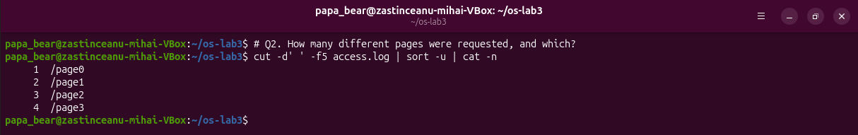
Figure 4.2 – Number and names of the requested pages
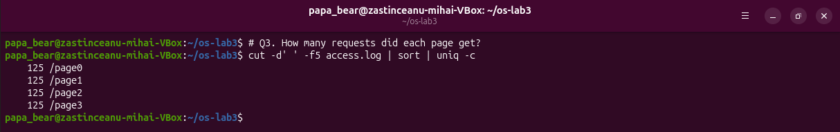
Figure 4.3 – Requests per page
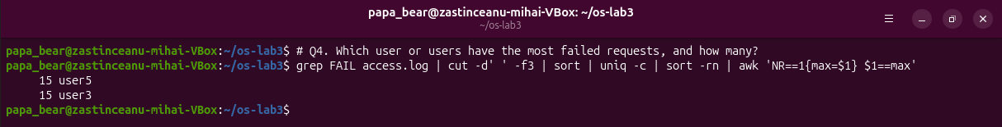
Figure 4.4 – Users with the most failed requests
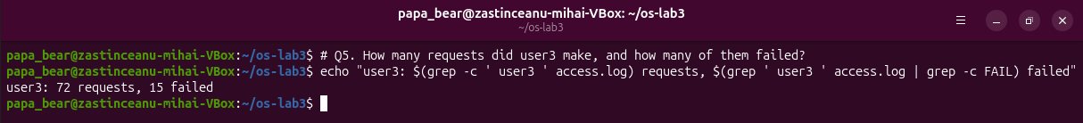
Figure 4.5 – Requests and failures of user3
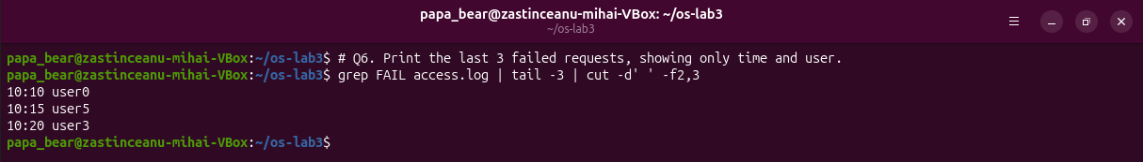
Figure 4.6 – The last three failed requests
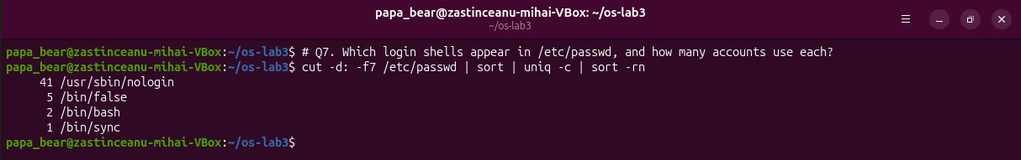
Figure 4.7 – Login shells in /etc/passwd
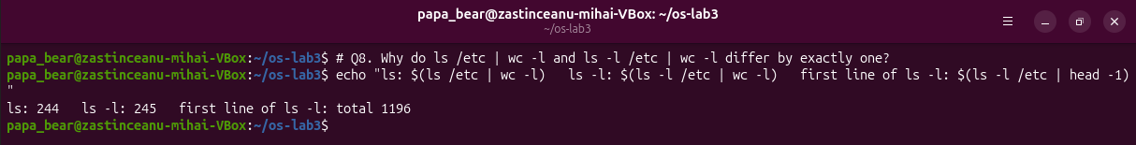
Figure 4.8 – Number of lines of ls and ls -l
Table 4.1 – Summary of the results
Question | Result
Q1 | 100 failed requests
Q2 | 4 pages: /page0, /page1, /page2, /page3
Q3 | 125 requests for each page (4 × 125 = 500)
Q4 | user3 and user5, 15 failed requests each
Q5 | user3 made 72 requests, 15 of them failed
Q6 | 10:10 user0, 10:15 user5, 10:20 user3
Q7 | 41 × /usr/sbin/nologin, 5 × /bin/false, 2 × /bin/bash, 1 × /bin/sync
Q8 | 244 and 245 lines
Bonus | 50 lines

The complete run of the file with the command bash oneliners.sh is displayed in Figure 4.9; it produces 71 lines, of which the middle part of the bonus list is not shown.
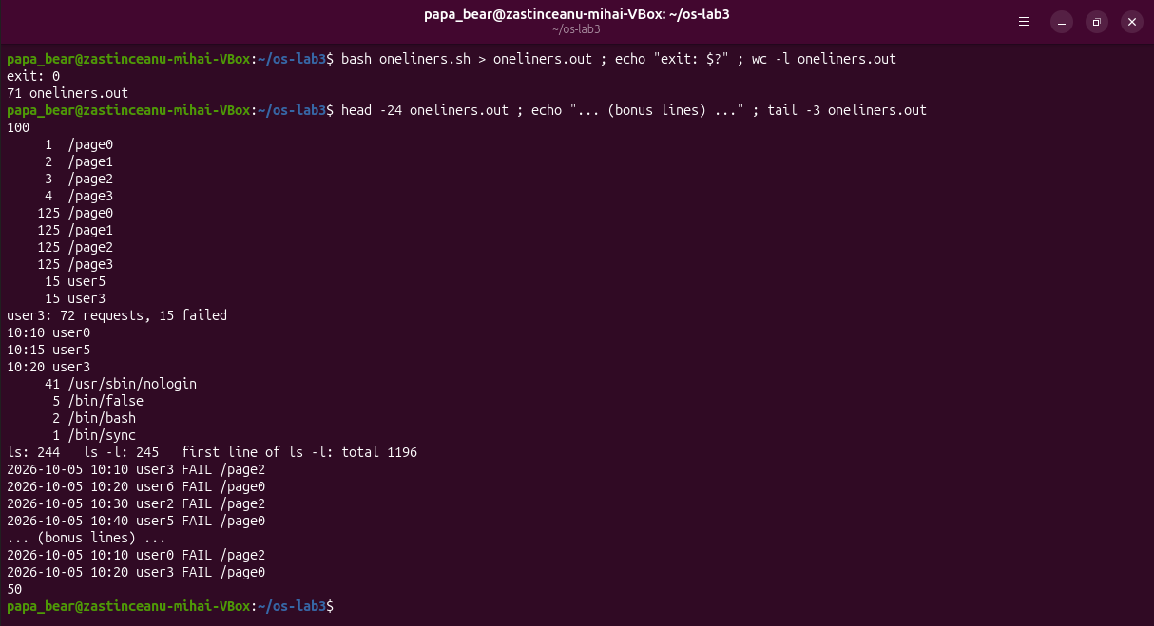
Figure 4.9 – Full run of oneliners.sh
Bonus. The lines where the minute ends in 0 and the request failed were selected with the extended regular expression of grep -E, and their number (50) is shown in Figure 4.10.
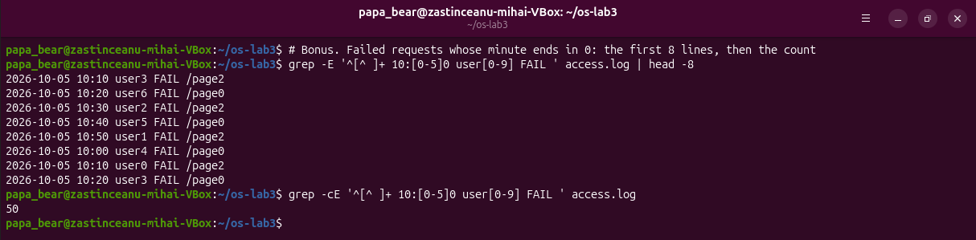
Figure 4.10 – Failed requests with the minute ending in 0 (bonus)

4.3 Answers to the questions
Self-check. The counts of question 3 add up to 500, and the failures per user (five users with 14 and two users with 15) add up to 100, which is equal to the answer of question 1.
Question 8. Prediction: ls -l prints one more line. The command ls -l prints one extra first line of the form "total N" (the number of 1 KiB blocks used by the listed files, here 1196), followed by one line for each entry; therefore ls -l /etc | wc -l (245) is greater by exactly one than ls /etc | wc -l (244). When the output is a pipe, plain ls prints one name per line.
Bonus. A line describes a failed request when its number i is a multiple of 5, and the minute equals i mod 60. The minute ends in 0 when i mod 60 is a multiple of 10, which, together with the first condition, means that i is a multiple of 10. The number of such lines is given by formula (4.1):
N = ⌊500 / 10⌋ = 50 (4.1)
where N is the number of requested lines, 500 is the number of lines of the log, and 10 is the period of the lines that satisfy both conditions. The value agrees with the output of Figure 4.10.

5 THE FIRST SCRIPT

5.1 Theoretical background
A shell script is a text file with commands. The first line #!/bin/bash (shebang) tells the kernel which interpreter must execute the file, and the execute permission, set with chmod +x, allows the file to be run directly. The positional parameter $1 holds the first argument, the test [ ! -f "$log" ] checks that the file exists, and exit 1 ends the script with a non-zero status, so that the calling program can detect the failure [2]. Messages about errors are written to the error stream with >&2. The service cron runs commands periodically according to the lines of the crontab of a user [7].

5.2 Work performed
The file report.sh was created from the template of the handout, and its TODO was completed with a loop for the users user0 – user6 (Listing 5.1, Figure 5.1).
#!/bin/bash
# usage: ./report.sh access.log
log=$1
if [ ! -f "$log" ]; then
echo "no such file: $log" >&2
exit 1
fi
total=$(wc -l < "$log")
fails=$(grep -c FAIL "$log")
echo "$total requests, $fails failed"
# for each of user0 ... user6, print "userN: X failures"
for n in 0 1 2 3 4 5 6; do
echo "user$n: $(grep " user$n " "$log" | grep -c FAIL) failures"
done
Listing 5.1 – The script report.sh
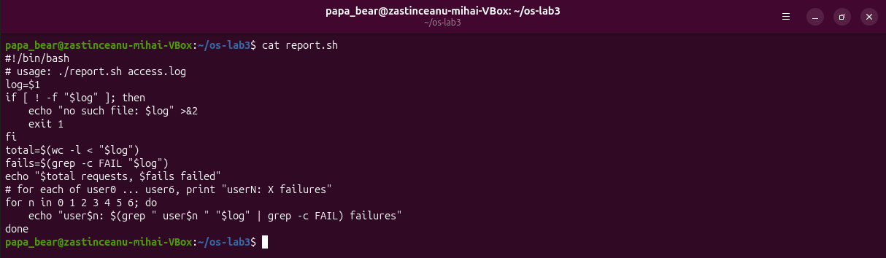
Figure 5.1 – Contents of report.sh
Without the execute permission the attempt to run the script failed with "Permission denied", and without the prefix ./ the shell answered "command not found" (Figure 5.2). After chmod +x the script printed 500 requests with 100 failures, and the failures of the users are 14, 14, 14, 15, 14, 15 and 14, which agrees with the results of the previous chapter. For the file nope.log the message "no such file: nope.log" and the exit code 1 were obtained (Figure 5.3).
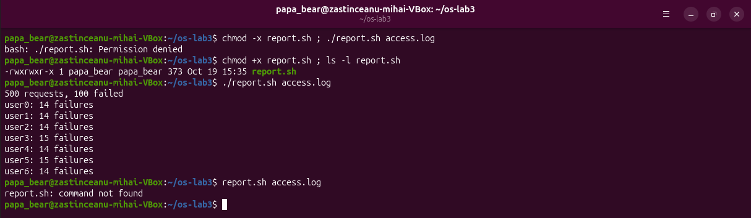
Figure 5.2 – Running the script without and with the execute permission
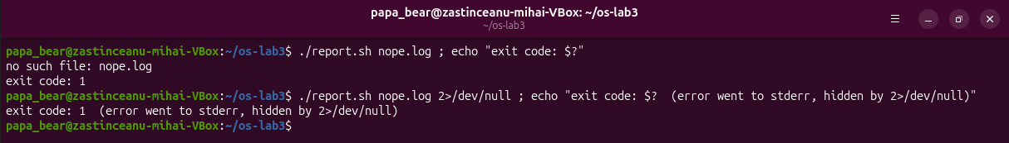
Figure 5.3 – Error handling for a missing file
Bonus. The line below was added to the crontab, so cron ran the script every minute and appended its output to report.log. After a few minutes the log had 48 lines, which are 6 runs of 8 lines (Figure 5.4); then the crontab was removed with crontab -r (Figure 5.5).
* * * * * /home/papa_bear/os-lab3/report.sh /home/papa_bear/os-lab3/access.log >> /home/papa_bear/os-lab3/report.log 2>&1
Listing 5.2 – The crontab line
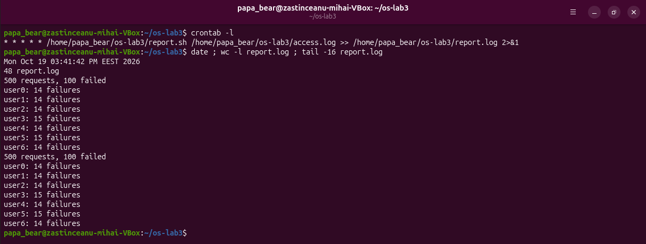
Figure 5.4 – The crontab line and the log written by cron
Figure 5.5 – The crontab removed

5.3 Answers to the questions
Question 1. The line #!/bin/bash specifies the interpreter with which the kernel executes the file. Without chmod +x the file has no execute permission, and the attempt ./report.sh ends with "Permission denied".
Question 2. The current directory is not listed in PATH; the command report.sh is searched only in the directories of PATH and gives "command not found", so the explicit path ./report.sh is necessary.
Question 3. The redirection >&2 sends the message to the error stream, so it is not mixed with the normal output when this one is redirected or passed through a pipe, and exit 1 returns a non-zero status, which allows the caller (the shell, cron or another script) to detect the failure with $?, && or ||.

CONCLUSIONS
In this work the main techniques of the bash command line were practised and verified on a real Linux system. Tab completion, the history search and the documentation tools (man, --help, man -k and help) shorten the work considerably, and the commands type and which show whether a command is built-in or external; cd must be built-in because it changes the state of the shell itself. The environment uses the uutils implementation of the core utilities, which explains the shorter output of ls --help.
The experiments with expansion showed that the shell, and not the program, produces the file lists, splits the line at spaces and interprets the quotes. The order of the redirections matters, because the operator 2>&1 copies the current destination of the output, and the operators ;, && and || control the execution by the exit status of the previous command.
The questions about the log were solved with one-line pipelines, and the results were validated by cross-checks (4 × 125 = 500 requests and a total of 100 failures). The pipelines were assembled into the script report.sh, which checks its argument, writes errors to the error stream, returns a non-zero exit code and was run automatically by cron. The files oneliners.sh and report.sh were placed in the folder lab3 of the Git repository of the course.

REFERENCES
1. The Command Line: Shell, Pipes and Text Filters. Laboratory Work 3, Operating Systems course. FCIM, Technical University of Moldova, 2026.
2. GNU Bash Reference Manual [online]. Free Software Foundation. Available: https://www.gnu.org/software/bash/manual/bash.html
3. uutils coreutils: cross-platform Rust rewrite of the GNU coreutils [online]. Available: https://github.com/uutils/coreutils
4. GNU Coreutils Manual [online]. Free Software Foundation. Available: https://www.gnu.org/software/coreutils/manual/coreutils.html
5. The Open Group Base Specifications, Shell Command Language [online]. IEEE Std 1003.1. Available: https://pubs.opengroup.org/onlinepubs/9699919799/utilities/V3_chap02.html
6. glob(7). Linux manual page [online]. Available: https://man7.org/linux/man-pages/man7/glob.7.html
7. crontab(5). Linux manual page [online]. Available: https://man7.org/linux/man-pages/man5/crontab.5.html

