MINISTRY OF EDUCATION AND RESEARCH OF THE REPUBLIC OF MOLDOVA
Technical University of Moldova
Faculty of Computers, Informatics and Microelectronics
Department of Software Engineering and Automatics

REPORT
on laboratory work no. 4
Course: Operating Systems
Topic: The xv6 Shell from the Outside

Done by: st. gr. FAF-243 | Zastinceanu Mihai
Checked by: | ____________________

Chișinău, 2026

Purpose of the work
To use the xv6 shell (user/sh.c, about 500 lines) side by side with bash and find out by experiment what a shell must do and what bash adds on top of that; to write a program that prints its own argv and use it to see who expands * and who removes quotes; to read the shell source and connect what was observed with the code. First, the sleep program from Lab 2 had to build on the current xv6.
Environment: the course VirtualBox VM (Ubuntu 26.04.1 LTS, Linux 7.0.0-34-generic, bash 5.3.9); xv6-riscv from github.com/mit-pdos/xv6-riscv (commit 06aad25, 2026-09-26), cross-compiler riscv64-linux-gnu-gcc 15.2.0, QEMU 10.2.1 (make qemu, 3 harts, 128 MB). All figures are screenshots of the VM terminal.

Part 1. Fix sleep for the current xv6
grep -n "pause\|sleep" user/user.h finds only 25:int pause(int);: in this tree the user-level system call is already called pause() (commit f5dea58, "user sleep() -> pause()", also renamed the kernel's internal fork/exec/wait to kfork/kexec/kwait). My user/sleep.c from Lab 2 already calls pause(), and $U/_sleep\ is on line 153 of the Makefile, so the program builds and works:
#include "kernel/types.h"
#include "user/user.h"
// sleep <ticks>: pause for the given number of clock ticks.
//
// Note: the lab sheet calls sleep(), but in current xv6 the user-level
// system call sleep() was renamed to pause() (commit f5dea58, Aug 2025,
// "user sleep() -> pause()"), because the kernel uses the name sleep()
// for its own internal sleep/wakeup mechanism. pause() is the same
// system call (SYS_pause, handled by sys_pause() in kernel/sysproc.c).
int
main(int argc, char *argv[])
{
if (argc != 2) {
fprintf(2, "usage: sleep <ticks>\n");
exit(1);
}
pause(atoi(argv[1])); // system call into the kernel
exit(0);
}
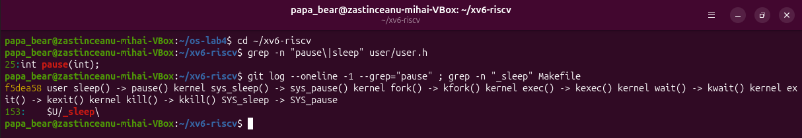
Figure 1.1 – The grep result in user.h (and the commit that renamed sleep to pause)
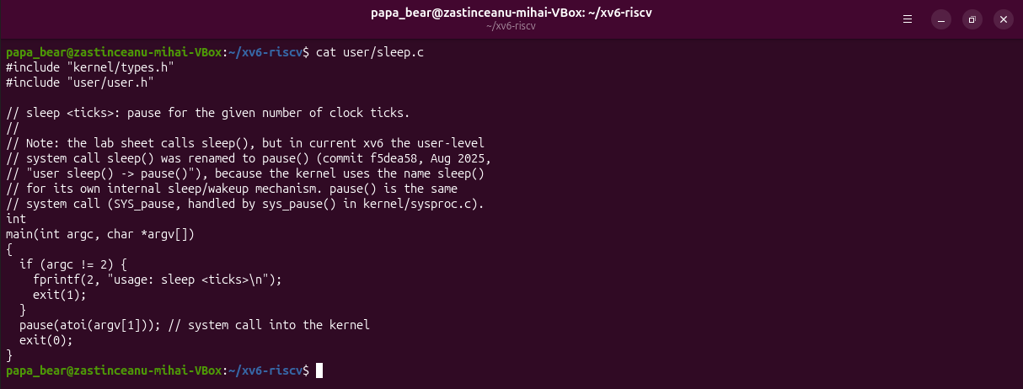
Figure 1.2 – The updated sleep.c
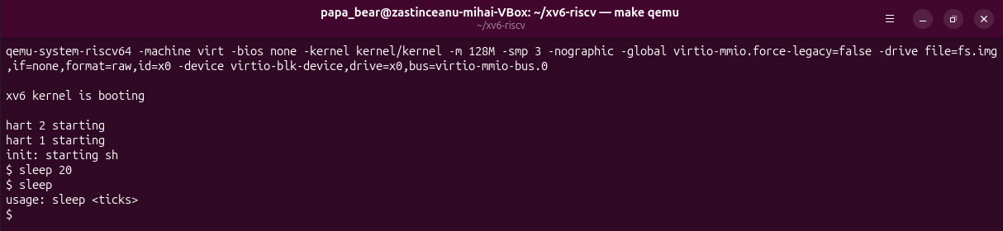
Figure 1.3 – sleep running in xv6, with and without an argument
sleep 20 paused for 20 ticks (about 2 seconds; one xv6 tick is 0.1 s) and returned to the prompt; sleep without an argument printed usage: sleep <ticks>.

Part 2. bash versus the xv6 shell
Every command was run in bash in ~/shtest (a folder with a single file README) and at the xv6 $ prompt after make qemu.
Command | Tests | bash | xv6 | Why
echo hello > f ; cat < f | redirection | hello | hello | both shells implement < and >
ls | grep READ | pipe | README | README 2 2 2441 | pipes work in both; xv6 ls also prints type, inode, size
(echo a; echo b) | wc | grouping, list | 2 2 4 | 2 2 4 | both know ( ) and ;
echo one ; echo two | sequence | one / two | one / two | same
echo bg & | background | [1] 31506, bg, later [1]+ Done | bg | xv6 runs it in the background but has no job control (no job number, no Done)
ls * | globbing | README f | ls: cannot open * | xv6 does not expand *, ls receives a literal "*"
echo $HOME | variables | /home/papa_bear | $HOME | xv6 has no variables
echo "a b" | quotes | a b | "a b" | xv6 does not remove quotes
mkdir d ; cd d ; ls .. | PATH | README d f (now in d) | exec cd failed, then the listing of / | xv6 treats cd as built-in only at the start of a line; here it tries to exec a program "cd"
arrow up, Tab, Ctrl+R | history, completion | all work | none works | xv6 has no line editing: the keys arrive as raw bytes

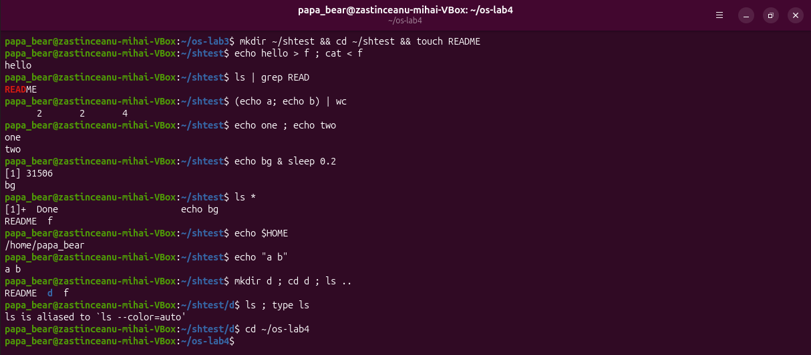
Figure 2.1 – The commands run in bash
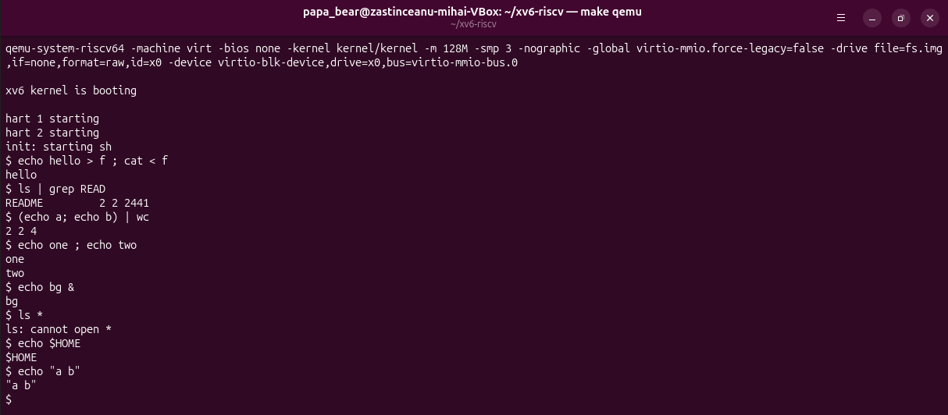
Figure 2.2 – The same commands run in xv6
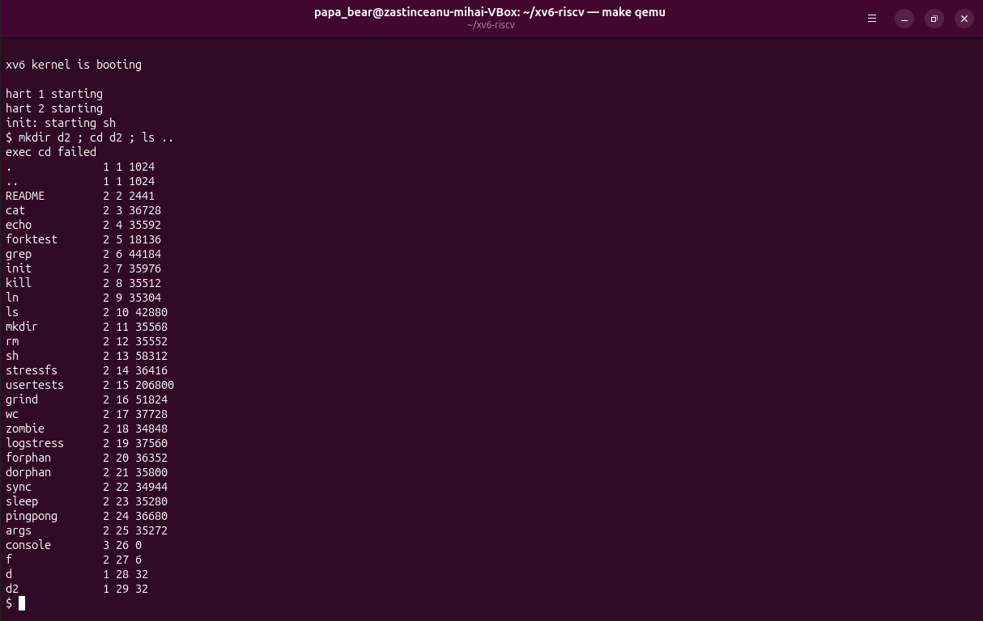
Figure 2.3 – mkdir d2 ; cd d2 ; ls .. in xv6: cd inside a list is not the built-in
Arrow up, Tab and Ctrl+R in xv6 were also tested with a script that sends the same bytes and logs the exact reply. The arrow key is the escape sequence ESC [ A; xv6 echoes it (the terminal then moves the cursor up, which garbles the screen) and the shell tries to run it as a program:
arrow up sent '\x1b[A' -> xv6 printed '\x1b[A\r\nexec \x1b[A failed\r\n'
Tab sent '\t' -> xv6 printed '\t\r\n'
Ctrl+R sent '\x12' -> xv6 printed '\x12\r\nexec \x12 failed\r\n'
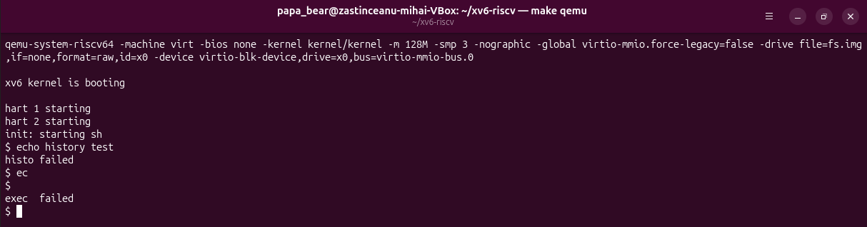
Figure 2.4 – Arrow up, Tab and Ctrl+R typed into xv6
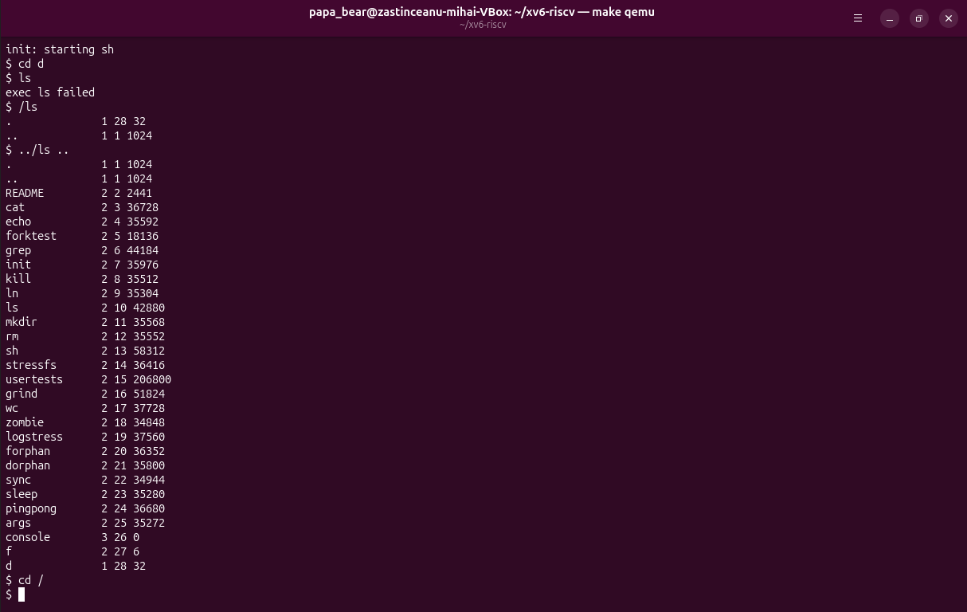
Figure 2.5 – ls failing after cd d, and the working alternatives /ls and ../ls

Answers
1. List the features both shells have, and the ones only bash has.
Both: running a program with arguments, redirection <, > and >>, pipes |, command lists ;, background &, grouping ( ), and the built-in cd. Only bash: globbing (*, ?, [..]), variables and expansions ($HOME, $(..), $((..)), {1..5}), quote removal, the PATH search, job control (jobs, %1, [1]+ Done), history and line editing (arrows, Ctrl+R, Tab completion), && and ||, numbered redirections such as 2> and 2>&1, cd anywhere in a line, and a scripting language (if, for, functions, aliases).
2. In xv6, ls stops working after cd d. Why? Find a way to run ls from inside d anyway.
The xv6 shell calls exec(argv[0], argv) with the word exactly as typed; there is no PATH. The kernel resolves a name without a leading / relative to the current directory, and all xv6 programs live in the root directory /. In /d there is no file ls, so exec ls failed. Giving a path works: /ls (absolute) or ../ls .. (relative), Figure 2.5.
3. Which missing feature would you miss most in daily work, and which would be easiest to add?
I would miss history with arrow up the most (and then *), because retyping long commands is slow. The easiest to add is a PATH-like fallback: in runcmd, case EXEC, if exec(argv[0]) fails and the name has no /, build the string "/" + name and call exec again. That is about five lines and makes ls work from any directory. Allowing cd inside lists would also be small (a LIST/EXEC check in the parent).

Part 3. Who expands *? A program that prints its argv
user/args.c (xv6) and args_linux.c (Linux, <stdio.h>, return 0) are the same program:
#include "kernel/types.h"
#include "user/user.h"
int
main(int argc, char *argv[])
{
printf("argc = %d\n", argc);
for(int i = 0; i < argc; i++)
printf("argv[%d] = [%s]\n", i, argv[i]);
exit(0);
}
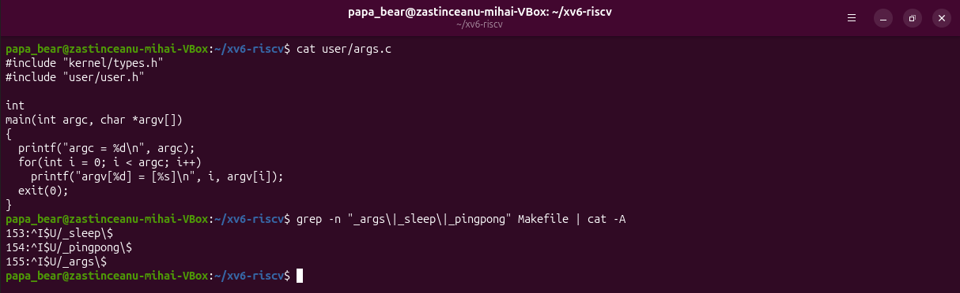
Figure 3.1 – args.c and the UPROGS line
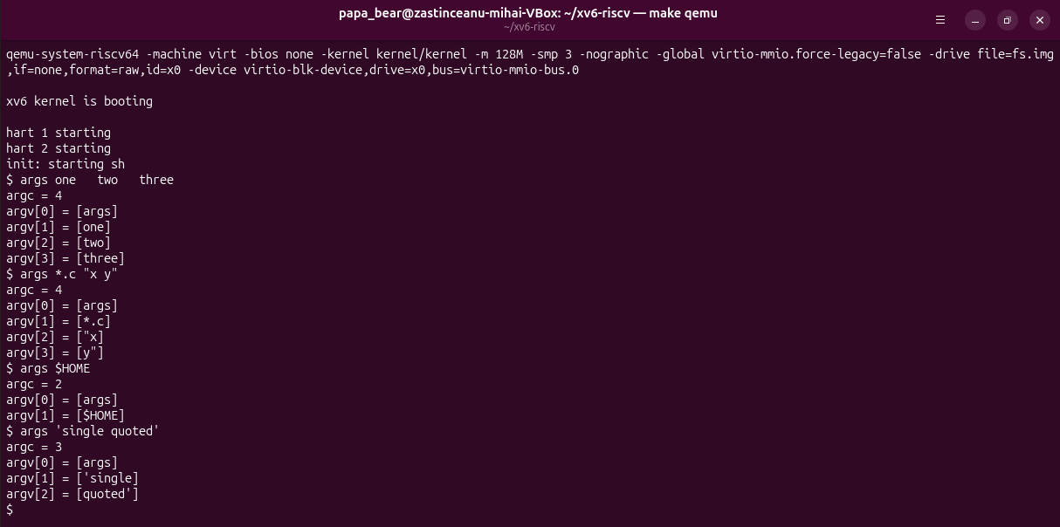
Figure 3.2 – args output in xv6
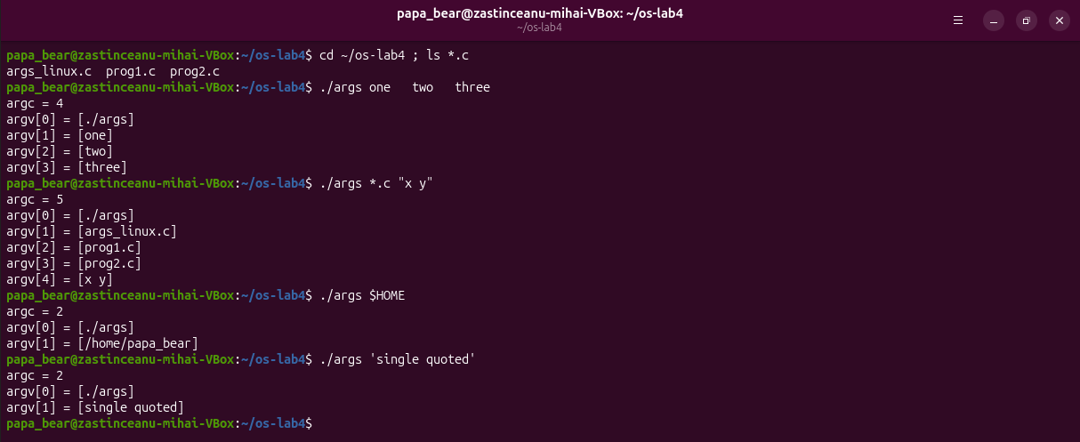
Figure 3.3 – args_linux output in bash (folder with args_linux.c, prog1.c, prog2.c)

Answers
1. Paste both outputs for args *.c "x y". How many arguments did each program receive?
bash: argc = 5, argv[0] = [./args], [args_linux.c], [prog1.c], [prog2.c], [x y]. xv6: argc = 4, argv[0] = [args], [*.c], ["x], [y"]. The same program got 5 arguments on Linux and 4 in xv6.
2. So who turns *.c into file names and removes the quotes: the program, the kernel, or the shell?
The shell. The program code is identical, and the kernel only copies the strings it is given in exec. bash replaced *.c with the three matching names and removed the quotes, keeping x y as one word, before calling execve. The xv6 shell does neither, so the program sees the raw words. In the same way $HOME and 'single quoted' arrive unchanged in xv6 ([$HOME], ['single], [quoted']), but as [/home/papa_bear] and [single quoted] in bash.
3. What happened to the extra spaces in one two three?
They disappeared in both shells: the line is split into words on whitespace, and a run of spaces is just one separator, so the program receives one, two, three (argc = 4) and never sees any spaces. In xv6 this is gettoken() skipping the characters in whitespace[]. To keep the spaces in bash one must quote: ./args "one two".

Part 4. Read the shell
wc -l user/sh.c → 499 lines.
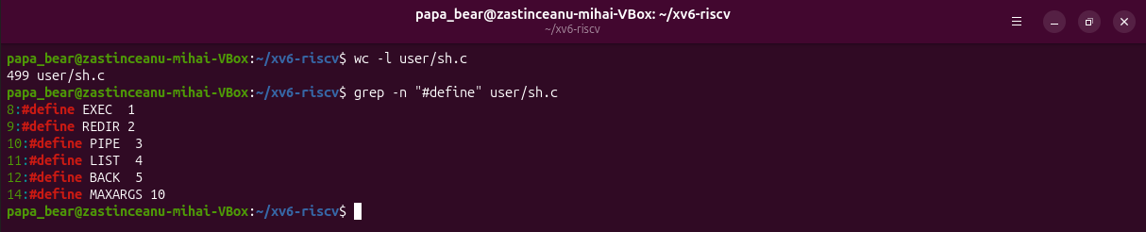
Figure 4.1 – The command kinds defined in sh.c
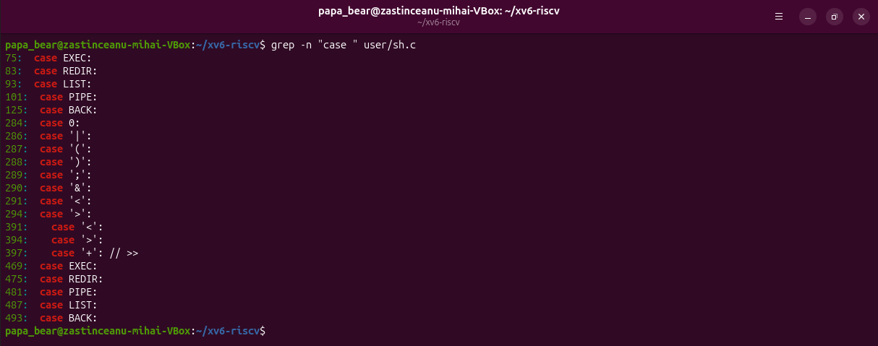
Figure 4.2 – Where each kind is run (case lines in runcmd and the tokenizer)
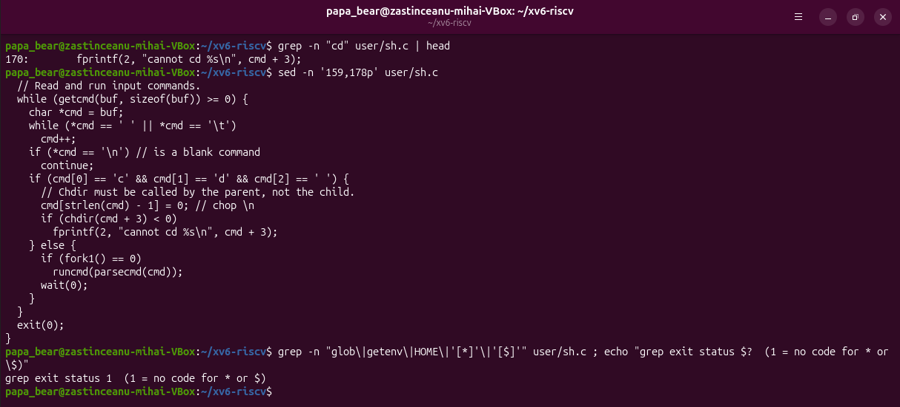
Figure 4.3 – The code that handles cd, and no code for * or $

Answers
1. Name the five kinds of command the xv6 shell knows and the character that produces each.
EXEC (1) – a plain command, a sequence of words; REDIR (2) – <, > or >>; PIPE (3) – |; LIST (4) – ;; BACK (5) – &. They are run in runcmd(): case EXEC at line 75 (exec), REDIR at 83 (close + open, then run the inner command), LIST at 93 (fork, wait, then the right side), PIPE at 101 (pipe, two forks with close/dup), BACK at 125 (fork without wait). Parentheses ( ) are parsed by parseblock() but do not form a sixth kind.
2. Where is cd handled, and why is it not run as a separate program?
In main(), lines 166-170: if the line starts with the three characters c, d, space, the shell itself calls chdir(cmd + 3) and prints cannot cd ... on failure; every other line goes to fork1() and runcmd() in a child. The comment says it: "Chdir must be called by the parent, not the child". A child would change only its own current directory and then exit. This check is done on the raw line, which is why mkdir d ; cd d ; ls .. printed exec cd failed (Figure 2.3).
3. Search sh.c for any code that handles * or $. What does that explain about Part 2?
There is none (the grep for glob, getenv, HOME, '*', '$' returns nothing, exit status 1). The tokenizer knows only whitespace[] = " \t\r\n\v" and symbols[] = "<|>&;()"; every other character, including *, $ and quotes, is just part of a word. That explains Part 2 and Part 3: ls * passed a literal *, echo $HOME printed $HOME, and echo "a b" kept the quotes.

Conclusions
A minimal shell needs surprisingly little: read a line, split it into words and the symbols < > | ; & ( ), and run it with fork, exec, wait, open, close, dup and pipe. xv6 does this in 499 lines and already supports redirection, pipes, lists, background jobs and grouping. cd is the one command that must be built in, because a child cannot change its parent's directory.
Everything else people think of as "the command line" is added by bash on top: globbing, variables and substitutions, quote removal, PATH search, job control, history and completion. The args experiment proved it: the same C program received 5 arguments from bash and 4 from xv6 for the same line, so the expansion of * and the removal of quotes are done by the shell, not by the program or the kernel.

