MINISTRY OF EDUCATION AND RESEARCH OF THE REPUBLIC OF MOLDOVA
Technical University of Moldova
Faculty of Computers, Informatics and Microelectronics
Department of Software Engineering and Automatics

REPORT
on laboratory works no. 5 and 6
Course: Operating Systems
Lab 5. Topic: The File System with Your Own Hands (Linux)
Lab 6. Topic: Inside the xv6 File System

Done by: st. gr. FAF-243 | Zastinceanu Mihai
Checked by: | ____________________

Chișinău, 2026

Purpose of the work
Lab 5: check on a real Linux system everything from the file-system lecture: the directory tree and the file types, inodes behind the names, hard and symbolic links, permissions (including setuid and the sticky bit), and the disks and the kernel exposed as files.
Lab 6: see the same ideas in the xv6 file system, which implements them in a few hundred readable lines: decode what xv6 ls prints, write a stat program (mystat), measure the limits written in kernel/fs.h, and write find, which walks the directory tree recursively.
Environment: the course VirtualBox VM, Ubuntu 26.04.1 LTS, Linux 7.0.0-34-generic, working as the normal user papa_bear (whoami does not print root); xv6-riscv commit 06aad25, riscv64-linux-gnu-gcc 15.2.0, QEMU 10.2.1. Figures are screenshots of the VM terminal and are numbered lab.part.n (Figure 5.2.1 is Lab 5, Part 2, first figure).

Lab 5. The File System with Your Own Hands (Linux)

Part 1. The tree and the file types
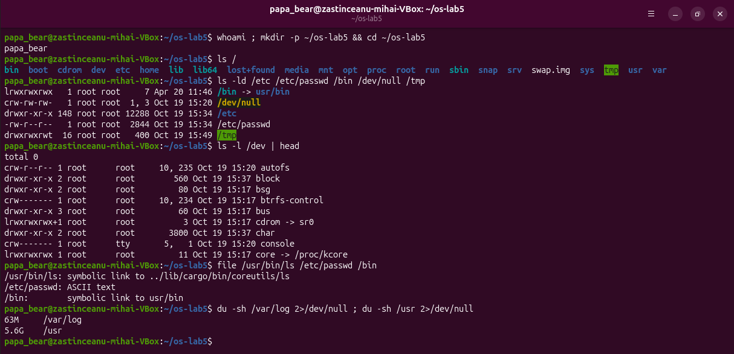
Figure 5.1.1 – The tree, file types, /dev, file and du
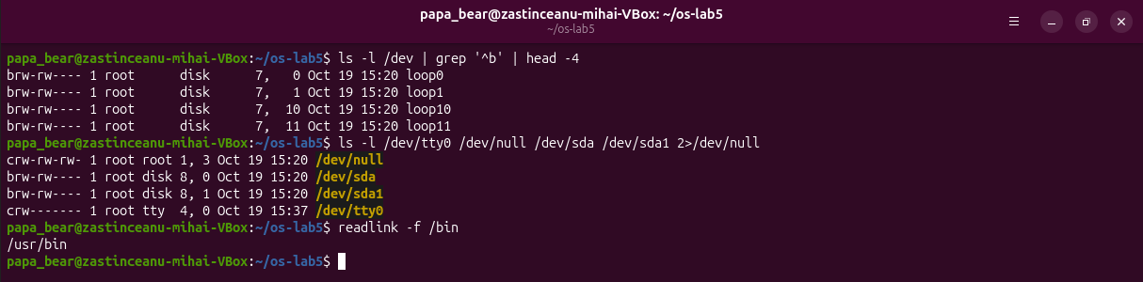
Figure 5.1.2 – Block and character devices; where /bin points
1. For each path in the second line, write its type from the first letter of ls -l.
/bin – l, symbolic link; /dev/null – c, character device (major 1, minor 3); /etc – d, directory; /etc/passwd – -, regular file; /tmp – d, directory (drwxrwxrwt, with the sticky bit).
2. What is /bin on your system: a directory or a link, and to where?
A symbolic link: /bin -> usr/bin (readlink -f /bin → /usr/bin). Ubuntu uses the "merged /usr" layout, so /bin, /sbin and /lib all point into /usr. file /bin also says "symbolic link to usr/bin".
3. Find one character device and one block device in /dev.
Character: /dev/tty0 (crw------- root tty 4, 0) or /dev/null. Block: /dev/sda (brw-rw---- root disk 8, 0), the virtual hard disk; /dev/sda1, /dev/loop0 are block devices too.
4. Which is bigger on your laptop, /var/log or /usr, and by roughly how much?
/usr is 5.6G and /var/log is 63M, so /usr is about 90 times bigger.

Part 2. Inodes and links
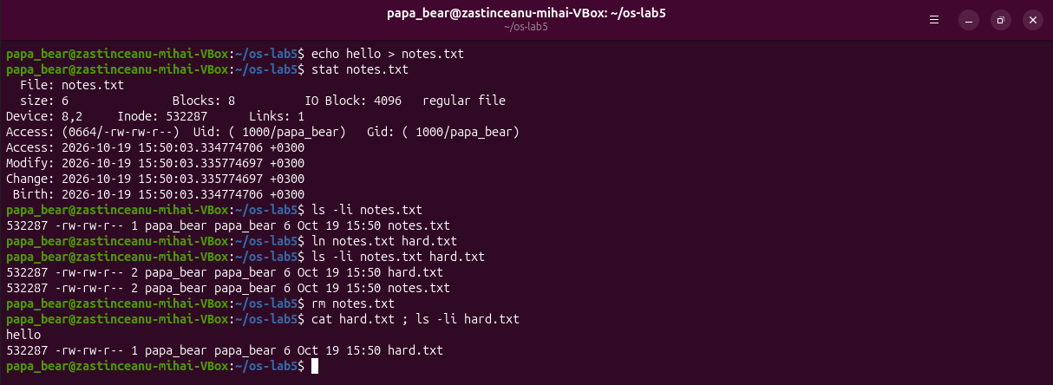
Figure 5.2.1 – stat, and a hard link that survives rm of the original name
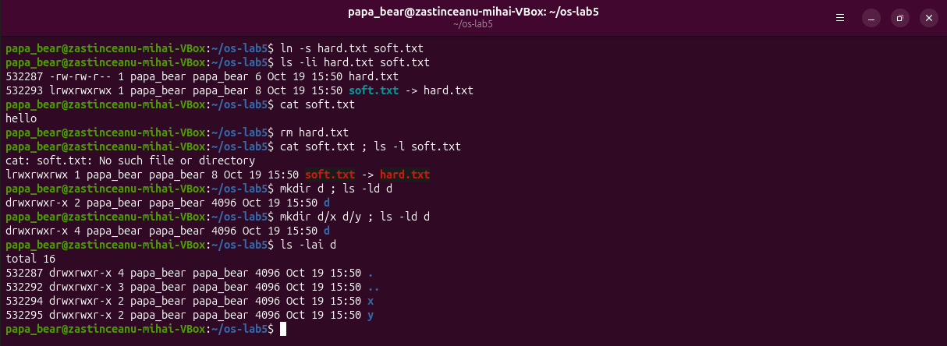
Figure 5.2.2 – A symbolic link that breaks, and the link count of directories
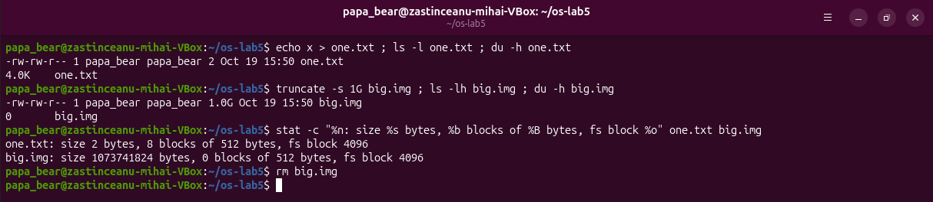
Figure 5.2.3 – Size is not space: a 2-byte file and a sparse 1 GB file
1. Which number in stat is the inode, and which tells how many names the file has?
Inode: 532287 is the inode number; Links: 1 is the number of names (hard links). After ln notes.txt hard.txt, ls -li shows the same inode 532287 for both names and the count 2.
2. After rm notes.txt, why could you still read hard.txt? What does rm really remove?
Both names point to the same inode; neither is "the original". rm calls unlink(), which removes one directory entry (one name) and decrements the link count to 1. The inode and its data blocks are freed only when the count reaches 0 and no process has the file open, so cat hard.txt still printed hello.
3. Why did cat soft.txt fail at the end, although soft.txt still exists? How big is soft.txt and why exactly that size?
A symbolic link is a separate file (its own inode, 532293) whose content is just a path. Opening it makes the kernel follow the path hard.txt, which no longer exists, so No such file or directory (ls shows it in red as a dangling link). Its size is 8 bytes, the length of the text hard.txt.
4. A new directory has 2 links, and 4 after you create two subdirectories. Explain where each link comes from.
Link 1 is the name d in its parent; link 2 is the entry . inside d, which points to d itself. Each subdirectory contains .., which points back to d, so x and y add one link each: 4. ls -lai d shows . with the inode of d and .. with the inode of the parent.
5. Why does a 2-byte file use 4.0K, and a 1 GB file use 0?
Disk space is given in whole blocks. ext4 here uses 4096-byte blocks, so the 2-byte one.txt takes one block = 8 sectors of 512 bytes = 4.0K. truncate -s 1G only sets the size field and allocates no blocks (a sparse file with a hole that reads as zeros), so du shows 0 and stat shows 0 blocks.

Part 3. Permissions
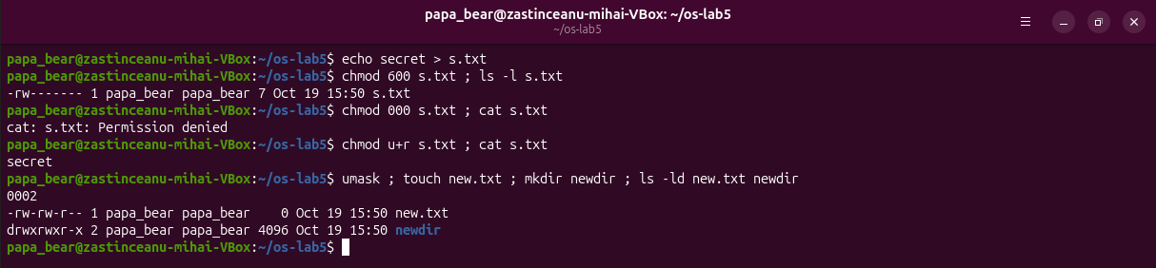
Figure 5.3.1 – chmod 600 / 000 / u+r and the umask
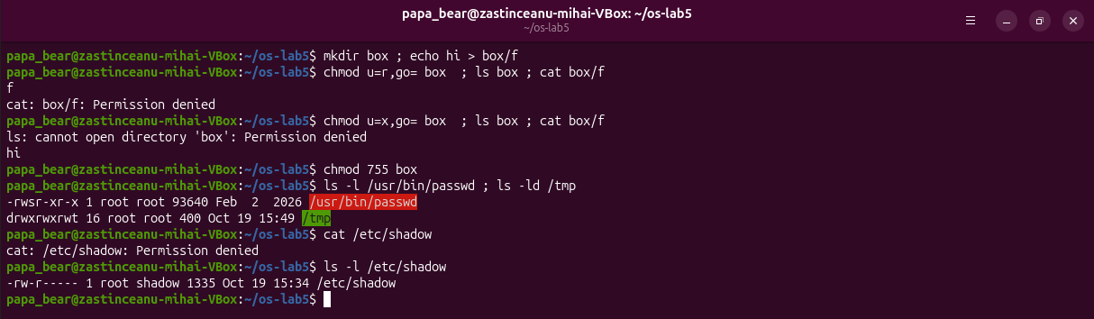
Figure 5.3.2 – The box experiment, setuid passwd, sticky /tmp and /etc/shadow
Predictions for the box experiment (written before running): with r only, ls box works and cat box/f fails; with x only, ls box fails and cat box/f works. Both were correct.
1. Write 600, 644, 755 and 700 as rwx strings, and give one real use for each.
600 = rw-------: private files, e.g. an SSH private key or s.txt here. 644 = rw-r--r--: ordinary documents and configuration readable by everyone, e.g. /etc/passwd. 755 = rwxr-xr-x: programs and public directories, e.g. /usr/bin/*, box at the end. 700 = rwx------: a private directory or a personal script, e.g. ~/.ssh.
2. With chmod 000 you own the file but cannot read it. Why does ownership not help?
For the owner the kernel checks only the owner bits, and they are ---, so read is denied. Being the owner gives only the right to change the mode, which is what chmod u+r did; after it, cat worked. (Only root ignores these checks.)
3. What is your umask, and how does it explain the permissions of new.txt and newdir?
0002. New files are created with 666 minus the mask → 664 = -rw-rw-r-- (new.txt); new directories with 777 minus the mask → 775 = drwxrwxr-x (newdir). The mask removes only write for "others".
4. Explain the box experiment: what does r allow on a directory, and what does x allow?
r lets you read the list of names: ls box printed f, but cat box/f was denied, because to reach a file inside you must pass through the directory. x lets you pass through (search) it and use a name you already know: cat box/f printed hi, but ls box gave "cannot open directory".
5. What do the s in /usr/bin/passwd and the t in /tmp mean, and why does passwd need the s?
s (-rwsr-xr-x root) is setuid: the program runs with the user ID of the file's owner, root, whoever starts it. passwd must change the password hash in /etc/shadow, which is -rw-r----- root shadow (I got Permission denied reading it), so without setuid a normal user could not change their password. t (drwxrwxrwt) is the sticky bit: everyone may create files in /tmp, but only a file's owner (or root) may delete or rename it.

Part 4. Disks and the kernel as files
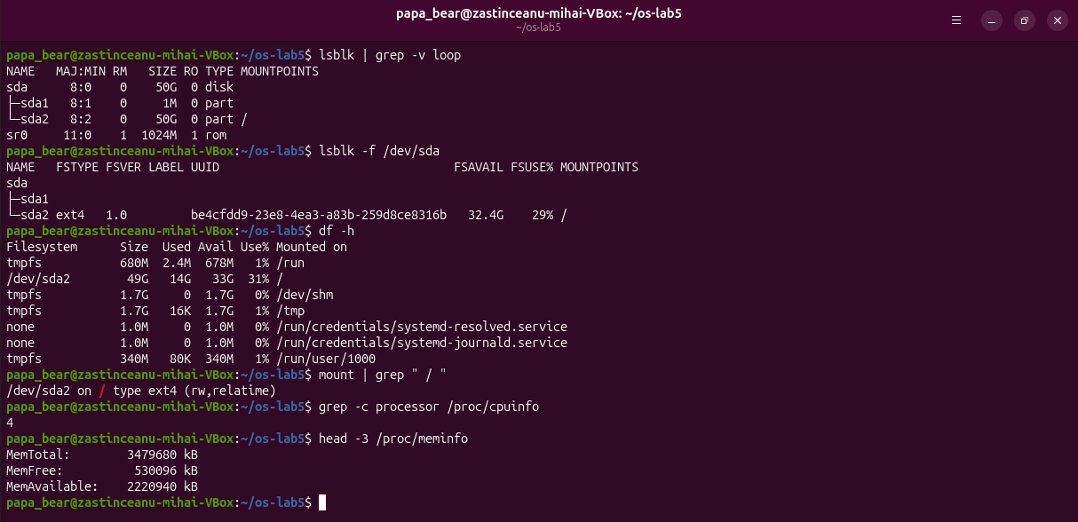
Figure 5.4.1 – lsblk, df, mount, CPU count and memory
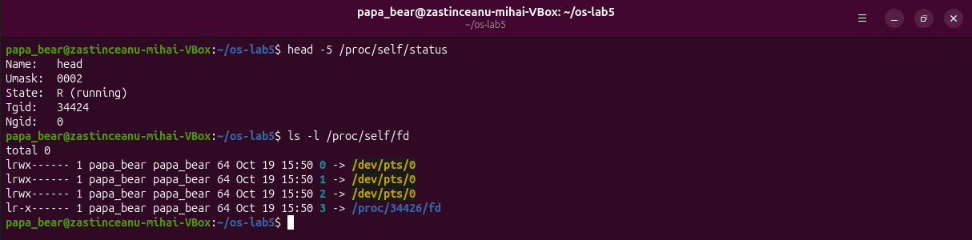
Figure 5.4.2 – /proc/self/status and /proc/self/fd
1. Draw your disk: disk name, partitions, which one is mounted at / and with what file system type.
See the drawing below. One 50 GB virtual disk sda: sda1 (1 MB, the BIOS boot partition for GRUB, no file system) and sda2 (50 GB, ext4, mounted at /). There is also sr0 (the virtual CD drive) and read-only loop devices for snap packages.
2. How full is your root file system?
/dev/sda2 has 49G, 14G used, 33G available: 31% (lsblk -f: 29% / 32.4G free).
3. How many CPU cores and how much RAM does your laptop have, according to /proc?
grep -c processor /proc/cpuinfo → 4 cores; MemTotal: 3479680 kB ≈ 3.3 GiB (the VM is given 4096 MB; the kernel keeps part of it for itself and does not count it).
4. /proc/self/status showed the name of a program. Which one, and why that one?
Name: head. /proc/self is a link that each process sees as its own /proc/<pid>; the process that opened the file was head, so it saw its own status. In the same way ls -l /proc/self/fd showed the descriptors of ls: 0, 1, 2 on the terminal /dev/pts/0 and 3 for the directory ls was reading.
sda 50G disk (/dev/sda, VirtualBox virtual disk)
├─sda1 1M part BIOS boot partition (no file system)
└─sda2 50G part ext4, UUID be4cfdd9-... mounted at / (14G of 49G used, 31%)
sr0 1024M rom virtual CD/DVD drive
loop0..loop21 snap packages (squashfs, read-only)

Stretch tasks (all four)
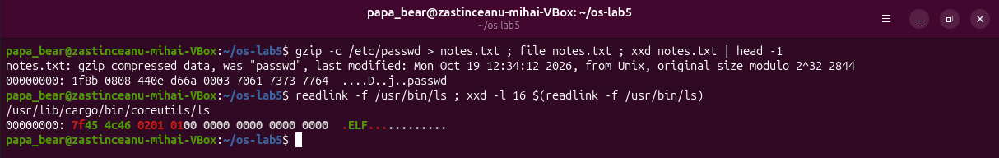
Figure 5.5.1 – (a) Magic numbers: gzip and ELF
(a) file ignores the name notes.txt and reads the first bytes: 1f 8b is the gzip magic number (08 = deflate), so it says "gzip compressed data, was passwd". An ELF executable starts with 7f 45 4c 46 = \x7fELF.
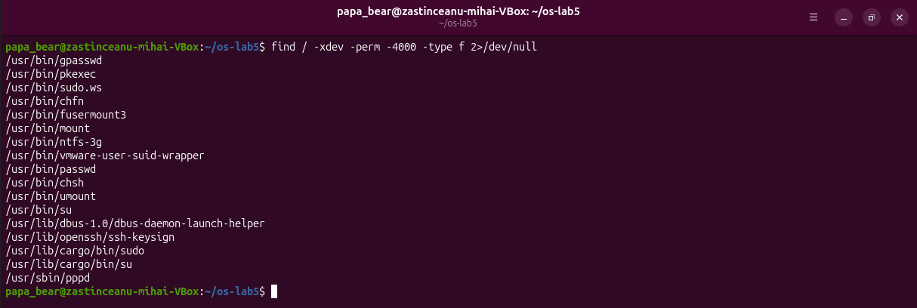
Figure 5.5.2 – (b) setuid programs on the VM
(b) 17 setuid programs. Besides the classic ones (passwd, su, mount, umount, chsh, chfn, gpasswd, pkexec, fusermount3), this Ubuntu 26.04 VM has some that are not on the usual list: /usr/lib/cargo/bin/sudo and su (the new Rust sudo-rs), /usr/bin/sudo.ws (the classic sudo, renamed), vmware-user-suid-wrapper, ntfs-3g, pppd, ssh-keysign and dbus-daemon-launch-helper.
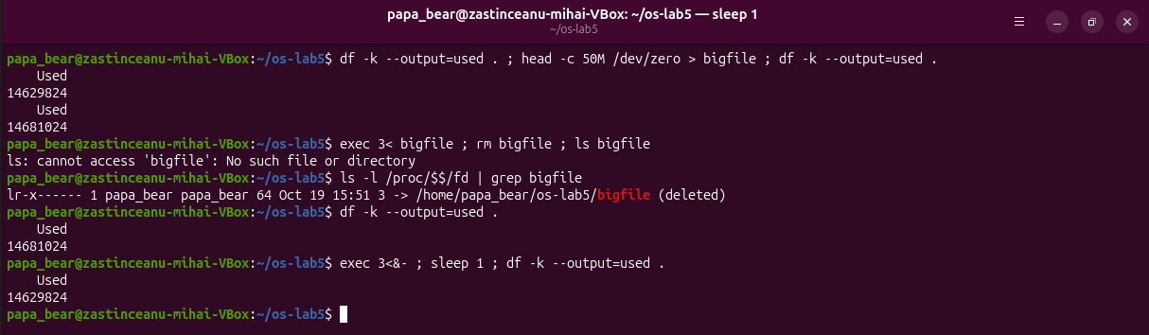
Figure 5.5.3 – (c) Deleting a file that is still open
(c) After rm bigfile the name is gone, but descriptor 3 of the shell still points to it: 3 -> /home/papa_bear/os-lab5/bigfile (deleted). The used space stays the same (14681024 KB). Only after exec 3<&- closes the last reference does it drop by 51200 KB (exactly the 50 MB) to 14629824 KB.
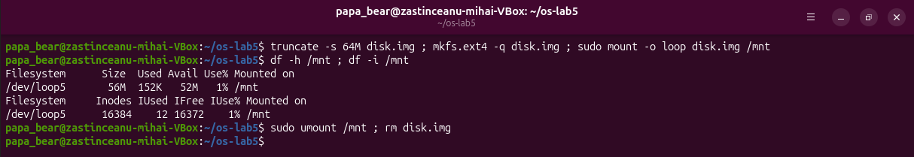
Figure 5.5.4 – (d) A 64 MB ext4 file system in a file, mounted with a loop device
(d) mkfs.ext4 created 16384 inodes in the 64 MB image (df -i); 12 are already used (the reserved inodes and lost+found). df -h shows 56M of usable size: the rest holds the metadata and the journal.

Lab 6. Inside the xv6 File System

Part 1. Read what xv6 shows you
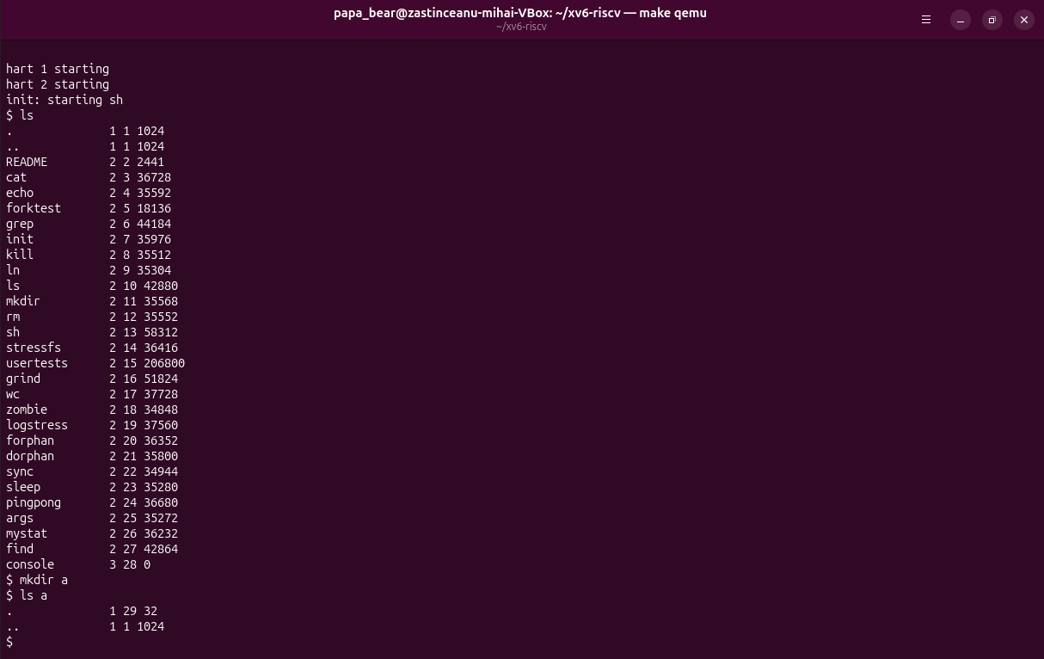
Figure 6.1.1 – ls in the root of a fresh xv6 disk, mkdir a, ls a
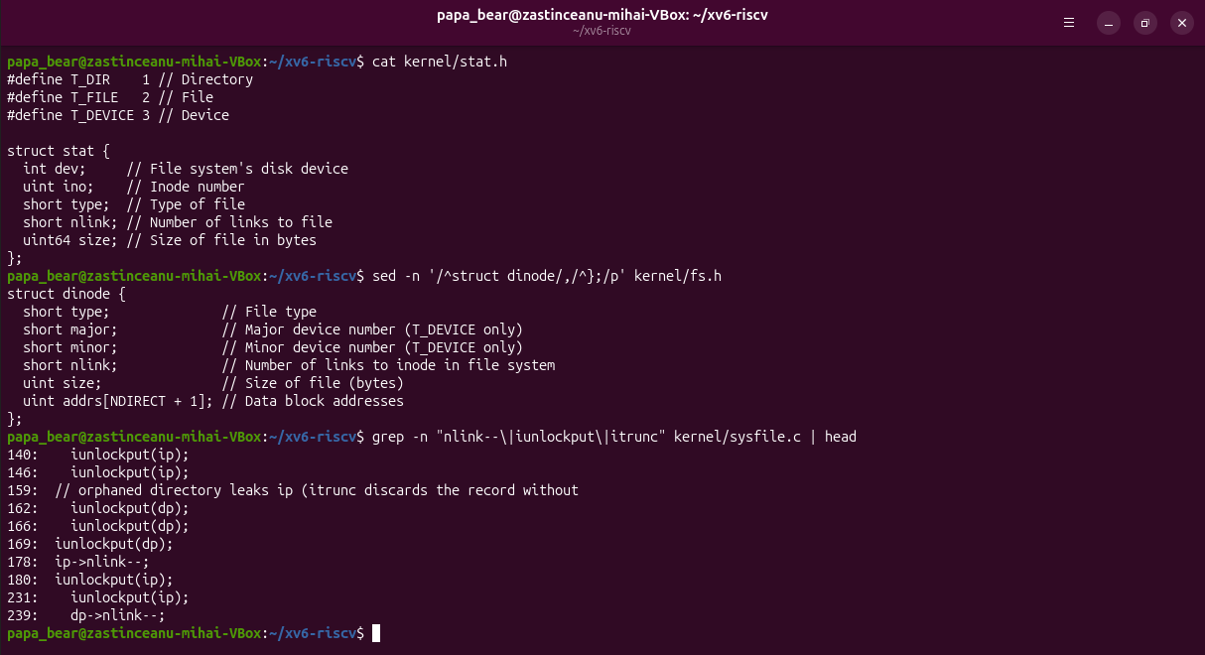
Figure 6.1.2 – kernel/stat.h, struct dinode and the link-count lines in sysfile.c
1. What do types 1, 2 and 3 mean (kernel/stat.h)?
T_DIR 1 – directory, T_FILE 2 – regular file, T_DEVICE 3 – device (only console here).
2. Which inode number does the root directory have, and why are . and .. the same there?
Inode 1 (ROOTINO 1 in kernel/fs.h). The root has no parent, so mkfs writes both . and .. with inode 1; that is why both lines are 1 1 1024.
3. An empty directory a has size 32. How big is one entry, and which two entries does a contain?
A struct dirent is ushort inum (2 bytes) + char name[DIRSIZ] (14 bytes) = 16 bytes. 32 bytes = two entries: . (inode 29, the directory itself) and .. (inode 1, the root), as ls a shows.

Part 2. Write mystat
#include "kernel/types.h"
#include "kernel/stat.h"
#include "user/user.h"
char *
typename(int t)
{
switch (t) {
case T_DIR:
return "directory";
case T_FILE:
return "file";
case T_DEVICE:
return "device";
}
return "?";
}
int
main(int argc, char *argv[])
{
struct stat st;
for (int i = 1; i < argc; i++) {
if (stat(argv[i], &st) < 0) {
fprintf(2, "mystat: cannot stat %s\n", argv[i]);
continue;
}
printf("%s: %s, inode %d, links %d, size %d bytes\n", argv[i],
typename(st.type), st.ino, st.nlink, (int)st.size);
}
exit(0);
}
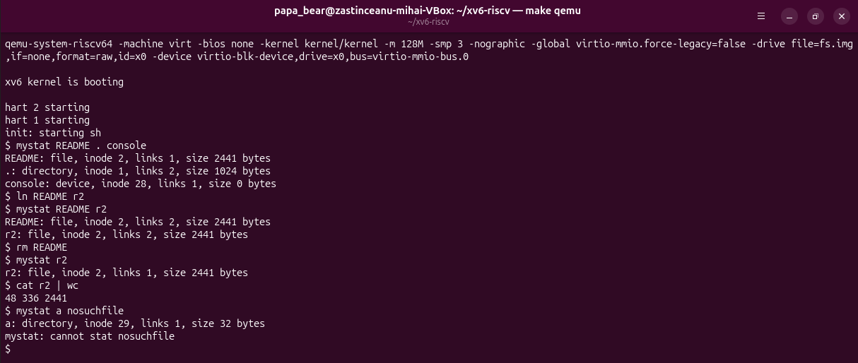
Figure 6.2.1 – mystat on README, . and console; a hard link, then rm of README
1. Paste the outputs after ln and after rm. What changed and what did not?
After ln README r2: README: file, inode 2, links 2, size 2441 bytes and the same line for r2. After rm README: r2: file, inode 2, links 1, size 2441 bytes, and cat r2 | wc still gives 48 336 2441. Only the link count changed (1 → 2 → 1); the inode number, size and data stayed the same. (Here . shows links 2, not 1 as in the sheet, because mkdir a before it added .. in a, which counts as a link to the root: dp->nlink++; // for ".." in create().)
2. Find the line in kernel/sysfile.c (sys_unlink) that decrements the link count. When are the data blocks freed?
sys_unlink() starts at line 202; line 244 is ip->nlink--;, followed by iupdate(ip) and iunlockput(ip). The blocks are not freed there. They are freed in iput() (kernel/fs.c, line 350): when the last in-memory reference is dropped (ip->ref == 1) and ip->nlink == 0, it calls itrunc(ip) to free the data blocks and marks the inode free. So, as on Linux, data disappears when there is no name left and no process has the file open.
3. xv6 has no symbolic links and no permissions. Look at struct dinode in kernel/fs.h: which fields does an xv6 inode have?
short type, short major, short minor (device numbers), short nlink, uint size and uint addrs[NDIRECT+1] (12 direct block numbers and 1 indirect). No owner, group, mode bits or timestamps, which is why xv6 has no permissions.
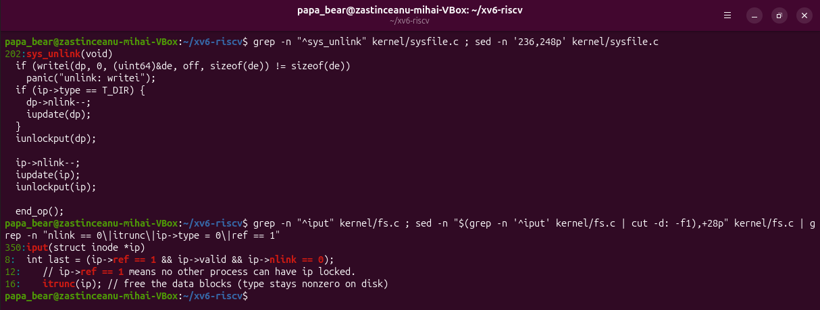
Figure 6.2.2 – nlink-- in sys_unlink and the freeing condition in iput

Part 3. Measure the limits
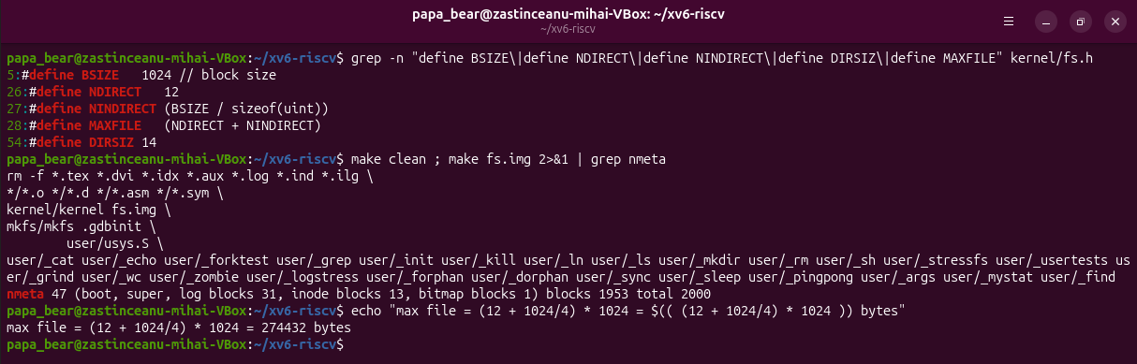
Figure 6.3.1 – The constants in fs.h and the nmeta line printed by mkfs
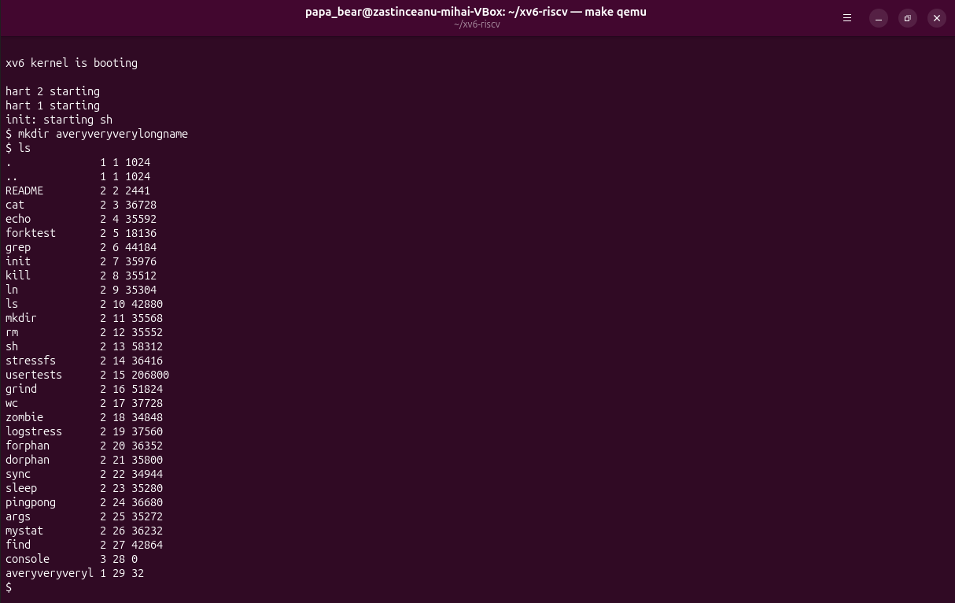
Figure 6.3.2 – A name longer than DIRSIZ
1. What does ls show for averyveryverylongname, and which constant explains it?
averyveryveryl – only the first 14 characters. DIRSIZ 14 is the size of the name field in a directory entry, so longer names are cut to 14 characters when the entry is written.
2. Compute the largest file xv6 can hold.
BSIZE = 1024 bytes, NDIRECT = 12, one indirect block holds NINDIRECT = 1024 / 4 = 256 block numbers. MAXFILE = 12 + 256 = 268 blocks, and 268 × 1024 = 274 432 bytes (268 KiB).
3. From the nmeta line: how many blocks does the whole disk have, and how many are for the log, the inodes, and the data?
nmeta 47 (boot, super, log blocks 31, inode blocks 13, bitmap blocks 1) blocks 1953 total 2000. The disk has 2000 blocks of 1 KB: 1 boot + 1 superblock + 31 log + 13 inode + 1 bitmap = 47 metadata blocks, and 1953 data blocks.

Part 4. Write find
find starts from user/ls.c: open the directory, read struct dirent entries, build the full path, stat it. It skips free slots (inum == 0), never recurses into . and .., compares the last component with strcmp, and closes every directory before returning (only 16 open files per process). The stretch option -n prints the inode number next to each path.
#include "kernel/types.h"
#include "kernel/stat.h"
#include "user/user.h"
#include "kernel/fs.h"
#include "kernel/fcntl.h"
// find <dir> <name> [-n]: print every path under <dir> whose last
// component is <name>; with -n, also print the inode number.
int show_inum;
// Return the last component of path (the part after the last '/').
char *
lastname(char *path)
{
char *p;
for (p = path + strlen(path); p >= path && *p != '/'; p--)
;
return p + 1;
}
void
find(char *path, char *name)
{
char buf[512], *p;
int fd;
struct dirent de;
struct stat st;
if ((fd = open(path, O_RDONLY)) < 0) {
fprintf(2, "find: cannot open %s\n", path);
return;
}
if (fstat(fd, &st) < 0) {
fprintf(2, "find: cannot stat %s\n", path);
close(fd);
return;
}
if (strcmp(lastname(path), name) == 0) {
if (show_inum)
printf("%s %d\n", path, st.ino);
else
printf("%s\n", path);
}
if (st.type != T_DIR) {
close(fd);
return;
}
if (strlen(path) + 1 + DIRSIZ + 1 > sizeof buf) {
fprintf(2, "find: path too long\n");
close(fd);
return;
}
strcpy(buf, path);
p = buf + strlen(buf);
*p++ = '/';
while (read(fd, &de, sizeof(de)) == sizeof(de)) {
if (de.inum == 0)
continue; // free slot
memmove(p, de.name, DIRSIZ);
p[DIRSIZ] = 0;
if (strcmp(p, ".") == 0 || strcmp(p, "..") == 0)
continue; // never walk back up or loop on ourselves
find(buf, name);
}
close(fd); // only 16 open files per process: close before returning
}
int
main(int argc, char *argv[])
{
if (argc < 3 || argc > 4 || (argc == 4 && strcmp(argv[3], "-n") != 0)) {
fprintf(2, "usage: find <dir> <name> [-n]\n");
exit(1);
}
show_inum = (argc == 4);
find(argv[1], argv[2]);
exit(0);
}
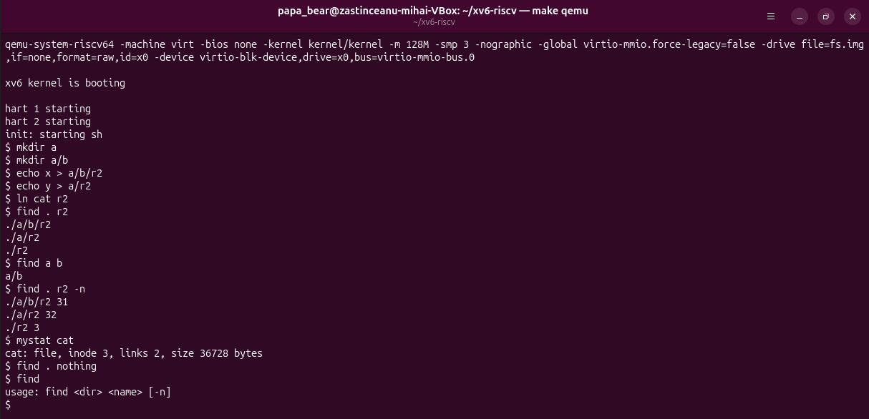
Figure 6.4.1 – find tests on a fresh disk, and the -n stretch option
find . r2 printed ./a/b/r2, ./a/r2, ./r2, and find a b printed a/b, as expected. With -n: ./a/b/r2 31, ./a/r2 32, ./r2 3. mystat cat shows inode 3 with 2 links, so only ./r2 is the same file as cat (it was made with ln cat r2); the other two are different files that just have the same name.

Conclusions
Lab 5 showed that a file name is only a directory entry pointing to an inode, and that the inode holds the real information: type, owner, mode, size, link count, blocks. A hard link is a second name for the same inode, a symbolic link is a small file containing a path, and rm only removes a name. Space is counted in blocks, so size and space differ in both directions (a 2-byte file takes 4K, a sparse 1 GB file takes nothing), and an open file keeps its blocks even after its last name is gone.
Permissions are checked by class (owner, group, others) and mean different things for files and directories (r = list, x = pass through). setuid and the sticky bit solve two real problems: letting a user change a root-owned file in a controlled way, and sharing /tmp safely. Disks, partitions and even the current process (/proc/self) are visible as files.
Lab 6 found the same ideas in xv6 in a much smaller form: a directory is a file of 16-byte entries, an inode has type, nlink, size and 13 block addresses, unlink decrements nlink and iput frees the blocks when nothing refers to the inode any more. The constants in fs.h fix the limits (14-character names, 268 KiB files, 2000-block disk). Writing mystat and a recursive find used exactly the calls ls uses: open, read of dirents, stat/fstat and close.

