Original scientific paper∗

TITLE OF PAPER (style heading 1: font formats - times new roman, 12 pt bold, ALL CAPS; paragraph formats: centered, spacing before 30 pt, spacing after 0 pt, keep with next, KEEP LINES TOGETHER)

Authors
(Style Heading 2: 10pt bold, title case, centered, spacing before 0 pt, spacing after 12 pt, keep with next, keep lines together)
Affiliation (Style Affiliation: 10pt, centered, spacing before 0 pt, after 18 pt, keep with next)
ORCID iDs: First Author  https://orcid.org/0000-xxxx-xxxx-xxxx
Second Author https://orcid.org/0000-xxxx-xxxx-xxxx
Third Author https://orcid.org/0000-xxxx-xxxx-xxxx
Fourth Author https://orcid.org/0000-xxxx-xxxx-xxxx
Abstract (bold). Short abstract (Style Abstract: 9 pt, italic, pt, justified, 0.75 pt left and right indentation).
Key words (bold): key word 1, key word 2... to (max) key word 6

1. Main Heading (Style Heading 3: small caps 10 pt, centered, spacing before 24 pt, spacing after 6 pt, keep with next, keep lines together)
Main text: only use characters and symbols available in the Times New Roman or Symbol font (as in the full text of paper), 10 pt; paragraph format: justified alignment, left and right indent 0 pt, space before and after 0 pt, first line indent 0.5 cm.

1.1. Subheading (Style Heading 4: 10 pt, bold, left, indentation left 5 pt,
spacing before 12 pt, after 6 pt, keep with next, keep lines together)
Sample of main text. Sample of main text. Sample of main text. Sample of main text. Sample of main text. Sample of main text. Sample of main text. Sample of main text. Sample of main text. Sample of main text. Sample of main text. Sample of main text. Sample of main text. Sample of main text. Sample of main text. Sample of main text.

1.1. Subheading (Style Heading 5: 10 pt, italic, left, indentation left 5 pt,
spacing before 12 pt, after 6pt, keep with next, keep lines together)
Sample of main text. Sample of main text. Sample of main text. Sample of main text. Sample of main text. Sample of main text. Sample of main text. Sample of main text. Sample of main text. Sample of main text. Sample of main text. Sample of main text.
Equations should be prepared using Equation Editor as a part of MS Word, with styles and sizes as defined (see Fig. 1).
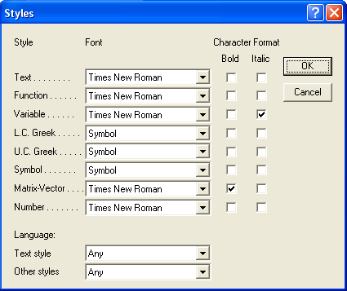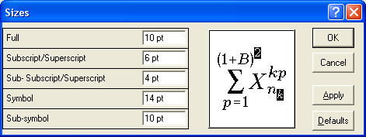
Fig. 1 Title of figure
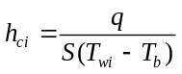 (1)
Paragraph format for equations are (Style Equation): left indentation, 6 pt before and after, equation is at position of centered tab at 6.25 cm, number of equation is at position of right tab at 12.7 cm.

Illustrations: figures, photographs, line drawings, graphs
(Styles Figure and Figure Title)
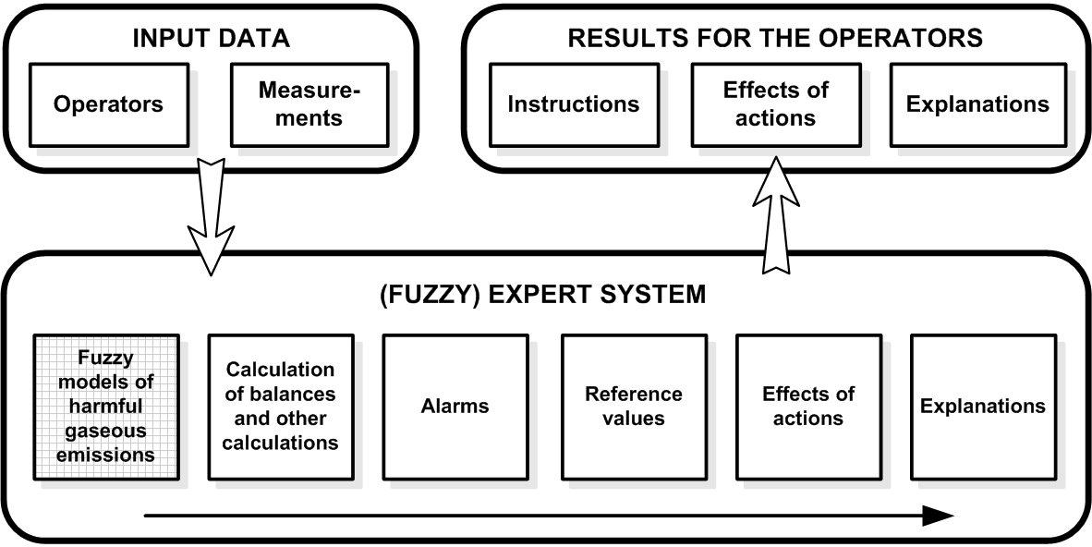
Fig. 2 Title of figure
All illustrations (figures, photographs, line drawings, graphs) should be numbered in series and all legends should be included at the bottom of each illustration. All figures, photographs, line drawings and graphs, prepared in electronic form, should be converted in TIFF or JPG (max quality) files, in 300 dpi resolution, for superior reproduction. Figures, line drawings and graphs prepared using elements of MS Drawing or MS Graph must be converted in form of pictures and unchangeable. All illustrations should be planned in advance so as to allow reduction to 12.75 cm in column width. Please review all illustrations to ensure that they are readable.

Tables
Table 1 Title of table (Style Table title)
System | Symbol
Without delay | +
Delay h = 1 | −
Delay h = N = 34 | *
All tables should be numbered with consecutive Arabic numbers. They should have descriptive captions at the top of each table and should be mentioned in the text.
Acknowledgement: The paper is a part of the research done within the project 1234567890. The authors would like to thank to the... (Style Acknowledgement).

References
N. S. Jayant and P. Noll, Digital Coding of Waveforms: Principles and Applications to Speech and Video. New Jersey: Prentice Hall, 1984, Chapters 4-5, pp. 115–251.
S. Na, "Asymptotic Formulas for Variance-Mismatched Fixed-Rate Scalar Quantization of a Gaussian Source", IEEE Trans. Signal Process., vol. 59, pp. 2437–2441, May 2011.
J. Vass, "Title of the Paper", Journal Name Stand. Abbrev., unpublished.
A. Ortega, "Title of the Paper", Journal Name Stand. Abbrev., in press.
Y. Yorozu, M. Hirano, K. Oka and Y. Tagawa, "Title", In Proceedings of the 4th International Conference on Matrix-Analytic Methods. River Edge, NJ: World Scientific, 2002, pp. 89–106.

Received Month XX, 2023 Corresponding author: Name and Surname Affiliation of corresponding author. (E-mail: authors@authors.com)

