Here Goes the Title of the Paper,
Please Use Soft Line Break
(Shift+Enter) for Long Titles if Needed
Author, Author 2, Author 3¹
Abstract: Here is Abstract. Abstract should contain short presentation of the paper and results given.
Keywords: Keywords, With initial caps.
1 Subtitle 1, Thus Should be According to the
Capitalization Rules
Please, type full names of all authors.
Do not use just initials for their names.
After keywords, the first section is usually Introduction, although some other subtitles can be used.
2 Subtitle 2
Each new paragraph should be clearly indicated. If the style used does not provide visual identification of paragraphs, author(s) should make one blank line between paragraphs.
2.1 Subsubtitle should be in Sentence case (thus, lowercase
except the first letter, names and acronyms)
For equations insert TAB before and after equation before the number (numbering is not obligatory). Equations use 11pt for full size. The best is to use trial version of MathType, since it can re-format all equations to change the full size and styles. Please, DO NOT type equations as text (especially, do not use subscript and superscript option in the text to simulate equations, e.g. x₁, x₂, ..., x_{n}), neither display ones (centered in a separate line) nor inline ones.
Here are some examples of display equations:
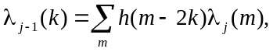 (1)
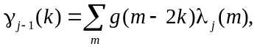 (2)
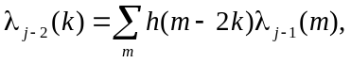 (3)
where after-equation text has no first-line indent, except if it is intended to be a new paragraph. Also, if using MathType, please do not use user-defined styles, except when unavoidable. Please, do not style any symbols or other content as user-defined, but choose built-in styles (e.g. vector, variable, text, etc.), since everything concerned with style and size of each equation element will be done with just simply applying our journal style to all equations. So, making some manual formatting will just cause problems. Please, always put some text before equations. A new paragraph or a sentence can not start with a centered equation.
3 Figures
Please, export figures from programs used for simulations or measurements in high quality format, preferably in vector (e.g., EPS) format. Also, export figures drawn in Corel Draw, Visio, etc, in EPS format, and save the original file to send it with the paper. You can send us exported EPS files and/or original files, so we can make minor corrections fast, if necessary, thus your paper, if accepted, will be published sooner. For photos and similar content please use highest quality JPEG or TIFF, while for diagrams high-resolution PNG format is preferable, if vector format is not available.
Please Avoid Drawing Figures in Microsoft Word directly, especially combining elements in Word with scanned images (e.g., inserting scanned graph and putting labels in Words as text boxes)!
3.1 Why not making figures directly in MS Word?
The main reason for this is that SJEE, besides printed version, publishes online version in PDF format, so important details can be seen in figures whenb zoomed-in. If figures are low resolution bitmaps or vectors made in MS Word, readers might not see correctly the results presented in the paper (especially since drawing tools in MS Word are not meant for high-precision drawing).
Thus, it is not just important to present a good result, but to do that in a good way, with high quality text, equations and figures.
In short, besides the quality of result(s), paper considered for publication must meet technical quality to be published in SJEE.
It makes sense that all figures are refereced somewhere in text, e.g. Fig. 1 or Figs. 1 and 2. It is necessary to prepare figures in such way that all content can be identified properly both in color and monochrome (graphs of different variables should be given in different styles, e.g. dotted, dashed etc.). Printed version will be in monochrome, while online version will be in color.
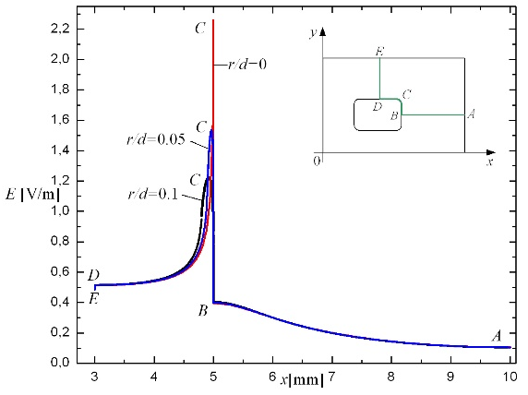
(a)
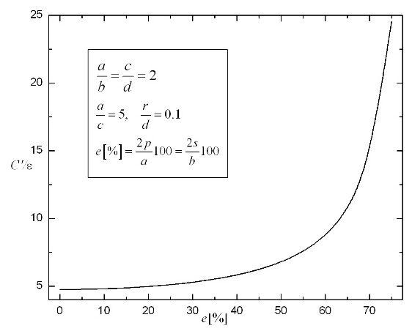
(b)
Fig. 1 – (a) Description; (b) Description.
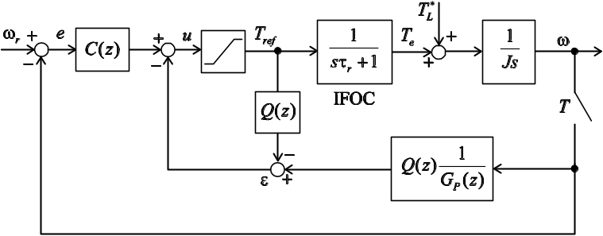
Fig. 2 – Figures should be inserted as vectors
whenever possible, preferably as EPS files.
4 Lists
Author(s) should use built-in styles for numbered (JText-numberedList)
- List element 1,
- List element 2, and
- List element 3,
and unordered lists (JText-unorderedList)
- List element 1,
- List element 2, and
- List element 3.
5 Tables
Tables should be referenced in text in bold font, e.g., as it is presented in Table 1. If the table can not fit at the bottom of the page, please move it to the next page. Also, put units in square bracket, e.g. for seconds [s].
Table 1
Description of the table.
 | IDCM |  | CONVENTIONAL
 | One level of  Decomposition [dB] |  | Three level of  Decomposition [dB]
Thr (%) | SNR | CR | SNR | CR
5 | 46.46 | 13.5 | 42.81 | 8.08
10 | 49.51 | 19.34 | 39.21 | 8.63
6 Conclusion
It is very important to write the paper in clear English language, without spelling and grammar errors. For that purpose, send your paper to professional lecturer. We can recommend you professional lecturers from Proof-Reading-Service (http://www.proof-reading-service.com).
All references should be formatted using examples given in Section 7. References should contain only correct data: names of all authors, paper title, publication name, date of publication, paper pages, and other. Authors should cite more recent references in the subject area. This will give higher value to the paper.
7 Acknowledgments
If Authors want to mention information about results published in the paper being supported by some project or institution, it should be done here.
For instance, this research is supported by Ministry of Science and Technology…
7 References
- U. Baader, M. Depenbrock, G. Gierse: Direct Self Control (DSC) of Inverter Fed Induction Machine: A Basis for Speed Control without Speed Measurement, IEEE Transaction on Industry Applications, Vol. 28, No. 3, May/June 1992, pp. 581 – 588.
- X. Hu, L. Zhang: A Predictive Direct Torque Control Scheme for a Three-level VSI-fed Induction Motor Drive, 9th International Conference on Electrical Machines and Drives, Canterbury, UK, 15 Oct. 1999, pp. 334 – 338.

Address of Authors 1 and 3 (If addresses of more authors are the same, then only one footnote should be inserted, for the first author, and for the others just put a superscript number of the footnote, E-mails of these authors should be put in this one footnote); E-mail: email1@address.com; email3@email.com
Address of Author 2; E-mail: email2@email.com

