34th Telecommunications Forum TELFOR 2026 Serbia, Belgrade, November 24-26, 2026
Anomalous Sound Detection on an ESP32-S3 with On-Device Commissioning from Normal Sound
Mihajlo Živković, Ivan Mezei
University of Novi Sad, Faculty of Technical Sciences, Novi Sad, Serbia
mihajlo11zivkovic@gmail.com, imezei@uns.ac.rs

Abstract—This paper presents an anomalous sound detector for fans that runs on an ESP32-S3 microcontroller with one MEMS microphone. A 96-band log spectrum from an 8192-point Welch estimate is scored by a squared Mahalanobis distance, using a Ledoit-Wolf precision matrix learned offline from normal DCASE 2026 recordings and a center learned on the device. In offline evaluation on the fan target domain, the design reaches an AUC of 0.863 with ten calibration windows, against 0.470 for the evaluated autoencoder baseline, and needs 716 ms of computation per 10 s window. In the reported trials the device learns the center, derives entry and release thresholds from 44 normal windows and checks them on 22 further windows before it starts monitoring. A reliability gate holds the decision on high-scoring windows whose sub-window spectra disagree. Physical trials confirmed local commissioning, detection of a sustained 1 kHz tone and alarm retention under hysteresis. A manually held paper strip produced variable spectra; one of three blocks raised an alarm, which was subsequently released. Offline replay reproduced the reliability and alarm decisions in all 180 monitoring windows. These results demonstrate the detector's operation and highlight its limitations under time-varying acoustic conditions and changes in sound level.
Keywords—Anomalous sound detection, condition monitoring, ESP32-S3, Mahalanobis distance, TinyML, unsupervised learning.

Introduction
Changes in the sound of a rotating machine can indicate a developing fault [8], and a microphone can listen without touching the machine. The DCASE challenge turned this into an established benchmark: a detector is trained on normal sound only and has to flag anomalies it has never heard, often on a machine instance or operating condition that was absent from training [1]-[5]. Published systems are mostly evaluated offline by the area under the ROC curve (AUC), on PCs or GPUs rather than on a microcontroller.
A detector mounted next to a machine has a different job. It has to set a threshold for one particular installation, reject audio it cannot trust, and decide when a deviation has lasted long enough to report. None of these steps may rely on fault examples, because a new installation has none. MLPerf Tiny includes anomaly detection on microcontrollers and measures inference accuracy, latency and energy [9]. Here the focus also includes commissioning and alarm decisions for one installation.
This paper describes a complete detector for fans on an ESP32-S3 and what happened when it was tested on a physical fan. The contributions are: 1) a statistical detector with higher AUC on the DCASE fan development data than the evaluated autoencoder baselines and less than half the measured computation time of the small int8 autoencoder; 2) commissioning on the device that learns the center and both alarm thresholds from normal sound and verifies them before monitoring; 3) a fail-closed decision chain: a window can raise an alarm only after it passes quality, machine-presence, reliability and temporal checks, and a failed check withholds the decision; 4) trials on a physical fan, with an offline replay of the recorded features, which confirm that the device made its decisions as specified and show where detection falls short for unsteady changes.

Detector

Hardware and signal path
The platform is an ESP32-S3-WROOM-1 module (240 MHz, 16 MB PSRAM) running ESP-IDF v5.5.5. An INMP441 MEMS microphone delivers I2S audio sampled at 16 kHz and converted to 16-bit samples. The user interface is one push-button and two LEDs. In the reported trials the button was emulated over UART through the same event path, and a PC logged telemetry and operator labels. Fig. 1 shows the signal path. The firmware image, including research telemetry, is 354,784 B.
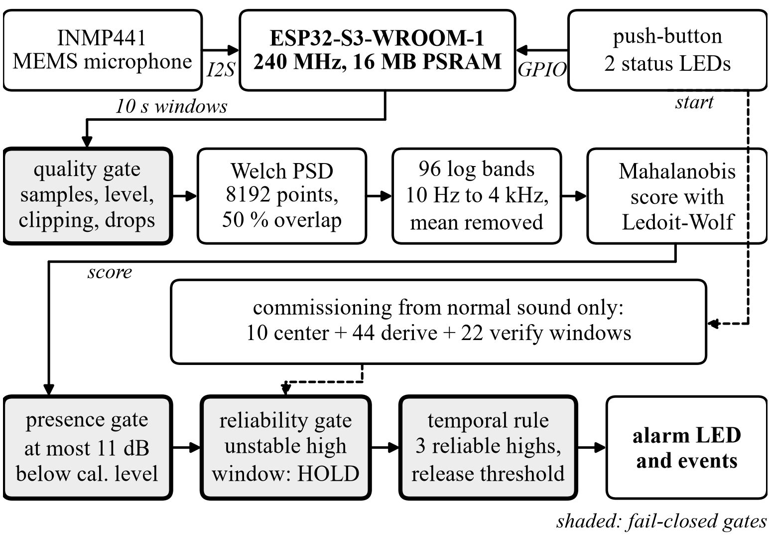
- Signal path and decision chain. Shaded blocks are fail-closed gates. Calibration, thresholds and alarms are computed on the device; the PC logs telemetry and sends operator commands.

Spectral feature
Each 10 s window of 159,744 samples is split into 38 Welch segments [6] of 8192 samples with a periodic Hann window and 50 % overlap, which gives a bin spacing of 1.95 Hz. Mean power is taken in 96 logarithmic bands from 10 Hz to 4 kHz and converted by log10, and the mean over bands is subtracted to reduce sensitivity to broadband level. The firmware accumulates segment power as audio arrives, so it never holds the 640 kB float buffer of a whole window. Fine resolution matters for fans, whose sound is dominated by narrow lines at the rotation and blade-pass frequencies and their harmonics [8]. A 1024-point frame has 15.6 Hz spacing, and mel filtering merges these lines further.

Model
Features are standardized with the mean and standard deviation of 990 normal source-domain clips of the DCASE 2026 fan [5], and a Ledoit-Wolf shrinkage estimate [7] of their covariance gives the precision matrix P. The center c is the mean standardized feature of the calibration windows recorded on site. A window with standardized feature z receives the score s = (z − c)ᵀ P (z − c). The covariance describes how the bands of a normal fan vary together and needs hundreds of clips, while the center needs only minutes of sound from the actual machine. P occupies 36,864 B and the normalization 768 B.
The same C source computes features on the PC and on the device. The maximum absolute feature difference between the Python reference and C is about 9.54·10⁻⁷ on a benchmark file, and the host-to-device difference on a live microphone capture is about 1.70·10⁻⁶. These checks confirm agreement of the feature computation on the tested audio.

Offline comparison
Table I compares the PSD detector design with the DCASE autoencoder baseline [2] and with log-mel statistics scored by the same Mahalanobis backend. Local-center results use 100 random calibration splits for each center size; the two 20-window rows share the same splits. Calibration windows are never scored. Offline PSD fits use canonical normalization, while the firmware export adds 10⁻⁸ to the standard deviation. The autoencoders follow the DCASE recipe without a local center, so their rows serve only as a reference point. With the same backend, the PSD front end gains 0.24 AUC over log-mel statistics. On the device it needs 0.72 s per window, while an int8 autoencoder with 45k parameters on TensorFlow Lite Micro needs 1.54 s including its log-mel front end.
- Detectors on the DCASE 2026 Fan, Target Domain
Detector | Center | AUC | Device
Autoencoder, 270k param. [2] | none | 0.470 ± 0.010 | -
Autoencoder, 45k param., int8 | none | 0.453 ± 0.005 | 1.54 s
Log-mel statistics + LW | 20 windows | 0.627 ± 0.035 | -
PSD, 96 bands + LW | 20 windows | 0.867 ± 0.027 | -
PSD, 96 bands + LW | 10 windows | 0.863 ± 0.028 | 0.72 s
± is the standard deviation over five training seeds for the autoencoders and over 100 calibration splits otherwise. LW: Ledoit-Wolf. Device: computation per 10 s window on the ESP32-S3.
The advantage is specific to the fan. On the other six DCASE machine types a log-mel front end wins on five, for example 0.539 against 0.448 on ToyCar, so we claim the result for fans only. Seven further candidates were declared before evaluation: rotation-order features, separate centers per operating speed, three variants that use the second DCASE 2026 channel, transient features, and PSD combined with transients. None improved on the PSD feature by more than 0.002 AUC over 20 splits. These results come from the development set that also guided the design, so they should be read as relative comparisons.

Commissioning on the Device

Why ten windows were not enough
The first firmware set the threshold from the ten calibration windows as max(Q0.90, mean + 3σ) of their leave-one-out scores. Three calibrations with the same board, microphone, loudspeaker replay of fan recordings and room produced thresholds of 5687, 347 and 1088. The thresholds spread by a factor of 16 while the median score changed by a factor of 4.7, and 92 % of the windows from the first run lay above the threshold of the second. Ten windows locate the center well, but they say little about the tail of the normal score distribution that sets the false-alarm rate.

Commissioning sequence
The firmware estimates the center and the thresholds from separate windows (Fig. 2). The trials used the GUIDED25 setting: 44 threshold windows and 22 verification windows, instead of the default 120 and 60. After at least four settling windows, three of them stable, the device records ten center windows. The coefficient of variation of their leave-one-out scores must not exceed 0.6. Up to two windows with the largest scores may be discarded, recomputing the center after each; otherwise calibration is rejected. The next 44 windows are scored against the frozen center. The entry threshold is their empirical upper 99th percentile, and the release threshold their 95th percentile kept between the median and half the entry threshold. The last 22 windows are checked with the same alarm entry and release rule, without reliability holds. A single alarm episode rejects commissioning. Including settling, this setting needs at least 80 windows, about 800 s of audio, and took 13.6 min in both trials. The center is never updated afterwards, so a slowly developing change cannot shift this reference automatically.
The verification step rejected a threshold that was too low. A robust candidate, the smaller of the empirical Q0.99 and median + 3·1.4826·MAD with a trimmed center, produced a threshold of 791 in one session. Its 22 verification windows scored from 263 to 7766. Eight exceeded the threshold, including the last six in a row, so the device correctly refused to start monitoring.

Runtime Decision Chain
Every window passes four gates before it can raise an alarm. The quality gate checks the exact sample count, RMS level, peak, clipped fraction (at most 10⁻³), zero and stuck-sample fractions and a per-window count of dropped samples, which must be zero, and requires all metrics and features to be finite. A violation stops the pipeline in every phase instead of producing a score. The presence gate treats the machine as running while the window level is no more than 11 dB below the calibrated level, and as stopped after three consecutive windows below this limit. A stopped fan can also score highly, so this check prevents low-level windows from triggering an anomaly alarm.
The reliability gate uses five sub-windows of each 10 s window, formed from the same Welch segments without extra FFTs. Its instability measure is the mean over bands of the standard deviation of the five standardized sub-window features. When a score exceeds the entry threshold and the instability exceeds 1.25 times the largest value among the ten calibration windows, the window is put on OBSERVATION_HOLD. A held window neither counts toward an alarm nor clears an active one, and it does not change the profile. Six consecutive holds raise a warning. The gate measures instability without identifying its cause, such as speech or a knock on the housing.
An alarm requires three consecutive reliable windows above the entry threshold and is released at the first window at or below the release threshold. In an earlier comparison of 11 temporal-rule configurations on 2000 normal windows over 40 splits, a rule of this form, with release at 0.7 of the entry threshold, produced no false alarm episodes, as did three consecutive windows without hysteresis. On recordings of a different fan, hysteresis reduced episodes from 11.2 to 5.4 per hour. At the twelfth alarm window the device emits a sustained-deviation event, and held windows pause this count. Events are reported as an unknown change, never as a diagnosed fault.

Trials on a Physical Fan
Both trials used the same firmware image and one electric fan, with the microphone 40 cm from the fan in a room. In the first, a paper strip was held by hand in the airflow in three blocks, followed by speech and a door disturbance. In the second, a loudspeaker played a 1 kHz tone at varying levels. The operator labeled conditions from the PC. Metrics use windows with a valid protocol, a confirmed label and no label change inside the window: 43 of 65 and 99 of 115 monitoring windows, held windows included. Table II summarizes both sessions and Fig. 2 shows every window.
- Physical Fan Trials, Same Firmware Image
Measurement | Paper strip | 1 kHz tone
Calibration LOO CV | 0.84 → 0.43, 2 trimmed | 0.43, none trimmed
Entry / release threshold | 8084 / 3707 | 21,810 / 10,905
Baseline median score | 1146 | 7085
Stimulus median score | 30,255, 62,344, 19,844 | 23,574
Held stimulus windows | 3/4, 3/4, 1/4 | 8/44
Alarm episodes (device) | 1, block 3; released | 1, retained by hysteresis
Sustained-deviation event | no | yes
Speech / door | no alarm, 5/6 held | not applied
Paper protocol criteria | not met: 1/3; carried alarm | not applicable
Decision replay | 65/65 agree | 115/115 agree
Dropped samples | 0 | 0
Eligible windows: 43/65 and 99/115. Episodes are counted from the alarm events emitted by the device.
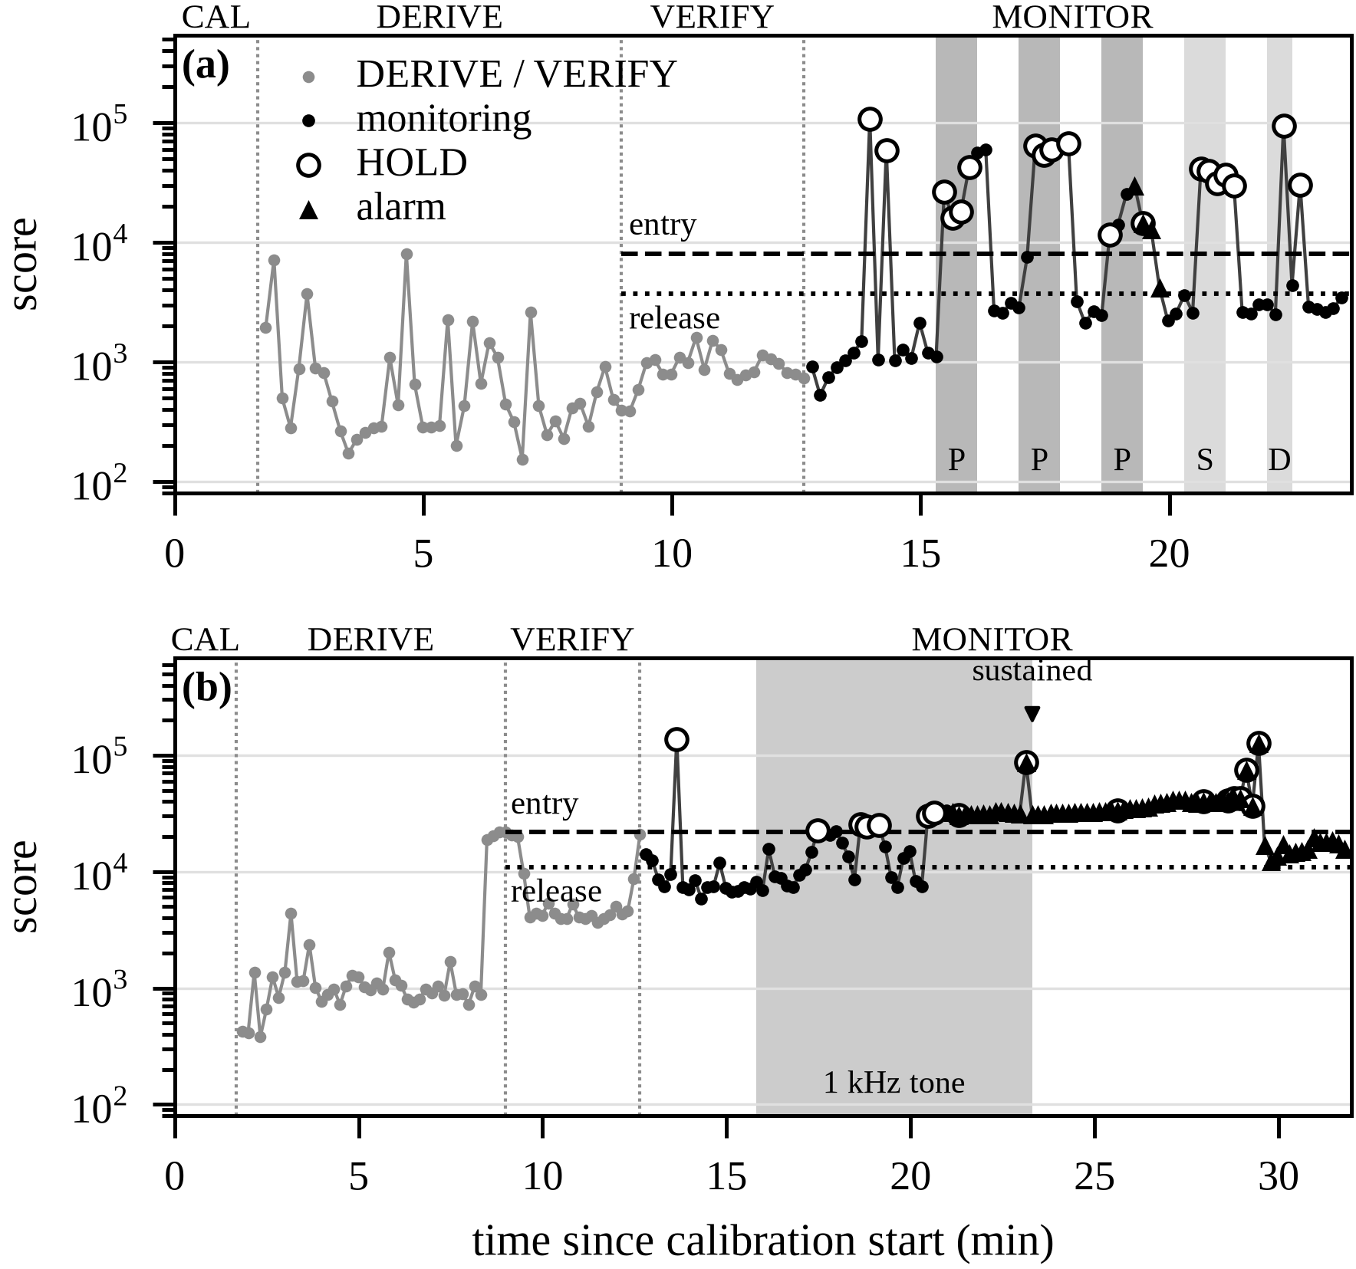
- Sessions from center learning through monitoring, one point per 10 s window: (a) paper strip (P), speech (S) and door (D); (b) 1 kHz tone. Shading follows operator labels, not independently measured stimulus boundaries; the tone continued beyond its shaded block. Thresholds come from DERIVE. Unconfirmed windows are excluded from Table II.

Paper strip
The strip raised the median scores of its three blocks to 30,255, 62,344, 19,844, against 1146 for the baseline, all well above the entry threshold of 8084. In the first two blocks, however, three of four windows were held, and three consecutive reliable exceedances never occurred. Holding the strip steady by hand was difficult. The recorded spectra varied within and between windows: in block one the scores ranged from 16,008 to 56,167. The five sub-window spectra often differed enough to trigger the reliability gate. An alarm entered only in block three, lasted two windows into the following recovery block and was then released. The predefined paper protocol criteria were not met: only one of three blocks was detected and the alarm extended into recovery. Speech and door windows reached medians of 38,307 and 49,549; all four speech windows and one of two door windows were held, and neither raised an alarm.

Sustained tone
The tone level varied early in the trial: the 1 kHz band rose from the first tone window but briefly returned close to its normal level later. Scores crossed above and below the entry threshold, and several windows were held. At about 20.5 min both the 1 kHz band and its third harmonic at 3 kHz rose strongly. This is consistent with a level increase noted by the operator without a time stamp. The alarm then entered after three reliable windows, and the sustained-deviation event followed 130 s later. The operator marked the end of the tone at 23.3 min, but the 1 kHz band stayed about 42 standardized units above the center for another 36 windows, indicating continued tonal sound until about 29.4 min. After that the scores settled between 12,266 and 19,561, below the entry threshold but above the release threshold of 10,905. The alarm therefore remained active as specified by hysteresis, which requires the score to reach the lower threshold rather than a fixed waiting time. The recording ended 14 windows later without a release, so its latency was not measured. The trial confirmed tone detection, sustained-deviation reporting and the expected alarm retention.
Offline verification recomputed the reliability holds from the five recorded sub-window features and replayed the temporal C code whose hash matches the trial provenance. All holds and alarm decisions agreed with the device: 65/65 paper-strip and 115/115 tone windows, including transitions and unconfirmed labels. This confirms that the recorded decisions follow the implemented rules; it does not mean that every induced change was detected. In both sessions computation took 716 to 728 ms per window, with no reported sample losses.

What the stimuli changed
Fig. 3 shows the median deviation of the standardized feature from the center for each stimulus, computed from the feature vectors the device sent during the trials. The paper strip raised narrow bands between 1.3 and 3.9 kHz and one near 436 Hz, speech raised the bands from 76 to 210 Hz, and the tone raised the bands at 1 kHz and 3 kHz. For speech the eight empty bands also dropped by about 12 units, although they contain no signal at all.
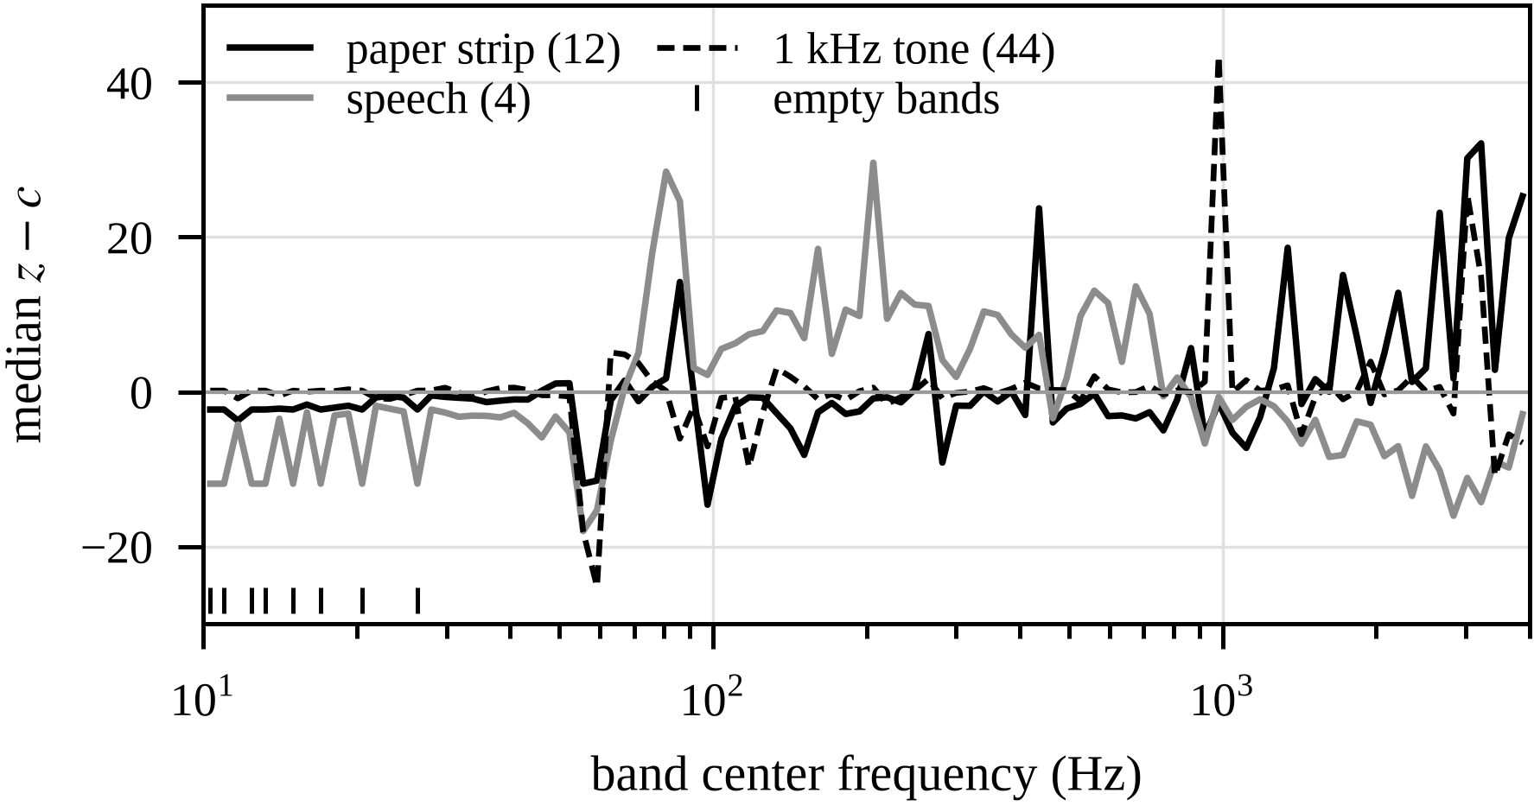
- Median deviation z − c of the standardized band feature from the calibration center, over the eligible windows of each stimulus (count in parentheses). Ticks mark the eight bands that contain no FFT bin.

Level dependence of the band map
At 1.95 Hz spacing, eight of the 96 bands below 28 Hz contain no FFT bin. The firmware gives them a fixed log value of −20 before the mean is removed, so they carry the broadband level into all 96 components and the feature is not level invariant as intended; the speech curve in Fig. 3 shows this leak. In an offline test that scales the evaluated clips while keeping the calibration center, a 6 dB increase multiplies the median normal score by 28 and lowers the AUC (ten calibration windows, 100 splits) from 0.863 to 0.505.
First, rescoring the original recorded features reproduced the device scores within a relative error of 10⁻⁶. We then separately reset each window's band level to the calibration value and rescored it. The medians of the paper-strip blocks and of the tone change by less than 4 %, indicating that their high scores mainly reflect spectral shape. Speech and door medians drop by 26 % and 34 % and remain several times above the entry threshold.
A band map that advances every band edge by at least one bin keeps 96 bands over the same range and has no empty bands. It removes this source of level dependence: on six normal clips and one broadband signal, the C feature changes by less than 3·10⁻⁶ for gains from 0.25 to 4. The AUC rises to 0.878, higher in 98 of 100 splits. It needs a new precision matrix and a new commissioning, and it has not yet been tested on the fan.

Discussion
The detector targets sustained, reliable spectral deviations; it does not require a single constant frequency. The hand-held paper strip produced variable sub-window spectra, whereas the tone eventually provided three reliable exceedances and a sustained alarm. The gate responded consistently to this difference. However, it cannot identify whether instability comes from the machine or its surroundings. The paper trial therefore demonstrates both the intended rejection of unstable observations and the limited detection of unsteady changes.
A second limitation is the threshold rule. With the 44 windows used in these trials, the upper 99th percentile equals the maximum, so one high normal window sets the entry threshold. In the tone session a short rise near the end of DERIVE put it at 21,810, three times the monitoring baseline of 7085, and the early tone windows scored close to this level. The rule is conservative on purpose. Two accepted sessions are too few to tell how repeatable the thresholds are across installations.

Conclusion
A statistical detector with 37.6 kB of fixed model parameters runs on the ESP32-S3 in 716 ms per 10 s window and achieves higher AUC on the DCASE fan development data than the evaluated autoencoder baselines. Physical trials demonstrated commissioning from normal sound, tone detection, sustained-deviation reporting and alarm retention consistent with hysteresis. The paper trial demonstrated alarm activation and release in one of three blocks. Replay reproduced all 180 monitoring decisions, confirming that the firmware behaved as specified in the tested installation.
The evidence comes from one fan, one room and two sessions, and both stimuli were induced changes; no mechanical fault was tested. The paper protocol did not meet its predefined detection and recovery criteria. Later standalone tests with the push-button and LEDs confirmed operation as intended, including alarm release after the tone; only power consumption remains to be measured, with a dedicated INA226 measurement board. Further work should repeat the paper trial with a fixed holder, test the level-invariant band map on hardware and assess detection of unsteady changes in independent installations.

References
- Y. Koizumi et al., “Description and discussion on DCASE2020 Challenge Task2: Unsupervised anomalous sound detection for machine condition monitoring,” in Proc. DCASE Workshop, Nov. 2020, pp. 81-85.
- N. Harada, D. Niizumi, Y. Ohishi, D. Takeuchi, and M. Yasuda, “First-shot anomaly sound detection for machine condition monitoring: A domain generalization baseline,” in Proc. 31st European Signal Processing Conf. (EUSIPCO), 2023, pp. 191-195, doi: 10.23919/EUSIPCO58844.2023.10289721.
- N. Harada et al., “ToyADMOS2: Another dataset of miniature-machine operating sounds for anomalous sound detection under domain shift conditions,” in Proc. DCASE Workshop, Barcelona, Spain, Nov. 2021, pp. 1-5, doi: 10.5281/zenodo.5770113.
- K. Dohi et al., “MIMII DG: Sound dataset for malfunctioning industrial machine investigation and inspection for domain generalization task,” in Proc. DCASE Workshop, Nancy, France, Nov. 2022, pp. 1-5.
- T. Nishida et al., “Description and discussion on DCASE 2026 Challenge Task 2: Noise-aware unsupervised anomalous sound detection for machine condition monitoring,” arXiv:2606.01578, 2026.
- P. D. Welch, “The use of the fast Fourier transform for the estimation of power spectra: A method based on time averaging over short, modified periodograms,” IEEE Trans. Audio Electroacoust., vol. 15, no. 2, pp. 70-73, Jun. 1967, doi: 10.1109/TAU.1967.1161901.
- O. Ledoit and M. Wolf, “A well-conditioned estimator for large-dimensional covariance matrices,” J. Multivariate Anal., vol. 88, no. 2, pp. 365-411, Feb. 2004, doi: 10.1016/S0047-259X(03)00096-4.
- R. B. Randall, Vibration-based Condition Monitoring: Industrial, Aerospace and Automotive Applications. Chichester, U.K.: Wiley, 2011.
- C. Banbury et al., “MLPerf Tiny benchmark,” in Proc. NeurIPS Datasets and Benchmarks Track, 2021.

