**Ονοματεπώνυμο : Γαλανάκης Μιχάλης**

**AM : p3622004**

**Exponential Model**

Εικόνα που περιέχει κείμενο

Περιγραφή που δημιουργήθηκε αυτόματαLet us have a look at the model in the OpenBUGS:

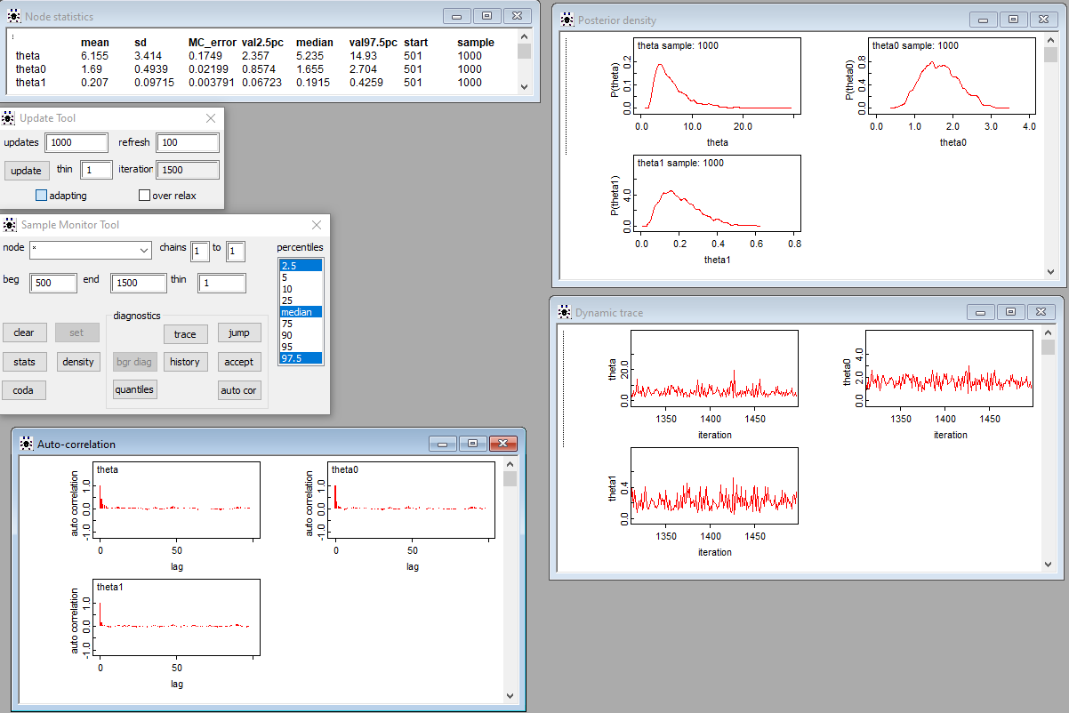After checking the model, loading the data, compiling and initializing it we obtain the following results (after discarding the 500 initial iterations which correspond to the burn-in period):

Εικόνα που περιέχει κείμενο

Περιγραφή που δημιουργήθηκε αυτόματαLet us check the exponential model in RStudio (in order to get a better picture) as well :

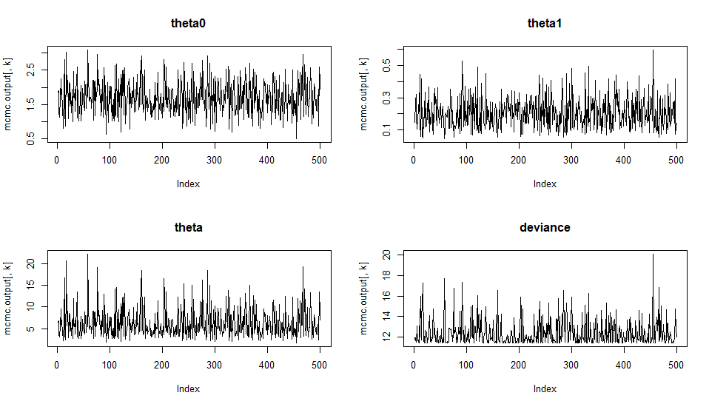We observe that there are the same posterior summaries as in OpenBUGS! ( sign of relief ) Let us have a look on the trace plots in RStudio:

All values are within a zone without strong periodicities and especially tendecies, so we can assume convergence!

Using the option CODA in OpenBUGS we observe a set windows with the sampled values in a format compatible to one used by CODA software. CODA is an add-in package for Splus and R that is used for checking convergence of the algorithm using a variety of diagnostics:

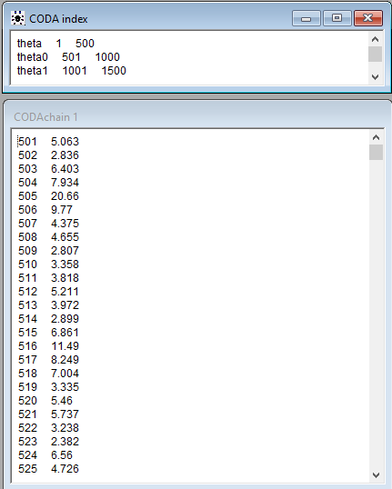

Εικόνα που περιέχει κείμενο

Περιγραφή που δημιουργήθηκε αυτόματαWe can use these values in order to create the Ergodic Mean Plots as follows:

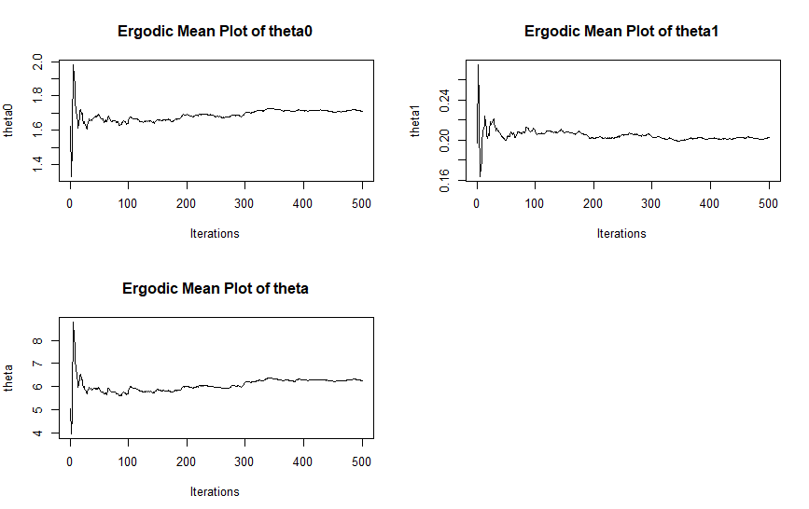Let’s have a look on the Ergodic Mean Plots now:

Stabilized ergodic means thus it's an indication of the convergence of the algorithm (it seems to have converged after about 70 iterations).

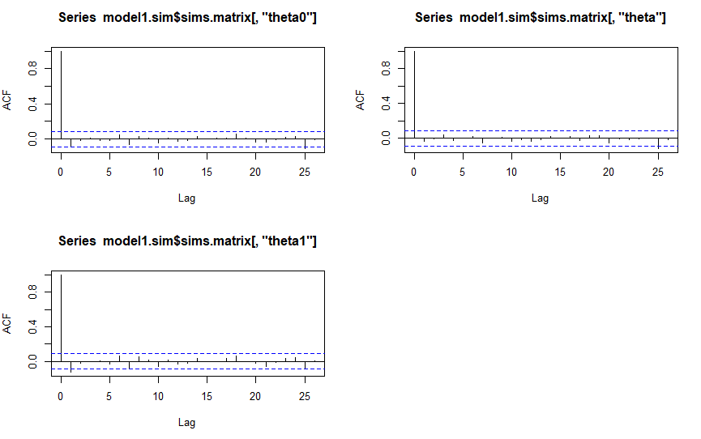Moreover, as regards the autocorrelation plots:

We can observe that there are not significant autocorrelations, hence there is no thinning required.

**Gamma model**

Εικόνα που περιέχει κείμενο

Περιγραφή που δημιουργήθηκε αυτόματαLet us have a glimpse of the model in the OpenBUGS:

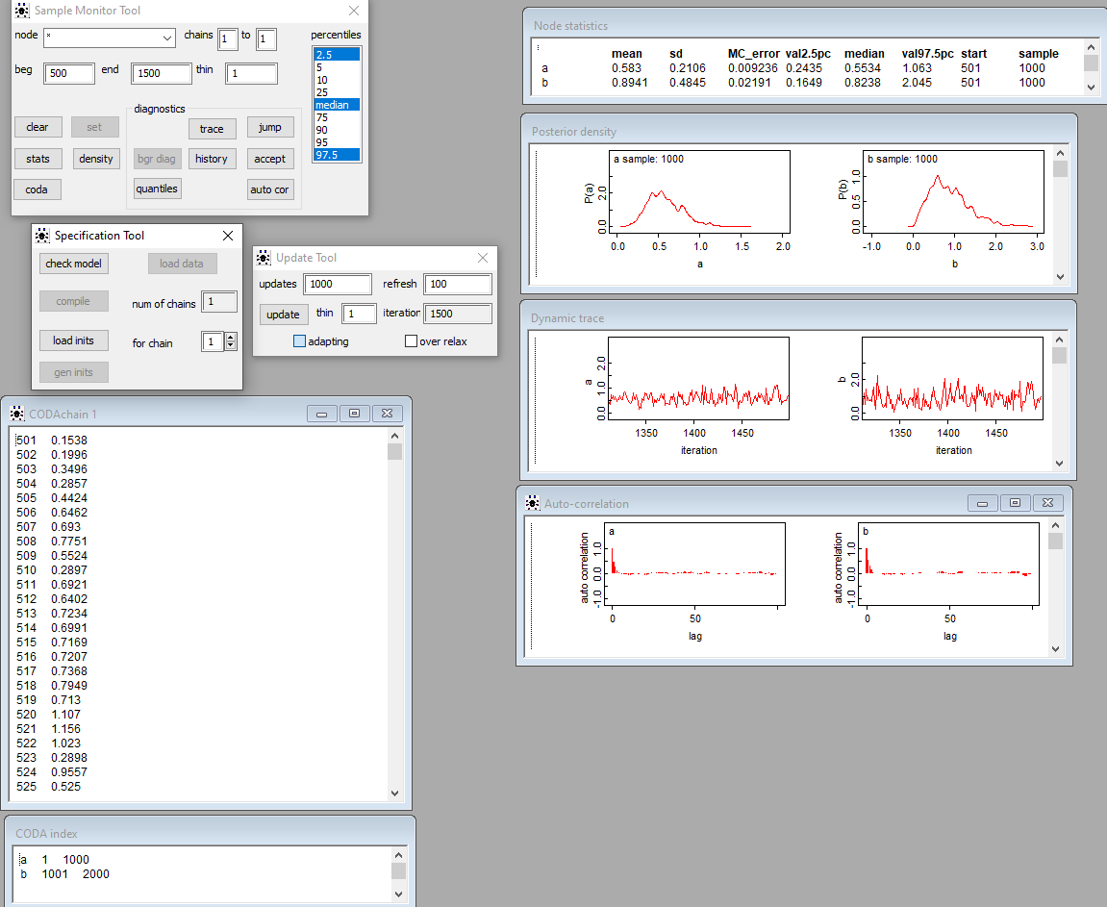After checking the model, loading the data, compiling and initializing it we obtain the following results (after discarding the 500 initial iterations which correspond to the burn-in period):

Εικόνα που περιέχει κείμενο

Περιγραφή που δημιουργήθηκε αυτόματαLet us check the gamma model in RStudio (in order to get a better picture) as well:

We observe that there are the same posterior summaries as in OpenBUGS! Let us have a look on the trace plots in RStudio:

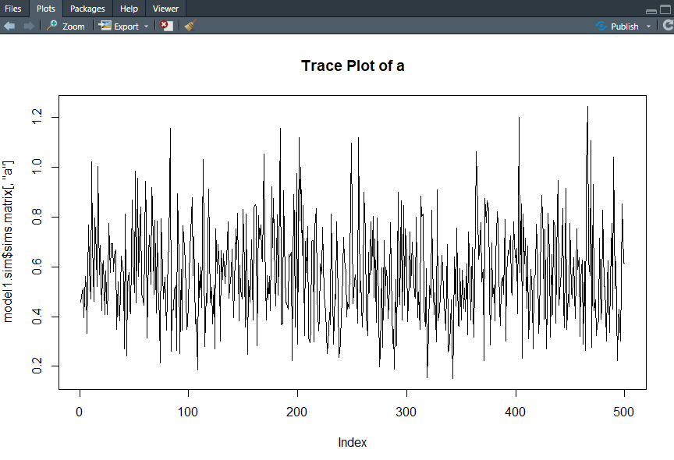

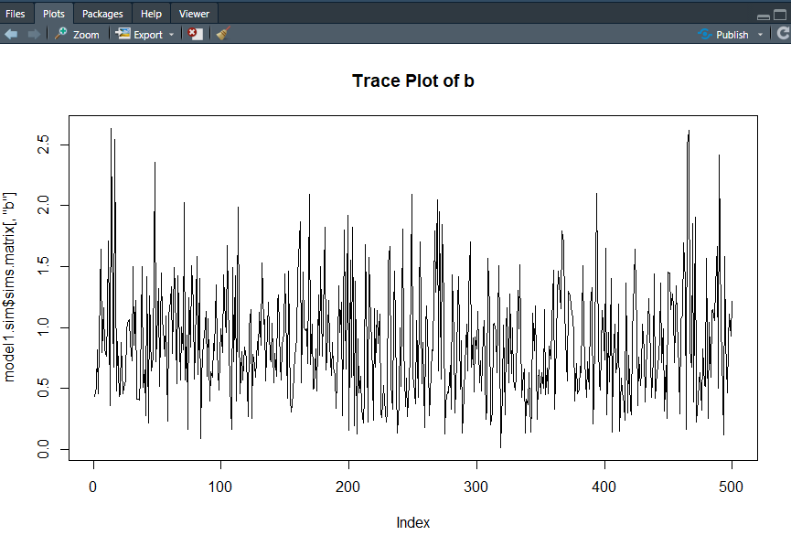

All values are within a zone without strong periodicities and especially tendecies, so we can assume convergence!

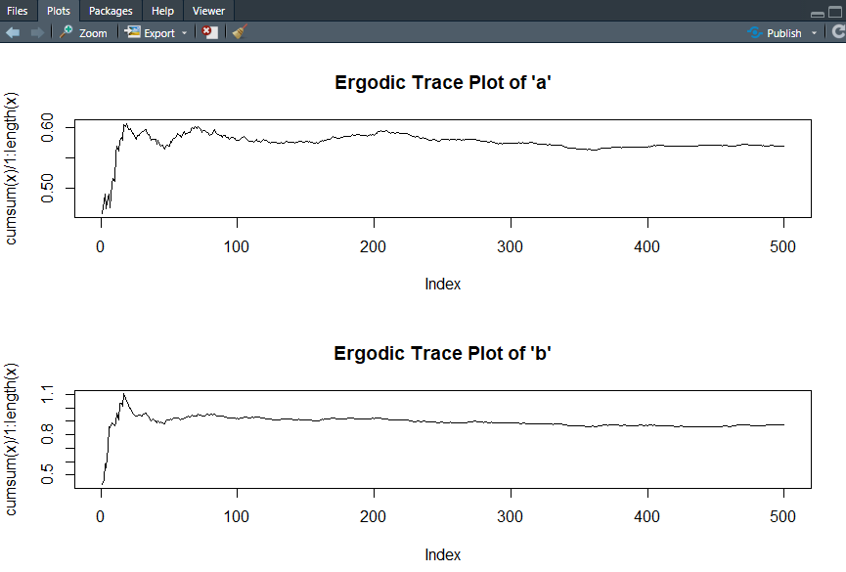Using CODA we can obtain the following Ergodic Mean Plots in RStudio:

Stabilized ergodic means, thus it's an indication of the convergence of the algorithm (it seems to have converged after about 60 iterations).

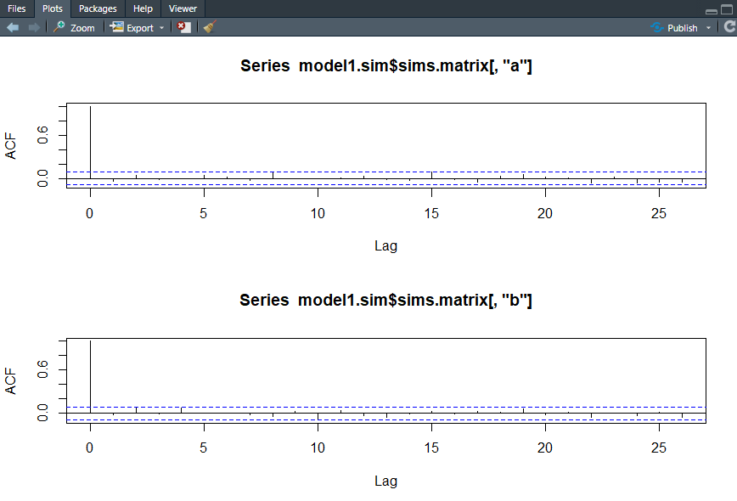Furthermore, as regards the autocorrelation plots:

We observe that there are not significant autocorrelations hence no thinning is required!

**Log Normal model**

Εικόνα που περιέχει κείμενο

Περιγραφή που δημιουργήθηκε αυτόματαLet us check the model in the OpenBUGS:

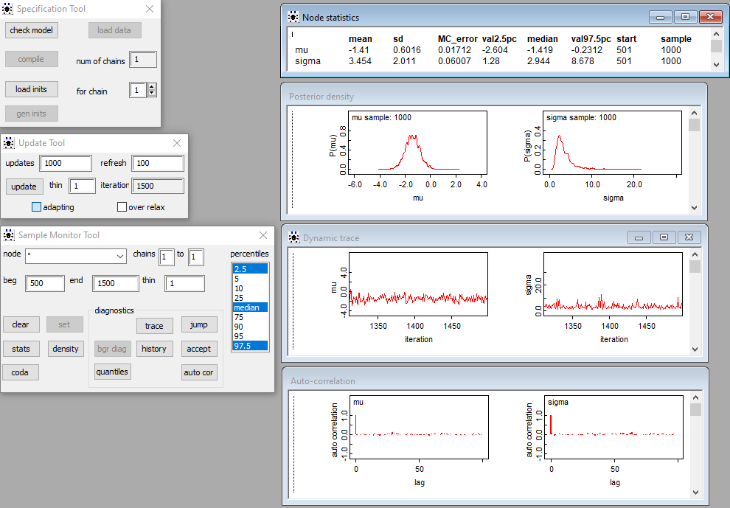After checking the model, loading the data, compiling and initializing it we obtain the following results (after discarding the 500 initial iterations which correspond to the burn-in period):

Εικόνα που περιέχει κείμενο

Περιγραφή που δημιουργήθηκε αυτόματαLet us check the gamma model in RStudio (in order to get a better picture) as well:

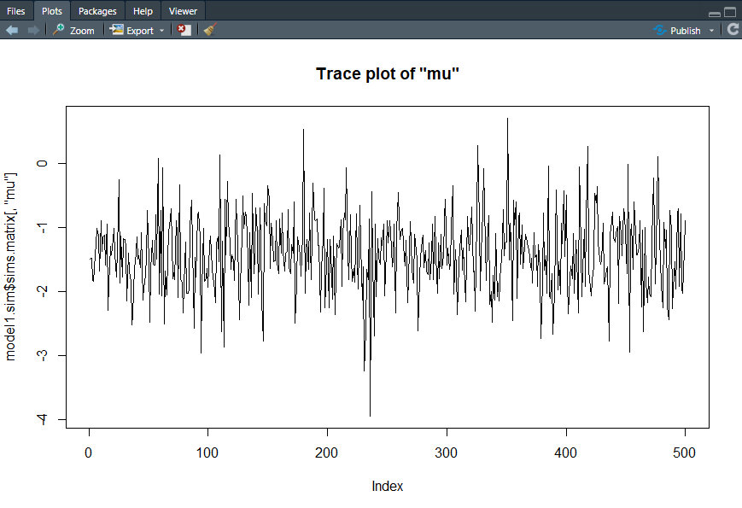We observe that there are the same posterior summaries as in OpenBUGS! Let us have a look on the trace plots in RStudio:

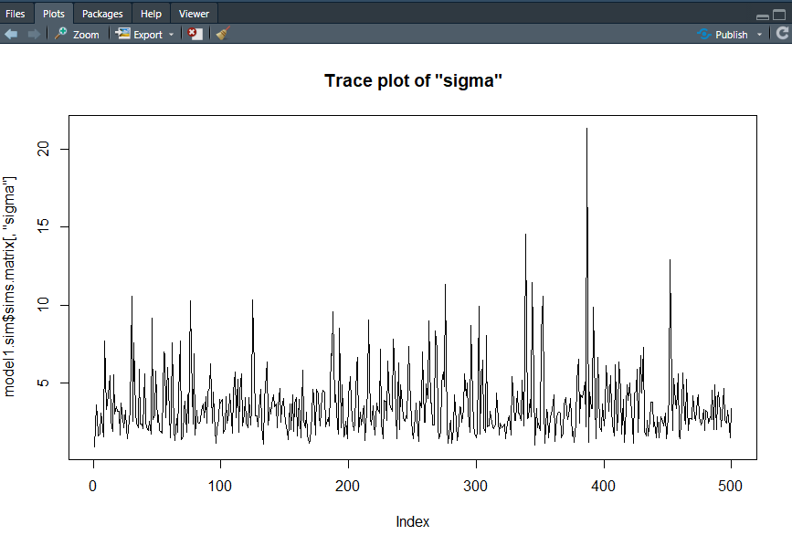

All values are within a zone without strong periodicities and especially tendecies, so we can assume convergence!

Using CODA we can obtain the following Ergodic Mean Plots in RStudio:

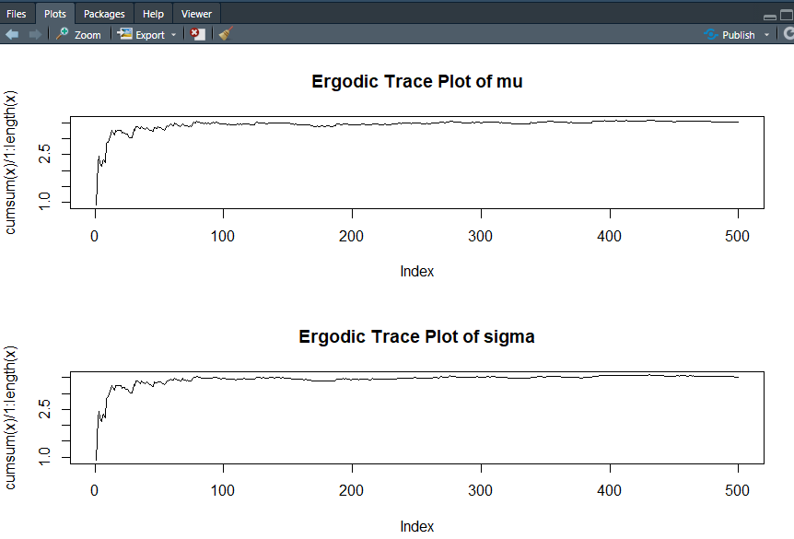

Stabilized ergodic means, thus it's an indication of the convergence of the algorithm (it seems to have converged after about 60 iterations).

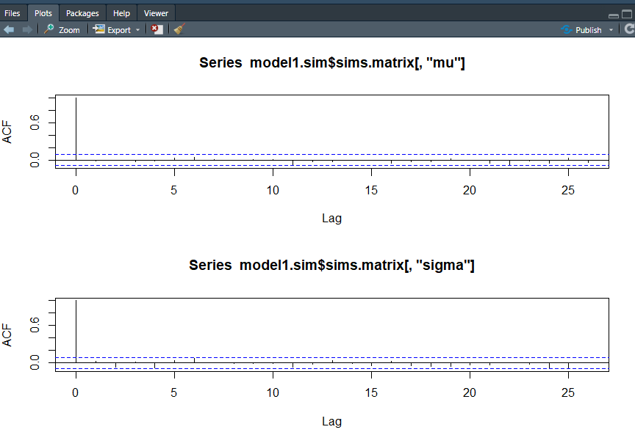In addition, the autocorrelation plots are as follows:

We can observe that there are not any significant autocorrelations, thus there’s no thinning required!

**Normal Model**

**Εικόνα που περιέχει κείμενο

Περιγραφή που δημιουργήθηκε αυτόματα**Let us check the model in the OpenBUGS:

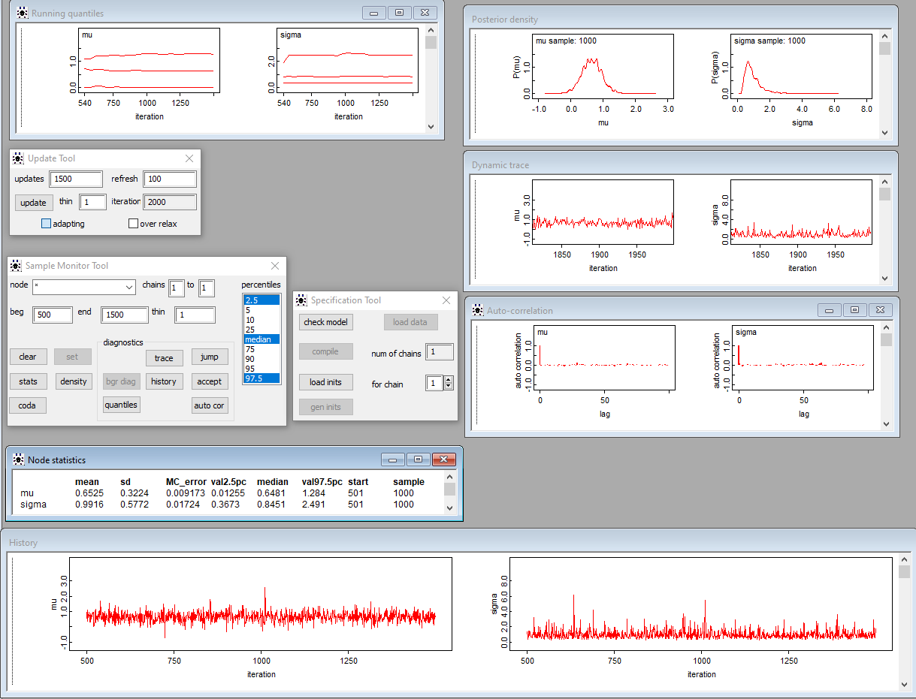After checking the model, loading the data, compiling and initializing it we obtain the following results (after discarding the 500 initial iterations which correspond to the burn-in period):

**Εικόνα που περιέχει κείμενο

Περιγραφή που δημιουργήθηκε αυτόματα**Let us check the normal model in RStudio (in order to get a better picture) as well:

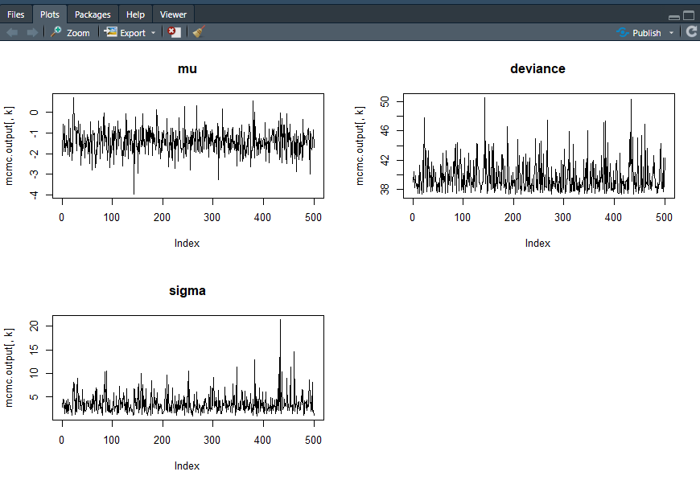We observe that there are the same posterior summaries as in OpenBUGS! Let us have a look on the trace plots in RStudio:

All values are within a zone without strong periodicities and especially tendecies, so we can assume convergence!

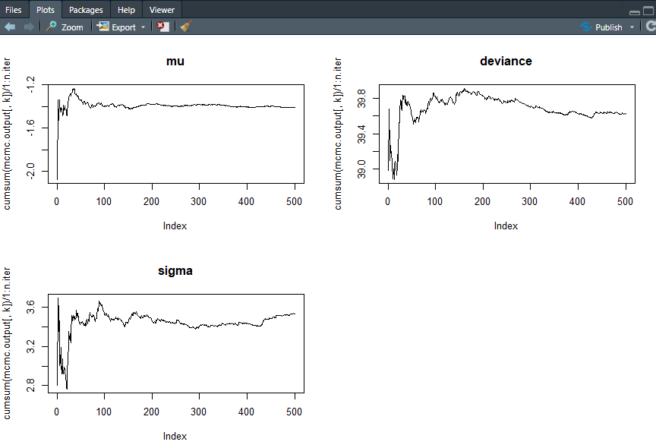Using CODA we can obtain the following Ergodic Mean Plots in RStudio:

Stabilized ergodic means, thus it's an indication of the convergence of the algorithm (it seems to have converged after about 150 iterations).

Last but not least, as regards the autocorrelation plots:

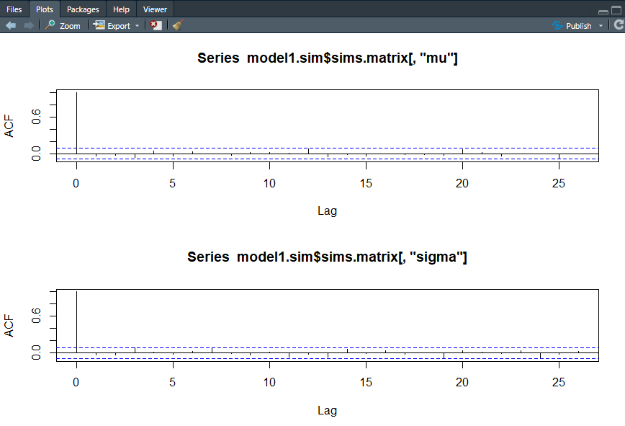We can observe that there are not any significant autocorrelations, thus there is no need for thinning!

To sum up we have tried 4 different type of models. In order to choose the one that fits our data the best we have to take into consideration the DIC values. DIC (Deviance Information Criterion) is a measure of model comparison and adequacy. It is equivalent to AIC for simple models. Smaller DIC values indicate better fitting models. DIC is comparable with models using the same data (just like our case). We observe that **the exponential model** has the smaller DIC value (13.2) so it’s the one we would pick to better fit our data!