FUNDAMENTAL PROGRAMMING TECHNIQUES
ASSIGNMENT 4
RESTAURANT MANAGEMENT SYSTEM

By Mihali Vlad
Group: 30424

Content
1. The objective of this assignment 2
2. Analysis of the problem 3
3. Design 4
4. Implementation 5
5. Results 14
6. Conclusions 15
7. References 16

1. The objective of this assignment
The amin objective is to implement a restaurant management system. The system is having three types of users: administrator, waiter and chef. The administrator can add, delete and modify existing products from the menu. The waiter can create a new order for a table, add elements from the menu, and compute the bill for an order. The chef is notified each time it must cook food that is ordered through a waiter.
The secondary objectives are:
- - implement the classes from the class diagram;
- - Define the interface IRestaurantProcessing;
- - design and implement the classes for MenuItem using Composite Design Pattern;
- - design and implement the class Restaurant using Design by Contract method;
- -GUI implementation;
- - Observe for chef;
- - Serialization for Restaurant;
- - system testing;

Parsing input data is done by extracting strings from file which is given as first command-line argument and convert into processable data. This are than by the class ParseInput.
This are inputs data read from a text file for the application:
- Number of clients (numberOfClients);
- Number of queues (numberOfQueues);
- Simulation interval (simulationInterval);
- Minimum and maximum arrival time (minArrivalTime and maxArrivalTime);
- Minimum and maximum service time (minServiceTime and maxServiceTime);

Define the interface IRestaurantProcessing containing the main operations that can be executed by the waiter/administrator, as follows:
• Administrator: create new menu item, delete menu item, edit menu item
• Waiter: create new order; compute price for an order; generate bill in .txt format.

Define and implement the classes from the class diagram shown above:
• Use the Composite Design Pattern for defining the classes MenuItem, BaseProduct and CompositeProduct
• Use the Observer Design Pattern to notify the chef each time a new order containing a composite product is added.

Implement the class Restaurant using a predefined JCF collection that is based on a hashtable data structure. The hashtable key will be generated based on the class Order, which can have associated several MenuItems. Use JTable to display Restaurant related information.
• Define a structure of type Map> for storing the order related information in the Restaurant class. The key of the Map will be formed of objects of type Order, for which the hashCode() method will be overwritten to compute the hash value within the Map from the attributes of the Order (OrderID, date, etc.).
• Define an appropriate collection consisting of MenuItem objects to store the menu of the restaurant.
• Define a method of type “well formed” for the class Restaurant.
• Implement the class Restaurant using Design by Contract method (involving pre, post conditions, invariants, and assertions).

2. Analysis of the problem
Use case of the application^{[1]}:
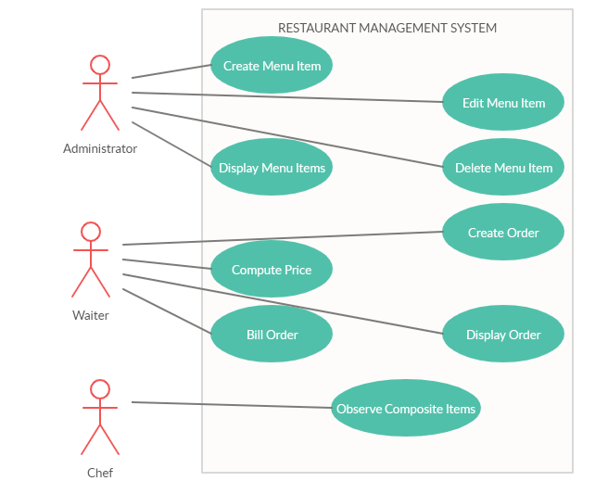 System: queue simulation (application)
3 actors: administrator, waiter, chef
Use case is a tool to analyze and divide the problem in small pieces easy to resolve. The main success scenario is the user provide a valid input and the application runs properly and the user can see the evolution of the restaurant management system. The alternative (failure) scenario is when the user provides an invalid data and an error message will be displayed in error dialog.

When talking about the input in the restaurant management system, there are 2 situations, being the waiter or the administrator. As the administrator he/ she should create menu items, simple ones or composite one.
For base item the input is the name of the item and the price and for a composite one just the name of the item and from combo box will be able to choose from the already existing items and build a composite one. Administrator can also delete or edit menu items in the same manner and also view the menu. When deleting an item, if the item is another item it will not be deleted, but you can update the price for all item that contain the choosing item.
The waiter should introduce the date of the order, the table; should choose item from the menu and add items from the menu to the client’s order.
When the waiter finishes to add all the products, the chef is instantly notified if a composite item need to be done and the waiter can view all the orders in a table, this is just to visualize all the existing orders. The waiter can also compute price and creating bills in TXT format.
3. Design
Class diagram^{[1]}:
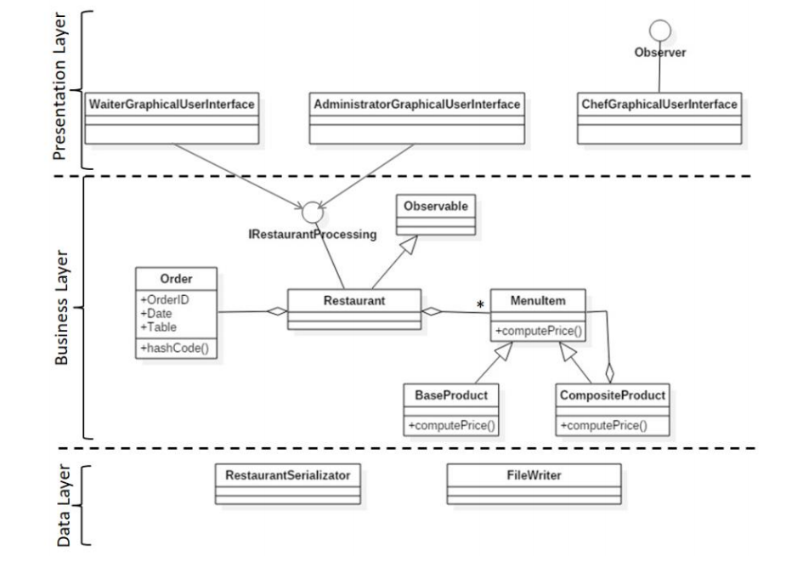
In my design I used 3 packages (tier architecture):
The application is split in different layers. Each layer has a special purpose and calls functions of the layers below it:
- Presentation Layer - contains the classes defining the user interface (AdministratorGUI, WaiterGUI, ChefGUI)
- Business Layer – contains the classes that encapsulate the application logic (MenuItem (BaseProduct, CompositeProduct), Order, Restaurant)
- Data Access Layer – contains the classes that stores, saves data (BillFileWriter, RestaurantSerializator)
- Main – contains the entry point into application (Main) ^{[2]}

Encapsulation is a mechanism of wrapping the variables and code acting on the methods together as a single unit. In encapsulation, the variables of a class will be hidden from other classes and can be accessed only through the methods of their current class. Therefore, it is also known as data hiding. ^{[3]}
The observer pattern is a software design pattern in which an object (restaurant), called the subject, maintains a list of its dependents, called observers (chef), and notifies them automatically of any state changes, usually by calling one of their methods (if an composite item is added).
Design by contract is to define formal, precise and verifiable interface specifications for software components, which extend the ordinary definition of abstract data types with preconditions, postconditions and invariants (IRestaurantProcessing).
In software engineering, the composite pattern is a partitioning design pattern. The composite pattern describes a group of objects that are treated the same way as a single instance of the same type of object (MenuItem). The intent of a composite is to "compose" objects into tree structures to represent part-whole hierarchies (CompositeProduct). Implementing the composite pattern lets clients treat individual objects (BaseProduct) and compositions uniformly (CompositeProduct).
To obtain an object-oriented programming design, I used following principles: encapsulation, inheritance, polymorphism.
Data structures used:
Java HashMap (in restaurant to store orders and menu items for the order) is a hash table based implementation of Java’s Map interface. A Map, as you might know, is a collection of key-value pairs. It maps keys to values (Map<Order, ArrayList<MenuItem>>).
Following are few key points why I used HashMaps in Java:
A HashMap cannot contain duplicate keys.
Java HashMap allows null values and the null key.
HashMap is an unordered collection. It does not guarantee any specific order of the elements.
Java HashMap is not thread-safe. You must explicitly synchronize concurrent modifications to the HashMap.
ArrayList is used in restaurant management system to store dynamically sized collection of MenuItem objects and Orders objects. Contrary to Arrays that are fixed in size, an ArrayList grows its size automatically when new elements are added to it and are easy to use.
4. Implementation
  - businessLayer
    - BaseProduct
float computePrice()
String getBaseProducts()
String toString()
protected void update(MenuItem item) – is not used
Methods inherited from class MenuItem: getName, getPrice, isBase, setBase, setName, setPrice
    - CompositeProduct
ArrayList<MenuItem> composition
float computePrice()
String getBaseProducts()
String toString()
void update(MenuItem item)
Methods inherited from class MenuItem: getName, getPrice, isBase, setBase, setName, setPrice
    - MenuItem
public abstract class MenuItem extends java.lang.Object implements java.io.Serializable
private boolean isBase
private java.lang.String name
private float price
abstract float computePrice()
abstract java.lang.String getBaseProducts()
java.lang.String getName()
float getPrice()
boolean isBase()
void setBase(boolean base)
void setName(java.lang.String name)
void setPrice(float price)
abstract java.lang.String toString()
protected abstract void update(MenuItem item)
    - Order
public class Order extends java.lang.Object implements java.io.Serializable
private int id
private java.util.Date orderDate
private int table

boolean equals(java.lang.Object o)
int getId()
java.util.Date getOrderDate()
int getTable()
int hashCode()
void setId(int id)
void setOrderDate(java.util.Date orderDate)
void setTable(int table)
java.lang.String toString()
    - Restaurant
public class Restaurant extends java.util.Observable implements IRestaurantProcessing, java.io.Serializable
private java.util.ArrayList<MenuItem> menu
private java.util.Map<Order,java.util.ArrayList<MenuItem>> orders
void addMenuItem(MenuItem mi)
void addOrder(Order o, java.util.ArrayList<MenuItem> mi)
private static void checkGreter0(float o)
private static void checkGreter0(int o)
private static void checkNull(java.lang.Object o)
float computePrice(Order o)
void deleteMenuItem(MenuItem mi)
void editMenuItem(MenuItem miOld, MenuItem miNew)
Order findByID(int id)
MenuItem findByName(java.lang.String str)
void generateBill(Order o)
int generateOrderID()
java.util.ArrayList<MenuItem> getMenu()
java.util.Map<Order,java.util.ArrayList<MenuItem>> getOrders()
void setMenu(java.util.ArrayList<MenuItem> menu)
void setOrders(java.util.Map<Order,java.util.ArrayList<MenuItem>> orders)
    - IRestaurantProcessing
public interface IRestaurantProcessing
addMenuItem
void addMenuItem(MenuItem mi)
Parameters:
mi - the menu item you want to add
Precondition:
menu item != null
Postcondition:
new size menu = old size menu + 1
Invariant:
for checking null objects
editMenuItem
void editMenuItem(MenuItem miOld,
MenuItem miNew)
Parameters:
miOld - old menu item will be replace
miNew - new menu item will be add instead of old one
Precondition:
(old menu item != new menu item) != null
Postcondition:
the item is edited
Invariant:
for checking null objects
deleteMenuItem
void deleteMenuItem(MenuItem mi)
Parameters:
mi - the menu item you want to delete
Precondition:
menu item != null
Postcondition:
new size menu = old size menu - 1
Invariant:
for checking null objects
getMenu
java.util.ArrayList<MenuItem> getMenu()
Returns:
the menu of the restaurant
addOrder
void addOrder(Order o,
java.util.ArrayList<MenuItem> mi)
Parameters:
o - is the specs of the order you want to add
mi - is the list of the products connected to the order
Precondition:
order != null and menu items != null and order id greater than 0
Postcondition:
new size orders = old size orders + 1
Invariant:
for checking null objects, int greater than 0
computePrice
float computePrice(Order o)
Parameters:
o - is the order to compute the price of
Returns:
a float value that represents the price of the order
Precondition:
order != null and order id greater than 0
Postcondition:
price greater than 0
Invariant:
for checking null objects, int greater than 0
generateBill
void generateBill(Order o)
Parameters:
o - is the order to print the bill as .txt
Precondition:
order != null and order id greater than 0
Postcondition:
a txt file is generated
Invariant:
for checking null objects, int greater than 0
getOrders
java.util.Map<Order,java.util.ArrayList<MenuItem>> getOrders()
Returns:
the orders of the restaurant
findByName
MenuItem findByName(java.lang.String str)
findByID
Order findByID(int id)
generateOrderID
int generateOrderID()
  - dataLayer
    - BillFileWriter
public class BillFileWriter
void writeBill(Order o, java.util.ArrayList<MenuItem> mi, float price)
    - RestaurantSerializator
public class RestaurantSerializator
Restaurant deserialize(java.lang.String input)
void serialize(Restaurant r)
  - presentationLayer
    - BillFileWriter
    - RestaurantSerializator
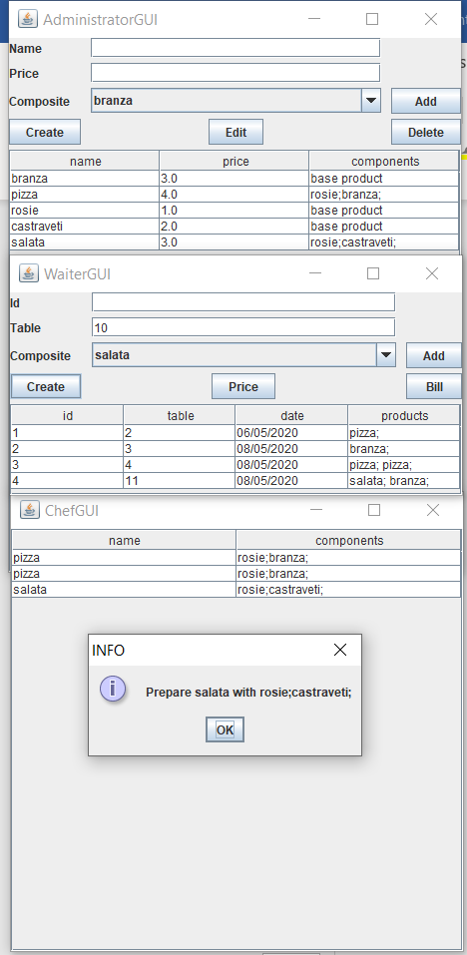
5. Results
5.1. System testing
System testing is a level of testing that validates the complete and fully integrated software product.
I tested on my own and analyses the response of main scenario and secondary scenarios.
Main scenario (success scenario):
- Introducing valid input;
- Verify the result by simulate your own next step and then checking the real simulation data;
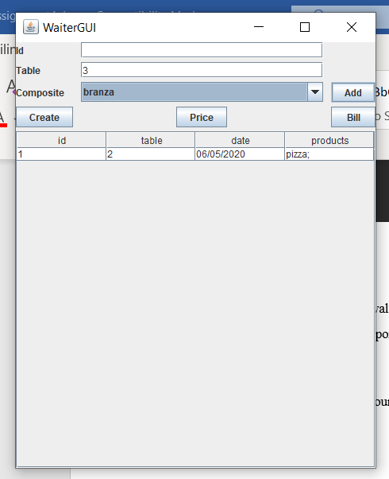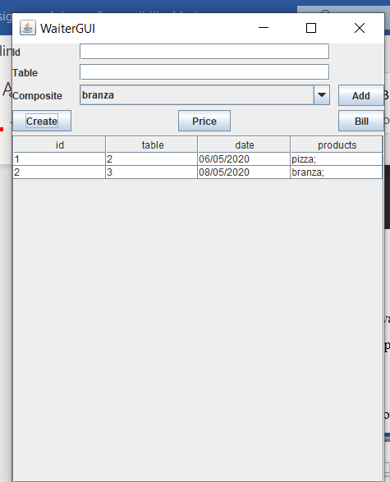
Failure scenario:
- Not a valid data;

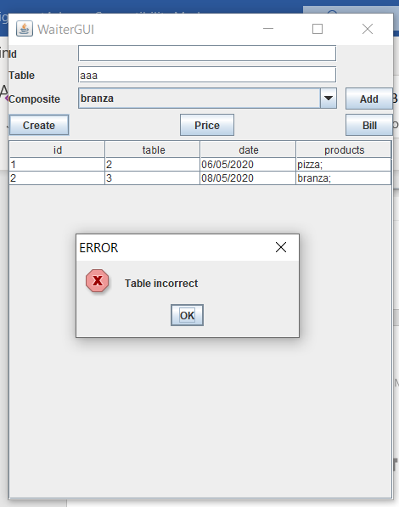

I tested all three GUI (administrator, waiter, chef) and verify multiple times the correctness of the application.
6. Conclusions
In conclusion, results of this paper work show fulfilling of the main objective and secondary goals. This application does simulate services for a restaurant. This assignment approached the following items: Object-oriented programming design; Java naming conventions ; Implement the class diagram from the homework specification. uses the appropriate data structures for saving the Orders and the MenuItems; Graphical interface: Window for Administrator operations: add new MenuItem, edit MenuItems, delete MenuItems, view all MenuItems in a table (JTable). Window for Waiter operations: add new Order, view all Orders in a table (JTable), compute bill for an Order; Use Composite Design Pattern for modelling the classes MenuItem, BaseProduct, CompositeProduct; Create bill in .txt format; Design by contract: preconditions and postconditions in the IRestaurantProcessing interface. Implement them in the Restaurant class using the assert instruction. Define an invariant for the class Restaurant; Window for Chef user: use Observer Design Pattern to notify each time a new Order is added; Save the information from the Restaurant class in a file (restaurant.ser) using serialization. Load the information when the application starts. Consequently, the application should permit to be run with the following command: java -jar PT2020_Group_LastName_FirstName_Assignment_4.jar restaurant.ser.^{[4]}
For future development of this application can be improved in following points: a graphical user interface with login and more users at the same time; notify the waiter when the chef is done with a product.

7. References
^{[1]} https://www.visual-paradigm.com
^{[2]} http://users.utcluj.ro/~cviorica/PT2020/
^{[3]} https://www.quora.com/What-is-encapsulation-in-Java
^{[4]} http://coned.utcluj.ro/~salomie/PT_Lic/4_Lab/Assignment_4/Assignment_4.pdf
^{[5]} http://www.tutorialspoint.com/java/java_serialization.htm
^{[6]} https://www.baeldung.com/java-serialization
^{[7]} https://www.geeksforgeeks.org/serialization-in-java/
^{[8]} https://docs.oracle.com/javase/8/docs/api/java/io/Serializable.html
^{[9]} http://javarevisited.blogspot.ro/2011/02/how-hashmap-works-in-java.html
^{[10]} http://docs.oracle.com/javase/8/docs/technotes/guides/language/assert.html
^{[11]} http://javarevisited.blogspot.ro/2012/01/what-is-assertion-in-java-java.html
^{[12]} http://stackoverflow.com/questions/11415160/how-to-enable-the-java-keywordassert-in-eclipse-program-wise
^{[13]} https://intellij-support.jetbrains.com/hc/en-us/community/posts/207014815-How-toenable-assert
^{[14]} https://docs.oracle.com/javase/7/docs/technotes/tools/windows/javadoc.html#tag

