**Semester project Summary**

Dynamic FC analysis on resting state fMRI data, healthy elderly effects of motor learning

Part of EconS project in the Hummel Lab

Author and code written by: Mihály Gayer, 2021.10.04

Supervised by Prof. Friedhelm Cristoph Hummel, worked directly on this project with Manon Chloé Durand-Ruel Phd candidate

**1, CONN Toolbox pre-processing** of the data based on the inputs from Manon and Julie Brancato. Denoising and preprocessing steps are confirmed by Dr. Chang Hyun, high pass filtering and window length parameters are finalised based on literature review cited in the May 2021 presentation and inputs from Dr. Preti (Zoom workshop with her on 2021.07.07).

**2, Conn project file for preprocessing the data:**

The preprocessing steps described in Julie Brancato’s master thesis helped the preparation of the data. The same CONN project file was used with modifications in the last, denoising step only.

jbrancato / Master project/  code / conn_project_all_subjects_s2_s3_stimulation_effect.mat

**3, Timeseries data is then imported to Matlab** for the analysis from:

jbrancato/MasterProject/Code/conn_project_all_subjects_s2_s3_stimulation_effect/results/preprocessing'

using this Matlab file:

/home/mgayer/**dfc_preparation.mat**

Then Time series is saved separately. In 4 different folders with names:

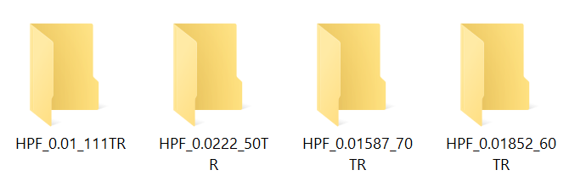

For the different window length different denoising parameters are used (Van de Ville and Bolton 2013, Preti et al 2017), and time series for Run 1 2 and 3 are stored separately with same name as illustrated below.

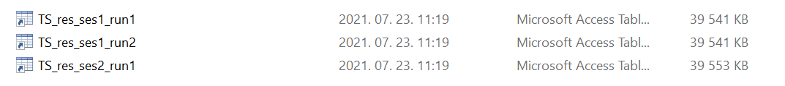

**4, The main analysis script** is dFC.mat (or dFC_09_30.mat depending on the date)

% 1. Load Time series data.

% - Run1 (Ses1-Run1)

% - Run2 (Ses1-Run2) and

% - Run3 (Ses2-Run1)

Import the time series from the chosen folder. Three runs of resting state fMRI is analysed.

Window length is specified in number of TRs. Run1 is before the experiment. Run 2 is after the motor task and nap. Run 3 (res-Ses2-Run1) is after Stimulation/Placebo and motor task. Time series data is with 0.9 TR resulting in 540 time points.

Load 264 ROI names from the file ROI_names.mat. Obtained from CONN Poweratlas (5mm). This is the only atlas used in this project.

Dimensions: 540 time points, 264 ROI and 37 subjects in total

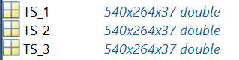

*Note: there exists the Run 4 and 5 from the next fMRI runs but not used in this analysis*

**5, Data transformation using the Matlab script (dFC.mat)**

1 FC symmetric matrix has dimensions 264x264 -> **FC vector** form has length **34716** (using FC(mask_ut) converts the matrix into vector form with ones in the upper triangular, zeros elsewhere)

**Number of layers** mean number of sliding windows with the chosen window length, window step and number of time points. With 60 TR window, step = 5 TR -> **numLayers = 97**

For one subject all the sliding window FC aggregated in series of vectors:



For all subjects



For all subjects horizontally aggregated



Same fashion for TS2 and TS3.

**aggregate_dFCw_2D:** horizontally put together TS1_dFCw_2D and TS2_dFCw_2D

(or run 1 and 3, specify by uncommenting)



Note: this is the input data for the clustering algorithm.

FCV calculations:

**FCs_run1** has dimensions:



Same for **FCs_run2, FCs_run3q**