mtcars

Autogenerated data summary from dataMaid

2024-05-29 09:05:55.33363

# Data report overview

The dataset examined has the following dimensions:

| Feature | Result |
| --- | --- |
| Number of observations | 32 |
| Number of variables | 11 |

### Checks performed

The following variable checks were performed, depending on the data type of each variable:

|  | character | factor | labelled | haven labelled | numeric | integer | logical | Date |
| --- | --- | --- | --- | --- | --- | --- | --- | --- |
| Identify miscoded missing values | × | × | × | × | × | × |  | × |
| Identify prefixed and suffixed whitespace | × | × | × | × |  |  |  |  |
| Identify levels with < 6 obs. | × | × | × | × |  |  |  |  |
| Identify case issues | × | × | × | × |  |  |  |  |
| Identify misclassified numeric or integer variables | × | × | × | × |  |  |  |  |
| Identify outliers |  |  |  |  | × | × |  | × |

Please note that all numerical values in the following have been rounded to 2 decimals.

# Summary table

|  | Variable class | # unique values | Missing observations | Any problems? |
| --- | --- | --- | --- | --- |
| mpg | numeric | 25 | 0.00 % |  |
| cyl | numeric | 3 | 0.00 % | × |
| disp | numeric | 27 | 0.00 % |  |
| hp | numeric | 22 | 0.00 % | × |
| drat | numeric | 22 | 0.00 % | × |
| wt | numeric | 29 | 0.00 % | × |
| qsec | numeric | 30 | 0.00 % | × |
| vs | numeric | 2 | 0.00 % |  |
| am | numeric | 2 | 0.00 % |  |
| gear | numeric | 3 | 0.00 % | × |
| carb | numeric | 6 | 0.00 % | × |

# Variable list

## mpg

| Feature | Result |
| --- | --- |
| Variable type | numeric |
| Number of missing obs. | 0 (0 %) |
| Number of unique values | 25 |
| Median | 19.2 |
| 1st and 3rd quartiles | 15.43; 22.8 |
| Min. and max. | 10.4; 33.9 |

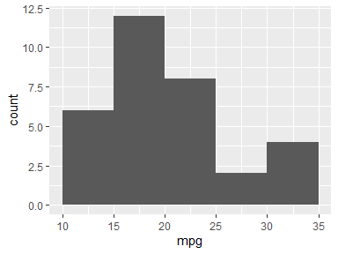

## cyl

* Note that this variable is treated as a factor variable below, as it only takes a few unique values.

| Feature | Result |
| --- | --- |
| Variable type | numeric |
| Number of missing obs. | 0 (0 %) |
| Number of unique values | 3 |
| Mode | “8” |
| Reference category | 4 |

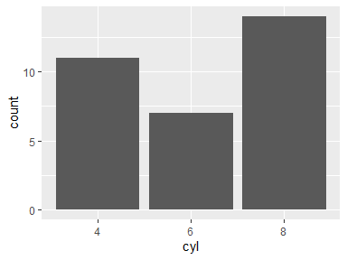

* The following suspected missing value codes enter as regular values: "8".

## disp

| Feature | Result |
| --- | --- |
| Variable type | numeric |
| Number of missing obs. | 0 (0 %) |
| Number of unique values | 27 |
| Median | 196.3 |
| 1st and 3rd quartiles | 120.83; 326 |
| Min. and max. | 71.1; 472 |

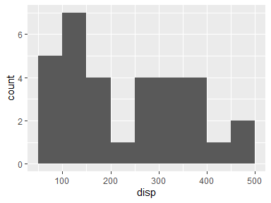

## hp

| Feature | Result |
| --- | --- |
| Variable type | numeric |
| Number of missing obs. | 0 (0 %) |
| Number of unique values | 22 |
| Median | 123 |
| 1st and 3rd quartiles | 96.5; 180 |
| Min. and max. | 52; 335 |

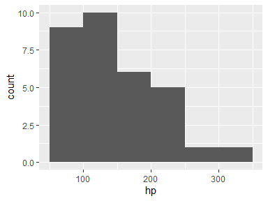

* Note that the following possible outlier values were detected: "52", "62", "65", "66".

## drat

| Feature | Result |
| --- | --- |
| Variable type | numeric |
| Number of missing obs. | 0 (0 %) |
| Number of unique values | 22 |
| Median | 3.7 |
| 1st and 3rd quartiles | 3.08; 3.92 |
| Min. and max. | 2.76; 4.93 |

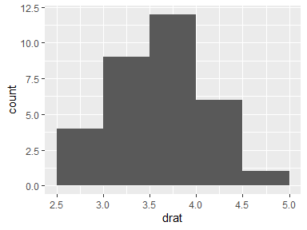

* Note that the following possible outlier values were detected: "4.43", "4.93".

## wt

| Feature | Result |
| --- | --- |
| Variable type | numeric |
| Number of missing obs. | 0 (0 %) |
| Number of unique values | 29 |
| Median | 3.33 |
| 1st and 3rd quartiles | 2.58; 3.61 |
| Min. and max. | 1.51; 5.42 |

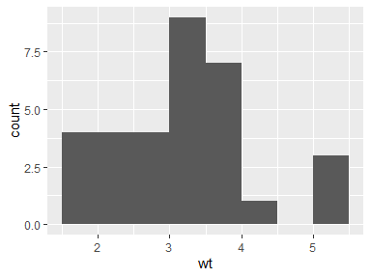

* Note that the following possible outlier values were detected: "5.25", "5.34", "5.42".

## qsec

| Feature | Result |
| --- | --- |
| Variable type | numeric |
| Number of missing obs. | 0 (0 %) |
| Number of unique values | 30 |
| Median | 17.71 |
| 1st and 3rd quartiles | 16.89; 18.9 |
| Min. and max. | 14.5; 22.9 |

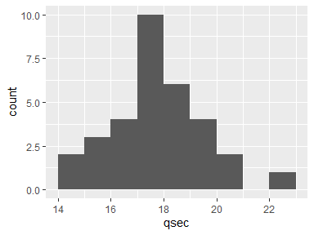

* Note that the following possible outlier values were detected: "14.5", "14.6", "22.9".

## vs

* Note that this variable is treated as a factor variable below, as it only takes a few unique values.

| Feature | Result |
| --- | --- |
| Variable type | numeric |
| Number of missing obs. | 0 (0 %) |
| Number of unique values | 2 |
| Mode | “0” |
| Reference category | 0 |

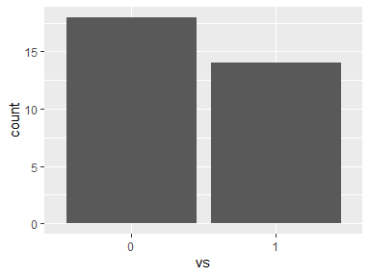

## am

* Note that this variable is treated as a factor variable below, as it only takes a few unique values.

| Feature | Result |
| --- | --- |
| Variable type | numeric |
| Number of missing obs. | 0 (0 %) |
| Number of unique values | 2 |
| Mode | “0” |
| Reference category | 0 |

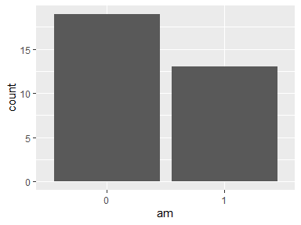

## gear

* Note that this variable is treated as a factor variable below, as it only takes a few unique values.

| Feature | Result |
| --- | --- |
| Variable type | numeric |
| Number of missing obs. | 0 (0 %) |
| Number of unique values | 3 |
| Mode | “3” |
| Reference category | 3 |

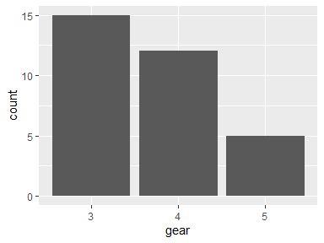

* Note that the following levels have at most five observations: "5".

## carb

| Feature | Result |
| --- | --- |
| Variable type | numeric |
| Number of missing obs. | 0 (0 %) |
| Number of unique values | 6 |
| Median | 2 |
| 1st and 3rd quartiles | 2; 4 |
| Min. and max. | 1; 8 |

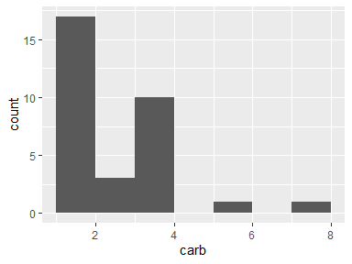

* The following suspected missing value codes enter as regular values: "8".
* Note that the following possible outlier values were detected: "1".

Report generation information:

* Created by: Miha Prajs (username: mihap).
* Report creation time: Wed May 29 2024 09:05:56
* Report was run from directory: C:/Users/mihap/Code/famnit23-podatkovno/class
* dataMaid v1.4.1 [Pkg: 2021-10-08 from CRAN (R 4.4.0)]
* R version 4.4.0 (2024-04-24 ucrt).
* Platform: x86_64-w64-mingw32/x64(Europe/Ljubljana).
* Function call: makeDataReport(data = mtcars)