Задание 1

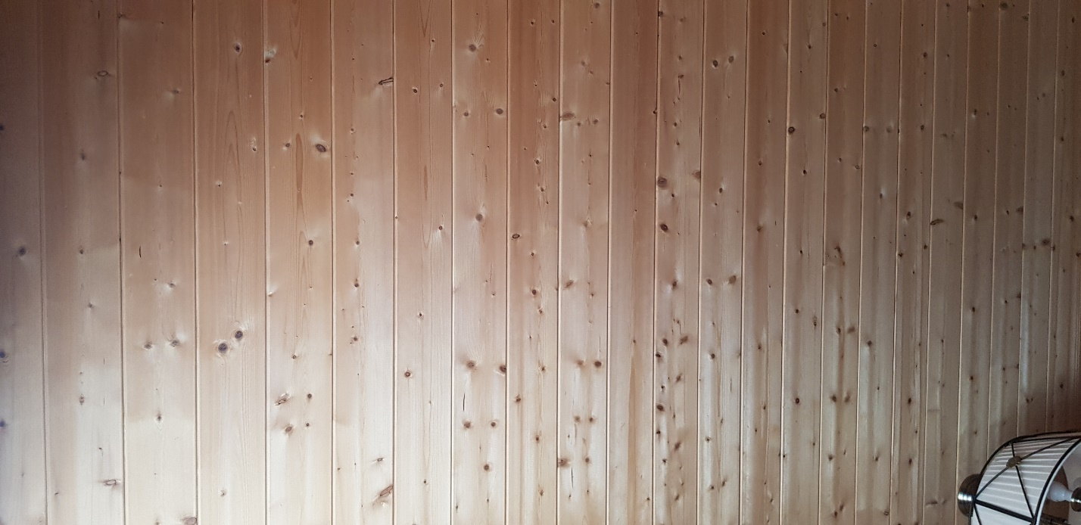

Exif Makernote:

Make samsung

Model SM-G955F

Orientation Right side, top (Rotate 90 CW)

X Resolution 72 dots per inches

Y Resolution 72 dots per inches

Resolution Unit Inches

Software G955FXXSBDTJ1

Date/Time 2020:11:17 13:43:27

YCbCr Positioning Center of pixel array

Exposure Time 1/60 sec

F-Number F 1,7

Exposure Program Program normal

ISO Speed Ratings 160

Exif Version 2.20

Date/Time Original 2020:11:17 13:43:27

Date/Time Digitized 2020:11:17 13:43:27

Components Configuration YCbCr

Shutter Speed Value 1/60 sec

Aperture Value F 1,7

Brightness Value 1,75

Exposure Bias Value 0

Max Aperture Value F 1,7

Metering Mode Center weighted average

Flash Flash did not fire

Focal Length 4,2 mm

User Comment

Sub-Sec Time 0367

Sub-Sec Time Original 0367

Sub-Sec Time Digitized 0367

FlashPix Version 1.00

Color Space sRGB

Exif Image Width 4032 pixels

Exif Image Height 1960 pixels

Scene Type Directly photographed image

Exposure Mode Auto exposure

White balance mode Auto white balance

Digital Zoom Ratio Digital zoom not used

Focal Length in 35mm Film 26 mm

Scene Capture Type Standard

Contrast None

Saturation None

Sharpness None

Image Unique ID F12LLJA00SM F12LLKL01GM

Thumbnail Image Width 496 pixels

Thumbnail Image Height 240 pixels

Compression JPEG (old-style)

Thumbnail Offset 1286 bytes

Thumbnail Length 10716 bytes

Thumbnail Data [10716 bytes of thumbnail data]

ЗАДАНИЕ 2

Большая часть файлов является HTML

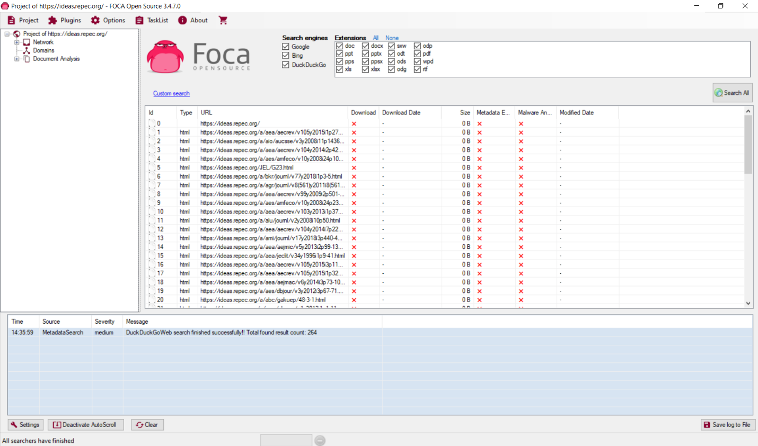

ЗАДАНИЕ 3

