THE LEGEND OF

NDABAGA

ARNOLD AGABA **DADYMINDS**

Copyright © 2020 ARNOLD AGABA

All rights reserved

No part of this book may be reproduced, or stored in a retrieval system, or transmitted in any form or by any means, electronic, mechanical, photocopying, recording, or otherwise, without express written permission of the author or publisher.

ISBN-13: 9798693992719 ISBN-10: 8693992719

Contributions by: ANATH LEE WALES

Publisher: DADYMINDS

Contact: dadyminds@gmail.com

Kigali-Rwanda

Dedicated to all young women around the world.

"When a child washes her hands well she can eat with kings" CHINUA ACHEBE

## CONTENTS

Title Page

Copyright

Dedication

Epigraph

Introduction

1

T HE LEGEND OF NDABAGA: RWANDA’S FAMOUS FEMALE 1 WARRIOR

About The Author 11

Untitled 13

Untitled 15

Untitled 17

Untitled 19

## INTRODUCTION

This book is about Ndabaga, a Rwandan woman who became a hero back in history by saving her father a the palace army and later became a queen! This book is dedicated to inspire condence and encourage creativity among young women and little girls. This book indicates that it is possible for a woman or a girl to work-hard and achieve success or even become a hero.

VII

THE LEGEND OF

NDABAGA: RWANDA’S

FAMOUS FEMALE

WARRIOR

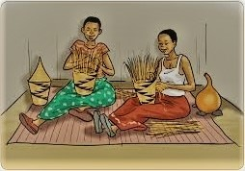

1

ARNOLD AGABA nce upon a time, very far from the land of a thousand hills, there lived a girl called Ndabaga and her Mother.

O

Ndabaga never saw her father since her childhood and she could always ask her mother,” mom, where is my father, why doesn’t he come home?” The mother could reply,” your father has gone to serve the kingdom army and he can’t come back because he doesn’t have a son to replace him.” Ndabaga asked again,” so does that I won’t be able to see my father because he doesn’t have a son to replace him?” Then her mother told her that,” my daughter that’s the truth, according to our culture, every man is supposed to serve the kingdom army and he can only be replaced by his son!”

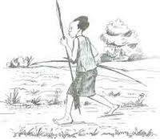

2

THE LEGEND OF NDABAGA fter asking her mother and knowing how the situation about her father was, Ndabaga made a plan to go to see her father and replace him in the kingdom army!

A

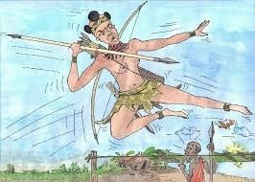

T

herefore, without telling anyone of her plans, Ndabaga started to train herself as a warrior! She would take cows to graze in the elds, she learned how to use a spear, she learned how to us a bow and arrow, she learned how to jump and she trained herself to run rst. Moreover, after a short time, Ndabaga was better than the boys at her age and she a skilled warrior ready to serve the kingdom.

3

ARNOLD AGABA

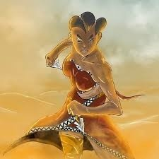

A

fter mastering all the manhood activities, she went to the kingdom and met her father, she talked to each other and Ndabaga asked her father to return to the family while she could replace him at the palace.

4

THE LEGEND OF NDABAGA

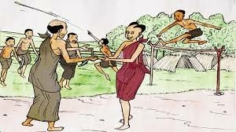

H

er father accepted and left his daughter; Ndabaga to continue their family legacy as servants of the king.

Meanwhile, Ndabaga excelled at war and all the war games that warriors participated in and this made the king to include her among his close bodyguards. However, the other warriors were not happy with her success and planed bring her down.

5

ARNOLD AGABA

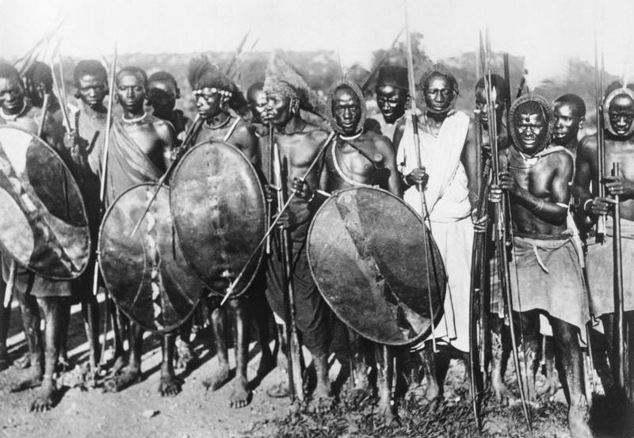

O

ther servants of the king grew suspicious of the young girl because whenever they would take a bath, she would

nd excuses not to shower with the other warriors so they told the king that she was really a girl. Then the king was surprised, he called Ndabaga and asked her,” are a boy or a girl?” Ndabaga answered in a soft and a fearful voice,” O mighty king, I had never seen my father ever since I was young, and that was because he left to ght for you, and he couldn’t come home for a long time because he had no son. Your majesty, I came at the palace to replace my father who was old and tired but had no son to replace him.” She explained to the king.

6

THE LEGEND OF NDABAGA

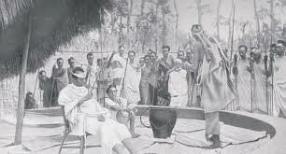

T

he King immediately understood her and he immediately revoked the law that required men to serve the king until they got old.The king loved Ndabaga and decided to

marry her!

7

ARNOLD AGABA

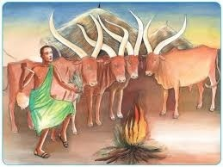

T hen the king called Ndabaga’s father and honored him.

8

THE LEGEND OF NDABAGA

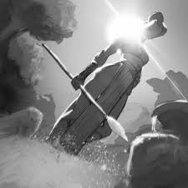

T

hat is how Ndabaga became the queen of the Great Kingdom of Rwanda.

9

# ABOUT THE AUTHOR

### Arnold Agaba

ARNOLD AGABA is a Rwandan Author, He is a talented jounalist and communications specialist holding a bachelors degree in economics. He is a graduate from Kigali Independent University and He is currently working at the Bank Of Kigali.

# UNTITLED

13

# UNTITLED

15

UNTITLED

17

UNTITLED

19

## Proof