Internship Report
Of
SAIL IT Helpdesk System
Submitted To
School of Computer Science and Engineering
IILM University, Greater Noida, U.P.
In partial fulfilment of the requirement of degree of
B.Tech CSE (AI/ML)

By
Roll Number of Student: CS-2341238
Name of Student: MIHIT NANDA
Program & Semester: 7th Semester, Section 4CSE2
Organization: Steel Authority of India Limited (SAIL)
Batch:
2026-27

1. Candidate's Declaration
I, MIHIT NANDA, do hereby declare that the internship report titled "SAIL IT Helpdesk System" has been completed by me to fulfil the requirement for the award of the degree of Bachelor of Technology in Computer Science and Engineering. All the references have been quoted and I have not taken as such any material from any other source. I affirm that this report is my own work and has not been submitted to any other institute for any degree/diploma requirement, and I shall be solely responsible for any kind of copyright violation in this regard.
This report documents the design, development, and deployment of the SAIL IT Helpdesk System carried out during a 6 Weeks (1st June 2026 – 13th July 2026) internship at Steel Authority of India Limited (SAIL), under the guidance of Mrs. Rajni Kapoor.
Signature: _______________________
Student Name: MIHIT NANDA
Roll No.: CS-2341238

2. Acknowledgement
I would like to express my sincere gratitude to Steel Authority of India Limited (SAIL) for providing me the opportunity to undertake this internship in the IT Department. I am thankful to my industry mentor, Mrs. Rajni Kapoor, and the IT team for their continuous guidance, technical support, and valuable feedback throughout the course of this project.
I am using this opportunity to express my gratitude to everyone who supported me throughout the internship program. I am thankful for their aspiring guidance, invaluably constructive criticism, and friendly advice during this work.
I also extend my gratitude to the faculty of IILM University, Greater Noida, for their academic support and for facilitating this internship as part of my Computer Science and Engineering curriculum. I express my gratitude to my parents for their blessings.
Signature: _______________________
Student Name: MIHIT NANDA
Roll No.: CS-2341238

3. Internship Completion Certificate
[Insert the scanned copy of the Internship Completion Certificate issued by Steel Authority of India Limited (SAIL) on this page. A copy of the certificate along with the communication mail proof is also attached in Section 4.10 as required by the report format.]

Table of Contents
1. Candidate's Declaration i
2. Acknowledgement ii
3. Internship Completion Certificate iii
4. Project Description 1
4.1 Introduction 1
4.2 Organization Profile 1
4.3 Problem Statement 2
4.4 Project Objectives 2
4.5 Scope of the Project 3
4.6 Technologies and Tools Used 3
4.7 System Architecture 4
4.8 Methodology 6
4.9 Expected Outcomes 9
4.10 Certificates and Communication Proof 10
5. Bibliography/References 11

4. Project Description
4.1 Introduction
This report documents the design, development, and deployment of the SAIL IT Helpdesk System — an enterprise-grade IT ticket management platform built for Steel Authority of India Limited (SAIL) during a 6 Weeks (1st June 2026 – 13th July 2026) internship period. The system was developed to replace ad-hoc, manual IT support request handling with a structured, auditable, and SLA-driven ticketing workflow accessible to employees, IT agents, and administrators across the organization.
The application follows a three-tier architecture comprising a React.js single-page frontend, a Node.js/Express REST API backend, and an Oracle Database persistence layer. Core capabilities delivered include role-based access control across four user roles, automated ticket reference generation, SLA-based due-date computation, a full audit trail of ticket history, file attachment support, email notifications at each stage of the ticket lifecycle, and an administrative reporting dashboard.
4.2 Organization Profile
Steel Authority of India Limited (SAIL) is one of India's largest state-owned steel producers, operating multiple integrated steel plants and subsidiary units across the country. As with any large industrial organization, SAIL's day-to-day operations depend heavily on internal IT infrastructure, and a reliable mechanism for employees to raise, track, and resolve IT-related issues is essential to maintaining operational continuity.
4.3 Problem Statement
Prior to this project, IT support requests within the organization were handled through informal channels such as phone calls and emails, with no centralized system to track ticket status, enforce service-level agreements (SLAs), or maintain an audit trail of actions taken. This resulted in delayed resolutions, lack of accountability, and no visibility into IT support performance for management.
4.4 Project Objectives
- To design and develop a centralized, web-based IT helpdesk/ticketing system for SAIL.
- To implement a secure, role-based access control model distinguishing Employees, Agents, Admins, and Super Admins.
- To automate SLA tracking through priority-based due-date computation.
- To provide complete traceability of every ticket through an audit trail and ticket history log.
- To integrate automated email notifications to keep stakeholders informed at every stage of a ticket's lifecycle.
- To build an administrative reporting and analytics dashboard for IT management oversight.
4.5 Scope of the Project
The scope of the internship covered the complete software development lifecycle for the helpdesk platform — from requirement gathering and database schema design, through backend API development and frontend interface implementation, to security hardening, testing with seeded demo data, and preparation for production deployment. The project was scoped as a functional, demonstrable end-to-end system rather than a partial proof of concept, so that it could realistically be evaluated against SAIL's day-to-day IT support workflow.
4.6 Technologies and Tools Used
Layer | Technology
Frontend | React 18, Tailwind CSS, Recharts, React Router v6
Backend | Node.js 18+, Express 4, JWT, Multer
Database | Oracle Database 19c / 21c / XE
ORM / Driver | oracledb (official Node.js Oracle driver)
Email | Nodemailer (SMTP)
Authentication | JWT + bcryptjs, rate limiting, account lockout
Logging | Winston
Table 4.6.1 — Technology stack used in the SAIL IT Helpdesk System
4.7 System Architecture
The application is organized as a modular three-tier system, cleanly separating presentation, business logic, and data persistence. This separation allows the frontend and backend to be developed, tested, and deployed independently. The frontend (served on port 3000 in development) communicates with the backend REST API (served on port 5000) over HTTPS/JSON, and the backend maintains a connection pool to the Oracle database for all persistent operations.
Requests from the browser first pass through the frontend's Axios client, which attaches the user's JWT to every call. On the server, each request flows through a chain of Express middleware — first Helmet's security headers, then rate limiting, then JWT verification and role extraction, then route-specific validation — before it ever reaches business logic.
4.7.1 Database Design
The system uses Oracle Database as its persistence layer, with a normalized relational schema designed around ten core tables covering organizational structure, ticket lifecycle, and system auditing, including DEPARTMENTS, CATEGORIES, PRIORITIES, USERS, TICKETS, TICKET_REPLIES, TICKET_ATTACHMENTS, TICKET_HISTORY, NOTIFICATIONS, and AUDIT_LOGS. TICKET_REF (e.g., SAIL-1000) is auto-generated via an Oracle trigger, and DUE_DATE is auto-computed at insert time from the priority-level SLA.
4.7.2 Role-Based Access Control (RBAC)
Access to system functionality is governed by a four-tier role hierarchy — Employee, Agent, Admin, and Super Admin — enforced at both the API route level and the business-logic level.
Feature | Employee | Agent | Admin | Super Admin
View own tickets | Yes | Yes | Yes | Yes
View all tickets | No | Yes | Yes | Yes
Create tickets | Yes | Yes | Yes | Yes
Update ticket status | No | Yes | Yes | Yes
Assign tickets | No | No | Yes | Yes
User management | No | No | Yes | Yes
View audit logs | No | No | No | Yes
Table 4.7.1 — Role-based access control matrix
4.7.3 Ticket Lifecycle and Email Notification Workflow
- Ticket Created → the creator receives a confirmation email containing the ticket reference number.
- Admins/Agents receive an in-app notification of the new ticket.
- Agent replies → the creator receives a reply notification.
- Status changes (e.g., moved to IN_PROGRESS) → the creator is notified of the update.
- Ticket RESOLVED → the creator receives a resolution email along with a feedback prompt.
- Creator submits a satisfaction rating (1–5 stars) to close the feedback loop.
4.7.4 Backend and Frontend Implementation
The backend is a modular Express.js application separating configuration, middleware, routing, and utility concerns, exposing REST endpoints under /api/auth, /api/tickets, /api/admin, and /api/lookup. The ticket-listing endpoint supports pagination and filtering via query parameters (page, limit, status, priority_id, category, department, search, sort, order).
The frontend was built using React 18 with functional components and React Router v6 for client-side routing, styled with Tailwind CSS for a consistent, responsive design system, and Recharts for data visualization in the administrative reporting dashboard. An AuthContext provider manages authentication state globally, while an Axios client with interceptors handles JWT attachment and centralized error handling.
4.7.5 System Screenshots
The login screen is the single entry point for all user roles — Employee, Agent, Admin, and Super Admin — and authenticates users against their SAIL Employee ID and password.
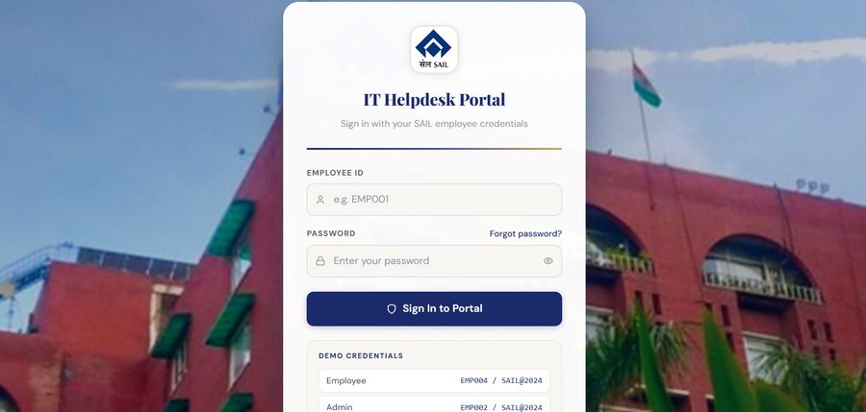
Figure 4.7.1 — SAIL IT Helpdesk Portal login screen
The Admin Dashboard serves as the operational command centre for the IT support team, organized around a navigation sidebar, an SLA-breach alert banner, and live KPI widgets showing Total, Open, In Progress, and Resolved ticket counts.
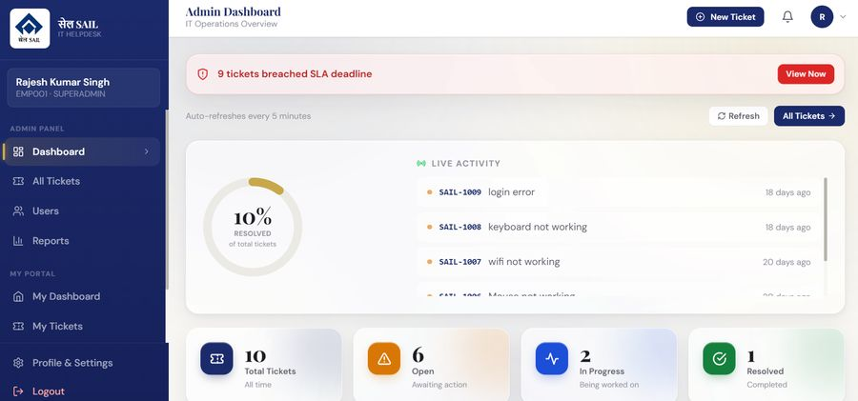
Figure 4.7.2 — Admin Dashboard showing SLA alerts, live activity feed, and ticket KPIs
4.7.6 Security Implementation
- JWT-based authentication with an 8-hour token expiry.
- Account lockout after 5 consecutive failed login attempts, with a 30-minute cool-down period.
- API rate limiting — 100 requests per 15 minutes globally, tightened to 20 requests per 15 minutes on the login endpoint.
- Helmet.js for secure HTTP response headers; password hashing via bcryptjs with 10 salt rounds.
- Server-side input validation using express-validator; file upload restrictions with MIME-type whitelist and 10 MB limit.
- Role-based access control enforced at both API route and business-logic layers.
- Comprehensive audit logging of all significant actions, persisted to the Oracle AUDIT_LOGS table.
4.8 Methodology
Development followed an iterative build-and-test methodology: requirement gathering and schema design, followed by backend API development, frontend implementation, security hardening, and finally deployment preparation. Each module was tested against seeded demo data covering every role before integration.
4.8.1 Testing and Demo Credentials
Role | Employee ID
Super Admin | EMP001
Admin | EMP002
IT Agent | EMP003
Employee | EMP004
Employee | EMP005
Table 4.8.1 — Seeded demo accounts by role (passwords withheld in this report for security)
4.8.2 Deployment
The system supports both traditional and containerized deployment. For production deployment, the backend runs under PM2 for process management and automatic restarts, while the built frontend bundle is served through Nginx or Apache with SSL/TLS termination. A Docker Compose configuration was also designed, provisioning separate containers for the backend, frontend, and an Oracle XE database instance.
4.8.3 Challenges Faced
- Configuring the Oracle Instant Client correctly across different operating systems for the oracledb Node.js driver.
- Designing an SLA due-date computation that correctly accounted for priority level at the point of ticket creation.
- Ensuring the ticket history/audit trail captured every field-level change without introducing significant write overhead.
- Coordinating the multi-stage email notification workflow so notifications remained consistent with the ticket's true status.
- Implementing rate limiting and account lockout in a way that balanced security against usability.
4.9 Expected Outcomes
This internship provided hands-on, end-to-end experience in building a production-style enterprise application, spanning full-stack development, authentication/authorization and RBAC, relational database design with trigger-based automation, secure coding practices, REST API design, and deployment practices including PM2, reverse proxying, and Docker containerization.
4.9.1 Future Scope
- Mobile application — a companion Android/iOS app or PWA build for field and plant-floor employees.
- AI-assisted triage — a classification model to auto-suggest category and priority at ticket creation.
- Chatbot / self-service layer for resolving common, repetitive issues without an agent.
- Advanced analytics extending the Admin Reports module with trend and agent-performance analysis.
- Integration with SAIL's Active Directory/LDAP for single sign-on and asset-management linkage.
- Multi-language support for SAIL's pan-India workforce.
- Load and performance testing at scale before organization-wide deployment.
4.9.2 Conclusion
The SAIL IT Helpdesk System successfully addresses the core problem of unstructured, untracked IT support requests within the organization by providing a centralized, secure, and auditable ticketing platform. The system automates SLA enforcement, keeps stakeholders informed through email notifications at every stage of the ticket lifecycle, and gives IT management visibility into support performance through a dedicated reporting dashboard. The project delivered a fully functional, deployable application and provided significant practical exposure to enterprise software development practices relevant to a large industrial organization such as SAIL.
4.10 Certificates of Completion and Communication Mail Proof
The Internship Completion Certificate issued by SAIL, confirming that the internship was undertaken from 1st June 2026 to 13th July 2026 under the guidance of Ms. Rajni Kapoor, GM (C&IT), SAIL, is reproduced below along with the original offer letter communicated to IILM University's Center of Career Services.
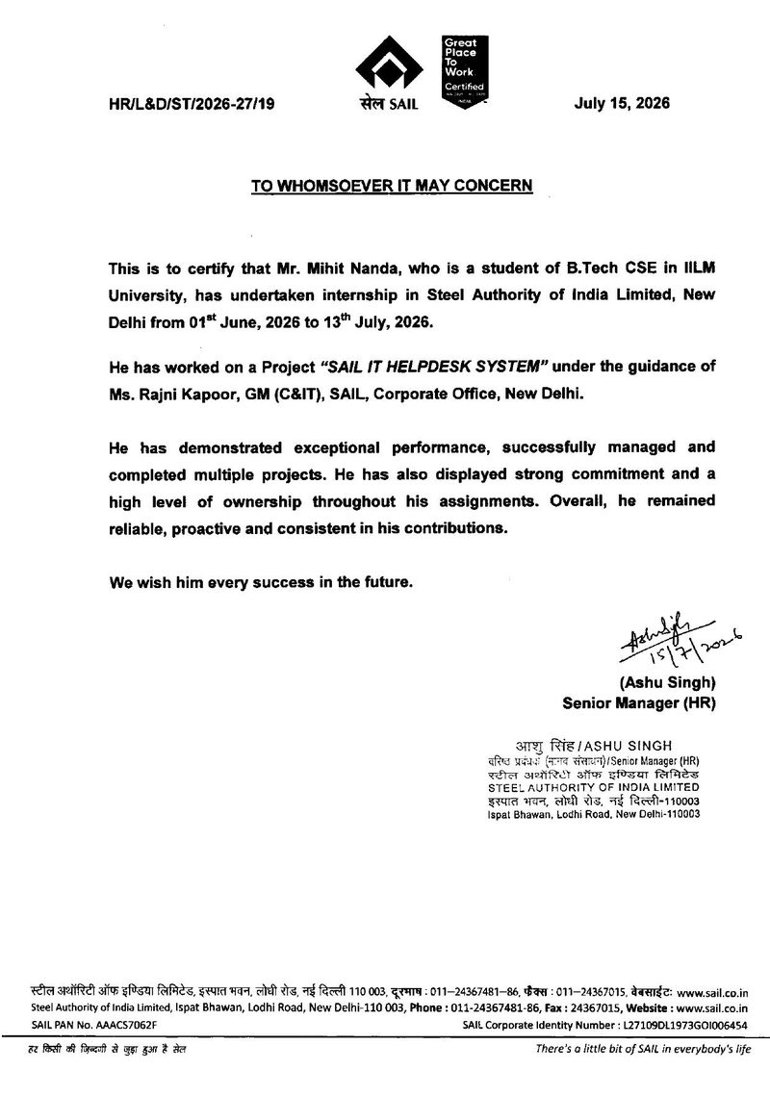
Figure 4.10.1 — SAIL Internship Completion Certificate

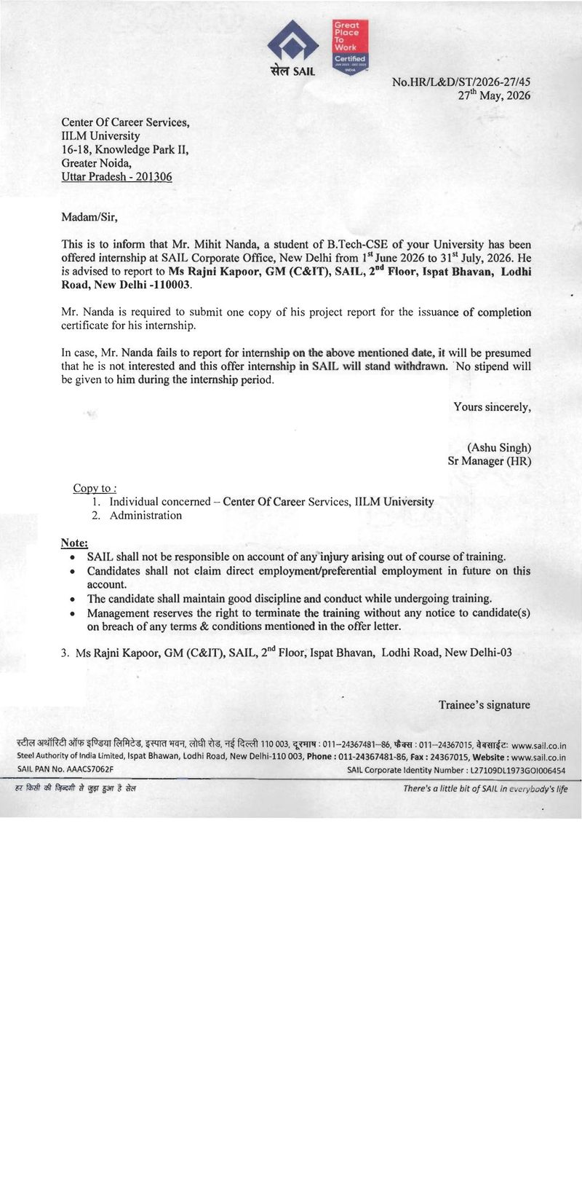
Figure 4.10.2 — SAIL Internship Offer Letter to IILM University

5. Bibliography/References
[1] Project Repository — SAIL IT Helpdesk System: https://github.com/mihiit/SAIL_Helpdesk_UPDATED
[2] React Documentation — https://react.dev
[3] Express.js Documentation — https://expressjs.com
[4] node-oracledb Documentation — https://oracle.github.io/node-oracledb/
[5] Oracle Database 21c XE Documentation — https://docs.oracle.com
[6] Tailwind CSS Documentation — https://tailwindcss.com

