NLP PROJECT REPORT
Hallucination Detection in Indic LLM Outputs
A Multilingual Benchmark and Classifier for Hindi, Marathi, and Tamil

Project Team:
Sr. | Roll No. | Name
1
2
3
4

Date of Submission: 17/10/26

Abstract
Large Language Models (LLMs) are increasingly used for question answering in Indian languages, yet they often produce fluent answers that are not supported by the source text. This behaviour, called hallucination, is well studied for English but has received limited attention for Hindi, Marathi, and Tamil. This project builds a reproducible pipeline for a multilingual hallucination-detection benchmark and classifier covering these three languages.
The workflow has five phases. Phase 1 prepares grounded question-answer data from two public datasets, IndicSQuAD and IndicQA, through Unicode-safe normalization, validation, script checks, deduplication, and leakage-aware splitting. The result is 278,058 clean examples (92,693 Hindi, 92,527 Marathi, 92,838 Tamil) divided into train, validation, and test sets. Phase 2 uses the Groq API with the qwen/qwen3.8-27b model to generate a faithful answer and a controlled hallucinated answer for each example, using four injection strategies: entity substitution, numeric/date corruption, unsupported claim addition, and contradicted fact. Phase 3 checks a stratified sample of the weak labels with an independent LLM judge. Phase 4 fine-tunes two multilingual transformer encoders (MuRIL and IndicBERT v2) as binary classifiers, first on rule-based weak-supervision pairs and then on the LLM-generated pairs, and Phase 5 compares them with two classical baselines across languages and hallucination types.
On a balanced run of 300 samples (600 labeled answers), the generator produced usable output for 95.5% of rows, and the independent judge agreed with 90.0% of the sampled weak labels (Cohen's kappa 0.80). On the held-out test split, MuRIL reached an F1 of 0.715 for the hallucinated class (mean of 3 seeds), compared with 0.851 for a lexical-overlap rule and 0.207 for TF-IDF with logistic regression.
A web dashboard (FastAPI backend and React frontend) reads the pipeline output files so that the results of each phase can be inspected in a browser.
Keywords: hallucination detection, Indic languages, Hindi, Marathi, Tamil, question answering, MuRIL, IndicBERT, weak supervision, low-resource NLP.

1. Introduction

1.1 Background
LLMs now power chatbots, search assistants, educational tools, and public-service applications. Users in India increasingly interact with these systems in their own languages. A hallucination occurs when a model produces content that is not supported by the evidence it was given or that contradicts it. Two kinds are commonly distinguished: an intrinsic hallucination contradicts the source (for example, the context states one number and the answer states another), and an extrinsic hallucination adds information that the source does not contain.

1.2 Problem Statement
Hallucination detection tools and benchmarks are mostly built for English. For Hindi, Marathi, and Tamil there is limited ready-to-use material for checking whether a model's answer is faithful to a given passage. Hindi and Marathi also share the Devanagari script, so script-level cues cannot separate them, and any classifier must handle language-specific content. Without a benchmark and a detector, developers of Indic-language QA systems cannot measure or reduce hallucination in a systematic way.

1.3 Motivation
- Users of Indic-language assistants have fewer independent sources to cross-check a wrong answer than English users.
- QA with a supplied context (retrieval-augmented generation) is a common deployment pattern, and in it faithfulness to the context is the key quality measure.
- A reusable pipeline can later be applied to other Indic languages.

1.4 Objectives
- Build a clean, reproducible grounded QA dataset for Hindi, Marathi, and Tamil.
- Generate faithful and hallucinated answers with controlled, recorded injection strategies.
- Assign weak labels automatically and verify a representative sample manually.
- Fine-tune MuRIL and IndicBERT to classify answers as faithful or hallucinated.
- Compare results across languages and hallucination types, and present them in a dashboard.

2. Background and Related Work

2.1 Question Answering Datasets
SQuAD (Rajpurkar et al., 2016) established the format of context, question, and answer span that many later datasets follow. IndicSQuAD (Endait et al., 2025) extends this format to several Indic languages and is the primary source here

2.2 Multilingual Encoders for Indic Languages
BERT (Devlin et al., 2019) showed that a pretrained bidirectional transformer can be fine-tuned for many classification tasks. MuRIL (Khanuja et al., 2021) is a BERT-base model pretrained for Indian languages, including transliterated text. IndicBERT (Kakwani et al., 2020) was first released as a compact ALBERT-based model; its second version, IndicBERT v2 (Doddapaneni et al., 2023), is a BERT-base model trained on the IndicCorp v2 corpus covering 23 Indic languages and English. This project uses MuRIL and IndicBERT v2, because the original IndicBERT checkpoint is access-restricted on Hugging Face, while IndicBERT v2 is openly available.

2.3 Hallucination Detection Approaches
Published approaches include checking an answer against retrieved evidence, natural language inference between context and answer, sampling several outputs and measuring consistency, and using an LLM as a judge.
3. NLP Concepts Demonstrated
NLP area | Where it appears in the project
Corpora and annotated data | Use of IndicSQuAD and IndicQA, schema harmonization, official splits
Text normalization | Unicode NFC normalization, control-character removal, whitespace handling, no transliteration or lowercasing
Script and language identification | Devanagari and Tamil Unicode range checks; discussion of why Hindi and Marathi cannot be separated by script
Question answering | Context, question, reference answer, extractive span verification
Semantic faithfulness / entailment | Defining hallucination as an answer not supported by the context
Language generation with LLMs | Prompted generation of faithful and hallucinated answers
Weak supervision | Labels assigned by construction, then cross-checked on a stratified sample by an independent LLM judge
Word and subword representations | Subword tokenization used by MuRIL and IndicBERT
Transfer learning | Fine-tuning pretrained multilingual encoders
Text classification and evaluation | Binary classifier, accuracy, precision, recall, F1, per-language analysis
4. System Workflow

4.1 Overall Workflow
The project is divided into five phases. Each phase produces files that the next phase consumes, and each was confirmed before the next began.
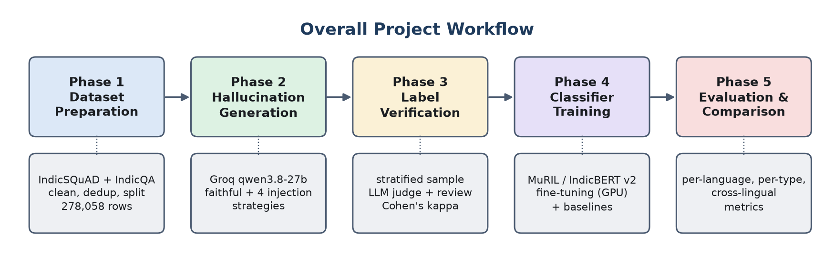
Figure 4.1: Overall five-phase project workflow
Phase | Purpose | Main output
1. Dataset preparation | Verify, download, clean, validate, deduplicate, and split grounded QA data | train / validation / test files, statistics JSON, EDA charts
2. Hallucination generation | Produce a faithful and a hallucinated answer for each row | Labeled pairs with injection strategy and quality flag
3. Label verification | Check a stratified sample of weak labels with an independent LLM judge; export it for manual review | Judge labels, agreement and Cohen's kappa per language and strategy
4. Classifier training | Fine-tune MuRIL and IndicBERT v2 as binary classifiers; fit two baselines | Epoch logs, test predictions, results JSON
5. Evaluation | Compare languages, models, and hallucination types | Metrics tables, confusion matrices, error analysis

4.2 Development Approach
Work was done phase by phase in the Google Antigravity IDE. An earlier partial Phase 1 implementation by a team member was audited before reuse. The audit found that the large data files were Git LFS pointer stubs (a zip download does not fetch LFS content) and that the cross-split leakage counting and statistics accounting contained errors. These were fixed and the pipeline was re-run to regenerate real data. A second audit, of the first Phase 2 run, found that its output could not be used (Section 10.2): the generator script was corrected and Phase 2 was re-run before any classifier was trained.

5. Technology Stack

Layer | Tool / library | Role
Language | Python 3.14 (pipeline); Python 3.11 with CUDA (training) | Pipeline, generation, training code
Data access | Hugging Face datasets, huggingface_hub | Download IndicSQuAD and IndicQA
Data handling | pandas, NumPy, PyArrow | Tables, hashing, Parquet and CSV export
Analysis | scikit-learn, matplotlib | Statistics, metrics, visualizations
Text processing | unicodedata, re, hashlib (standard library) | NFC normalization, script checks, SHA-256 hashing
LLM generation | Groq API and SDK; qwen/qwen3.8-27b (generator), openai/gpt-oss-120b (judge) | Answer generation and independent label check
Configuration | python-dotenv, .env file | Secret handling for the API key
Classifier models | MuRIL, IndicBERT v2 (Hugging Face Transformers, PyTorch 2.6, CUDA 12.4) | Fine-tuned binary classification
Backend | FastAPI, Uvicorn | Serve Phase 2 rows and save reviews as JSON
Frontend | React 19, Vite, React Router, Axios, lucide-react | Six-page results dashboard
Storage / versioning | Git, Git LFS, Parquet, CSV, JSONL | Version control, large files, checkpoints
Environment / hardware | Google Antigravity IDE; local NVIDIA RTX 3050 6 GB GPU | Development, generation and training

6. Datasets

Dataset | Hugging Face ID | Languages | License | Role
IndicSQuAD | l3cube-pune/indic-squad | Hindi, Marathi, Tamil (verified) | CC-BY-4.0 | Primary source with official train / validation / test splits
IndicQA | ai4bharat/IndicQA | Hindi, Marathi, Tamil (verified) | CC-BY-4.0 | Supplementary benchmark, routed to the test split

7. Methodology

7.1 Phase 1: Dataset Preparation
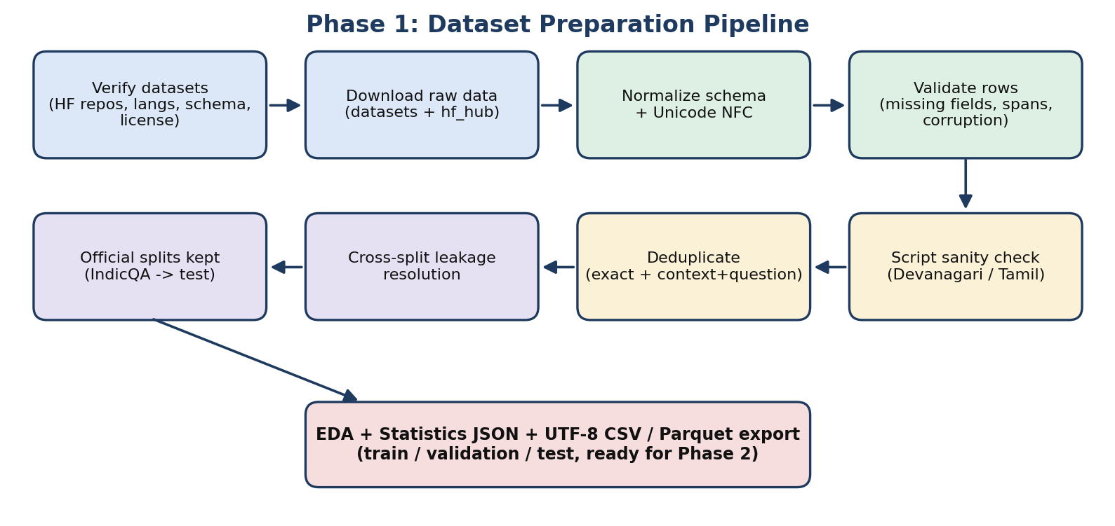
Figure 7.1: Phase 1 data preparation pipeline

7.1.1 Common schema
Both sources are mapped to one schema through explicit adapters, not by assuming matching column names.
Field | Description
sample_id | Deterministic SHA-256 hash of source_dataset, language_code, and source id
language, language_code | Hindi / Marathi / Tamil and hi / mr / ta
source_dataset, source_split, split | Origin dataset, original split, and final split
context, question, reference_answer | Grounding passage, question, ground-truth answer
answer_start | Character offset of the answer in the context, null when unavailable
task_type | extractive or abstractive
is_suspicious_language, validation_flags | Script sanity flag and validation notes
Table 7.1: Standardized schema

7.1.2 Text normalization
- Unicode NFC normalization so that combined characters and vowel signs (matras) are stored consistently.
- Removal of non-printable control characters, normalization of line breaks, and collapsing of excess whitespace.
- No transliteration, translation, lowercasing, or tokenization, so Indic text is preserved.

7.1.3 Validation
Every example is checked for missing or empty context, question, and reference answer, for corrupted text, and for answer-span validity. For extractive data the reference answer must occur in the context. Abstractive items are not discarded merely because the answer is not an exact substring. When normalization shifts character offsets slightly, a row whose answer is still a substring of the context is flagged and kept.

7.1.4 Language and script check
The dataset language metadata is the primary language label. Unicode ranges are used only as a sanity check: Devanagari (U+0900–U+097F) for Hindi and Marathi, Tamil (U+0B80–U+0BFF) for Tamil. Because Hindi and Marathi share a script, the check cannot separate them and is not used to relabel rows. Suspicious rows are flagged, not relabeled. No suspicious-language rows were found in the final run.

7.1.5 Deduplication and leakage prevention
- Exact duplicates: SHA-256 over normalized context, question, and reference answer; the first occurrence is kept.
- Context-question duplicates: SHA-256 over context and question within each source split.
- Cross-split leakage: identical context-question pairs appearing in more than one split are resolved by keeping the highest-priority split (test, then validation, then train). The priority is read from the assigned final split.
Deduplication by context alone was deliberately not used. In SQuAD-style data several questions legitimately share one passage, and removing them would discard most valid pairs.

7.1.6 Splitting
The official IndicSQuAD train, validation, and test splits are kept because their passages are already separated by document. All valid IndicQA items are assigned to the test split. This avoids overwriting official test data and prevents the same passage from appearing in both training and test sets. The resulting proportions (about 84% / 6% / 10%) differ from a default 80/10/10 split; the proportions follow the official splits.

7.1.7 Configuration for later balancing
The configuration holds SEED = 42, BALANCE_LANGUAGES = False, and MAX_SAMPLES_PER_LANGUAGE = None. The natural distribution is nearly balanced across the three languages, so no data was discarded to force balance.

7.2 Phase 2: Hallucination Generation
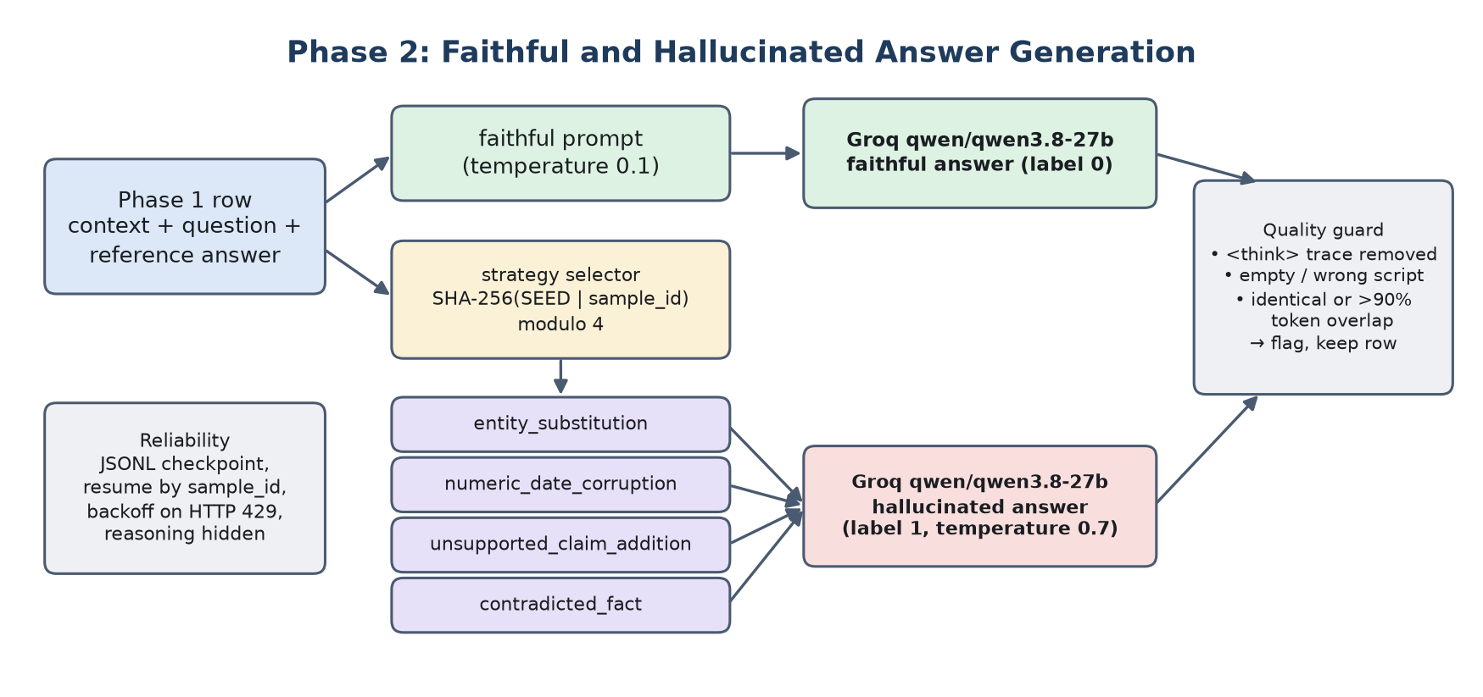
Figure 7.2: Phase 2 generation flow
Each Phase 1 row yields two output rows: a faithful answer (label 0) and a hallucinated answer (label 1). The Groq API with qwen/qwen3.8-27b is used for both. Faithful generation uses temperature 0.1 for grounded, stable output. Hallucination generation uses temperature 0.7 for controlled distortion. Because the model can emit a reasoning trace, requests set reasoning_format to hidden, allow up to 512 output tokens, and any remaining <think> block is removed before the answer is stored.

7.2.1 Injection strategies
Strategy | Description | Example
entity_substitution | Replace a named entity with a plausible but wrong one | Gandhi replaced by Nehru; Chennai by Madurai
numeric_date_corruption | Change a number, date, count, or quantity | 1947 changed to 1952
unsupported_claim_addition | Add a specific detail that the context does not contain | Adding a prize the passage never mentions
contradicted_fact | State the opposite of what the context asserts | Reduced inflation becomes raised inflation
Table 7.2: Hallucination injection taxonomy

7.2.2 Prompt design
There is one faithful prompt and one prompt per strategy. All prompts require output only in the target language and script, no preamble or quotation marks, and a short answer. Each prompt receives the language, context, question, and reference answer.

7.2.3 Strategy assignment and quality guard
- The strategy for each sample is chosen by a seeded hash of the sample_id, so assignment is reproducible and roughly even.
- A hallucinated answer is flagged in the column possible_generation_failure if it is empty, identical to the reference, shares more than 90% of its tokens with the reference, still contains a reasoning trace, is mostly in Latin script, or fails the script check. Flagged rows are kept for review but excluded from classifier training.
- The faithful answer has its own guard (empty output, reasoning trace, wrong script). If its API call fails, the row is flagged instead of silently copying the reference answer, which the first version of the script did.

7.2.4 Reliability
Records are checkpointed to JSONL files, and a re-run skips sample_ids already processed; duplicate records from resumed runs are removed on export. HTTP 429 responses trigger exponential backoff with jitter (up to ten attempts). Samples are processed round-robin across languages, so a run stopped by API limits stays balanced. The API key is read from a .env file that is excluded from version control. The reported run uses 100 samples per language (it contains the original 50-per-language review subset).

7.2.5 Output schema
sample_id, language, language_code, split, context, question, reference_answer, generated_answer, label, injection_strategy, source_dataset, possible_generation_failure.

7.3 Phase 3: Label Verification
Weak labels come from the construction process (faithful or injected) and may contain errors, for example an injected answer that is still correct, or a faithful answer that adds extra content. A stratified random sample, balanced across language and injection strategy, is drawn from the rows that passed the quality guard (src/phase3_verify.py). Each sampled row is labeled by an independent LLM judge, openai/gpt-oss-120b, a different model family from the generator, which reads the context, question, and candidate answer and returns FAITHFUL or HALLUCINATED. Agreement between the judge and the weak label is measured as accuracy and Cohen's kappa. The same sample is exported to data/phase3/review_sample.csv and can be reviewed manually in the dashboard.

Sample: 120 rows (20 faithful and 5 hallucinated per strategy for each language, seed 42). Annotators: one automatic annotator (the LLM judge). The judge agreed with 90.0% of the weak labels, with Cohen's kappa = 0.800. Results per language and strategy are in Tables 10.7 and 10.8. Eight manual reviews saved during the first Phase 2 run referred to unusable answers and were discarded.

7.4 Phase 4: Classifier Training
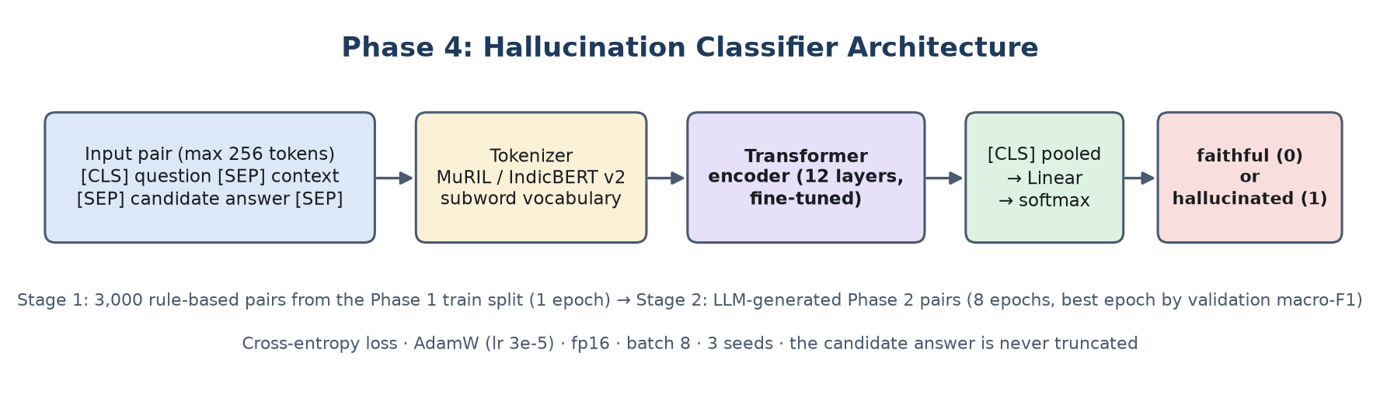
Figure 7.3: Hallucination classifier architecture
Detection is treated as sentence-pair classification. The first segment is the question and the context, the second is the candidate answer, joined with the special tokens of the chosen encoder ([CLS] question [SEP] context [SEP] answer [SEP]) and limited to 256 tokens; only the context is truncated, so the answer is always seen. The pooled representation of the first token passes through a linear layer and softmax to give the probability that the answer is hallucinated (threshold 0.5).
- Models: MuRIL (google/muril-base-cased, 238M parameters) and IndicBERT v2 (ai4bharat/IndicBERTv2-MLM-only, 278M parameters), fine-tuned end to end.
- Loss and optimizer: cross-entropy loss with AdamW (learning rate 3e-05 for both models, weight decay 0.01, 10% linear warm-up), mixed precision, batch size 8.
- Data and two-stage training: the Phase 2 rows that passed the quality guard are split by the Phase 1 split column into 388 training, 91 validation and 94 test rows. Fine-tuned on these 388 pairs alone, both encoders stayed at chance level (Table 10.10), so training uses two stages. Stage 1 is one epoch on 3,000 rule-based weak-supervision pairs (1,000 per language) drawn from the Phase 1 train split, with no overlap with Phase 2 or test data: half keep the reference answer (faithful), half replace it with the answer to another question, taken alternately from the same passage (a plausible in-context entity) or from a random passage. Stage 2 is 8 epochs on the LLM-generated pairs; the epoch with the best validation macro-F1 is kept, and every model is trained with 3 seeds (42, 43, 44).
- Baselines: (a) a lexical-overlap rule that calls an answer faithful when it occurs verbatim in the context, and (b) character 2-4-gram TF-IDF features of question, context and answer with logistic regression.
- Compute: a local NVIDIA RTX 3050 laptop GPU (6 GB). One fine-tuning run takes about 6.0 minutes for MuRIL and 9.9 minutes for IndicBERT v2 (src/train_phase45.py).

7.5 Phase 5: Evaluation
- Accuracy, precision, recall, F1, and macro-F1 on the test split.
- Results separated by language (Hindi, Marathi, Tamil) and by injection strategy.
- Confusion matrices and examples of misclassified pairs.
- Cross-lingual check: MuRIL trained on one language and tested on all three.
- Agreement of the weak labels with the independent judge on the Phase 3 sample, as an estimate of label noise.

8. Algorithms and Models
Component | Algorithm / model | Type | Used in
sample_id and duplicate keys | SHA-256 hashing | Deterministic | Phase 1
Text normalization | Unicode NFC, regex control-character removal | Rule-based | Phase 1
Script check | Unicode range matching | Heuristic | Phase 1
Span validation | Substring match of answer in context | Rule-based | Phase 1
Leakage resolution | Priority-ordered drop of duplicate keys | Deterministic | Phase 1
Strategy assignment | Seeded hash modulo number of strategies | Deterministic | Phase 2
Answer generation | qwen/qwen3.8-27b via Groq | LLM prompting | Phase 2
Quality guard | Token overlap, script and reasoning-trace checks | Heuristic | Phase 2
Label agreement | LLM judge (gpt-oss-120b) and Cohen's kappa | Statistic | Phase 3
Weak-supervision pairs | Answer swapping (same passage / random passage) | Rule-based | Phase 4
Classification | MuRIL, IndicBERT v2 fine-tuning | Transformer encoder | Phase 4
Baselines | Lexical-overlap rule; TF-IDF + logistic regression | Rule-based / linear | Phase 5
Evaluation | Accuracy, precision, recall, F1 | Metrics | Phase 5
Table 8.1: Algorithms and models

8.1 Deduplication and leakage resolution
key_exact = sha256(norm(context) + norm(question) + norm(reference_answer))
key_cq = sha256(norm(context) + norm(question))

drop rows with repeated key_exact (keep first)
drop rows with repeated (key_cq, source_split) (keep first)
priority = {test: 3, validation: 2, train: 1} # from assigned split
sort by priority descending; drop later rows with repeated key_cq

8.2 Strategy assignment
strategies = [entity_substitution, numeric_date_corruption,
unsupported_claim_addition, contradicted_fact]
h = int(sha256(f"{SEED}|{sample_id}|injection_strategy").hexdigest(), 16)
strategy = strategies[h % 4]

The strategy-assignment snippet shows the idea. The exact implementation is in src/generate_phase2.py.

8.3 MuRIL and IndicBERT v2
MuRIL is a BERT-base model pretrained on Indian-language text, including transliterated data, which helps with informal and mixed input. IndicBERT v2 is also a BERT-base model, trained on IndicCorp v2 with a larger vocabulary for 23 Indic languages. The two models have the same architecture size, so comparing them shows how much the pretraining data and vocabulary matter for each language.
The Dataset Management page of the dashboard lists the generated Phase 2 rows with their language, question, reference answer and generated answer, and can be filtered by language (Figure 8.1).
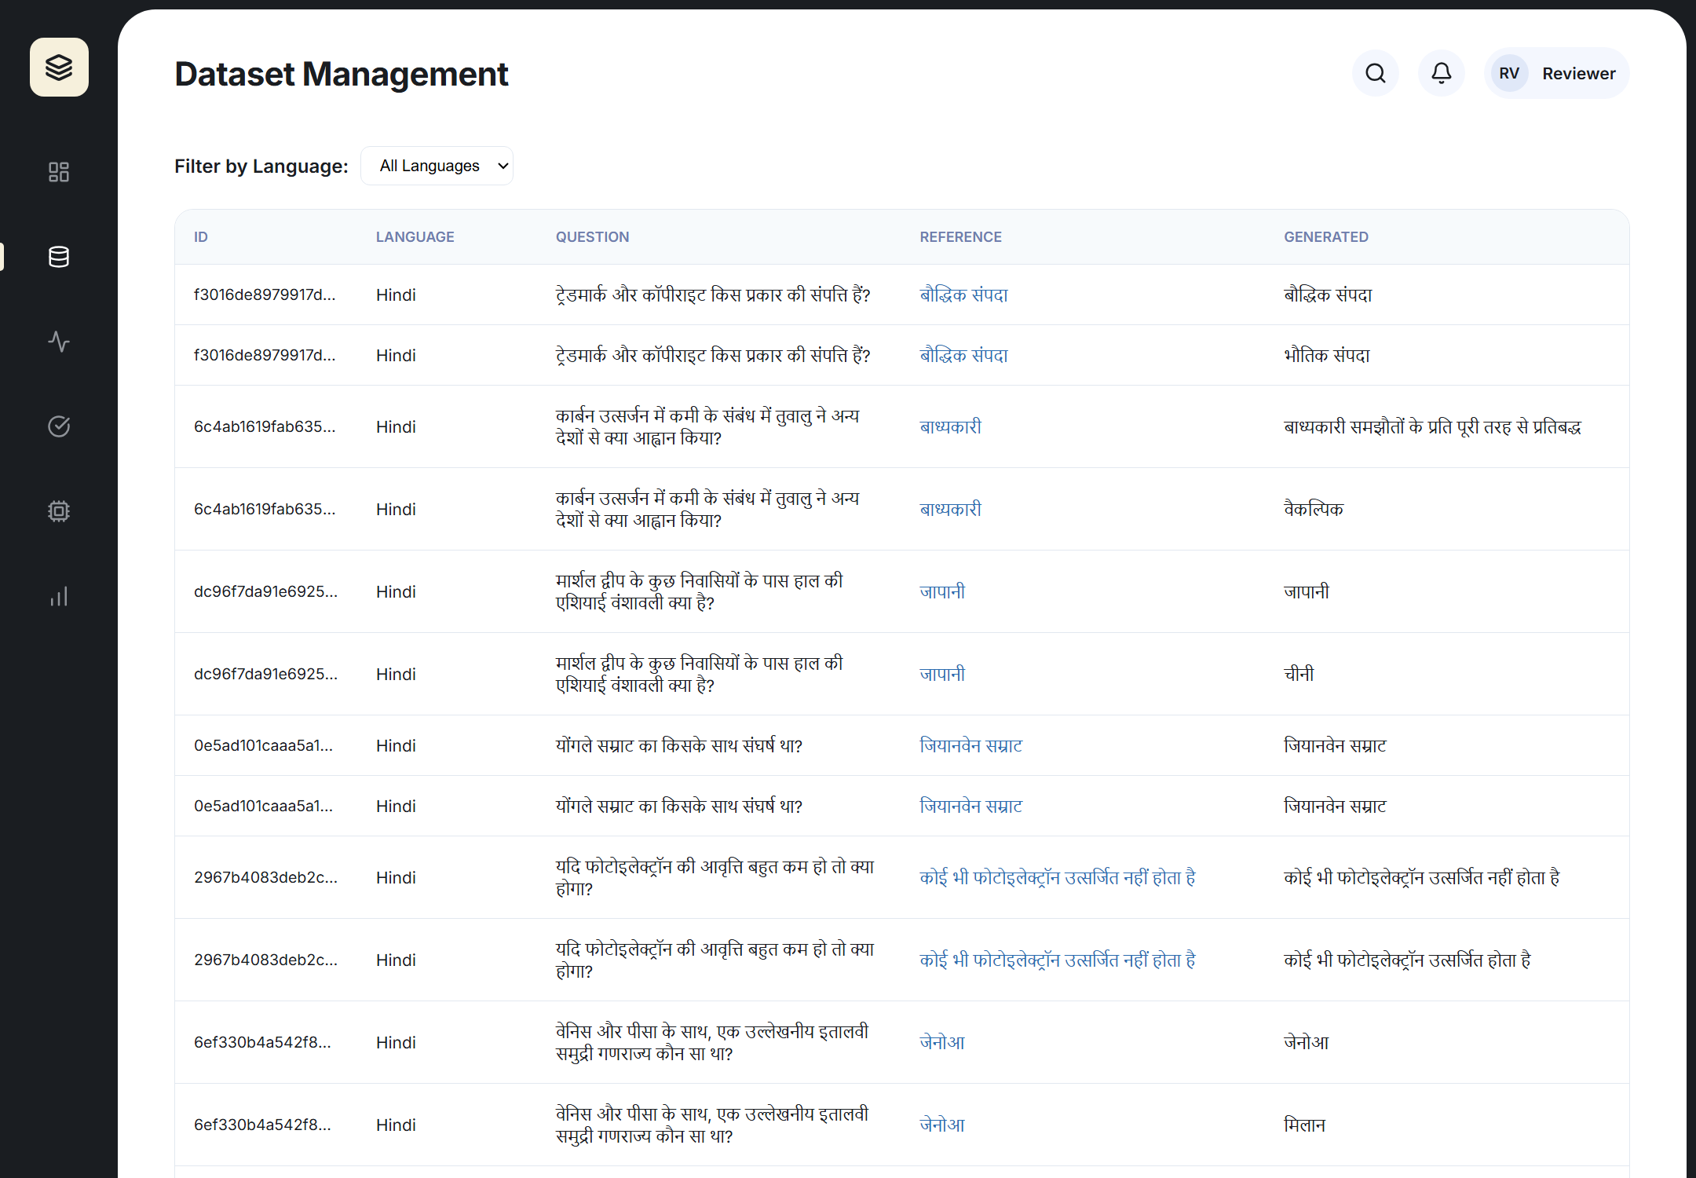
Figure 8.1: Dataset Management page showing the generated Phase 2 rows
9. System Architecture and Dashboard
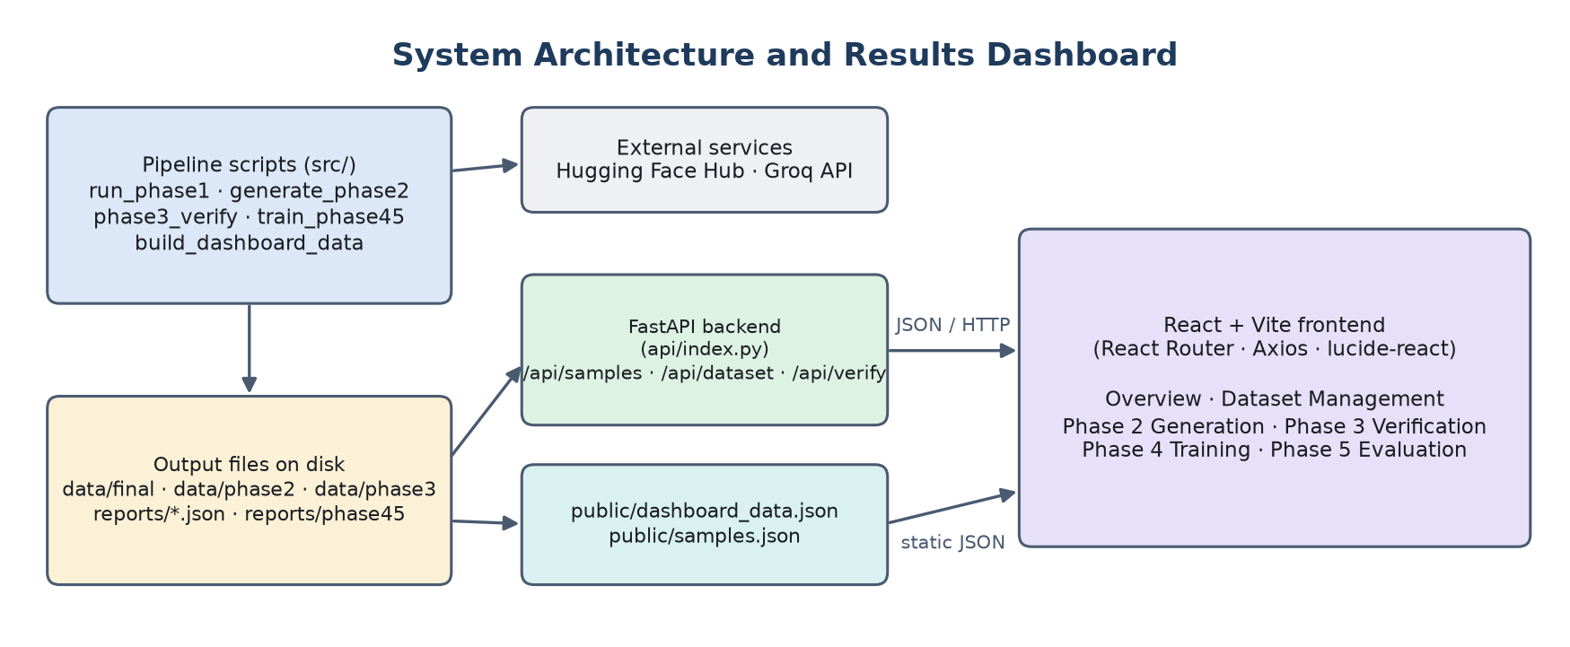
Figure 9.1: System architecture and results dashboard
The pipeline scripts write their outputs to disk (the statistics JSON, the final CSV or Parquet files, the Phase 2 dataset, the Phase 3 summary and the Phase 4/5 results). src/build_dashboard_data.py collects these files into public/dashboard_data.json, and a FastAPI backend serves the Phase 2 rows and stores manual reviews. The React frontend, built with Vite, React Router, Axios and lucide-react, has six pages: Overview, Dataset Management, Phase 2 Generation, Phase 3 Verification, Phase 4 Training, and Phase 5 Evaluation. The dashboard holds no hardcoded numbers; every value comes from the real files, and a page shows an empty state when its phase has not been run. When no backend is available (static hosting), the pages fall back to the exported JSON files.

Figure 9.2 shows the Overview page and Figure 9.3 the Phase 3 verification page used for manual review.
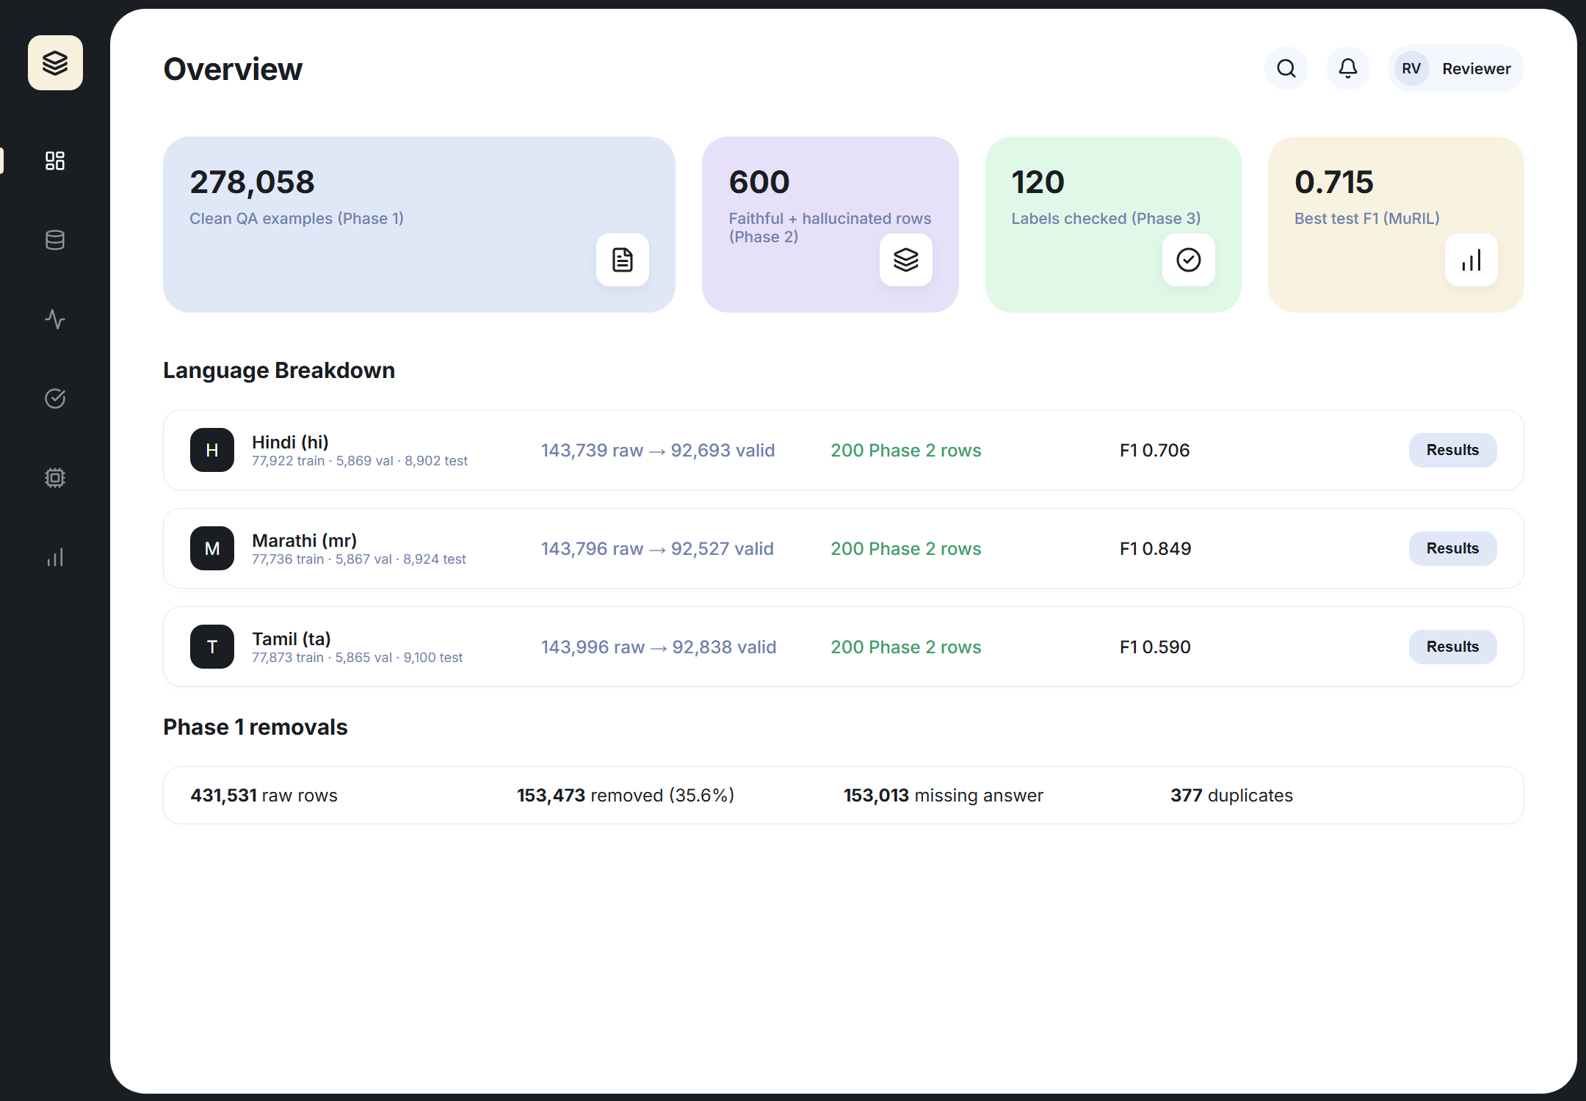
Figure 9.2: Dashboard Overview page with Phase 1 to Phase 5 headline numbers
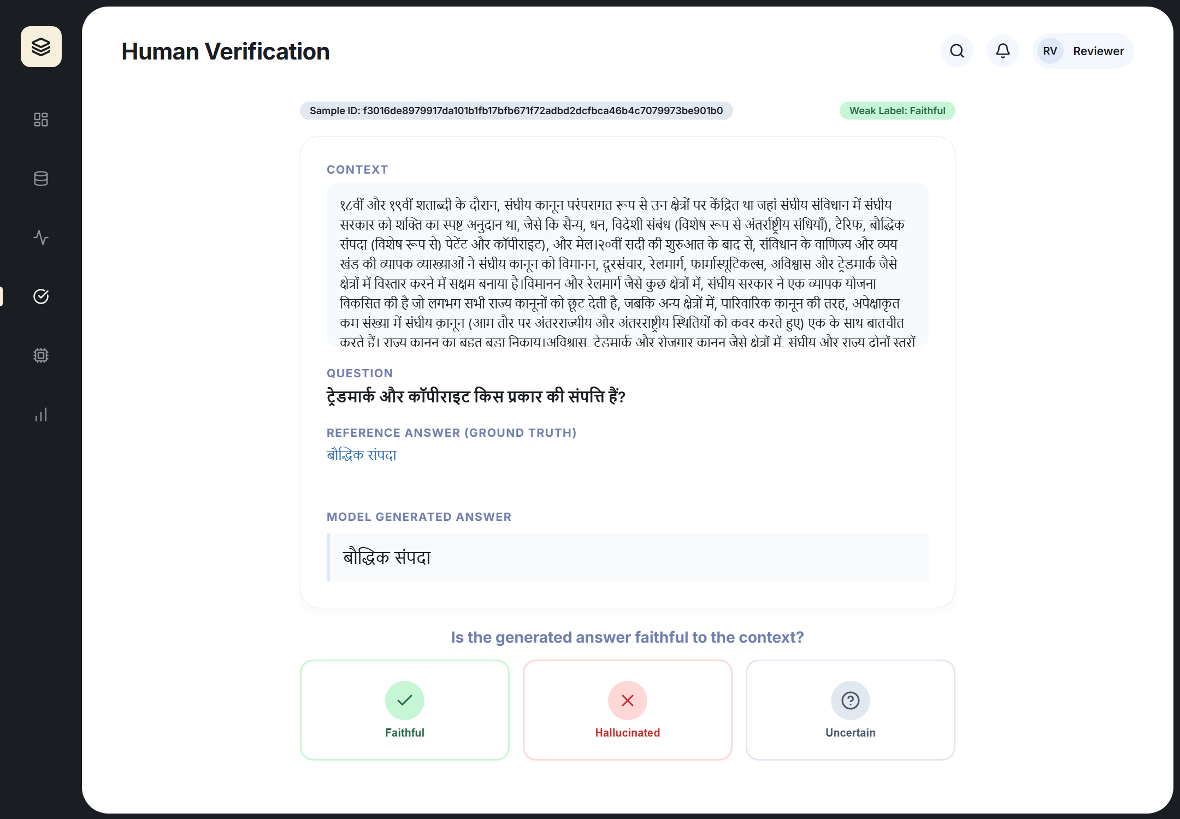
Figure 9.3: Phase 3 verification page (weak label, context, question, reference and generated answer)

10. Results and Analysis

10.1 Phase 1 Results
The results below come from reports/phase1_statistics.json after the corrected pipeline was re-run. Every value was checked against the file, and re-running the validation step on the committed normalized data reproduced the same 278,058 rows with identical sample IDs and split assignments.
Language | Original | Removed | Duplicates | Final valid
Hindi (hi) | 143,739 | 51,046 | 128 | 92,693
Marathi (mr) | 143,796 | 51,269 | 125 | 92,527
Tamil (ta) | 143,996 | 51,158 | 124 | 92,838
Total | 431,531 | 153,473 | 377 | 278,058
Table 10.1: Examples per language
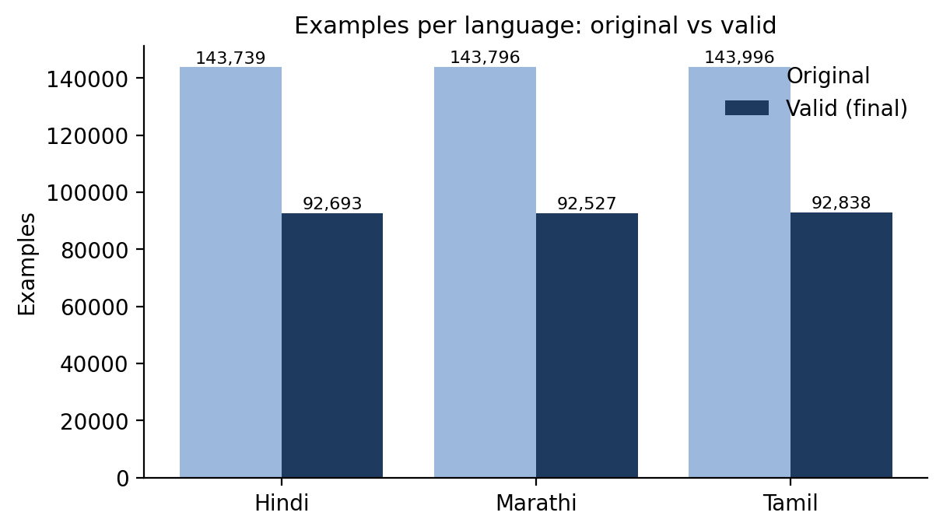
Figure 10.1: Original and valid examples per language
Split | Samples | Share
Train | 233,531 | 83.99%
Validation | 17,601 | 6.33%
Test | 26,926 | 9.68%
Total | 278,058 | 100%
Table 10.2: Final split sizes
Removal reason | Rows
Missing reference answer | 153,013
Exact duplicates | 265
Context-question duplicates | 112
Answer-span failures | 82
Corrupted question | 1
Cross-split leakage removed | 0
Total removed | 153,473
Table 10.3: Removal reasons (the reasons sum exactly to the total removed)
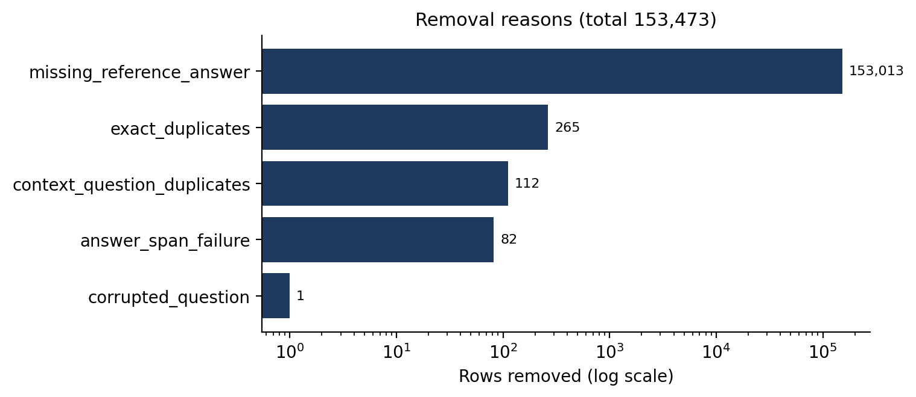
Figure 10.2: Removal reasons

Observations
- Missing reference answers account for almost all removals (99.7%), mainly because of abstractive items without answers.
- The three languages end with nearly equal counts, so no balancing was needed.
- No cross-split leakage was found after deduplication, and no suspicious-language rows were flagged.
- The test split is larger than the validation split because IndicQA was added to it.

10.2 Phase 2 Results
A first Phase 2 run on 50 samples per language could not be used. In its checkpoint, all 100 Hindi answers and 94 of 100 Marathi answers were truncated <think> reasoning traces in English (the reasoning model used the whole 256-token limit before reaching an answer), and all 50 Tamil hallucinated answers were empty after API errors, with the faithful answers replaced by copies of the reference answer. The committed phase2_dataset.csv from that run contained only reference copies and empty strings. The generator was fixed as described in Section 7.2 and Phase 2 was re-run; all numbers below come from the re-run (reports/phase2_summary.json).

The re-run covers 300 samples (100 per language) and produced 600 rows, one faithful and one hallucinated answer per sample. There were 0 API errors; the free tier's limit of 8,000 tokens per minute caused 17 back-off waits but no lost rows. The quality guard flagged 27 rows (4.5%), almost all hallucinated answers that repeated the reference answer.
Language | Samples | Faithful rows | Hallucinated rows | Flagged | Train / val / test samples
Hindi | 100 | 100 | 100 | 9 | 68 / 16 / 16
Marathi | 100 | 100 | 100 | 9 | 68 / 16 / 16
Tamil | 100 | 100 | 100 | 9 | 68 / 16 / 16
Total | 300 | 300 | 300 | 27 | 204 / 48 / 48
Table 10.4: Phase 2 rows by language and label
Strategy | Hindi | Marathi | Tamil | Total
Entity substitution | 27 | 25 | 28 | 80
Numeric / date corruption | 25 | 20 | 22 | 67
Unsupported claim addition | 24 | 27 | 25 | 76
Contradicted fact | 24 | 28 | 25 | 77
Table 10.5: Injection strategies used for the hallucinated answers
Faithful answers stay close to the reference: on average 3.6, 2.6 and 3.7 words for Hindi, Marathi and Tamil, against reference answers of 3.4, 2.6 and 2.6 words, and 93.7% of them occur verbatim in the context. Hallucinated answers are slightly longer and only 27.3% occur verbatim in the context, which matters for the baselines in Section 10.3. Table 10.6 shows sample pairs.
Lang. | Question | Reference | Faithful (label 0) | Hallucinated (label 1, strategy)
Hindi | ट्रेडमार्क और कॉपीराइट किस प्रकार की संपत्ति हैं? | बौद्धिक संपदा | बौद्धिक संपदा | भौतिक संपदा (Numeric / date corruption)
Hindi | कार्बन उत्सर्जन में कमी के संबंध में तुवालु ने अन्य देशों से क्या आह्वान किया? | बाध्यकारी | बाध्यकारी समझौतों के प्रति पूरी तरह से प्रतिबद्ध | वैकल्पिक (Numeric / date corruption)
Marathi | ग्रोनर वि मिनिस्टर फॉर एज्युकेशन मधील डब्लिन कॉलेजमध्ये शिकवण्यासाठी कोणती भाषा कोर्टाने स्वीकारली? | गेलिक | गेलिक | फ्रेंच (Contradicted fact)
Marathi | चॉपिन या गायन विद्यार्थ्याचे नाव काय होते? | कोन्स्टँजा ग्लाडकोव्स्का या | कोन्स्टँजा ग्लाडकोव्स्का | कोन्स्टँजा ग्लाडकोव्स्का (Unsupported claim addition)
Tamil | மசோவியாவின் இரண்டாம் போல்ஸ்லாவ் யார்? | ப்லாக் இளவரசர், இந்த | ப்லாக் இளவரசர் | ப்லாக் மன்னர், இந்த (Numeric / date corruption)
Tamil | மூளை எந்த திசுக்களால் சூழப்பட்டுள்ளது? | மூளைக்காய்ச்சல் | மெனிங்கஸ் எனப்படும் இணைப்பு திசு சவ்வுகள் | மூளை, மண்டை ஓட்டை பிரிக்கும் மெனிங்கஸ் எனப்படும் இணைப்பு திசு சவ்வுகளால் சூழப்பட்டுள்ளது. (Unsupported claim addition)
Table 10.6: Sample faithful and hallucinated answers from the re-run

10.3 Phase 3 to 5 Results

Phase 3: label verification
The LLM judge labeled all 120 sampled rows (0 unparsable replies). Overall it agreed with 90.0% of the weak labels (Cohen's kappa 0.800). Agreement was 93.3% on faithful rows; for hallucinated rows, the share the judge confirmed as hallucinated is shown per strategy.
Reading the 12 disagreements shows errors on both sides. 3 of the 4 faithful answers the judge rejected are identical to the reference answer, so these are judge errors. Among the 8 injected answers the judge accepted, some are real weak-label errors (for example, a Marathi unsupported-claim answer that only drops a particle and is still correct, or an added detail that the passage does support), while others are entity or number substitutions that the judge missed. Unsupported claim addition is the least reliable strategy, which is expected because an added detail can turn out to be supported by the passage.
Language | Rows | Agreement | Cohen's kappa
Hindi | 40 | 97.5% | 0.950
Marathi | 40 | 85.0% | 0.700
Tamil | 40 | 87.5% | 0.750
All | 120 | 90.0% | 0.800
Table 10.7: Agreement between the weak labels and the independent LLM judge, by language
Hallucination strategy | Rows | Confirmed hallucinated by judge
Entity substitution | 15 | 86.7%
Numeric / date corruption | 15 | 86.7%
Unsupported claim addition | 15 | 73.3%
Contradicted fact | 15 | 100.0%
Table 10.8: Share of sampled hallucinated rows confirmed by the judge, by strategy

Phases 4 and 5: classifiers
Table 10.9 gives the test results per language (hallucinated = positive class, mean of 3 seeds). The test split has 94 rows.
Model | Language | Accuracy | Precision | Recall | F1
MuRIL | Hindi | 0.729 | 0.782 | 0.646 | 0.706
MuRIL | Marathi | 0.867 | 0.896 | 0.810 | 0.849
MuRIL | Tamil | 0.667 | 0.781 | 0.479 | 0.590
IndicBERT v2 | Hindi | 0.542 | 0.375 | 0.479 | 0.415
IndicBERT v2 | Marathi | 0.600 | 0.415 | 0.524 | 0.455
IndicBERT v2 | Tamil | 0.562 | 0.383 | 0.417 | 0.396
Table 10.9: Classifier results on the test split (mean of 3 seeds)
Table 10.10 compares the two-stage models with the two baselines and with the same encoders fine-tuned on the LLM-generated pairs only, on the whole test split.
Model | Accuracy | Precision | Recall | F1 | Macro-F1
MuRIL | 0.752 ± 0.025 | 0.816 ± 0.038 | 0.638 ± 0.037 | 0.715 ± 0.030 | 0.747 ± 0.026
IndicBERT v2 | 0.567 ± 0.096 | 0.388 ± 0.286 | 0.471 ± 0.334 | 0.424 ± 0.306 | 0.505 ± 0.150
Lexical overlap | 0.862 | 0.902 | 0.804 | 0.851 | 0.861
TF-IDF + LR | 0.511 | 0.500 | 0.130 | 0.207 | 0.427
MuRIL, LLM pairs only (seed 42) | 0.511 | 0.000 | 0.000 | 0.000 | 0.338
IndicBERT v2, LLM pairs only (seed 42) | 0.500 | 0.494 | 0.913 | 0.641 | 0.408
Table 10.10: Overall test results (two-stage models: mean ± standard deviation over seeds)
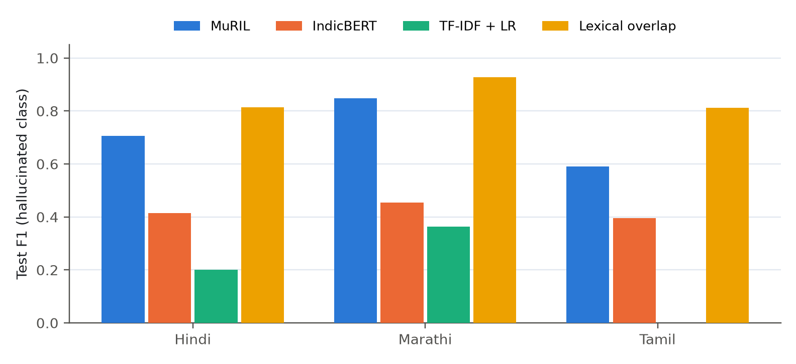
Figure 10.3: Test F1 by language for the fine-tuned models and the baselines
Hallucination type | Test rows | MuRIL | IndicBERT v2 | Lexical overlap
Entity substitution | 14 | 0.548 | 0.500 | 0.714
Numeric / date corruption | 6 | 0.667 | 0.389 | 0.833
Unsupported claim addition | 12 | 0.778 | 0.472 | 1.000
Contradicted fact | 14 | 0.595 | 0.476 | 0.714
Faithful answers (specificity) | — | 0.861 | 0.660 | 0.917
Table 10.11: Recall by hallucination type (share of hallucinated test answers detected)
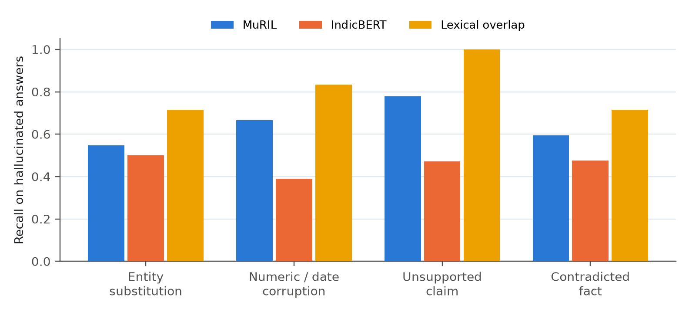
Figure 10.4: Recall by hallucination type
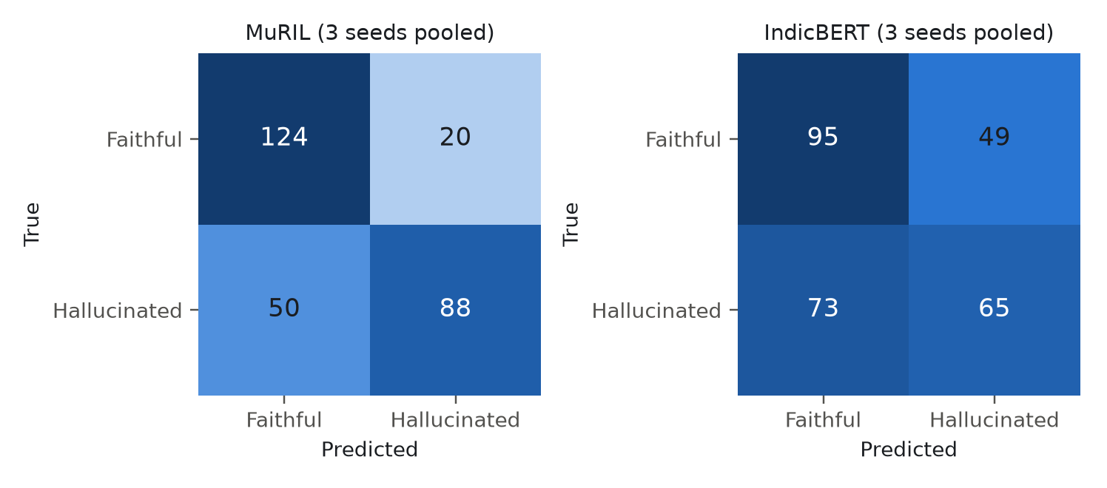
Figure 10.5: Confusion matrices on the test split (predictions of the three seeds pooled)
Trained on ↓ / tested on → | Hindi | Marathi | Tamil
Hindi | 0.643 | 0.545 | 0.562
Marathi | 0.429 | 0.400 | 0.438
Tamil | 0.286 | 0.235 | 0.571
Table 10.12: Cross-lingual transfer, F1 of MuRIL trained on one language (seed 42)

Observations
- MuRIL is the strongest model overall (F1 0.715 ± 0.030), ahead of IndicBERT v2 (F1 0.424 ± 0.306).
- The rule-based first stage is what makes fine-tuning work on this small set: trained on the LLM pairs only, MuRIL reaches macro-F1 0.338 and IndicBERT v2 reaches macro-F1 0.408 (chance level is about 0.5), against 0.747 and 0.505 with stage 1.
- The lexical-overlap rule is a strong baseline (F1 0.851); the best fine-tuned model is below it by 0.135 F1, while TF-IDF with logistic regression, which sees no explicit overlap feature, reaches only 0.207.
- Across languages, MuRIL scores highest on Marathi (F1 0.849) and lowest on Tamil (F1 0.590).
- By hallucination type, unsupported claim addition is detected most reliably (recall 0.778) and entity substitution least reliably (recall 0.548).
- Cross-lingual check: MuRIL trained on a single language reaches an average F1 of 0.538 on its own language and 0.416 on the other two, so the learned signal transfers only partly: with a third of the data, in-language results are clearly better than cross-language ones.
- IndicBERT v2 is unstable on this small set: 1 of its 3 seeds collapsed to predicting only the faithful class (F1 0.000), which explains its large standard deviation.
Figure 10.6 shows the Phase 5 page of the dashboard, which reads the same results file.
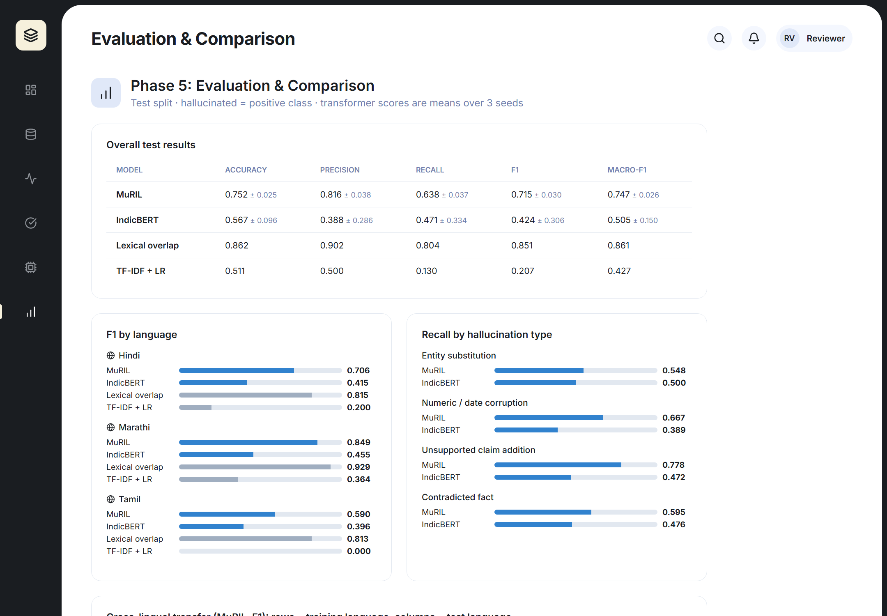
Figure 10.6: Phase 5 Evaluation page of the dashboard

11. Use Cases and Applications
- Benchmarking: measure how often an LLM hallucinates in Hindi, Marathi, and Tamil, and compare models.
- Guardrail for RAG systems: a trained classifier can check an answer against its retrieved passage before it reaches the user.
- Education and public services: assistants that answer from official documents in local languages can be checked for faithfulness.
- Customer support and enterprise QA: automatic flagging of unsupported answers for human review.
- Research: a labeled resource with known hallucination types for error analysis in low-resource languages.
- Reusable method: the same pipeline can be applied to further Indic languages that have a QA dataset.

12. Challenges and Limitations

- Synthetic hallucinations: injected errors may differ from the natural errors of a deployed LLM, so a detector trained on them may not transfer fully.
- Weak labels: labels come from construction, so some are wrong; only a sample is checked, and by an LLM judge rather than by human annotators.
- Generator bias: one generator model (qwen/qwen3.8-27b) shapes the style of all hallucinations, and its quality in Marathi and Tamil may be lower than in Hindi.
- Extractive source data: short span answers limit the variety of answer styles.
- Translated data: IndicSQuAD is derived from an existing QA set and may contain translation artifacts.
- Hindi and Marathi script overlap: language checks rely on metadata, not on script.
- API limits: the free tier allows 8,000 tokens per minute and 200,000 tokens per day per model; the 300-sample run (600 rows) exhausted one account's daily budget and was finished with a second key. A full run needs a paid tier, a faster model, or several keys in parallel.
- Reproducibility issues found: Git LFS pointer files in a zip download, leakage-counting errors in the first Phase 1 version, and an unusable first Phase 2 run (reasoning traces, silent fallback to the reference answer) were corrected and documented.
- Lexical shortcut: faithful answers are almost always spans copied from the context, while most injected answers are not, so a simple overlap rule is a strong baseline; harder, paraphrased faithful answers are needed to make the benchmark more challenging.
- Small labeled set: 388 training and 94 test rows give noisy per-language and per-strategy estimates, which is why results are averaged over three seeds.

13. Future Scope
- Extend to more Indic languages such as Bengali, Telugu, Kannada, and Malayalam.
- Add natural hallucinations by collecting real outputs from several LLMs and labeling them.
- Use more than one generator model to reduce generator bias.
- Move from answer-level to span-level (token-level) hallucination localization.
- Add abstractive and long-form answers, and multi-document contexts.
- Test code-mixed inputs such as Hinglish.
- Compare with larger multilingual models and LLM-as-judge detectors.
- Publish the dataset and code with a documented license, after the literature-gap claim is verified.
- Complete a double human annotation of the exported Phase 3 sample and report human-human and human-judge kappa.
- Generate paraphrased faithful answers so that lexical overlap no longer separates the classes.

14. Conclusion
This project sets up an end-to-end, reproducible pipeline for hallucination detection in Hindi, Marathi, and Tamil. Phase 1 produced a clean, deduplicated, leakage-checked dataset of 278,058 grounded QA examples with a nearly equal share for each language. Phase 2, after its first run was diagnosed and fixed, generated 600 labeled answers with four recorded hallucination strategies and no API errors. An independent LLM judge agreed with 90.0% of the sampled weak labels (kappa 0.80). Because 388 LLM-generated training pairs were too few for the encoders to learn from directly, a rule-based weak-supervision stage was added, after which MuRIL detected hallucinated answers with a test F1 of 0.715. The dashboard shows each phase's real outputs in a browser.
The work shows how several parts of NLP combine in one application: corpus preparation, Unicode-aware text processing, LLM generation, weak supervision, and transformer-based classification. Its main limits are the synthetic nature of the hallucinations, the lexical shortcut between extractive faithful answers and injected ones, the small generated subset, and the dependence on one generator model. Addressing these is the natural next step.

References
- Endait, S., Ghatage, R., Kulkarni, A., Patil, R., and Joshi, R. (2025). IndicSQuAD: A Comprehensive Multilingual Question Answering Dataset for Indic Languages. arXiv:2505.03688.
- Doddapaneni, S., Aralikatte, R., Ramesh, G., Goyal, S., Khapra, M. M., Kunchukuttan, A., and Kumar, P. (2023). Towards Leaving No Indic Language Behind: Building Monolingual Corpora, Benchmark and Models for Indic Languages. ACL 2023, pp. 12402-12426. (IndicQA and IndicBERT v2.)
- Rajpurkar, P., Zhang, J., Lopyrev, K., and Liang, P. (2016). SQuAD: 100,000+ Questions for Machine Comprehension of Text. EMNLP 2016, pp. 2383-2392.
- Devlin, J., Chang, M.-W., Lee, K., and Toutanova, K. (2019). BERT: Pre-training of Deep Bidirectional Transformers for Language Understanding. NAACL-HLT 2019, pp. 4171-4186.
- Khanuja, S., et al. (2021). MuRIL: Multilingual Representations for Indian Languages. arXiv:2103.10730.
- Kakwani, D., Kunchukuttan, A., Golla, S., Gokul, N. C., Bhattacharyya, A., Khapra, M. M., and Kumar, P. (2020). IndicNLPSuite: Monolingual Corpora, Evaluation Benchmarks and Pre-trained Multilingual Language Models for Indian Languages. Findings of EMNLP 2020, pp. 4948-4961.
- Ji, Z., Lee, N., Frieske, R., Yu, T., Su, D., Xu, Y., Ishii, E., Bang, Y., Madotto, A., and Fung, P. (2023). Survey of Hallucination in Natural Language Generation. ACM Computing Surveys, 55(12), Article 248.
- Groq API documentation. https://console.groq.com/docs (accessed October 2026).
- Qwen Team (2025). Qwen3 Technical Report. arXiv:2505.09388.
- OpenAI (2025). gpt-oss-120b & gpt-oss-20b Model Card. arXiv:2508.10925.
- Cohen, J. (1960). A Coefficient of Agreement for Nominal Scales. Educational and Psychological Measurement, 20(1), 37-46.

