Data Description
Since the data is too large, we cannot upload it to GitHub. The following is the link for our dataset
https://developer.imdb.com/non-commercial-datasets/
https://datasets.imdbws.com/

The attached screenshots show the same:

title.crew.csv
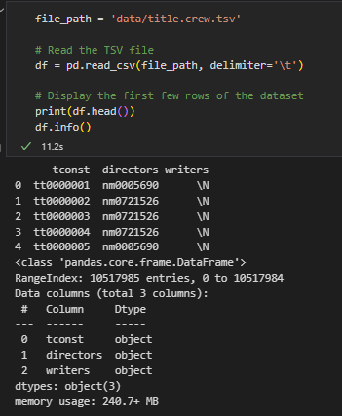

Title.basics.tsv
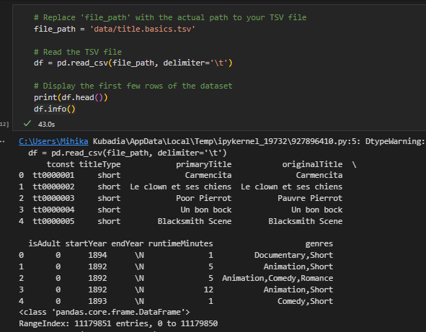
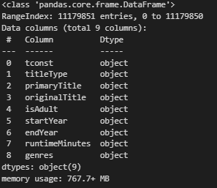

titile.episode.tsv

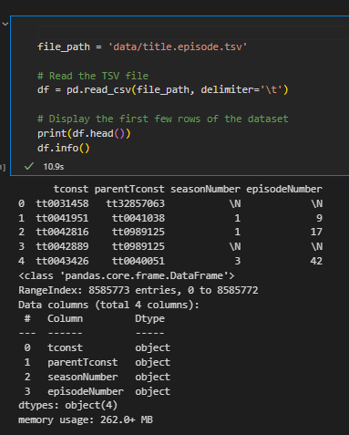

title.principals.tsv
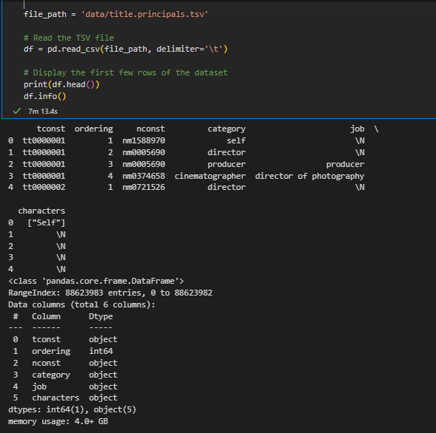

Title.rating.tsv

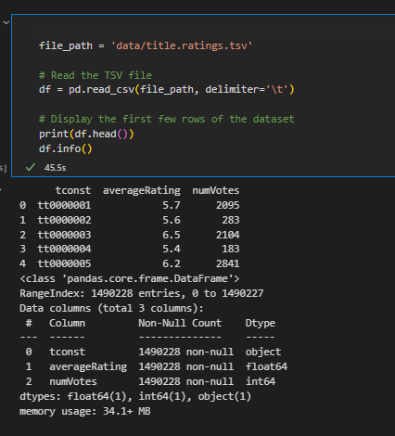

Name.basics.tsv

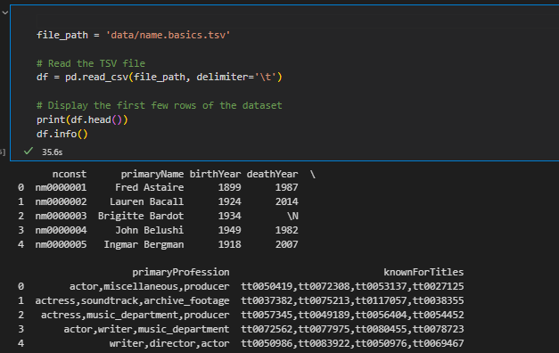
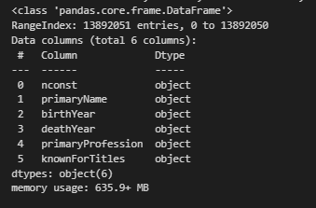

title.crew.tsv
