Dashboard Interpretation Report

Social Insights Dashboard by Mihika Pargai
The Social Insights Dashboard provides a comprehensive overview of social media performance across multiple platforms, content formats, audience segments, and creators. The visuals collectively help understand engagement patterns, audience behavior, and performance trends over time.

KPI Summary:
The KPI cards at the top highlight the key metrics:
- Total Likes: Indicates the overall audience appreciation and popularity of posts.
- Average Likes: Shows the typical engagement level received per post.
- Total Posts: Represents the volume of content shared.
- Total Views: Measures audience reach across all platforms.
- Total Shares: represents how often users shared the content across social platforms.
- Weekday Posts: Shows how many posts were published from Monday to Friday.
Interpretation:
The high number of total views and likes suggests strong audience engagement, while the weekday posting trend helps understand content scheduling behavior.

Graph Insights:

Audience Gender Distribution (Pie Chart)
This chart visualizes the audience split across male, female, non-binary, and unknown categories.
Interpretation:
The largest segment belongs to [your largest category from the pie], showing that this gender group contributes significantly to the platform’s engagement. The distribution also highlights diversity among viewers.
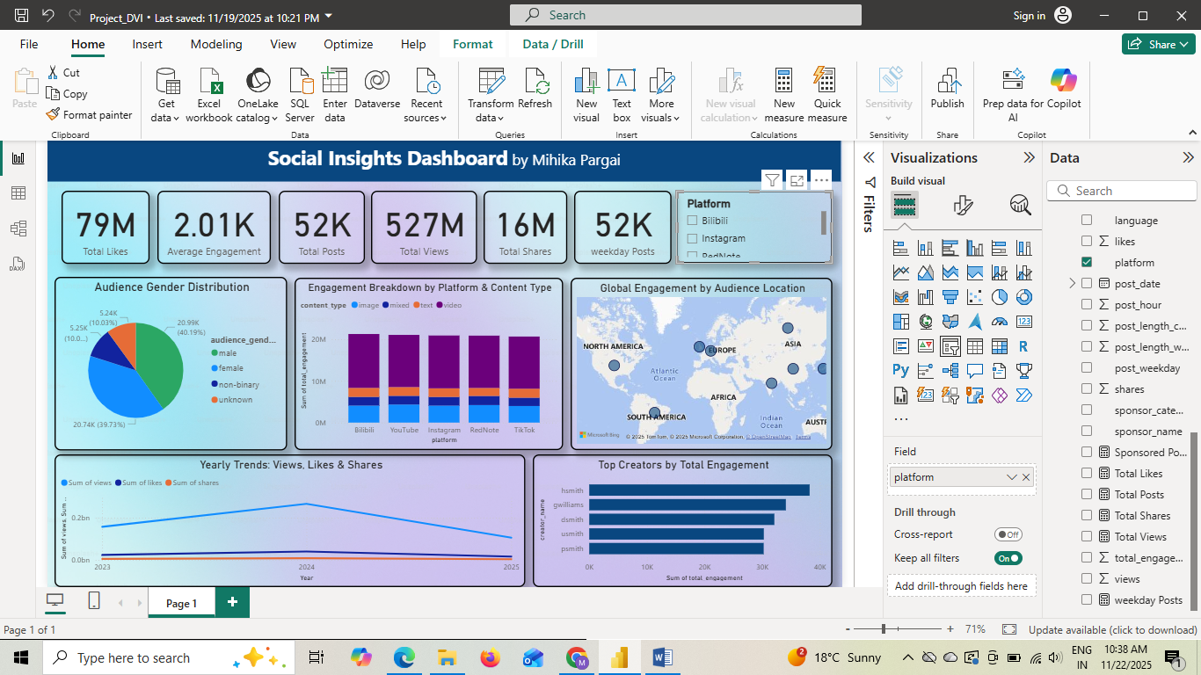

Engagement by Platform & Content Type (Stacked Bar Chart)
This chart compares how different types of content (image, video, text, mixed) perform across major platforms like YouTube, Instagram, TikTok, Reddit, and Bilibili.
Interpretation:
The stacked bars show which platforms drive the highest engagement and what content formats perform best. For example, video content may dominate on YouTube or TikTok, while image posts may perform better on Instagram.

Global Engagement by Audience Location (Map Visualization)
Shows total engagement contributed by audiences from different regions across the world.
Interpretation:
Regions such as Asia, North America, or Europe appear as engagement hotspots. This helps identify which geographic markets are most responsive and where content is most popular.

Yearly Trends for Views, Likes & Shares (Line Chart)
The line chart shows how total views, likes, and shares have changed over time (2023–2025).
Interpretation:
A clear trend can be observed—for example, a rise in 2024 followed by slight decline/increase in 2025. This highlights long-term performance and gives insights into whether audience interest is growing, stable, or decreasing.

Top Creators by Total Engagement (Clustered Bar Chart)
Displays creators ranked by the total engagement they generate.
Interpretation:
Creators such as (creator with highest engagement) stand out as top performers. This visual helps identify influential creators and guides future collaboration or content strategy decisions.

Slicer Feature (Platform Filter)
The slicer allows users to filter insights by specific platforms, making the dashboard interactive and enabling focused analysis of engagement trends across different social media channels.
Example- How the dashboard changes as we select the Instagram platform slicer.
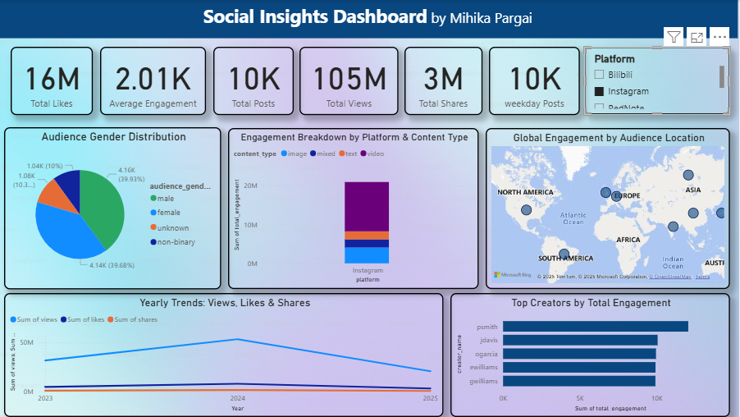

Overall Dashboard Insight:
The dashboard provides a clear picture of:
- Which platforms and content formats perform best
- How audience demographics are distributed
- Which regions contribute most engagement
- How engagement trends evolve over time
- Which creators are the strongest performers
Overall, this dashboard helps guide content strategy, posting schedule, platform focus, and audience targeting decisions.

