Software Requirements Specification

for

Encryption Tool

Version 1.0 approved

Prepared by Shefali Gill

**20th September 2016**

Table of Contents

Table of Contents ii

Revision History ii

1. Introduction 1

1.1 Purpose 1

1.2 Document Conventions 1

1.3 Intended Audience and Reading Suggestions 1

1.4 Product Scope 1

1.5 Use Case Diagram 2

1.6 References 2

2. Overall Description 3

2.1 Product Perspective 3

2.2 Product Functions 3

2.3 User Classes and Characteristics 3

2.4 Operating Environment 4

2.5 User Documentation 4

3. External Interface Requirements 5

3.1 User Interfaces 5

3.2 Hardware Requirements 5

3.3 Software Requirements 5

4. System Features 6

4.1 Learning Tool 6

4.2 Testing Tool 6

4.3 Encryption/DecryptionTool…………………..……………………………………6

5. Other Nonfunctional Requirements 7

5.1 Safety Requirements 7

5.2 Security Requirements 7

5.3 Software Quality Attributes 7

6. Other Requirements 8

**1. Introduction**

**1.1 Purpose**

This SRS document will go for depicting the general particulars and usefulness of our encryption device. This archive will give a point by point rundown of the details of the encryption tool and the framework and outline prerequisites. It will outline the different layers of the product and its components. It will give subtle elements of the encryption utilized as a part of the project and the learning perspective the device gives.

**1.2 Document Conventions**

This SRS record is composed in the Arial text style, with headings in text dimension 11 and depictions in text dimension 12.

**1.3 Intended Audience and Reading Suggestions**

This project has been outlined and executed by undergraduate students, under the department of software engineering. This project is proposed for overall population and business associations and encourages all who wish to utilize the encryption instrument or take in the nuts and bolts of cryptography in the digital world.

**1.4 Product Scope**

The product is proposed for individuals of fluctuating foundations and with no earlier learning of cryptography. This product helps people dig into the universe of cryptography and take in its working in the meantime giving them a product that puts to utilize the very ideas they learn. The product utilizes the RSA encryption calculation to give secure transmission of information over open channels. It additionally shows the individuals about RSA and numerous other encryption strategies. Organizations can utilize the product to encode and send touchy data, though the overall population can utilize it to find out about the universe of cryptography.

**1.5 Use Case Diagram**

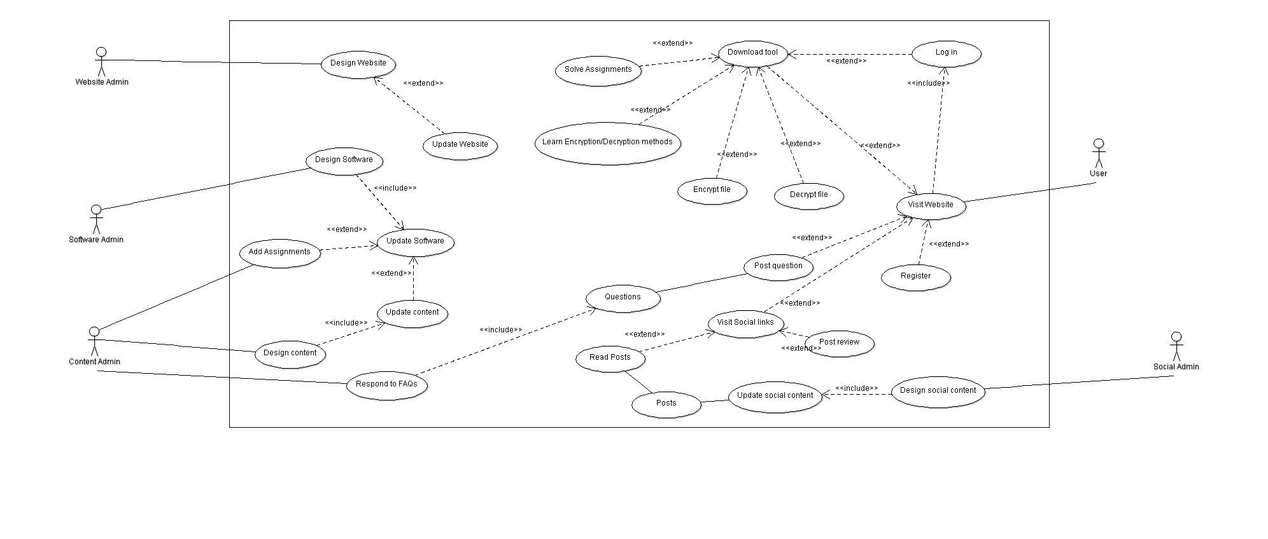

**1.6 References**

**2. Overall Description**

**2.1 Product Perspective**

This SRS report contains the subtle elements of the item viewpoint. It gives the itemized elements of our product alongside requirements, limitations, presumptions and conditions.

**2.2 Product Functions**

This product serves the accompanying capacities:

• Teaching the client the nuts and bolts of cryptography and different encryption procedures.

• Allowing clients to take assignments and tests to evaluate their present capability w.r.t. what they have learnt.

• Users can encode and decode literary information and documents got from any source utilizing the product.

**2.3 User Classes and Characteristics**

The clients will have the capacity to view data in light of their individual prerequisites and find out about the different cryptographic systems at their sought pace and accommodation. They will likewise have the capacity to encode and unscramble records essentially by moving the document into the product.

The client ought to be acquainted with the Windows UI and essential utilization of an internet searcher (Google, Bing, and so on.). The client can see any data relating to any subject identified with cryptography via hunting down the catchphrase in the given search bar.

**2.4 Operating Environment**

For the framework to run appropriately the purchaser must guarantee that on the machines there is the Java Runtime Environment introduced, ideally the most recent form with the goal that all overhauls are incorporated. Adaptation 7 Update 25 might be downloaded from this site: http://java.com/en/download/index.jsp.

The upside of utilizing java and its runtime surroundings is that it empowers the framework to keep running on any stage, whether it is Windows, Mac OS, Linux or Solaris. Makes it more compact and stage autonomous.

The client ought to likewise have a web-program that can run the most recent adaptation of HTML and JavaScript (ideally Google Chrome or Firefox).

**2.5 User Documentation**

All client documentation including client manual will be accessible online on the site. Any inquiries can be posted on the discussion accessible on the site and will be tended to by the designers.

**3. External Interface Requirements**

**3.1 User Interface**

The UI will be outlined utilizing front end dialects which will require a web-program to translate.

Customer side advances utilized are:

• HTML5

• JavaScript

• JQuery

• CSS

Server-side advances include:

• Java

• PHP

• Python

**3.2 Hardware Requirements**

• Microsoft Windows XP Professional SP3/Vista SP1/Windows 7 Professional:

o Processor: 800MHz Intel Pentium III or comparable

o Memory: 512 MB

o Disk space: 1GB of free plate space

• Ubuntu 9.10:

o Processor: 800MHz Intel Pentium III or comparable

o Memory: 512 MB

o Disk space: 1GBof free plate space

**3.3 Software Requirements**

• Java Runtime Environment

• Web Browser supporting HTML5, CSS, JavaScript

**4. System Features**

**4.1 Learning instrument**

The product gives literary data to instruct the client the nuts and bolts or cryptography and different strategies for encryption and unscrambling. This permits the client to tailor-make the course, to suit their learning rate and accommodation.

**4.2 Testing instrument**

The product permits clients to check the amount they have learnt by taking online tests and comprehending assignments to encourage their comprehension of the subject. These assignments are totally deliberate and can be taken by the client anytime amid the course. They offer fluctuated trouble and propose regions for development.

**4.3 Encryption/Decryption apparatus**

The product permits clients to scramble records and send them to a beneficiary. The beneficiary can unscramble the record utilizing the same programming. The product utilizes RSA strategy to encode and decode the information safely.

**5. Other Non-Functional Requirements**

**5.1 Safety Requirements**

The apparatus does not bring about any harm to your framework or information. Despite everything we prescribe utilizing an Anti-Virus programming to make your download more secure.

**5.2 Security Requirements**

The client may to allow the engineers to gather unknown use information and different details. The client should likewise enroll on the site to download the device and log-into utilization the site and instrument.

**5.3 Software Quality Attributes**

The Admins and designers will be accessible to answer the inquiries of the client and in noting the inquiry the administrators guarantee minimum conceivable deferral.

The instrument and site will be overhauled if any mistake is found or the client thinks that its hard to utilize.

The clients can report any issues on the site and all mysterious utilization details will likewise be utilized to locate any shrouded blunders.

**6. Other Requirements**

The product has no different necessities other than the ones said above.