**Assignment Number 01**

**Name:** Mihir Unmesh Patil

**Roll No:** TYCOC213

**Batch:** C/C-3

**Code:**

#include <stdio.h>

#include <stdlib.h>

#include <sys/types.h>

#include <sys/wait.h>

#include <unistd.h>

#include <string.h>

int main() {

int choice;

char searchTerm[100];

pid_t pid;

printf("Select an option:\n");

printf("1. Copy a file (cp)\n");

printf("2. Search in file (grep)\n");

printf("Enter choice: ");

scanf("%d", &choice);

getchar();

if (choice == 1) {

pid = fork();

if (pid == -1) {

perror("fork failed");

exit(1);

}

if (pid == 0) {

printf("Child (pid: %d) executing cp command\n", getpid());

execl("/bin/cp", "cp", "source.txt", "destination.txt", (char *)NULL);

perror("execl failed");

exit(1);

} else {

wait(NULL);

printf("Parent (pid: %d) cp process finished\n", getpid());

}

} else if (choice == 2) {

printf("Enter search term: ");

fgets(searchTerm, sizeof(searchTerm), stdin);

searchTerm[strcspn(searchTerm, "\n")] = 0;

pid = fork();

if (pid == -1) {

perror("fork failed");

exit(1);

}

if (pid == 0) {

printf("Child (pid: %d) executing grep command\n", getpid());

execl("/bin/grep", "grep", searchTerm, "file.txt", (char *)NULL);

perror("execl failed");

exit(1);

} else {

wait(NULL);

printf("Parent (pid: %d) grep process finished\n", getpid());

}

} else {

printf("Invalid choice!\n");

}

return 0;

}

**Output:**There are two outputs… The first output had direct command of cp as well as grep…while searching “m” only.

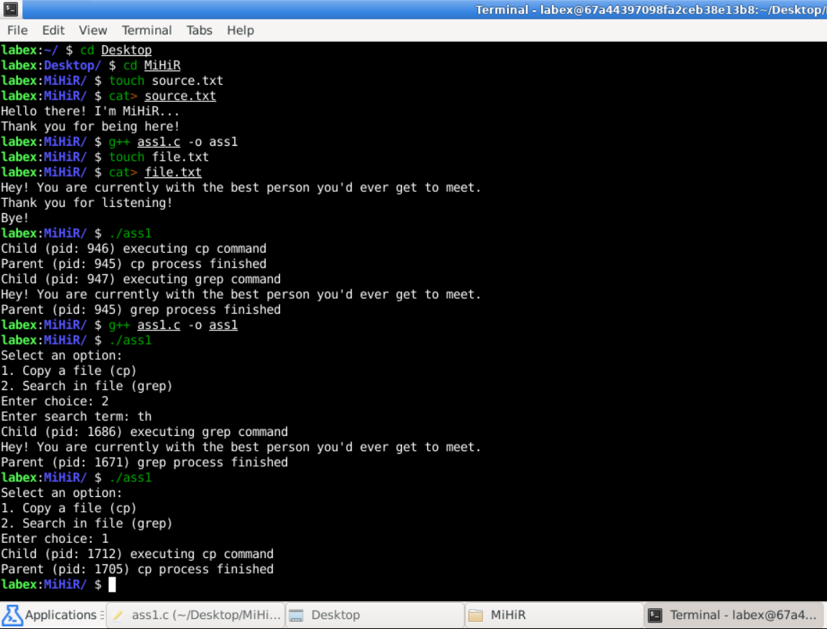

Destination.txt:

