**Assignment Number 01**

**Name:** Mihir Unmesh Patil

**Roll No**: TYCOC213

**Batch:** C/C-3

**Code:**

<!DOCTYPE html>

<html lang="en">

<head>

    <meta charset="UTF-8">

    <meta name="viewport" content="width=device-width, initial-scale=1.0">

    <title>Delicious Butter Chicken Recipe</title>

    <link rel="stylesheet" href="https://stackpath.bootstrapcdn.com/bootstrap/4.5.2/css/bootstrap.min.css">

    <style>

        body {

            font-family: 'Segoe UI', Tahoma, Geneva, Verdana, sans-serif;

            background: linear-gradient(120deg, #f8f9fa, #e9ecef);

            color: #333;

            margin: 0;

            padding: 0;

        }

        header {

            background: linear-gradient(120deg, #ff7e5f, #feb47b);

            padding: 40px 20px;

            text-align: center;

            color: #fff;

            border-bottom: 5px solid #ffcc00;

        }

        header h1 {

            font-size: 2.5rem;

            margin: 0;

        }

        header p {

            font-size: 1.2rem;

            margin: 10px 0 0;

        }

        .container {

            padding: 20px;

            max-width: 800px;

            margin: 0 auto;

            box-shadow: 0 4px 20px rgba(0, 0, 0, 0.1);

            background-color: #fff;

            border-radius: 12px;

        }

        .recipe-section {

            margin-bottom: 30px;

        }

        h2 {

            font-size: 1.8rem;

            margin-bottom: 20px;

            color: #ff7e5f;

            text-align: center;

        }

        ul, ol {

            padding-left: 20px;

        }

        li {

            line-height: 1.6;

            font-size: 1rem;

        }

        .image-container {

            background: #fff5f5;

            border: 2px dashed #feb47b;

            padding: 20px;

            border-radius: 8px;

            text-align: center;

        }

        img {

            max-width: 100%;

            border-radius: 8px;

            transition: transform 0.3s ease;

        }

        img:hover {

            transform: scale(1.05);

        }

        footer {

            text-align: center;

            background: #feb47b;

            color: #fff;

            padding: 15px;

            margin-top: 30px;

            border-top: 5px solid #ff7e5f;

        }

        footer p {

            margin: 0;

            font-size: 0.9rem;

        }

    </style>

</head>

<body>

<header>

    <h1>Delicious Butter Chicken Recipe</h1>

    <p>Enjoy this classic Indian dish!</p>

</header>

<div class="container">

    <section class="recipe-section">

        <h2>Ingredients</h2>

        <ul>

            <li><strong>For General Recipe:</strong>

                <ol>

                    <li>½ cup natural yogurt</li>

                    <li>Juice of ½ lemon</li>

                    <li>1 tsp ground turmeric</li>

                    <li>2 tsp garam masala</li>

                    <li>1 tsp ground cumin</li>

                    <li>1 tsp red chili powder</li>

                    <li>1 tbsp fresh ginger, grated</li>

                    <li>3 cloves garlic, minced</li>

                    <li>Cashews</li>

                    <li>1 kg chicken breast or thighs, cut into cubes</li>

                </ol>

            </li>

            <li><strong>For the Sauce:</strong>

                <ol>

                    <li>2 tbsp vegetable oil</li>

                    <li>1 onion, finely chopped</li>

                    <li>2 cloves garlic, minced</li>

                    <li>500 ml crushed tomato</li>

                    <li>500 ml heavy cream</li>

                    <li>1 tbsp sugar</li>

                    <li>Salt to taste</li>

                </ol>

            </li>

        </ul>

    </section>

    <section class="image-container recipe-section">

        <h2>Butter Chicken Image</h2>

        <img src="https://i2.wp.com/www.downshiftology.com/wp-content/uploads/2022/04/Butter-Chicken-Ingredients.jpg" alt="Butter Chicken Ingredients">

    </section>

    <section class="recipe-section">

        <h2>Instructions</h2>

        <ol>

            <li>If using bone-in chicken thighs, make 2 to 3 deep gashes in the chicken; skip this if you use the boneless pieces.</li>

            <li>Place all the ingredients for the marinade in a medium bowl or zip-top bag and combine until smooth. Fold in the chicken and make sure the chicken is completely coated with the marinade. Leave in the refrigerator covered for 1 hour, preferably overnight.</li>

            <li>When ready to cook, preheat the oven to 400F/200C.</li>

            <li>Lay the marinated chicken pieces out on a baking dish or roasting pan. Roast the chicken in the oven until the internal temperature reaches 164F/74C, 30 to 45 minutes (boneless chicken takes about 20 minutes), rotating the dish halfway through during cooking.</li>

            <li>At the 20-minute mark of cooking the chicken, start the sauce. Melt the butter in a medium Dutch oven or saucepan over low heat. Add the Kashmiri chili powder, toasted cumin, garlic, ginger, garam masala, and green chili. Stir until fragrant, then add the tomato paste and cook until the paste begins to turn light brown. Pour in the heavy cream and add the chicken. Stir in lemon juice, season with salt, and bring to a boil over medium-high heat. Serve hot with rice or naan.</li>

        </ol>

    </section>

    <section class="image-container recipe-section">

        <h2>Final Dish Image</h2>

        <img src="https://foodess.com/wp-content/uploads/2022/10/Foodess-Best-Butter-Chicken-1-2-819x1024.jpg" alt="Final Butter Chicken Dish">

    </section>

    <footer>

        <p>&copy; 2025 Delicious Recipes | All Rights Reserved</p>

    </footer>

</div>

</body>

</html>

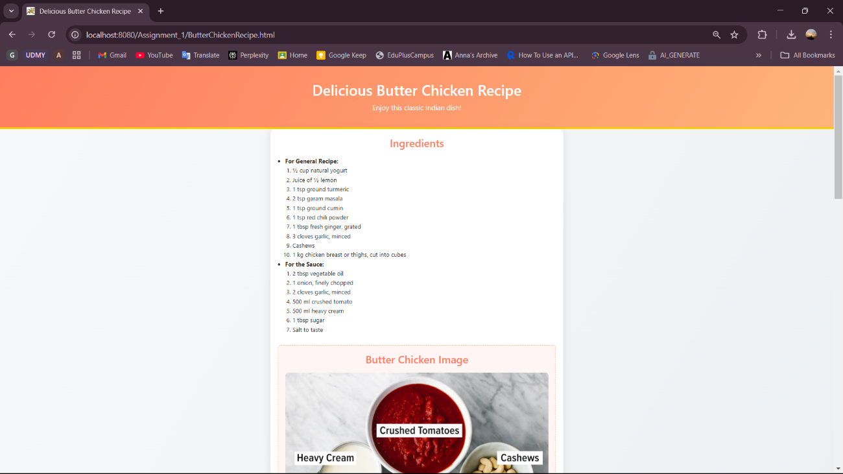

**Output:**

