**Assignment Number 03**

**Name:** Mihir Unmesh Patil

**Roll No**: TYCOC213

**Batch:** C/C-3

**CODE:**

**Shiporder.xml:**  
<?xml version="1.0" encoding="UTF-8"?>

<shiporder orderid="123"

xmlns:xsi="http://www.w3.org/2001/XMLSchema-instance"

xsi:noNamespaceSchemaLocation="shiporder.xsd">

  <orderperson>ABCD1</orderperson>

  <shipto>

    <name>ABCD</name>

    <address>sdfsdf</address>

    <city>Pune</city>

    <country>India</country>

  </shipto>

  <item>

    <title>Mobile Phone</title>

    <note>Special Edition</note>

    <quantity>1</quantity>

    <price>24555.77</price>

  </item>

  <item>

    <title>Car</title>

    <quantity>1</quantity>

    <price>124566</price>

  </item>

</shiporder>

**Shioorder.xsd:**

<?xml version="1.0" encoding="UTF-8" ?>

<xs:schema xmlns:xs="http://www.w3.org/2001/XMLSchema">

<xs:element name="shiporder">

  <xs:complexType>

    <xs:sequence>

      <xs:element name="orderperson" type="xs:string"/>

      <xs:element name="shipto">

        <xs:complexType>

          <xs:sequence>

            <xs:element name="name" type="xs:string"/>

            <xs:element name="address" type="xs:string" minOccurs="1" />

            <xs:element name="city" type="xs:string"/>

            <xs:element name="country" type="xs:string"/>

          </xs:sequence>

        </xs:complexType>

      </xs:element>

      <xs:element name="item" maxOccurs="unbounded">

        <xs:complexType>

          <xs:sequence>

            <xs:element name="title" type="xs:string"/>

            <xs:element name="note" type="xs:string" minOccurs="0"/>

            <xs:element name="quantity" type="xs:positiveInteger"/>

            <xs:element name="price" type="xs:decimal"/>

          </xs:sequence>

        </xs:complexType>

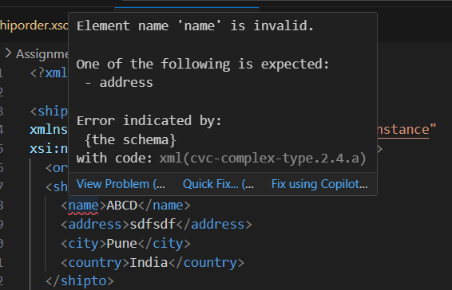      </xs:element>

    </xs:sequence>

    <xs:attribute name="orderid" type="xs:string" use="required"/>

  </xs:complexType>

</xs:element>

</xs:schema>

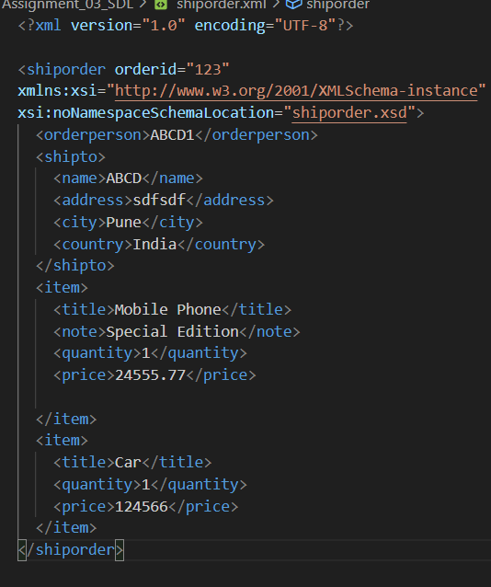**OUTPUT:**

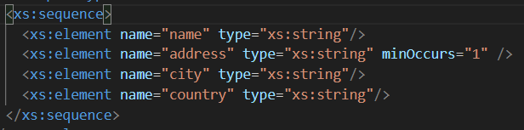

Changed to:

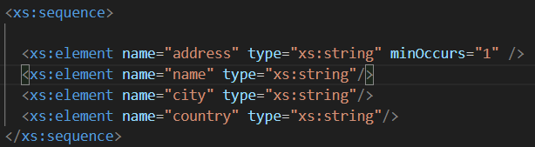

XML FILE:

Changed to: