**Assignment Number 06**

**Name:** Mihir Unmesh Patil

**Roll No**: TYCOC213

**Batch:** C/C-3

**CODE:**

**Contact.html:**

<!DOCTYPE html>

<html xmlns="http://www.w3.org/1999/xhtml">

<head>

<meta http-equiv="Content-Type" content="text/html; charset=utf-8" />

<title>Contact Form - PHP/MySQL Demo Code</title>

</head>

<body>

<fieldset>

<legend>Contact Form</legend>

<form name="frmContact" method="post" action="contact.php">

<p>

<label for="fname">fname </label>

<input type="text" name="txtfname" id="txtfname">

</p>

<p>

<label for="mname">mname</label>

<input type="text" name="mname" id="mname">

</p>

<p>

<label for="lname">lname</label>

<input type="text" name="lname" id="lname">

</p>

<p>

<label for="pwd">pwd</label>

<textarea name="txtpwd" id="txtpwd"></textarea>

</p>

<p>&nbsp;</p>

<p>

<input type="submit" name="Submit" id="Submit" value="Submit">

</p>

</form>

</fieldset>

</body>

</html>

**Contact,php:**

<?php

// Database connection

$con = mysqli_connect('localhost', 'root', 'Mihir0209', 'Student');

// Check if the connection was successful

if (!$con) {

    die("Database connection failed: " . mysqli_connect_error());

}

// Get the POST records safely

$txtfname = mysqli_real_escape_string($con, $_POST['txtfname']);

$txtmname = mysqli_real_escape_string($con, $_POST['mname']);

$txtlname = mysqli_real_escape_string($con, $_POST['lname']);

$txtpwd   = mysqli_real_escape_string($con, $_POST['txtpwd']);

$sql = "INSERT INTO `registration` (`fname`, `mname`, `lname`, `pwd`)

        VALUES ('$txtfname', '$txtmname', '$txtlname', '$txtpwd')";

// Execute the insert query

if (mysqli_query($con, $sql)) {

    echo "✅ Contact Record Inserted Successfully! <br><br>";

} else {

    echo "❌ Error: " . mysqli_error($con);

}

// Fetch records from the database

$sql = "SELECT * FROM `registration`";

$result = mysqli_query($con, $sql);

// Check if records exist

if (mysqli_num_rows($result) > 0) {

    while ($row = mysqli_fetch_assoc($result)) {

        echo "EMP ID : " . $row['Id'] . " <br> ";

        echo "EMP First NAME : " . $row['fname'] . " <br> ";

        echo "EMP Middle Name : " . $row['mname'] . " <br> ";

        echo "EMP Last Name : " . $row['lname'] . " <br> ";

        echo "--------------------------------<br>";

    }

} else {

    echo "⚠️ No records found!";

}

// Close the connection

mysqli_close($con);

?>

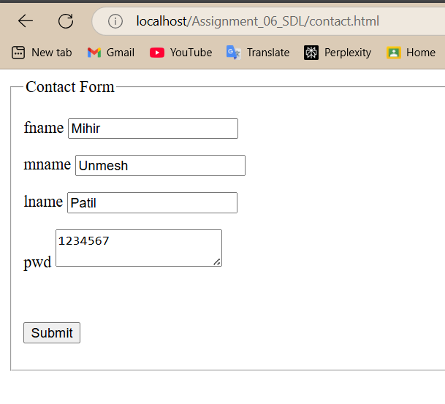

**OUTPUT:**

