**Simulation time issues :**

* Support structure module was being called multiple times + Teamplay was called multiple times inside support structure module. This took upto 15-20 minutes.
* Linearization : Linearization was being performed at all wind speeds from 5 to 25 for around 68 seconds which took upto half an hour.
* ULS : 3 load cases were being run in which, DLC1.3 was run for 600 seconds.
* Control.DT used for linearization and ULS was 0.008
* Practical issues with FAST as for some seeds, Vx might go to -ve values and it gives an error. Therefore, running it for long simulation times has higher chances of running into an error.
* Fatigue was not considered at this moment because evaluating fatigue damage would take additional 2 hours

All of this led to a total function evaluation time of around 1.5 hours

**Decisions taken :**

* Teamplay was called only once and all values of costs, diameters and thickness were extracted. Support structure is yet being called 5 times as there are 5 connects. Total time taken is around 2-3 minutes.
* Linearization : Linearization is now done from rated to 25 in intervals of 2 m/s. [11.4, 13, 15, ….25]. Also, linearization time was reduced to around 15 seconds as the transients for power and pitch angles died out by then. This reduced the overall time to around 5 minutes.
* ULS : ULS was run for only one load case that was the worst, DLC1.3. This would also help in making a direct comparison with the static model as the loads and stresses there are maximum for rated wind speeds.
* Time domain simulations with 10 different seeds were done and the results of tip deflection and moments were analyzed for different simulation time steps. This would help in viewing the variation of average values over time and also the dependence of that particular simulation time on the number of seeds.
* The decision taken was to go for a fixed seed that would give the highest tip deflection and root moment for 60-100 seconds and use a factor of safety so as to compensate for missing out on extremes that might have occurred if it was run for 600 s. Longer simulation times would mean higher chances of error.
* It should be kept in mind that the purpose of running the DLC was not to certify the turbine but to use it for optimization purposes. Thus, reducing the simulation time is an important concern. Also, keeping a fixed seed would mean a ‘fairer’ comparison between different designs. Otherwise, there would have been instances when a particular design might have the highest tip deflection because of a particular seed and another, less stiffer design might have a tip deflection lower than the previous case because it encountered a seed that would produce a lower extreme.
* For simulation removal time (first few seconds), finally check when tip deflection and root moments settle instead of tower acc. etc.
* Control.DT (time step for the fixed integrator) depends on the highest blade frequency and at least a minimum factor of that. It significantly reduces simulation time. Run BModes, check for frequencies and see what factor of that should be used.
* For Fatigue, maybe a surrogate model will be developed for few design combinations based on Latin Hypercube sampling.

**Analysis :**

* A simple simulation of FAST for steady wind speeds shows that the tip deflection and root moments settle (transients die out) within the first 20 seconds. These transients are due to a different initial point given to FAST because of which the rotor has to accelerate or decelerate instantly. Thus, first 20 seconds of the simulation will be removed.

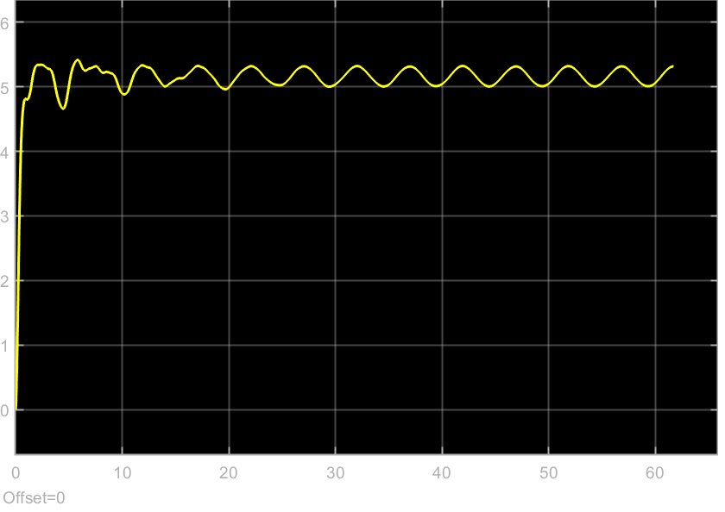

* For linearization (rated and above), the quantity of interest is aerodynamic power sensitivity and hence, the power and pitch values were analyzed. The power transients die out within 15 seconds while the pitch angle remains constant. Hence, linearization was done for 15 seconds only.

Control.DT depends on the highest system natural frequency and as recommended by the FAST guide, Control.DT < 1/(10*Highest natural frequency). (Readme_FAST).

The highest system natural frequency in Table 9 is around 3 Hz, which is of the tower. However, the Nacelle yaw DOF has a frequency of about 6 Hz, leading to a time step of 0.015 s.

Rotor mass: (19*3 = 72 tonnes) is about 20 % of the RNA mass : 350 tonnes. During optimization, a change in the mass of about 6 tonnes changes the RNA mass by around 1 ~ 2 %, which means that the natural frequency of the yaw DOF won’t be affected. Hence, a constant time step of 0.015 s was used throughout.

Function evaluation time now is : 5-10 mins. Charging increases the frequency to above 2.4 GHz and reduces time from 10 mins to 6 mins

Ultimate Limit States :

10 different seeds were run for a 600 second time simulation to analyze the tip deflection and the root moment .

The stochastic nature of the wind is clearly visible, if the range of output values for each simulation time step is viewed. The range slightly decreases as a full 10 min simulation is performed but does not completely eliminate the problem.

* Running for 600 s reduces the stochastic nature, however drastically increases the time for one function evaluation.
* Running for 60 s has a higher range but at the same time, reduces the function evaluation time 10 fold.
* The stochastic nature of wind would give different realizations even for the slightest change in designs and the optimizer would be all around the place ( different constraint every time) if a gradient based optimizer is used. Hence, the decision of using a constant seed that gives the highest realization was used. A constant wind profile would enable a fair comparison between different designs.
* A safety factor was applied, based on the average values as the average value captures the dependence of that particular simulation time on the no. of seeds. Also, the seed with the highest realization was chosen for the optimization to compensate for the low sample size that was tested. In reality, worse conditions that can lead to an extreme higher than the current maximum value exists. Taking the seed with the highest value multiplied with the safety factor based on average values would compensate for : A lower simulation time and a smaller sample size of just 10 seeds.
* Tip deflection Safety factor : 1.16
* Root Moment safety factor : 1.13
* An averaged safety factor of 1.15 was applied to both.

**ULS stresses comparison with SANDIA:**

DLC 1.3 Conversion factor for strains :

Flapwise : 0.787

Edgewise : 0.885

|  |  |  |  |  |  |  |
| --- | --- | --- | --- | --- | --- | --- |
| Material | SANDIA | | Dynamic model | | Static (without 1.5) | |
|  | Flapwise | Edgewise | Flapwise | Edgewise | Flapwise | Edgewise |
| T.E. Reinf | 168 | 133 | - | 143 | - | 120.57 |
| Skin |  | 89 | 85.3 | 74 | 68 | 62 |
| UD | 460 |  | 446 | - | 353 | - |

**Tip Deflection :**

SANDIA, DLC1.3 at 19 m/s : 5.6 m

My model, DLC1.3 at rated : 4.5 m Static : 3.7 m (Without 1.5)

My model, DLC1.3 at 19 m/s : 2.85 m