MySQL database and tables created successfully.
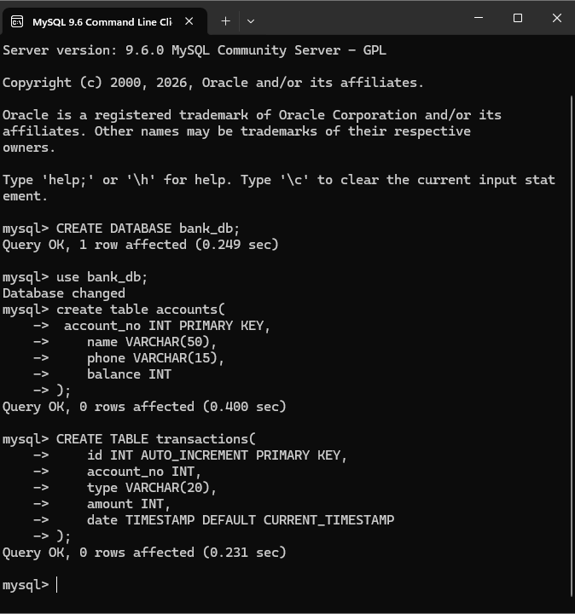
Bank Management System running successfully in terminal.
