Probability & Stats Project Report
MACD-Based Technical Analysis

Stock: ANGELONE LIMITED (NSE: ANGELONE)



Mihir Deogaonkar (612515381)
Tanishq Bharud (612515312)

1. Company Overview – Angel One Limited

1.1 About the Company
Angel One Limited (formerly known as Angel Broking Limited) is one of India's largest full-service retail broking and financial-services companies. Incorporated in 1996 and headquartered in Mumbai, Maharashtra. The company offers products including equity and commodity broking, currency derivatives, mutual funds, insurance distribution, loans against securities, and algo-trading services through its proprietary platform and mobile application.
Angel One is listed on both the National Stock Exchange (NSE) and the Bombay Stock Exchange (BSE) under the ticker symbol ANGELONE.

1.2 Key Financial & Market Snapshot
Attribute | Details
Listed Exchange | NSE & BSE
Ticker Symbol | ANGELONE
Sector | Capital Markets / Financial Services
Industry | Stockbroking & Wealth Management
Market Cap (approx.) | ₹ ~22,000 Cr (as of early 2026)
52-Week High (in data) | ₹ 3,681.34
52-Week Low (in data) | ₹ 1,910.15
Data Window | April 2021 – February 2026
Founding Year | 1996
Headquarters | Mumbai, Maharashtra, India

1.3 Business Model & Competitive Position
Angel One operates on a flat-fee, discount-brokerage model, charging ₹20 or 0.25% (whichever is lower) per executed order. As of FY 2024-25, the company had over 22 million registered clients, making it one of the top three retail brokers in India by active client base. Key revenue drivers include brokerage income, distribution commissions, interest income from margin funding, and subscription fees for premium advisory services.

2. Moving Average Convergence Divergence (MACD)

2.1 Overview
The Moving Average Convergence Divergence (MACD) is a momentum-based trend-following oscillator developed by Gerald Appel in the late 1970s. It measures the relationship between two Exponential Moving Averages (EMAs) of a security's closing price, making it simultaneously a trend indicator and a momentum indicator. Because it oscillates above and below a zero line, it can identify the direction, duration, momentum, and strength of a trend, and signal potential reversals when the indicator and price diverge.

2.2 Mathematical Formulation
The MACD system consists of three components derived from the closing price series:
Component | Formula | Parameters Used
Fast EMA | EMA(Close, n_fast) | n_fast = 12 periods
Slow EMA | EMA(Close, n_slow) | n_slow = 26 periods
MACD Line | Fast EMA − Slow EMA | —
Signal Line | EMA(MACD Line, n_signal) | n_signal = 9 periods
Histogram | MACD Line − Signal Line | —

All EMAs are computed using the standard recursive formula

EMAₜ = α × Priceₜ + (1 − α) × EMAₜ₋₁ where α = 2 / (n + 1)

2.3 Parameter Selection (12, 26, 9)
The default parameters 12, 26, and 9 are the industry-standard settings originally proposed by Gerald Appel. The 12-period fast EMA reacts quickly to recent price changes, while the 26-period slow EMA provides a smoother, longer-term baseline. Their difference (the MACD line) captures short-to-medium-term momentum. The 9-period signal EMA smooths out the MACD line's noise and triggers crossover signals.

2.4 Signal Generation Rules
Two types of crossover signals are used in this study:
Signal Type | Condition | Action
Bullish Crossover (BUY) | MACD Line crosses ABOVE Signal Line  (prev: MACD ≤ Signal; curr: MACD > Signal) | Enter long at Close of crossover bar
Bearish Crossover (SELL) | MACD Line crosses BELOW Signal Line  (prev: MACD ≥ Signal; curr: MACD < Signal) | Exit long at Close of crossover bar

The crossover flag is set on bar i−1 (detected by comparing bars i−1 and i), and the trade executes at that bar's close price. Each bullish crossover is paired with the chronologically next bearish crossover; each sell signal can only be used once.

2.5 Interpretation of the Histogram
The MACD histogram visually represents the gap between the MACD line and the Signal line. A growing histogram indicates accelerating momentum in the direction of the trend. Shrinking bars suggest momentum is fading, and a histogram crossing zero corresponds to a MACD–Signal line crossover. Histogram divergences with price (price making new highs/lows while the histogram does not) serve as an early warning of trend exhaustion.

3. Methodology & Data

3.1 Data Description

Timeframe | Period | Source
Daily | Feb 17, 2025 – Feb 13, 2026 | Yahoo Finance / NSE
Weekly | Oct 30, 2023 – Feb 09, 2026 | Yahoo Finance / NSE
Monthly | Apr 01, 2021 – Feb 01, 2026 | Yahoo Finance / NSE

3.2 Implementation
The analysis was implemented in Python 3 using the following libraries: pandas (data processing and EMA computation), mplfinance (candlestick charts), and matplotlib (additional chart customisation). OHLCV data was loaded from CSV files exported via yfinance. Each CSV had a two-level header; the second level (ticker name) was dropped and column names were stripped of whitespace before analysis.
The backtesting strategy pairs each bullish crossover with the first subsequent bearish crossover, using a pointer-based approach. Open trades at the end of the data window are closed at the last available bar's close price.

4. Backtesting Results

4.1 Daily Timeframe (Feb 2025 – Feb 2026)
The chart below shows ANGELONE candlesticks with MACD buy/sell markers on the price panel and the MACD oscillator on the lower panel. Green triangles mark entry points, red triangles mark exits.
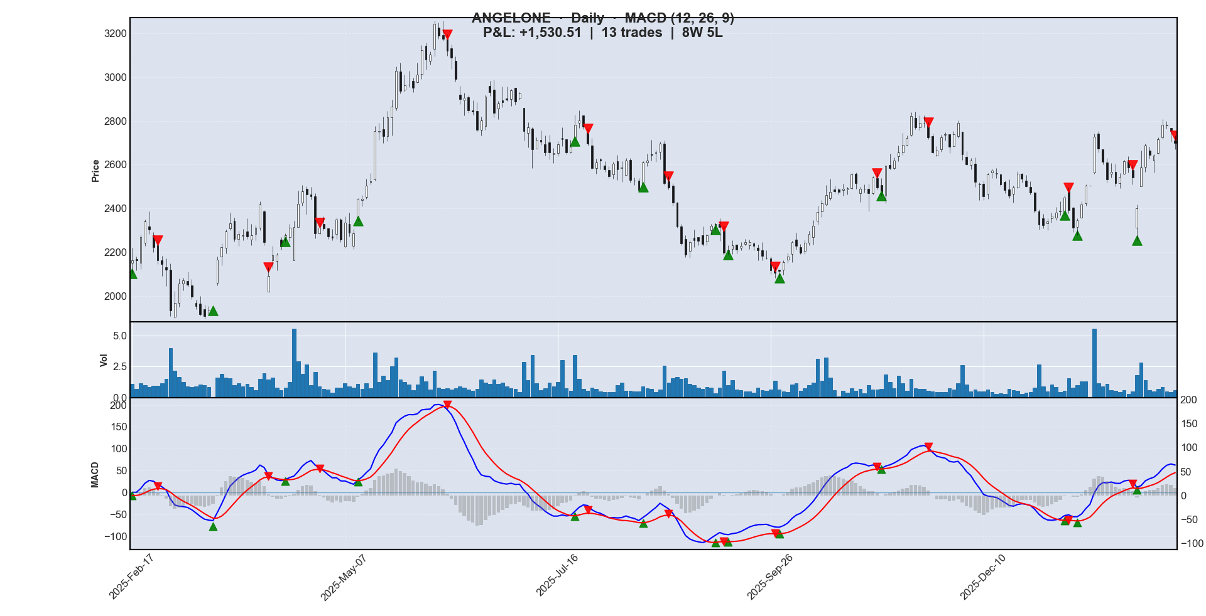
Figure 1 – ANGELONE Daily Chart with MACD (12,26,9) crossover signals [Feb 2025 – Feb 2026]
Buy Date | Buy ₹ | Sell Date | Sell ₹ | P&L ₹ | P&L % | Result
2025-02-17 | 2162.52 | 2025-02-25 | 2164.04 | +1.52 | +0.07% | ✓
2025-03-18 | 1935.92 | 2025-04-07 | 2093.57 | +157.65 | +8.14% | ✓
2025-04-15 | 2278.27 | 2025-04-28 | 2313.45 | +35.18 | +1.54% | ✓
2025-05-12 | 2443.95 | 2025-06-10 | 3117.95 | +674.00 | +27.58% | ✓
2025-07-22 | 2780.92 | 2025-07-25 | 2696.36 | −84.56 | −3.04% | ✗
2025-08-13 | 2608.83 | 2025-08-22 | 2496.62 | −112.21 | −4.30% | ✗
2025-09-09 | 2315.62 | 2025-09-11 | 2196.66 | −118.95 | −5.14% | ✗
2025-09-12 | 2202.91 | 2025-09-29 | 2106.36 | −96.55 | −4.38% | ✗
2025-09-30 | 2113.89 | 2025-11-04 | 2496.42 | +382.53 | +18.10% | ✓
2025-11-06 | 2464.80 | 2025-11-21 | 2724.12 | +259.32 | +10.52% | ✓
2026-01-07 | 2449.04 | 2026-01-08 | 2391.55 | −57.49 | −2.35% | ✗
2026-01-12 | 2347.83 | 2026-01-30 | 2540.90 | +193.07 | +8.22% | ✓
2026-02-02 | 2401.30 | 2026-02-13 | 2698.30 | +297.00 | +12.37% | ✓

Summary: 13 trades | 8 wins | 5 losses | Win rate: 61.5% | Total P&L: +₹ 1,530.51

4.2 Weekly Timeframe (Oct 2023 – Feb 2026)
On the weekly chart, signals are fewer but each trade holds for several weeks
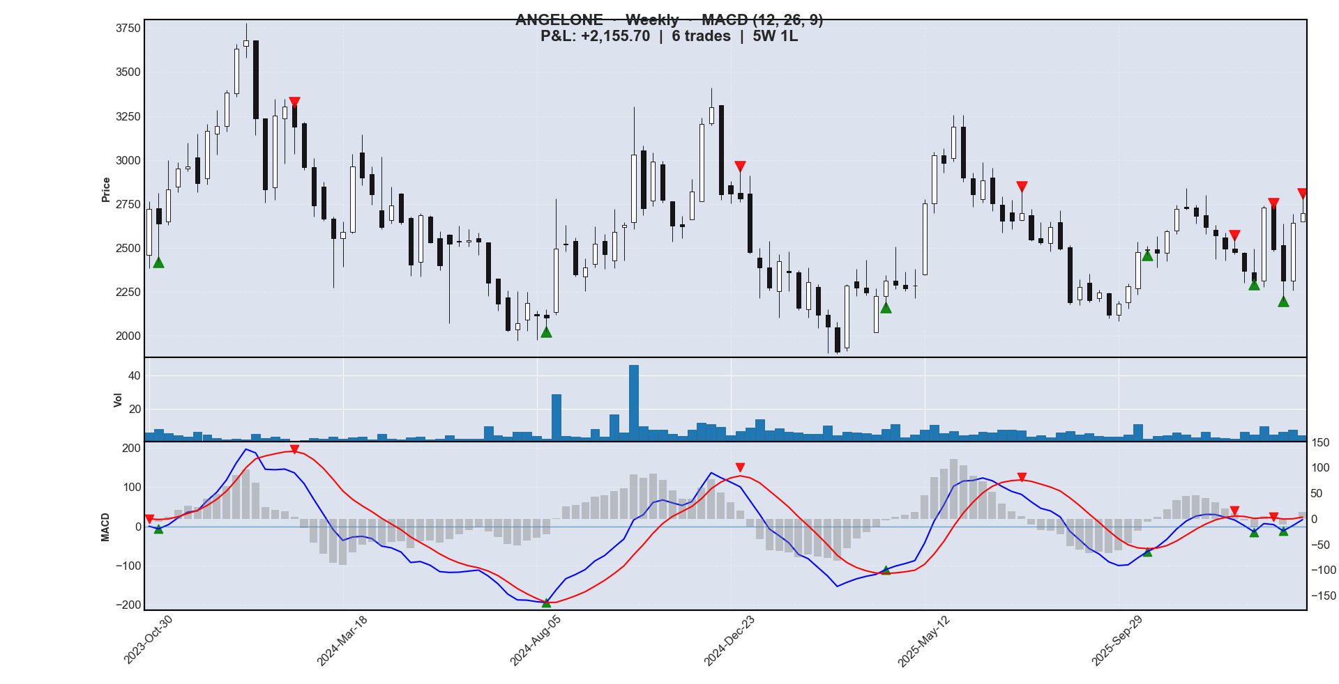
Figure 2 – ANGELONE Weekly Chart with MACD (12,26,9) crossover signals [Oct 2023 – Feb 2026]
Buy Date | Buy ₹ | Sell Date | Sell ₹ | P&L ₹ | P&L % | Result
2023-11-06 | 2638.60 | 2024-02-12 | 3188.86 | +550.26 | +20.85% | ✓
2024-08-12 | 2103.24 | 2024-12-30 | 2780.95 | +677.71 | +32.22% | ✓
2025-04-14 | 2315.41 | 2025-07-21 | 2696.36 | +380.95 | +16.45% | ✓
2025-10-20 | 2492.56 | 2025-12-22 | 2474.02 | −18.54 | −0.74% | ✗
2026-01-05 | 2313.14 | 2026-01-19 | 2493.15 | +180.02 | +7.78% | ✓
2026-01-26 | 2313.00 | 2026-02-09 | 2698.30 | +385.30 | +16.66% | ✓

Summary: 6 trades | 5 wins | 1 loss | Win rate: 83.3% | Total P&L: +₹ 2,155.70

4.3 Monthly Timeframe (Apr 2021 – Feb 2026)
The monthly chart spans Angel One's entire post-listing history in this dataset. Only three MACD crossovers occurred over five years, each capturing a major multi-month trend phase.

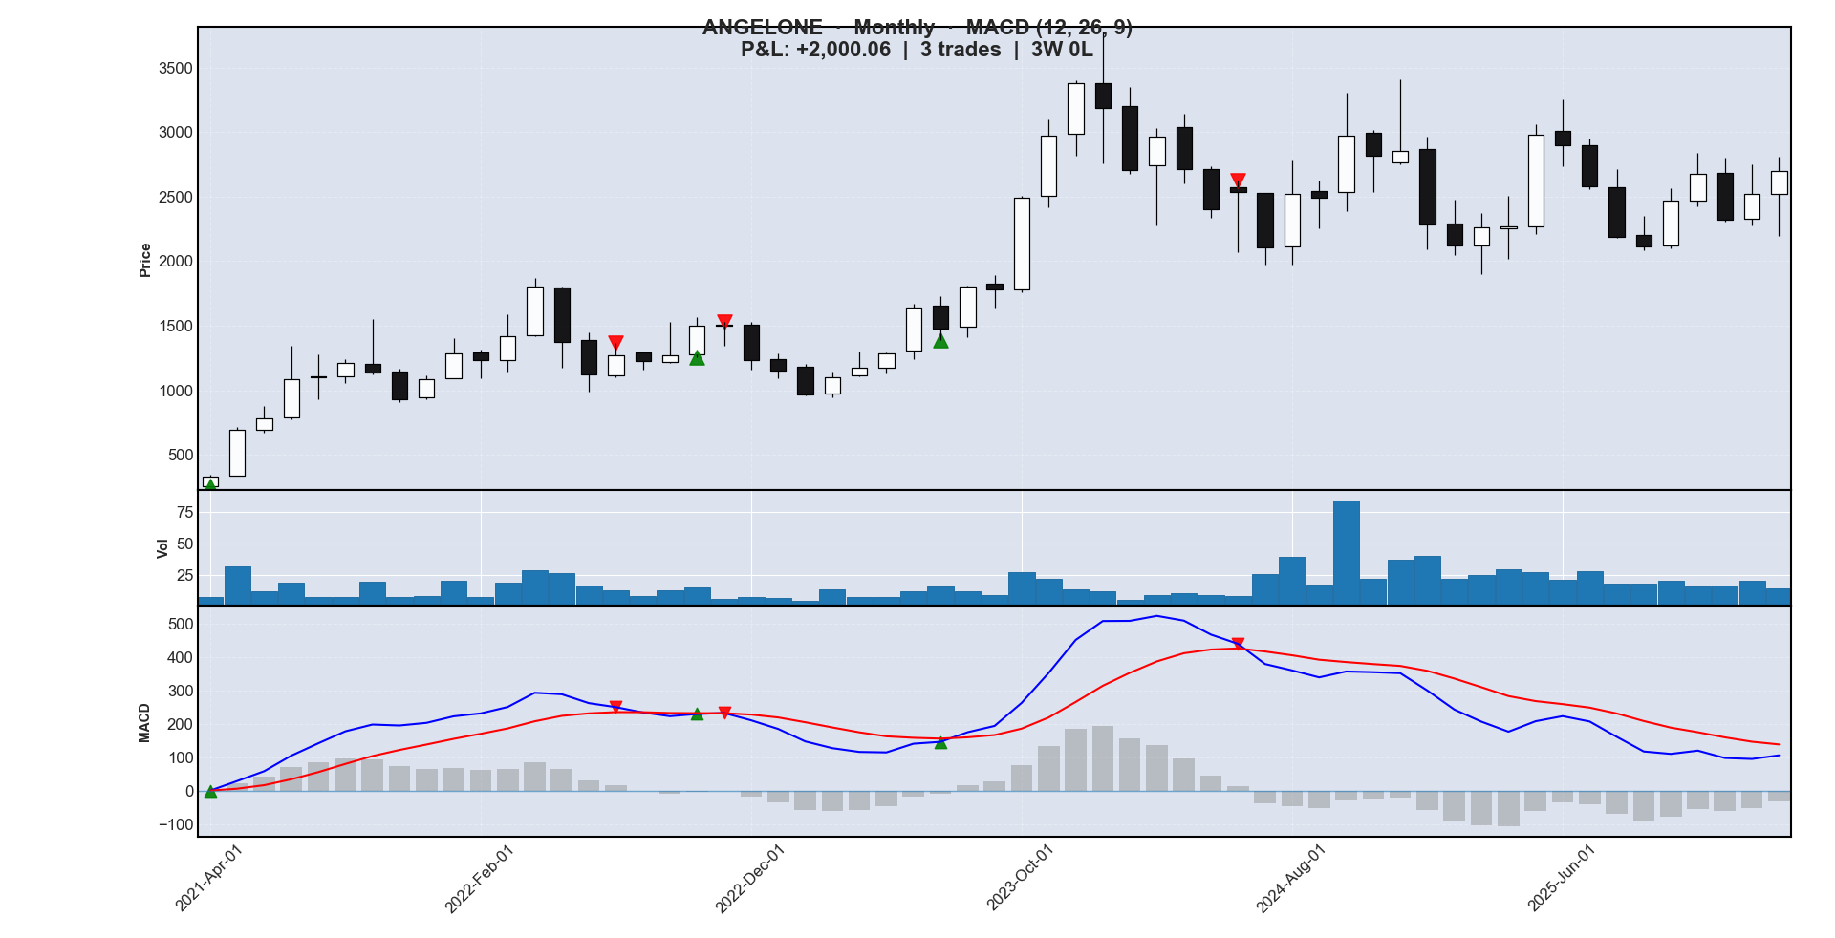
Figure 3 – ANGELONE Monthly Chart with MACD (12,26,9) crossover signals [Apr 2021 – Feb 2026]
Buy Date | Buy ₹ | Sell Date | Sell ₹ | P&L ₹ | P&L % | Result
2021-04-01 | 331.32 | 2022-07-01 | 1272.10 | +940.77 | +283.94% | ✓
2022-10-01 | 1500.16 | 2022-11-01 | 1503.41 | +3.25 | +0.22% | ✓
2023-07-01 | 1477.41 | 2024-06-01 | 2533.44 | +1056.04 | +71.48% | ✓

Summary: 3 trades | 3 wins | 0 losses | Win rate: 100.0% | Total P&L: +₹ 2,000.06

5. Analysis Across Timeframes

Metric | Daily | Weekly | Monthly
Period Covered | Feb 2025 – Feb 2026 | Oct 2023 – Feb 2026 | Apr 2021 – Feb 2026
Number of Bars | 246 | 120 | 59
Total Trades | 13 | 6 | 3
Wins | 8 | 5 | 3
Losses | 5 | 1 | 0
Win Rate | 61.5% | 83.3% | 100.0%
Total P&L (₹ per share) | +1,530.51 | +2,155.70 | +2,000.06
Best Trade | +27.58% | +32.22% | +283.94%
Worst Trade | −5.14% | −0.74% | +0.22%

5.1 Observations
1. Higher timeframes produce fewer but higher-quality signals. The monthly chart generated only 3 trades with a 100% win rate, while the daily chart produced 13 trades with a 61.5% win rate, consistent with the well-known "noise vs. signal" trade-off in technical analysis.
2. The daily timeframe captured the most extreme single gain (+27.58% on the May–June 2025 breakout) and the most concentrated run of losses (four consecutive losing trades during August–September 2025)
3. The weekly timeframe offered the best balance between trade frequency and accuracy, achieving 83.3% win rate, with the best individual trade of +32.22% (August 2024 – December 2024).
4. The monthly chart's +283.94% trade (April 2021 – July 2022), demonstrating that MACD on higher timeframes can hold through major price cycles with very little noise.

5.2 Limitations
This backtest assumes: (a) trades execute at the exact close price of the crossover bar; (b) there are no brokerage costs, taxes; (c) no risk management (stop-losses or position sizing) is applied

6. Code Implementation
This section presents the key code segments of the project. The implementation is split across two Python scripts: datafetch.py, which fetches historical OHLCV data from Yahoo Finance, and macd.py, which computes the MACD indicator, detects crossovers, simulates trades, and renders the charts.

6.1 Data Fetching (datafetch.py)
Historical price data for ANGELONE.NS is fetched using the yfinance library. Three separate calls retrieve daily, weekly, and monthly OHLCV bars, each saved to a CSV file that the analysis script reads.
import yfinance as yf
from datetime import datetime, timedelta
import time

symbol = "ANGELONE.NS"
end_date = datetime.now()

# ── 1. Daily data – last 365 calendar days ──────────────────────────────
start_date_daily = end_date - timedelta(days=365)

daily_data = yf.download(
symbol,
start = start_date_daily,
end = end_date,
interval = "1d",
progress = False
)
daily_data.to_csv("angelone_daily_365d.csv")

time.sleep(2) # polite delay between API calls

# ── 2. Weekly data – last 120 weeks (~2.3 years) ────────────────────────
start_date_weekly = end_date - timedelta(weeks=120)

weekly_data = yf.download(
symbol,
start = start_date_weekly,
end = end_date,
interval = "1wk",
progress = False
)
weekly_data.to_csv("angelone_weekly_120w.csv")

time.sleep(2)

# ── 3. Monthly data – last 60 months (~5 years) ─────────────────────────
start_date_monthly = end_date - timedelta(days=60 * 30)

monthly_data = yf.download(
symbol,
start = start_date_monthly,
end = end_date,
interval = "1mo",
progress = False
)
monthly_data.to_csv("angelone_monthly_60m.csv")

datafetch.py: Downloads OHLCV data for ANGELONE.NS across three timeframes using yfinance.

6.2 MACD Calculation (macd.py)
The calculate_macd() function takes an OHLCV DataFrame and returns the MACD line, Signal line, Histogram, and two Boolean series marking bullish and bearish crossover bars. All EMAs are computed with pandas .ewm()
def calculate_macd(df, fast=12, slow=26, signal=9):
# ── Exponential Moving Averages ─────────────────────────────────────
exp1 = df["Close"].ewm(span=fast, adjust=False).mean() # fast EMA
exp2 = df["Close"].ewm(span=slow, adjust=False).mean() # slow EMA

macd = exp1 - exp2 # MACD line
signal_line = macd.ewm(span=signal, adjust=False).mean() # Signal line
histogram = macd - signal_line # Histogram

# ── Crossover Detection ─────────────────────────────────────────────
bullish_crossover = pd.Series(index=df.index, data=False)
bearish_crossover = pd.Series(index=df.index, data=False)

for i in range(1, len(macd)):
prev_macd, curr_macd = macd.iloc[i-1], macd.iloc[i]
prev_sig, curr_sig = signal_line.iloc[i-1], signal_line.iloc[i]

# Bullish: MACD crosses above Signal line
if prev_macd <= prev_sig and curr_macd > curr_sig:
bullish_crossover.iloc[i-1] = True # flag on the crossover bar

# Bearish: MACD crosses below Signal line
elif prev_macd >= prev_sig and curr_macd < curr_sig:
bearish_crossover.iloc[i-1] = True

return macd, signal_line, histogram, bullish_crossover, bearish_crossover

macd.py: Computes MACD (12,26,9) and detects signal-line crossovers bar-by-bar. The crossover flag is set at bar i−1, the bar where the cross is first observable.

6.3 Trade Simulation (macd.py)
The simulate_trades() function pairs each bullish crossover with the next available bearish crossover using a pointer-based scan.
def simulate_trades(df, bullish, bearish):
buy_dates = df.index[bullish.values] # all bullish crossover dates
sell_dates = df.index[bearish.values] # all bearish crossover dates

rows = []
used = 0 # pointer into sell_dates – advances forward only

for buy_date in buy_dates:
# Skip sell signals that occurred before (or on) this buy date
while used < len(sell_dates) and sell_dates[used] <= buy_date:
used += 1

# Use next sell, or fall back to the last available bar
sell_date = sell_dates[used] if used < len(sell_dates) else df.index[-1]

rows.append({
"buy_date" : buy_date,
"buy_price" : df.loc[buy_date, "Close"],
"sell_date" : sell_date,
"sell_price": df.loc[sell_date, "Close"],
})
used += 1 # consume this sell signal

trades = pd.DataFrame(rows)
if not trades.empty:
trades["pnl"] = trades["sell_price"] - trades["buy_price"]
trades["pnl_pct"] = trades["pnl"] / trades["buy_price"] * 100

return trades

macd.py: Pairs each BUY signal with the chronologically next available SELL signal. Entry and exit prices are the closing prices of the respective crossover bars.

7. Conclusion
This study applied the classical MACD (12, 26, 9) crossover strategy to Angel One Limited (NSE: ANGELONE) across three timeframes; daily (1 year), weekly (~2.5 years), and monthly (~5 years). In all three cases, the MACD strategy generated positive total returns, with win rates ranging from 61.5% (daily) to 100% (monthly).
The results confirm that MACD is most effective on higher timeframes where trends are more sustained and signals are less susceptible to short-term noise.
────────────────────────────────────────────────────────────
References & Tools
• Yahoo Finance — Historical price data for ANGELONE (NSE).
• Python libraries: pandas, mplfinance, matplotlib, yfinance.
• Angel One Limited — Annual Reports & Investor Relations (angelone.in/investor-relations).

