“TRUMP” EFFECT

A Statistical Analysis

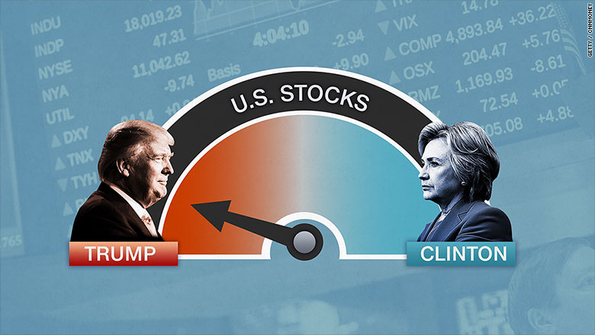

Lyu Wu (LW2704)

Mihir Sanghavi (MS4267)

Visswanath Venkataraman (VV2270)

TAble of  
Contents

MOTIVATION AND BACKGROUND 1

“OLD WIVES’ TALE” 2

APPROACH AND TOOLS 2

DATASET 3

ANALYSIS AND INSIGHTS 4

RETURNS 4

QUANTILE–QUANTILE PLOTS 5

REGRESSION AGAINST TIME 6

REGRESSION AGAINST S&P 500 7

EQUALITY OF MEANS TEST 7

MEANS C.I. COMPARISON 8

VARIANCES C.I. COMPARISON 8

MODELING ERRORS 9

CONCLUSION 9

Application URL: <https://mihirsanghavi.shinyapps.io/ieor4150project/>

MOTIVATION AND BACKGROUND

The announcement of Donald Trump running for presidency has been extremely controversial in general. It has also been very tumultuous for the stock market. Thus, our investors have been nervous and have been looking to us to provide some amelioration. Take this quote for example (that our investors enquired about)

"… if Clinton wins it should be up about 3 percent and if Trump wins, it should go down 7 percent,"

[Eric Zitzewitz, Economics Professor at Dartmouth (Domm, P)].

At the time, some renowned economists had speculated significant drops in the market - whereas other parties had expected markets to perform much better - possibly under the administration of a more business-friendly government. In fact, anyone with an opinion had been making their own prediction as to how the market (including certain stocks) would perform, if Trump was elected. Unfortunately, as we often see, no matter how good the model and assumptions are, the resulting predictions are often wildly off. This is exactly what happened when the markets dipped but then rallied to reach an all-time high.

Since the date Trump became the republican nominee on July 19th, 2016 - until he was elected president - there has been a substantial effect on the stock markets. This is the date where we split our dataset into two parts. Both Trump and journalists writing about Trump caused huge market swings.

Additionally, Trump has also taken many jabs at specific companies such as Boeing (BA), which has caused speculation related swings in their stock prices. Other stocks such as Apple (AAPL) have been influenced by his foreign policy (Stewart, E). At times stocks moved because of news of his future economic policies, otherwise they moved based on his comments. We would like to, in retrospect, further understand the impacts of the election caused by the afore mentioned actions.

Due to the panic-inducing and controversial nature of this phenomenon (coined by us, the “Trump” Effect), we have decided to carry out some in-depth statistical investigation and build an insight gathering application to present to investors and have them hopefully be assured that they have made the right decision to invest with us. (In fact, we’re sure they will rest assured. Are they going to get “panic-suppression-through-rational-analysis” tools elsewhere? We don’t think so.)

## “OlD Wives’ TALE”

“Democratic Presidents Lead to Better Stock Market Performance.” (Long, H)

## APPROACH AND TOOLS

As of today, we have some historical data about the Trump Effect. We would like to analyze the implications of the Trump election on certain sectors of interest, benchmarking them against the market. In other words, we would like to adopt a “long horizon” event methodology to analyze the general market “pre-” and “post-” Trump related news. The two timeframes we are investigating range from six months prior to July 19th, 2016 (absence of “Trump” Effect) and from this date until the present (possible presence of Trump Effect).

We are selecting the S&P 500 index to be representative of the market and allowing the client to select another stock of interest (from each major sector) to compare against.

We will be leveraging the following tools to analyze the data: histograms, quantile-quantile plots and regression plots. Once the data has been analyzed, we will be using the following: confidence interval computation, means comparison using two-tailed test statistics and regression (i.e. stock against index) plots. This will allow us see the correlations between stocks and the market as well as notice the change in returns of individual stocks, which in turn should shed some light on the encompassing sector as well.

## DATASET

We have used the following stocks, assuming they are representative of their respective sectors:

Apple Inc. (AAPL),

Exxon Mobil Corporation (XOM),

Boeing Co (BA),

JP Morgan Chase & Co. (JPM)

Apple represents technology, Exxon – commodities, Boeing – manufacturing and JP Morgan – finance. Apple prices were expecting significant gains

**“Under Trump's plan, no business of any size would pay more than 15% of their business income in taxes …”**

(Stewart, E). Boeing is also of interest because it was bashed heavily by Trump (owing to its manufacturing in Mexico) (La Monica). We use the closing prices of these stocks from 01/01/2016 until the present.

## ANALYSIS AND INSIGHTS

### RETURNS

We first graphed log-returns of each of our symbols for the date ranges 01/01/2016 - 07/18/2016 and 07/19/2016 – 12/09/16 and noticed that they were all normally distributed. (See figures below.) We also noticed more interesting observations for each stock. Apple’s returns did move from a more negative to positive skewness – “loosely” showing an increase in returns as predicted by (Stewart, E). Boeing, despite being bad-mouthed by Trump, showed an increase in returns – consistent with (La Monica). We say “loosely” because interpreting skewness is complicated and situational.

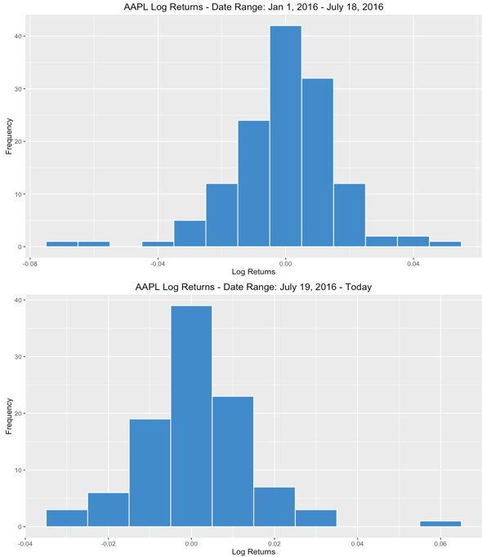 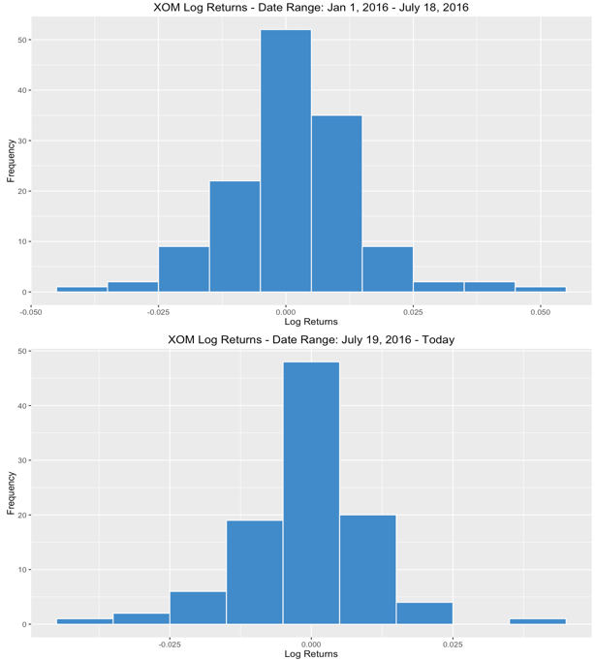

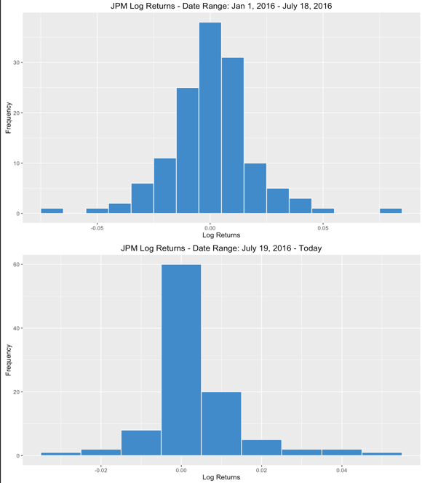 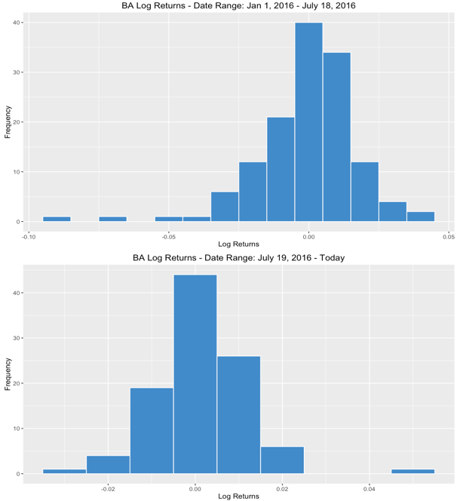

Exxon and JPM largely remain unchanged, graphically.

### QUANTILE–QUANTILE PLOTS

We then created quantile-quantile (probability) plots for each of our symbols. We noticed that since the datasets followed an approximately straight line in all cases, we further confirmed that our price data was normally distributed. Here is an example of the Apple Q-Q plot.

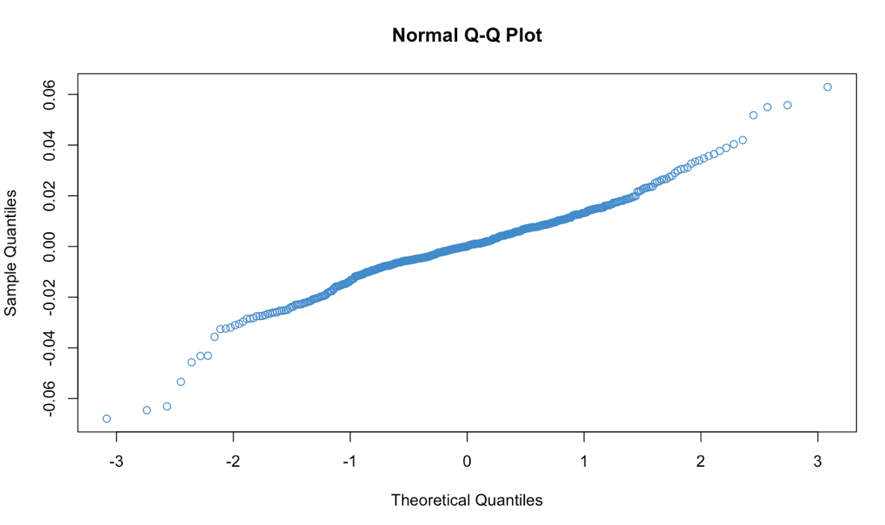

### REGRESSION AGAINST TIME

We then created a regression of stock prices against time and noticed that the regression was extremely noisy with R2 very close to 0 in all cases. Exact values are given in the table below.

|  |  |
| --- | --- |
| **Symbol** | **R2** |
| **AAPL** | **4.74957 E-08** |
| **XOM** | **0.001669402** |
| **JPM** | **0.004031247** |
| **BA** | **0.000316093** |

The residuals were extremely off-center as well. The best fit line hardly intersected the data points. Regression and residual plots can be found in the application. This make sense because it is impossible to predict price movements with any reasonable accuracy using just linear regression and residual plots.

### REGRESSION AGAINST S&P 500

Since the time regressions plots did not yield any profound insights, we performed a regression of each stock against the S&P 500. We found linear relationships varying in strength.

|  |  |
| --- | --- |
| **Symbol** | **R2** |
| **AAPL** | **0.3889015** |
| **XOM** | **0.4483366** |
| **JPM** | **0.6430491** |
| **BA** | **0.4669391** |

This table indicates that the markets have been doing well in general and individual stock performance is strongly correlated with them. This is an important insight because it shows the market momentum also has a significant impact on individual stocks and it makes it harder to gauge the impact of just the Trump Effect.

### EQUALITY OF MEANS TEST

The best litmus test for whether trump has had any effect on the markets is to test the equality of the means of the two durations. We found a p-value of 0 in all cases within our choice of stock symbols. This provides evidence against the fact that the two means are equal. Since the two means are unequal, we are certain the returns have changed with the advent of Trump.

### MEANS C.I. COMPARISON

We thought a great way to further test the Trump Effect would be to compare the confidence intervals of means of log returns of each of our stocks, before and after 07/19/2016. Table below shows Confidence Intervals at the 5% significance level. Our application allows significance level from 20% to 1%.

|  |  |  |
| --- | --- | --- |
| **Symbol** | **CI (01/01/2016 - 07/18/2016)** | **CI (07/19/2016 - Today)** |
| **AAPL** | **[-0.0032, 0.0024]** | **[-0.0012, 0.0038]** |
| **XOM** | **[-0.00075, 0.00375]** | **[-0.0027, 0.0015]** |
| **JPM** | **[-0.0031, 0.0032]** | **[0.000769, 0.0050]** |
| **BA** | **[-0.0035 0.0027]** | **[-0.00058 0.0035]** |

As can be seen from the data table above, Trump has caused a positive Effect on the market because each stock’s confidence interval for the mean is higher after July 18, 2016 than before. As seen before, these stocks have varying regression with the market, so the entire effect cannot just be attributed to the market momentum. Trump has had an impact as well.

### VARIANCES C.I. COMPARISON

We compared variances of each stock as well and found the confidence interval shrunk in each case “pre-” Trump, because we have more data points for the first half of the data. These confidence intervals can be found by running the application. We don’t believe that many insights can be gained from this comparison.

## MOdeling errors

On major error that exists in our analysis is that there were several other events that influenced the stock market during which we investigated the ‘Trump Effect’. For example, the United Kingdom’s withdrawal from the European Union (Brexit), which happened in June 2016, injected a lot of volatility in the market. Another major event was the Chinese stock market crash (where the major Chinese index halved) significantly impacting financial markets worldwide. These events will also bias our data and analysis since we are unable to separate the ‘Trump Effect’ from them. A possibility is to use some machine learning techniques such as Regression Discontinuity Design to find evidence for the ‘Trump Effect’ with much less noise.

In addition to the above, the companies we analyzed all have large market capitalizations. This has also created a bias in our analysis since companies with different capitalizations were probably affected differently by the ‘Trump Effect’. We would like to conduct further analysis with mid-cap and small-cap companies in the future and study the phenomenon there.

## Conclusion

In conclusion, the event that Donald Trump became Republican nominee has in fact influenced the stock market in general and has impacted different sectors. The different stocks have displayed divergent patterns with a marginal gain in returns. The effect has been mostly positive which has now debunked all the media hype about an impending market crash.

REfERENCES

Long, Heather. "The Stock Market Does Better Under... Democrats." CNNMoney. Cable News Network, n.d. Web. 12 Dec. 2016. <http://money.cnn.com/2015/10/28/investing/stock-market-democrats-republicans/>

Domm, Patti (2016). “This is what could happen to the stock market if Donald Trump wins.” Retrieved December 01, 2016, from <http://www.cnbc.com/2016/11/02/this-is-what-could-happen-to-the-stock-market-if-donald-trump-wins.html>

Stewart, Emily. "6 Stocks to Buy When Donald Trump Is President." The Street. N.p., 2016. Web. 12 Dec. 2016.

<https://www.thestreet.com/story/13357827/1/6-stocks-to-buy-if-donald-trump-becomes-president.html>

La Monica, Paul R. "Good to Be on Trump Blacklist. Stocks He Bashed Soar." CNNMoney. Cable News Network, n.d. Web. 01 Dec. 2016.

<http://money.cnn.com/2016/12/09/investing/donald-trump-stocks/>