*Bathroom Renovations*

Build-It-Bob, the Bathroom Boys

Mr. Bob Burton

*08/04/2020*

*Term Assignment:* INFO20172 Project Management for Information Technology

*For Professor:* Vidya Narayan

4thAugust, 2020

*Class:* Tuesday (11-1)

*Team Members:*

1. Patel, Dharam Pankajbhai
2. Panchal, Siddharth Vijay
3. Patel, Mihir Kalpeshkumar
4. Patel, Kishankumar

*Checklist:*

* Project Charter (Part 1, Task 1)
* Scope Statement (Part 2, Task 1)
* WBS – List Form (Part 2, Task 2)
* Gantt chart (Part 2, Task 3)
* SMART paper (Part 3, Task 1)
* Milestone Report (Part 3, Task 2)
* Gantt chart (Part 3, Task 3)
* Cost estimate (Part 4, Task 1)

Introduction

A bathroom renovation project management company name “Build-It-Bob, the Bathroom Boys” is a niche business that is been into the construction industry for several years and has a reputable position in this market.

The Fulcher family has decided to renovate their house because of the unproductive use of the space into their house. They are planning to renovate the bathroom which is still functional but wanted to get better enlightenment of their house. Following their due diligence they contacted several professional contractors and finally decided to hire “Build-It-Bob” Professional services.

The owner of the company Mr. Bob Burton was willing to start the work with his team from July 1 and guaranteed to complete by September 1 or they would refund 25% of the total cost of the contract.

Deliverable Details

In this project a bathroom is to be renovated of a family named Fulcher’s in their house. As they want to use the extra space and expand the bathroom. So for this our company has to start work from July 1 and must be guaranteed completed by Sept 1. We have hired different field of employees for this project including architect, plumber, electrician, painter and mason.

We have attempted in making project charter, scope statement, work breakdown structure, Gantt chart, milestones, cost overview and management. The work is distributed to each employee in specific hours. Resource form and sheet is created for more details. Task usage is created for each employee with their payment details.

Project Charter

**Project Manager:** Mr.Mihir Patel, (647) 123-4567, mihir@builditbob.com

**Project Title:** Bathroom Renovation

**Project Start Date:** July 1, 2020 **Project End Date:** September 1, 2020

**Key Schedule Milestones:**

* Completeall the materialand other requirements by July 5
* Complete the design by July 10 so that we can begin getting building permits
* All the samples must be ready by July 15 so that Fulcher’s can finalize their choice by July 20

|  |  |  |  |  |  |  |  |  |  |  |  |  |  |  |  |  |  |  |  |  |
| --- | --- | --- | --- | --- | --- | --- | --- | --- | --- | --- | --- | --- | --- | --- | --- | --- | --- | --- | --- | --- |
| **Budget Information:** The firm has allocated $15,000 for this project. The cost is divided in two parts one for materials which will cost in total $8000 and labour cost which will be $7000.  **Budget Breakup**   |  |  | | --- | --- | | **Description** | **Amount** | | Materials (flooring; drywall; paint; tiles; lights; bathtub, toilet, sink and vanity; and pipes) | $8000 | | Labour Cost | $7000 | | **Breakup of Labour Cost** | | | Contractor (Owner) | $200/hr | | Architect | $120/hr | | Demolition and Build | $80/hr | | Plumber | $150/hr | | Electrician | $150/hr | | Student painter and mason (tile work) | $50/hr | |

**Approach**:

* Hold regular kick off meeting with the project manager and bi-weekly with project sponsor.
* Get all the permits from the government as soon as possible to start the construction work.
* Get all the raw and hardware materials during design phase.
* Contact all the contractors like plumbers, electrician, architecture before design phase.
* Develop detailed WBS, Gantt Chant and Scope statement for the renovation project.
* The Duration of the project is 45 days that is 2 months and the completion date is 01/09/2020 respectively.

**Main Project Success Criteria:** A redesigned and renovated ultra modern, stylish, and highly functional bathroom meeting the desires and prerequisites of Mr. and Mrs. Fulcher with better utilization of space and convenience. And the project should pay for itself within one year of completion.

**Project Objectives:**

1. Functional Bathroom
2. Evacuation of Bathtub and better use of its space
3. Fix the walls completely with no cracks
4. Use modern, stylish, and energy-consumption lightning in bathroom
5. Replace tiles and flooring
6. Replace windows and screens with the best quality ones
7. Replace broken installations
8. Solve plumbing issues

|  |  |  |  |  |  |  |  |  |  |  |  |  |  |  |  |  |  |  |  |  |  |  |  |  |
| --- | --- | --- | --- | --- | --- | --- | --- | --- | --- | --- | --- | --- | --- | --- | --- | --- | --- | --- | --- | --- | --- | --- | --- | --- |
| **Roles and Responsibilities**   |  |  |  | | --- | --- | --- | | Name | Role | Responsibility | | Mr. Bob Burton | Sponsor | CEO | | Mr. Mihir Patel | Project Manager | Project head | | Mr. Billy Burton | Architect | Design the layout of the bathroom | | Mrs. Bessy Burton | Demolition and Build | Evacuate and rebuild the bathroom | | Mrs. Brenda Burton | Plumber | Install new pipes and solve plumbing issues. | | Mrs. Bonnie Burton | Electrician | Fit lights and other electrical things in bathroom | | Mrs. Tina | Temp- Student Painter and Mason | Painting walls and replace tiles and flooring | |
|  |

|  |
| --- |
| **Comments:**  *“We will do our best in completing this project on time. The high quality standards will be maintained while building up this project. And I assume that each phase will be completed successfully” – Mihir Patel*  “We need to be careful during demolition as there are very old pipes attached with other rooms. So to avoid leakage we have to work precisely and same goes with electric wires as well” – Brenda and Bonnie Burton  **Sign-Off:** (Signatures of all the above stakeholders)  *Bob Burton Brenda Burton*  *Mihir Patel Bonnie Burton*  *Billy Burton Tina*  *Bessy Burton* |

Scope Statement

|  |  |
| --- | --- |
| **Project Title:** | Bathroom Renovations |
| **Date:** | 16-07-2020 |
| **Prepared by:** | The KNIGHTS |
| **Project Justification:** | * Replace their bathtub which is not used to utilize the space. * Replace the tiles which had fallen off. * Replace the old tiles with something fashionable and new. * Replace the windows and the screen with a new stylish frame. * Fill the cracks in the walls and repaint it. * The total budget of the contract is $15,000. |
| **Product Characteristics and Requirements:** | 1. This project’s completion will allow the Fulcher family to reuse the space from the bathroom and renovate it for better use. 2. The project would start on July 1 and must end by 1st September, in order to avoid paying a refund of 25%. 3. Must stay under the budget contract of $15,000. 4. Flooring must be laid properly before the flooring is installed. 5. Quality must be maintained as per the company standards, so that the renovation is good for another 5-10 years. |

|  |  |
| --- | --- |
| **Product User Acceptance Criteria:** | 1. The Fulcher Family finds the newly renovated bathroom to the point and are satisfied with the work done. 2. Old walls with cracks have been renovated. 3. Fallen tiles are fixed. 4. Old lights have been replaced with new ones. 5. Bathroom window and screen are fixed. |
| **Summary of Project Deliverables**  **Project management-related deliverables:**  **Product-related deliverables:** | 1. Project Charter 2. Team Contract 3. Scope Statement 4. WBS 5. Project Schedule 6. Project Cost Structure 7. Progress Reports 8. Final Project Presentation 9. Lessons Learned Reports 10. Floor Plan: Given for approval to the department, also shown to the Fulcher family for any suggestions. 11. Approval: The plan is approved and signed. 12. Contract: Including the cost, date when the project is expected to be completed, etc. |

Work Breakdown Structure – List Form

|  |
| --- |
| **Bathroom Renovations** |
| 1.1 Research   * + 1. **Customer Requirements list** * Make customer requirement list   + 1. **Market research** * Research cost and requirement in market   + 1. **Create Research Report** |
| 1.2 Planning and Designing  1.2.1 **Create design**   * + - 1. Demolition Plan * Create demolition plan   1.2.1.2 Electrical plan   * Create electrical plan   1.2.1.3 Plumbing plan   * Create plumbing plan   1.2.1.4 Paint plan   * Create painting   1.2.2 **Make deal with new subcontractors**  1.2.2.1 Research and Interview new subcontractor   * Find subcontractor in market and take interview   1.2.2.2 Hire Subcontractors (For mechanical, plumbing, flooring and electric)   * Hire after interview   1.2.3 **Get permits**  1.2.3.1 Electrical Safety permit   * Get permit from government for electrical path   1.2.3.2 Plumbing permit   * Get permit from government for New plumbing   1.2.3.3 Flooring construction permit   * Get permit from government for New flooring construction   1.2.3.4 New construction   * Get permit from government for New construction   1.2.4 **Create Planning and Designing Report** |

|  |
| --- |
| 1.3 Demolition  1.3.1 **Check current bathroom condition**   * Visit site and check condition   1.3.2 **Hire Demolition team**   * Hire team for demolition   1.3.3 **Prepare site for construction**  1.3.3.1 Remove old connection   * Remove existing connection of electric and plumbing   1.3.3.2 Close plumbing, drainage, and electric connection   * Close connections for construction   1.3.3.3 Clean site  1.3.4 **Create Demolition Report** |
| 1.4 Construction  1.4.1 **Purchase require materials**  1.4.1.1 Buy modern and stylish lights   * Buy new lights   1.4.1.2 Buy tiles and flooring material   * Buy flooring related materials   1.4.1.3 Buy new windows and screen   * Buy new windows and glass   1.4.1.4 Buy painting materials   * Buy painting materials   1.4.2 **Mechanical**  1.4.2.1 Clear site   * Clean site for construction   1.4.2.2 Build or Install   * Install new product   1.4.2.3 Check final job  1.4.3 **Plumbing**  1.4.3.1 Install new connection   * Install new pipelines and connections   1.4.3.2 Check final job |

|  |
| --- |
| 1.4.4 **Electrical**  1.4.4.1 Install new connection and lights   * Install new wiring and electronics product   1.4.4.2 Check final job  1.4.5 **Flooring**  1.4.5.1 Install new flooring   * Install new tiles on the floor   1.4.5.2 Check finishing  1.4.6 **Paint**  1.4.6.1 Paint walls and others   * Paint wall with different color   1.4.6.2 Give final finishing   * Give bathroom final finishing   1.4.6.3 Check final job  1.4.7 **Create construction report** |
| 1.5 Monitoring by customer  1.5.1 **Give final checklist to customer**   * Customer checks all renovated things   1.5.2 **Solve problem**   * If customer have problem than solve that   1.5.3 **Create monitoring report** |
| 1.6 Invoice and job done  1.6.1 **Give final Invoice to customer**   * Give Final amount of cost   1.6.2 **Accept payment**   * Accept payment by credit, debit or cash   1.6.3 **Ready to use**   * Give bathroom for use |

Gantt Chart

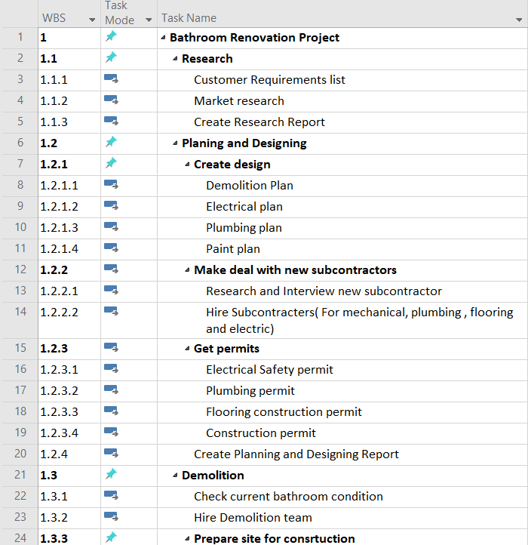

SMART paper

|  |
| --- |
| Milestone 1: The research phase is completed on 3 July 2020.  • Mr. Bob Burton and Mr. Mihir Patel are responsible for this task and it completed in the first three days from the project start date. They make customer requirement list and Research cost and market analysis. In the end, they show a research report. |
| Milestone 2: Create bathroom Design takes 2 days.   * Mr. Billy Burton created an architect plan for bathroom renovation as per customer requirement and discuss it with the manager and customer. This task should complete before 5th July. |
| Milestone 3: Make deal with new subcontractors and Get permits from the government in next the three days.   * Architect Mr. Billy Burton got permission for plumbing, flooring, Electrical Safety from the government, and hire a subcontractor for the project. At last, create a report of planning and designing by the end of 10th July. |
| Milestone 4: Demolition phase takes 6 days.   * Mrs. Bessy Burton check the bathroom condition and hire the demolition team before 15th July. Prepare the site for construction and create a demolition report by the end of 20 July. |

|  |
| --- |
| Milestone 5: In construction phase, purchase require material in 4 days.   * Bessy Burton(mechanical), Brenda Burton(plumber), Bonnie Burton(electrician) and Tina(painter) give require list and Mihir Patel purchased that material. This work complete before 24th July. |
| Milestone 6: Main construction phase takes 19 days.   * Bessy Burton(mechanical), Brenda Burton(plumber), Bonnie Burton(electrician), and Tina(painter) completed their task before 20th August. And Mihir Patel(manager) create a construction report. These tasks will complete before 20th August. |
| Milestone 7: Monitoring phase takes 6 days.   * This task is done by customer and solve their problems in 5 days. Mihir Patel will create a monitoring report by the end of 28th August. |
| Milestone 8: Complete bathroom renovation project before 1st September.   * Give the final invoice to Mr. and Mrs. Fulcher and receive payment by Mihir Patel. The Bathroom renovation project closes on 1st September. |

Milestone Report

|  |  |  |  |  |
| --- | --- | --- | --- | --- |
| Milestone | Date | Status | Responsible | Issues/Comments |
| Create Research Report | July 2 | Completed | Project Manager |  |
| Electrical plan | July 6 | Completed | Electrician |  |
| Paint plan | July 7 | Completed | Student Painter and Mason | Planning is going good. |
| Electrical Safety permit | July 10 | Completed | Electrician |  |
| Plumbing permit | July 10 | Completed | Plumber |  |
| Flooring construction permit | July 10 | Completed | Student Painter and Mason |  |
| Construction permit | July 10 | Completed | Demolition and Build |  |
| Create Planning and Designing Report | July 10 | Completed | Project Manager | Went very well |
| Create Demolition Report | July 20 | Completed | Demolition and Build |  |
| Check final job | July 28 | Completed | Project Manager | Reviewed with sponsor and team |
| Create construction report | August 20 |  | Project Manager |  |
| Create monitoring report | August 28 |  | Project Manager |  |

Gantt Chart

Gantt Chart (Resource Sheet)

Cost Estimate

