**Research and Implementation of Handwritten**

**Text Recognition**

**By**

**Ayushi Rajesh Lad**

**15BIT025**

**Mihirkumar Rajeshkumar Patel**

**15BIT034**



**DEPARTMENT OF INFORMATION TECHNOLOGY & ENGINEERING**

**Ahmedabad 382481**

Research and Implementation of Handwritten

Text Recognition

**Minor Project**

Submitted in fulfilment of the requirements

For the degree, of

**Bachelor of Technology in Information Technology**

By

**Ayushi Rajesh Lad**

**15BIT025**

**Mihirkumar Rajeshkumar Patel**

**15BIT034**

Guided By

**Prof. Parita Prajapati**

**DEPARTMENT OF INFORMATION TECHNOLOGY**



**DEPARTMENT OF INFORMATION TECHNOLOGY**

**Ahmedabad 382481**

**CERTIFICATE**

This is to certify that the Minor Project entitled “Research and Implementation of Handwritten

Text Recognition” submitted by Ayushi Lad (15BIT025) and Mihirkumar Patel (15BIT034), towards the partial fulfilment of the requirements for the degree of Bachelor of Technology inInformation Technology of Nirma University is the record of work carried out by their under my supervision and guidance. The submitted work has reached a level required for being accepted for examination.

_______________________ ________________________

Prof. Parita Prajapati Dr. Madhuri Bhavsar

Asst. Professor Professor and Head of Department

Department of Information Technology, Dept. of Information Technology,

Institute of Technology, Institute of Technology,

Nirma University, Nirma University,

Ahmedabad. Ahmedabad.

**ACKNOWLEDGEMENT**

We would like to express our special thanks of gratitude to our guide Prof. Parita Prajapati for guiding us along the way during the research of our project on the topic ‘Research and Implementation of Handwritten Text Recognition’.

We would also like to thank our friends who have always been supportive and helped us when we were stuck in the middle of something and extended their help. We would like to thank the university to enable us to take up this project and provide us with the necessary resources. Lastly, we would thank our parents for encouraging us to work harder and providing us the necessary tools.

**ABSTRACT**

With the development of OCR technologies at grand scale, the need for fast and efficient techniques to recognize patterns with varying complexity has increased. Text Recognition deals with recognizing the printed texts. Hand written Text Recognition is trickier than normal text recognition because of the varied personal writing styles of different people. Thus, when it comes to Hand Written Texts, it becomes very difficult to attain high accuracy while maintaining the speed.

Captcha are used as human response tests. It stands for “Completely Automated Public Turing test to tell Computers and Humans Apart.” Captchas are used for distinguishing between humans and a computer in order to prevent spamming. Keeping in the limited types of captchas, we have proposed a type of captcha which can be used for the same purpose. These captchas will make use of Handwritten text recognition for distinguishing between humans and computers.

**CONTENTS**

Certificate………………………………………………………………………………….3

Acknowledgement………………………………………………………………………....4

Abstract…………………………………………………………………………………….5

Table of Contents…………………………………………………………………………..6

**Chapter 1 Introduction……………………………………………………………….7**

**Chapter 2 Literature Survey…………………………………………………………8**

**Chapter 3 Data set used….…………………..………………………………….……9**

**Chapter 4 Convulation Neural Network used..………………………………….…10**

**Chapter 5 Screenshots of the system………………………………………………...12**

**Chapter 6 Conclusion………………………………………………………………...14**

**Chapter 1: Introduction**

**_______________________________________________**

None of us can escape from the technology that surrounds us in our everyday life. With the advent of technology, comes the negative sides too. Computer codes trying to spam websites have created nuisances for website owners. Captchas come to aid here. These can be added to our websites or applications during the authentication of the user and check if the user trying to use the website is genuine or not.

Hand Written Text Recognition has wide applications. We have attempted to combine the issue of website spamming and the applications of Handwritten text recognition in order to propose a system which can be used to prevent spamming.

**Chapter 2: Literature Survey**

**_______________________________________________**

Wide ranges of applications have been made using text recognitions techniques. Text recognition have been used in banks for reading cheques, getting document of printed copies, number plate recognition, etc. But the handwritten text recognition hasn’t yet been used to its full potential. Here, training plays a major role in developing the model. Keeping this in mind, a captcha can be made and using captchas, security can be added to websites and applications.

Following are the types of captchas currently in use.

* Word solving
* Audio
* Branded
* 3D
* Math solution
* Drag and Drop
* JQuery Slider
* Tic Tac Toe

Thus, we a captcha security system with the help of handwritten text recognition can proved to be helpful.

**Chapter 3: Data set used**

**_______________________________________________**

**NIST Special Database DB19**

* Contains 810,000 segmented handwritten characters
* Superset of MNIST that includes alpabetic characters
* 62 character classes [A-Z], [a-z], [0-9], 128 X 128 pixels

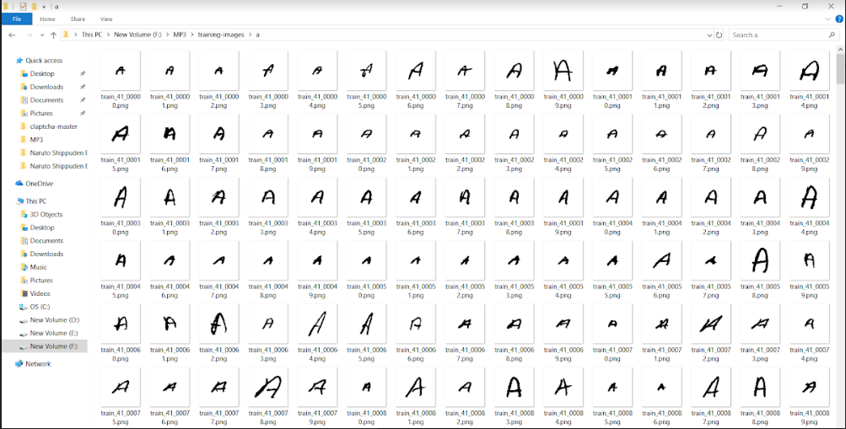

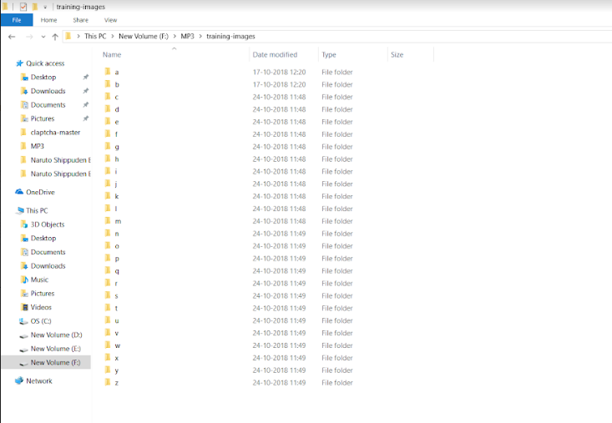

**Chapter 4: Convoluted Neural Network**

**_______________________________________________________**

The working of convolutional network used can be explained by the given picture.

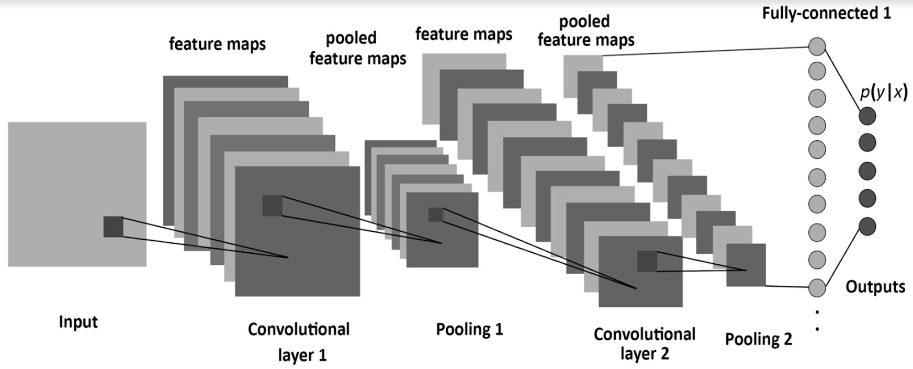

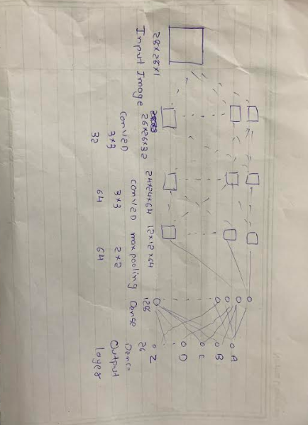

Following is the model used:

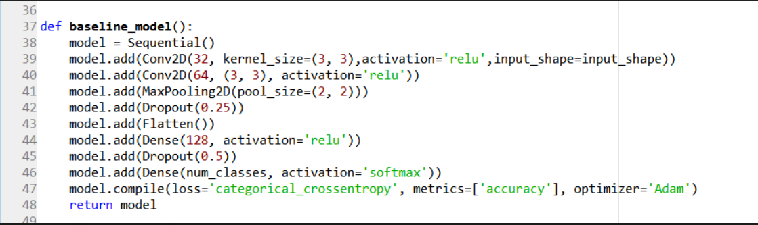

**Chapter 5: Screenshots**

**_______________________________________________**

On running the code, the console screen will generate a 3-lettered Captcha which will be displayed and it will wait for the user to be ready with their hand written converted text of the captcha. On entering the character ‘r’ which show that you are ready, the correctness of the inputted image will be checked. If all the letters match in the given sequence, an appropriate message will be displayed.

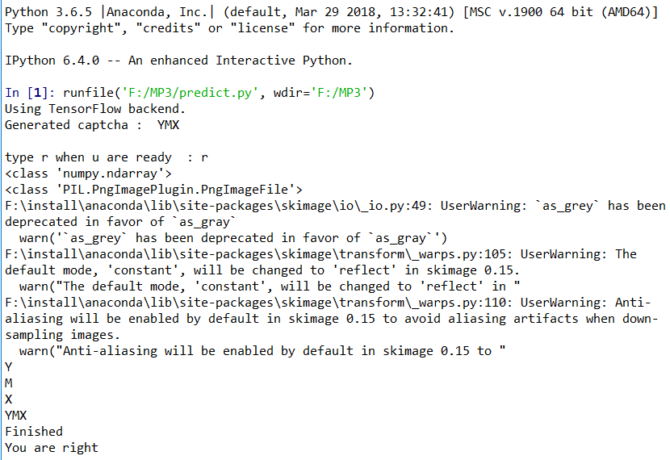

An example of the captcha generated is shown as follows:

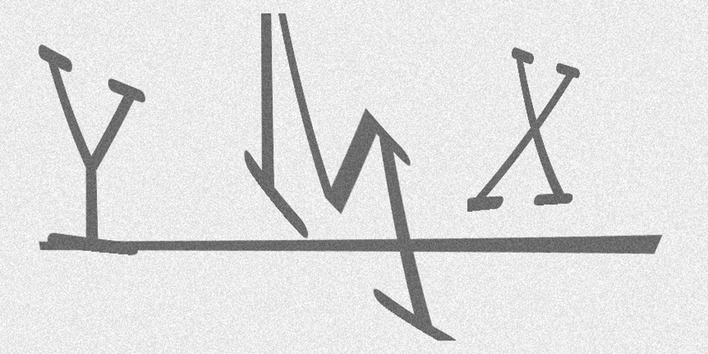

An inputted image made in paint for the given captcha is as follows:

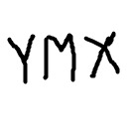

**Chapter 6: Conclusion**

**_______________________________________________**

There has been growing use of OCR techniques in a variety of areas. We have attempted to use hand written text recognition in order to add a security measure to websites and applications as Captchas. These captchas can be used to prevent spamming in websites and applications. There aren’t any such captchas available in the market yet but this kind of captcha can be used widely since computers cannot mimic hand written texts due to the personal styles of writing of each individual. We believe this can further be developed into a reliable security check.

# 