**NAME : Mihir Nikam**

**UID: 2019140042**

**BE IT (DA LAB)**

**Aim:** : Understanding and learning SAS Studio

#### **Introduction:**

SAS Studio a web browser-based interface for SAS programmers that also suits the needs of novice users by providing an assistive framework. SAS Studio lets you work with the same SAS server from your desk, your laptop at home or wherever you have a browser and a connection.

Using SAS we can access data files, libraries and existing programs – or write new ones – with this developmental web application accessible through your browser. With SAS Studio, we can use predefined tasks to generate SAS code. When we run a program or task, the technology processes the SAS code on a SAS server, which can be a server in a cloud environment, in your local environment, or SAS installed on our local machine. After the code is processed, the results are returned to SAS Studio in your browser.

In addition to writing and running your own SAS programs, you can use the predefined tasks that are included with SAS Studio to analyze your data. The tasks are based on SAS procedures and provide access to some of the most commonly used graph and analytical procedures. You can also use the default task template to write your own tasks.

#### **Implementation:**

* Data used
  + File name: Student body weight and height
  + Other important parameters of the data are age, height, sex and weight

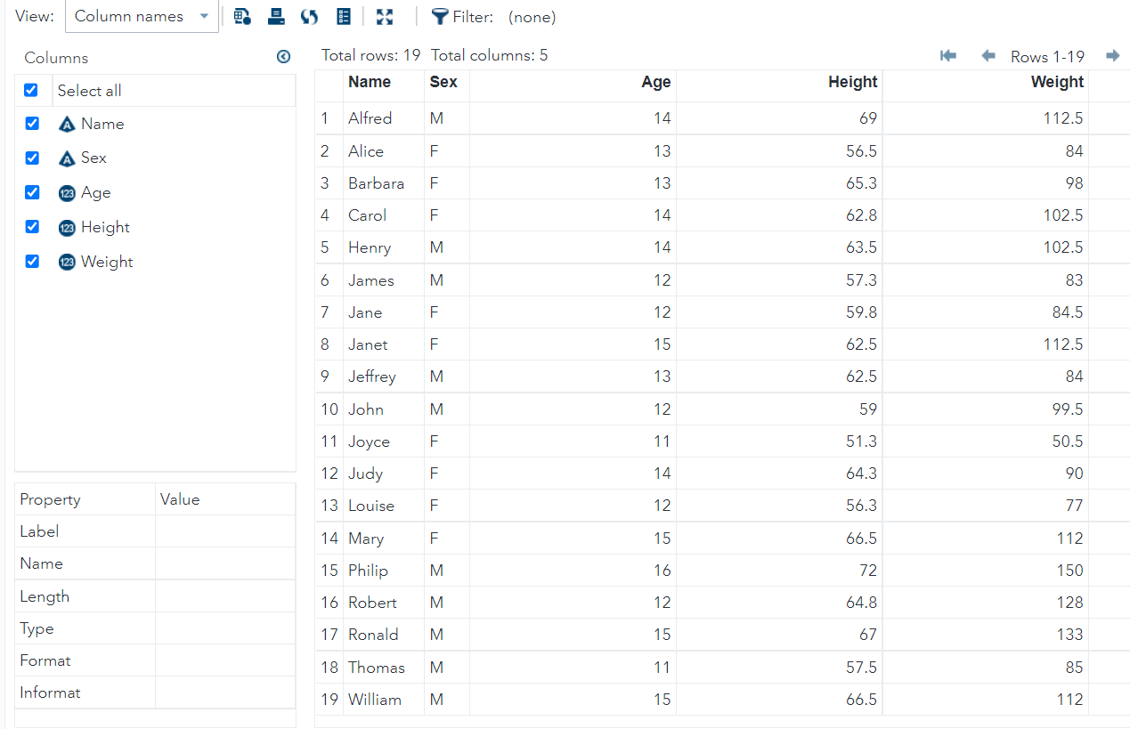

* Input file information

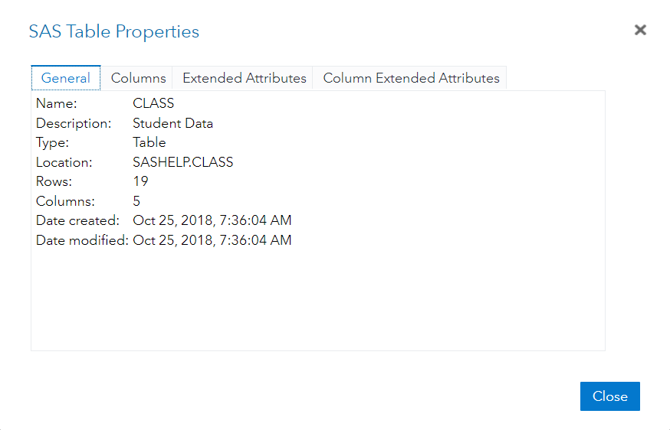

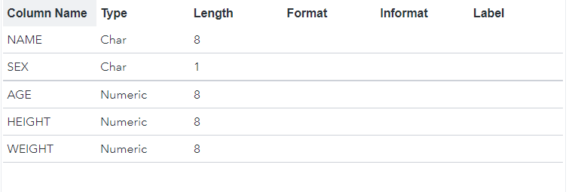

* Import file

Code:

/* Generated Code (IMPORT) */

/* Source File: HT_2013-2020.xlsx */

/* Source Path: /home/u62272461 */

/* Code generated on: 11/3/22, 3:15 PM */

%web_drop_table(WORK.IMPORT1);

FILENAME REFFILE '/home/u62272461/HT_2013-2020.xlsx';

PROC IMPORT DATAFILE=REFFILE

DBMS=XLSX

OUT=WORK.IMPORT1;

GETNAMES=YES;

RUN;

PROC CONTENTS DATA=WORK.IMPORT1; RUN;

%web_open_table(WORK.IMPORT1);

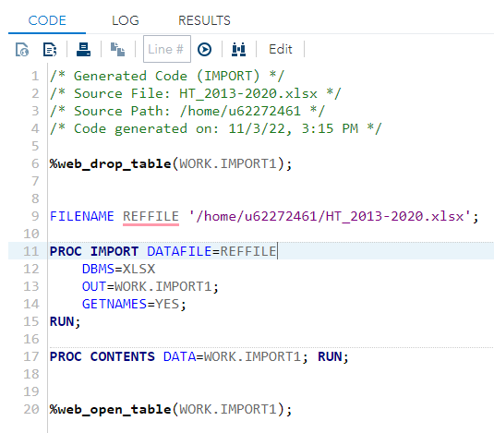

Result:

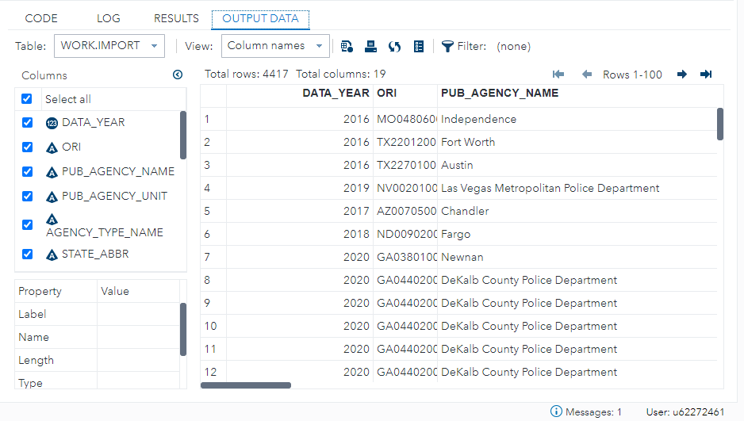

* Plotting scatter plot of horsepower vs make using the “CARS” dataset that is readily available in SAS Studio for implementation

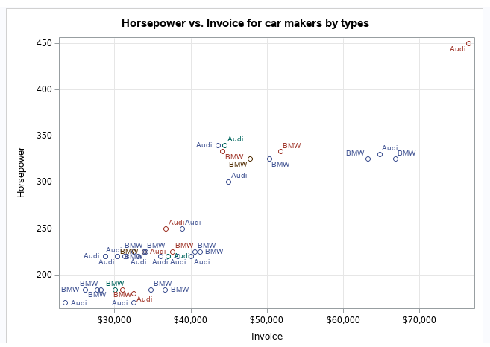

* Plotting a scatter matrix

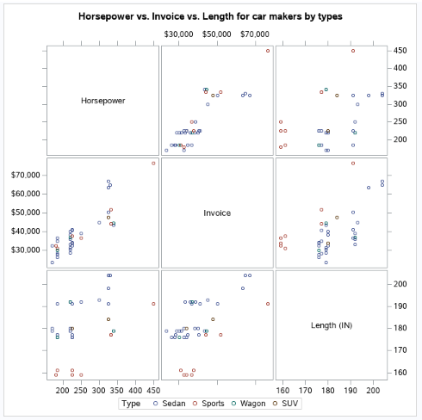

Code:

/* scatter plot */

PROC SQL;

create table CARS1 as

SELECT make, model, type, invoice, horsepower, length, weight

FROM

SASHELP.CARS

WHERE make in ('Audi','BMW')

;

RUN;

TITLE 'Scatterplot - Two Variables';

PROC sgscatter DATA = CARS1;

PLOT horsepower*Invoice

/ datalabel = make group = type grid;

title 'Horsepower vs. Invoice for car makers by types';

RUN;

/* scatter matrix */

PROC sgscatter DATA = CARS1;

matrix horsepower invoice length

/ group = type;

title 'Horsepower vs. Invoice vs. Length for car makers by types';

RUN;