TASK 1: Repository Setup
Goal: Initialize Git and create first commit
Steps:
- Create a folder named git-assignment-yourfullname
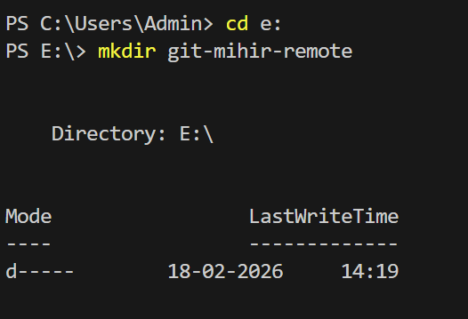
- Navigate into the folder
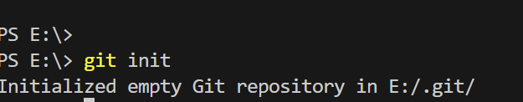
- Initialize Git repository
4. Create a file named index.txt
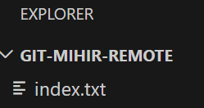
- Check repository status
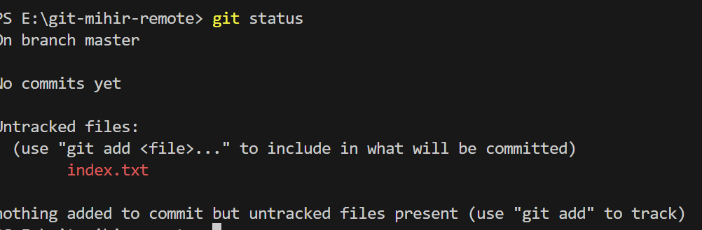
- Stage the file
7. Commit with message:
Initial project setup
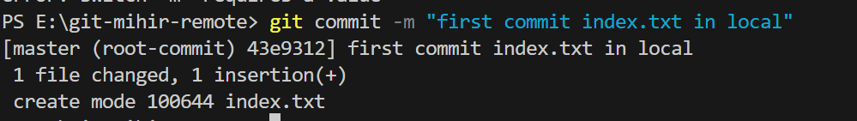

TASK 2: Branch Creation & Work
Goal: Work independently in a branch
Steps:
- Create a branch named feature-header
- Switch to feature-header
- Create a file named header.txt
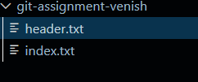
- Stage the file
- Commit with message:
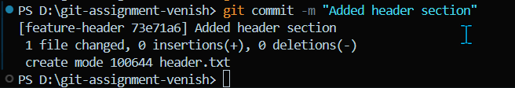
Added header section

TASK 3: Branch Switching Observation
Goal: Observe branch isolation
Steps:
- Switch back to master
- List files and observe
- Switch again to feature-header
- List files and observe
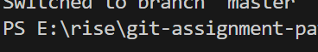

TASK 4: Undo a Mistake
Goal: Safely undo file changes
Steps:

- In feature-header, modify index.txt
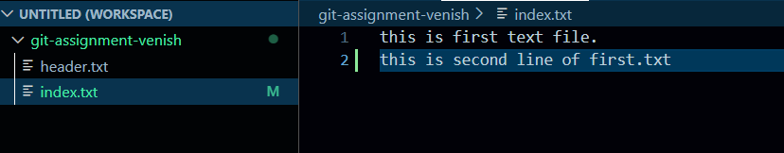
- Check repository status
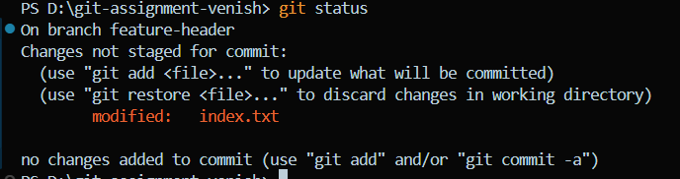
- Undo the change using Git
4. Verify status again
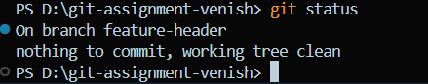
TASK 5: Merge Feature Branch
Goal: Combine work into master
Steps:
- Switch to master
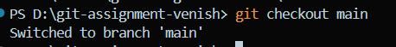
- Merge feature-header
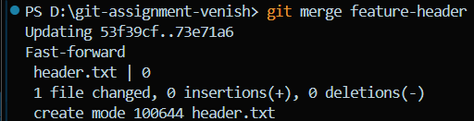
- Verify merged files
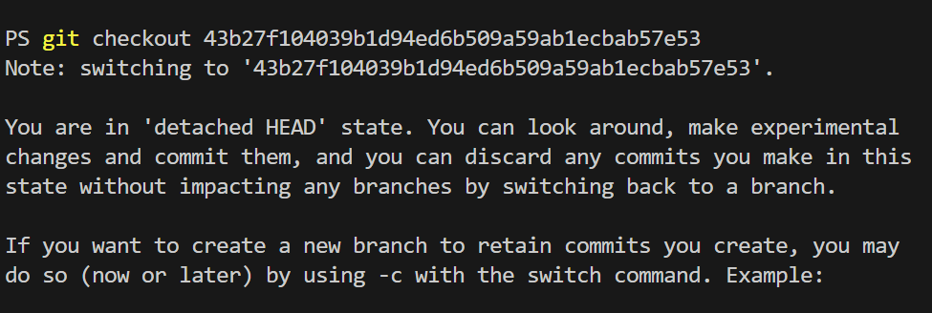
- Check commit history
