|  |  |
| --- | --- |
|  |  |

Synoptic Prediction of North Indian Ocean Cyclone Intensity using Machine Learning Classifiers

Mihir Agarwal1, Sheshmani Shakya2, Samridh Pathela3,

Samarthya Kesarwani4, Kakoli Banarjee5 and Sakshi Aggrawal6

1 JSS Academy of Technical Education/Computer Science and Engineering, Noida, India

Email: [mihiragarwal15@gmail.com](mailto:mihiragarwal15@gmail.com)

2-6 JSS Academy of Technical Education/Computer Science and Engineering, Noida, India

Email:{ shakyashesh101, samridh2102002, samarthya1211.kesarwani; kakolibanerjee80, iauthor}@gmail.com

**Abstract**— Tropical cyclone (TC) intensity estimation of the North Indian Ocean (NIO) is quite challenging and requires a huge amount of computational power and data collected over open oceans to improve efficiency for meteorologists. Best Track data of TCs collected from the Indian Meteorological Department (IMD) is used for intensity prediction. This research compares different Machine Learning (ML) classifiers based on different predictors received from the Indian Meteorological Department (IMD). The five predictors that are used for estimating the intensity of TCs are Latitude, Longitude, Central Pressure, Pressure Drop, and Maximum Sustained Wind Speed (MSW). Random Forest achieved the best accuracy in prediction.

Keywords**—** **Machine Learning, Tropical Cyclone, Best Track Data, North Indian Ocean**

I. Introduction

Focused, rapidly rotating cloud storms that form in the tropics are called TCs. TC causes a huge number of casualties and consequences when landing in coastal areas.

[1]. A complete study of TC cloud strength is therefore essential to predict its destructive power and loss mitigation. Many measures are used to estimate TC intensity around the world. Common methods for TC strength analysis are Dvorak method [2-3] and extended versions of Dvorak method [2]. TC intensity prediction by Numerical Weather Prediction (NWP) models are one of the most important models for TC intensity estimation [3]. However, NWP models remain a challenge for predicting most TC intensities [4]. The domain expert therefore applies these scales to satellite imagery by applying their data-driven NWP model [5] to TC intensity.

Other TC intensity estimation approaches include multi-layer perceptrons, deep learning architectures, and other machine learning approaches have gained popularity during recent years to improve classification results [6]. Other methods for TC study include TC eye-based intensity prediction [7], TC image study with elliptic Fourier descriptors [8], TC image texture study [9] and various ML techniques [10], image contour extraction [11]. Artificial Neural Network [12], multilayer perceptron [13], Convolution Neural Network (CNN) [11], K-nearest Neighbors (KNN) [14]. The contribution of this research can be summarized as follows: 1. This research takes the best track data from IMD, of 97 TCs during 2001- 2020 over NIO containing five different predictors.

There are 2965 instances of 39 TCs. A relative analysis is done to measure accuracy using various ML classifier 2. An analysis approach to understand the cycles and occurrence of TCs. The proposed work and some brief idea about the TC predictors along with a brief discussion about the different ML classifiers used in the research for comparative study are shown in section 2. The dataset and pre-processing used in this research is described in section 3. In section 4, results are discussed with the conclusions of the work.

##### II. Overview and Related Works

TC forecasts use primarily statistical, numerical, and empirical forecasting models to predict the central location and intensity of tropical storms (TCs) as well as the effects of catastrophic weather when TCs make landfall or approach the coast. With the exception of a few aberrant courses, path prediction has advanced significantly in recent years and can now produce findings that are reasonably accurate. Because [16] TC genesis and intensity are not as well defined as TC location, and [17] the physical processes involved are more complex and challenging to precisely describe by statistical models or dynamic equations, there are still very few methods available for predicting the genesis and intensity of TCs. Furthermore, the present estimates of severe winds, rainstorms, and storm surges in TC-affected areas are concerning because they heavily depend on precise trajectories and intensity forecasts.

Making forecasts is the main use case. This kind of non-physics-restricted rule- finding approach to data is especially well-suited for resolving issues where the physical mechanisms are not quite evident, like temperature variations. Therefore, machine learning is likely to accurately predict TC outbreaks if there are enough historical TC samples and a significant amount of pertinent meteorological and oceanographic data.

Of course, there are a ton of chances for machine learning in TC forecasts due to the rapidly expanding amounts of satellite, observational, and re-analysis data. There are five different ways to categorize machine learning applications in TC predictions. In order to better monitor the tropical ocean, the ultimate goals of TC genesis predictions are to produce quantitative forecasts at the time and location of cyclone genesis as well as probabilistic forecasts of a specific region in real-time. Currently, machine learning can only predict whether the precursors can develop into TCs and the seasonal frequency of TC genesis in each location, which are machine learning tasks related to regression and classification, respectively. [18] For the purpose of predicting TC generation, researchers thus mainly employ a number of standard methods, such as DT, logistic regression (LR), SVM, and ensemble algorithms, such as AdaBoost and random forest (RF). Even though these ensemble algorithms are potentially superior to solo algorithms, each situation must be evaluated separately. [19] Furthermore, deep learning algorithms that can handle visual data and fit complex functions better, including CNNs and multi-layer perceptrons (MLPs), are crucial in enhancing TC genesis prediction methods.

SVR can also be used to predict the wind field close to the ocean surface, while CNN is more frequently employed to mimic the wind field in the core or boundary layer. It is currently impossible to accurately estimate the full TC wind field, though.[20] Creating a physics-based machine learning model is an additional technique to enhance forecast outcomes in addition to the purely data-driven machine learning approaches discussed above for TC origin, tracks, intensity, and catastrophic weather impact forecasts. While current methods are insufficient to fully enhance numerical forecast models with machine learning, there have been some successful examples in this area. We’ll quickly categorize them into three groups here.

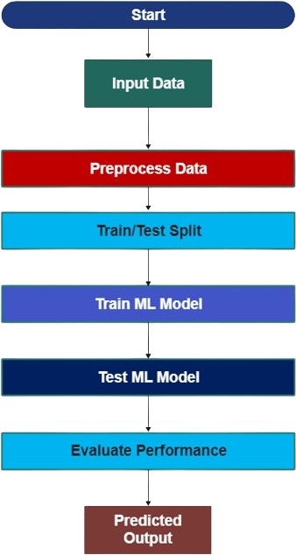

Figure 1. Flowchart of Machine Learning in Prediction of Tropical Cyclones

The first step is pre-processing, which entails inspecting the data that was used to build the model’s starting field. To detect whether a TC zone exists in the data, for instance, SVM can be used to either remove it or apply additional processing to enhance the data’s quality. The second involves making enhancements to the model itself, such as better parameterization and model error correction.

##### III. Methodologies

## A. Decision Tree (DT)

Decision trees are powerful non-parametric supervised learning algorithms that recur- sively partition the feature space into regions, enabling the classification or regression of data points based on their attributes. [27] Their hierarchical structure and intuitive representation make decision trees particularly appealing for understanding the underlying relationships within complex datasets.

## B. Support Vetor Machine (SVM)

SVM’s capacity to generate accurate results quickly has made it popular among many. The most prevalent application for it is in classification difficulties. [28] In order to dimensionalise the input, support vector machines use a kernel function to identify the best hyperplane as quickly as possible. Of the three functions we examined, the radial basis function was the most efficient and performed better than the linear and polynomial kernel functions.

## C. Gaussian Na¨ıve Bayes (GNB)

The Bayes’ theorem serves as the primary foundation for the classification method. Naive Bayes is not very effective when there is little information available. The likelihood of every value of a characteristic must be evaluated using a frequentist method. As probability approaches 0 or 1, this may result in numerical instability and less than ideal outcomes. The effective use of naive Bayes classifiers in document categorization and other spam filtering applications has been demonstrated despite their apparently excessive dependence on too simplified assumptions. [20]

## D. Logistic Regression (LR)

One of the main applications of machine learning, regression analysis, is included in the Supervised Learning approach. Making predictions about a categorical dependent variable based on a set of independent factors is the main goal of logistic regression. As a result, the outcome needs to be discrete or categorical. We will now create a confusion matrix to guarantee a correct categorization. A common option is the logistic regression model, which has a 79% success rate and is straightforward.

## E.. Random Forest (RF)

It operates by constructing a multitude of decision trees during training and outputs the mode of the classes (classification) or mean prediction (regression) of the individual trees. Each decision tree in the forest is trained on a random subset of the training data and a random subset of features, which helps to mitigate overfitting and improve generalization performance. The final prediction is then determined by aggregating the predictions of all trees in the forest. Random Forest is known for its robustness, scalability, and ability to handle high-dimensional data, making it a versatile tool for classification and regression tasks in diverse domains.

## F. Stochastic Gradient Descent (SGD)

Stochastic Gradient Descent (SGD) is a fundamental optimization algorithm widely employed in machine learning and optimization tasks. Unlike traditional gradient descent methods, which update model parameters based on the average gradient computed over the entire dataset, SGD updates parameters incrementally using a single or a small subset of training examples.

## G. K-Nearest Neighbours (KNNs)

Based on feature similarity, the k-nearest Neighbors (KNN) algorithm is a non- parametric method. The Euclidean norm is used as the distance measure by the algorithm to classify fresh data according to how close it is to the training set.

## H. Perceptron

An artificial neuron. It is the simplest possible neural network. It is used as an algorithm or a linear classifier to facilitate supervised learning of binary classifiers [29].

##### IV. Literature Survey

[30] It’s difficult and complicated to forecast a tropical storm’s intensity. The track data is the foundation for the intensity projections. The following algorithms were examined: Sequential Minimum Optimization, Random Forest, Random Tree, Naive Bayes, Multilayer Perceptron, and Logistic Regression. The location of the NIO can be ascertained by utilizing its center’s coordinates, maximum sustained wind speed, and pressure drop magnitude. Using the top track data from 2011 to 2020, we evaluate the effectiveness of many machine learning classifiers and compare the results. ML classifiers with a 97.99% success rate were discovered by the study.

[16] According to comparative research, the choice of infrared (IR) channels has a significant influence on the efficacy of TC intensity estimates using CNN models. The best multicategory CNN classification model produced mean bias of 2.15 m/s and low RMSE of 5.24 m/s, respectively, yielding an accuracy of roughly 84.8%. In order to choose the best track data, it is also compared to the maximum sustained wind speed. The CNN model can be made more accurate by adding attention layers after the input layer, which also keeps the model stable even when there is noise in the images. A targeted loss function was used in the CNN model to mitigate the TC category sample distribution’s extreme unbalance. The CNN model is used to determine the TC from the geostationary satellite photos.

[17] Ocean Observation Systems operates a network of deep-sea moored buoys to collect data in the Indian Ocean. OMNI measures temperature, current direction, and subsurface salinity. The buoys monitor long-term weather patterns and cyclone activity. Novel technological aspects of buoy system operation in rough seas were investigated. 95% of data is recovered on average. Patterns and severity of cyclones are revealed by subsurface data. Deep down, sensors are utilized to monitor the water level.

[31] For commercial cyclone separators, an accurate assessment of the pressure drop is necessary. The intricate nonlinear relationships between the geometric factors and the cyclone PDC need predictive modelling. Theoretical semi-empirical approaches are used in existing methodologies, but they are not very generic, and creative ways to predict the pressure drop in the cyclone separator have not been examined. This study uses a new Extended Kalman Filter (EKF) and fuzzy modelling to train a Multi-Layer Neural Network (MLNN). A dual Lagrange model is used to compare regression. Following training, these models are constructed by grid search and manual methods. [31] A fuzzy system’s (FS) prediction accuracy is 3.97e-04 MSE.

[32] To train the model, a dataset of actual tropical cyclones from 1945 to 2017 was used. The model performs better than conventional forecasting techniques such as the Sanders Barotropic methodology, a Numerical Weather Prediction (NWP) model, and a climatology-based forecasting technique. Without utilizing a feature selection layer, the model performs better than several deep learning techniques as well as CNN-GRU, AE-RNN, and CNN-RNN.

[33]A GFS-based dual-branch CNN model to pinpoint cyclones of various kinds, covering tropical, extratropical, and subtropical cyclones. Using a dual-branch CNN model based on GFS, it is capable of recognizing key features, interpreting geographical data, and generating detailed forecasts. Geographic features, noteworthy characteristics, and precise projections can all be taught to the model. The model properly detects tropical cyclones and cyclone disturbances more than 90% of the time. [34]

[20] The Deep Convolutional Neural Network (DCNN) approach is used to classify the satellite cloud images. The down-sampling procedure is used to retrieve the features. DCNN is incredibly well-trained and has an amazing level of prediction accuracy using cloud imagery. A deep convolutional network improves prediction accuracy and reduces delivery time for testing images when it is trained on a large training dataset. India and its subcontinent’s satellite photos are gathered from the Meteorological and Oceanographic Satellite Data Archival Centre. The proposed cloud picture categorization with DCNN architecture demonstrates 94% prediction accuracy. [32]

[19] The satellite cloud pictures are classified using the Deep Convolutional Neural Network (DCNN) technique. The process of down sampling is employed in order to obtain the features. When it comes to cloud imaging prediction, DCNN is extraordinarily accurate and well-trained. When trained on a large training dataset, a deep convolutional network improves prediction accuracy and decreases delivery time for testing images. Meteorological and Oceanographic Satellite Data Archival Centre satellite images of India and its subcontinent are collected. The DCNN architecture- based cloud picture classification that has been suggested has a 94% prediction accuracy rate.

[34] Approximately ninety tropical cyclones (TCs) form in the tropical oceans each year. The impacted areas can be warned with the help of the prompt tracking and identification of TCs. Remote sensing can help identify these storms over open waters far from a continent. In this work, we identify TCs automatically in satellite photos using deep learning. For TC detection, we specifically offer a three-stage deep learning architecture that consists of a CNN detector, an R-R-CNN classifier, and a wind speed filter (CNN). The pipeline’s hype parameters are optimized with the application of Bayesian approaches. The proposed technique provides outstanding precision (97.10%), accuracy (86.55%), and specificity (97.59%) when applied to test images.

[35] Polynomial regressing models and the Support Vector Machine (SVM) are combined to create the Tropical Cyclone tracking system. A polynomial regressing model is used to predict the path of tropical cyclones once the center of the storm has been determined using Support Vector Machines (SVM). For cyclone tracking, the ”ground truth” data is gathered using JTWC’s best track.

[36] The two primary tools used to forecast cyclones are Doppler radars and archived satellite imagery. Because cyclone prediction is a mostly manual procedure with a limited scope, automating it is important. The creation of an automated system that predicts a cyclone’s path and movement toward a certain location and notifies subscribers of this information is required. Fuzzy C-means clustering is used to segment each cyclone image, and then its texture, color, and shape are extracted. The features taken from a cyclone’s multi-temporal infrared photographs are compared with one another to ascertain its motion. With the use of this comparison, we can spot any variations in the cyclone’s properties over time and utilize that knowledge to calculate its direction and speed of movement.

[37] The Joint Typhoon Warning Center (JTWC) as a source of information The Indian Meteorological Department uses TC to determine which TC route is optimal. The TC path was taken out of each ensemble and its separation from the JTWC track was calculated using RStudio to finish this phase. All simulated pathways’ cyclone landfall times have been analyzed in order to provide the most accurate atmospheric data for TC. According to preliminary research, ensembles 6–9 are generally better at following the path and forecasting the landfall location of tropical storms.

. [38] The system reduces dimensionality and recognizes patterns by combining tensor analysis and deep neural networks. Furthermore, the two important models are succinctly and explicitly mathematically described by Tensor CNN. The suggested framework can classify cyclones using a Tensor CNN classification in addition to using the computed categories and a successive regression model to forecast wind speed. The FY-4 satellite’s multispectral imagery is used in experiments. The framework performs better than a number of well-known models for cyclone category estimation as well as the Deviation Angle Variance Technique (DAVT), a cutting-edge technique for regressing wind speed, according to the results.

. [39] Forecasting Tropical Cyclones (TCs) is a significant task that is not without challenges. Deep learning research on the generative adversarial network, or GAN, is ongoing, and recent results in temperature control (TC) prediction are promising. But the many types of GAN used in meteorology usually focus on producing high-quality photos, ignoring the process by which GAN acquires physical feature knowledge during the training phase.

[40] In past years, there has been enough progress made in the forecasting of tropical cyclones. Our capacity to anticipate and get ready for these potent natural events has been completely transformed by the application of cutting-edge technologies in tropical cyclone prediction. Understanding of cyclone behaviour, track prediction, and intensity forecasts has been efficiently improved by these techniques, which consists of complex computer models to satellite photography and specialized data-gathering equipment. In order to help at-risk populations prepare for and lessen the effects of devastating storms, more research and development work is important to increase pre- diction accuracy and lengthen lead times. Taking about the critical role that technical innovation plays is still worthy in our continuous efforts to protect people and property from the threats that tropical storms present.

##### IV. Implementation

## A. Proposed Methodology

The best track data of the past 20 years comes from the Regional Specialized Meteorological Center (RSMC) New Delhi, India. This data consists of TC name, the hourly instance of each TC (Latitude and Longitude, Central Pressure, Pressure Drop and MSW). The research work is shown in figure 1. Additionally, a brief description of the above predictors is provided below. Status of the cyclones is used as a label.

This research is done to analyse the effect of predictors and used to estimate the TC intensity. The following predictors are collected from the best track data [24].

1. Latitude and Longitude of a TC

TC generally occur between 10 and 30 degrees of latitude, 60-to-70-degree longitude in the Arabian sea, 85-to-90-degree longitude in Bay of Bengal as shown in figure 7.

1. Estimated Central Pressure and Pressure Drop

It is calculated from wind speed [2]. Central pressure intensities help to estimate the destructive ability of a TC [17]. The wind and pressure relationship for a TC is calculated using equation 1.

$S=C\sqrt{P_{r}-P_{c}}$ (1)

S is the sustained maximum wind speed,

C is the empirical parameter that varies between 0 and 1.

Pr – Pc is the pressure drop

1. MSW

It can be calculated using central pressure, as seen in equation 1. Earlier the MSW is assessed depending on the cloud patterns of satellite imagery [18]. Finally, in the NIO basin equation 2 represents the wind and pressure drop relation [19].

$S=16\sqrt{P_{r}-P_{c}}$ (2)

Eventually, equation (2) was modified [20]:

$S =14.2\sqrt{P_{r}-P_{c}}$

##### 

Figure 2. Diagram of the proposed work

## A. Dataset and Processing

A temporal resolution of six/three-hour data of TCs from 2001 to 2020 are collected from the RSMC, India. Seven classes of TCs over NIO have been observed according to the IMD TC intensity scale as shown in the Table 1 [41]. The training and testing dataset is divided into the ratio 8:2 using python package ‘sklearn’. ‘Standard Scaler’ is used to remove mean and scale all the features to unit variance. A ten-fold cross validation is used to ensure average and correct accuracy of the ML classifiers.

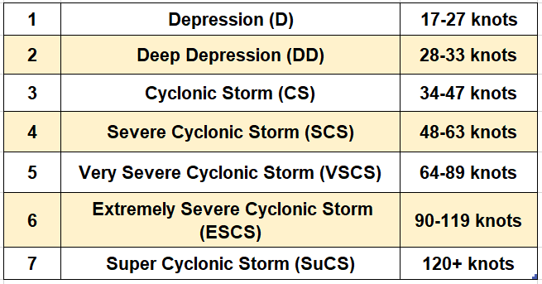

Table 1. India Meteorological Department TC Intensity Scale

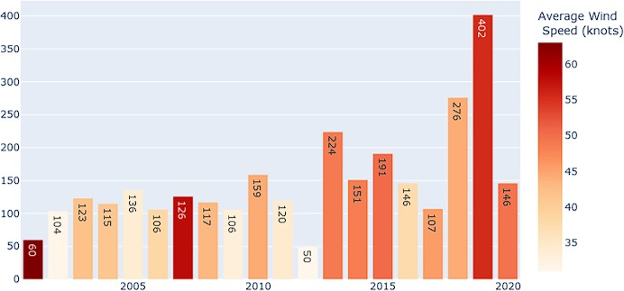Here, 97 TC were extracted for the research. The distribution of count of these TC are given in figure 6. The average wind speeds of cyclones over the years in the NIO is given in figure 3. [41]. The scatterplot of cyclonic regions in the NIO is given in figure 4. Figure 5 shows the wind speed distribution over the complete dataset between 2001 to 2020. The outliers in the maximum wind speed are shown in figure 7. Figure 8 shows the distribution of cyclones over latitude and longitude in the NIO. Most number of cyclones pass between 12-to-15-degree latitude, 85-to-90-degree longitude. There are two maxima in the longitude, which shows the cyclones occurring in the Arabian Sea on the left and Bay of Bengal on the right. Figure 8 shows the different cyclones occurring over different timestamps. Table 2 shows that most of TC occurrence over different timestamps.

Figure 3. Average wind speed of large storms according to NIO (2001-2020)

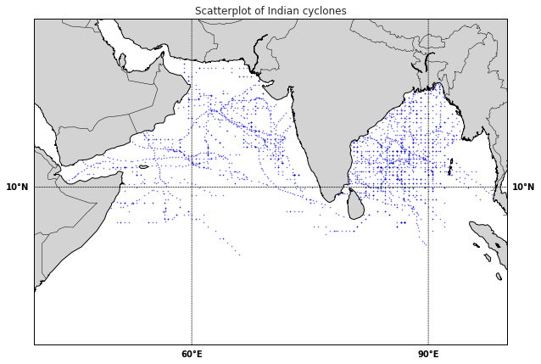

Figure 4**.** Scatterplot of NIO cyclones

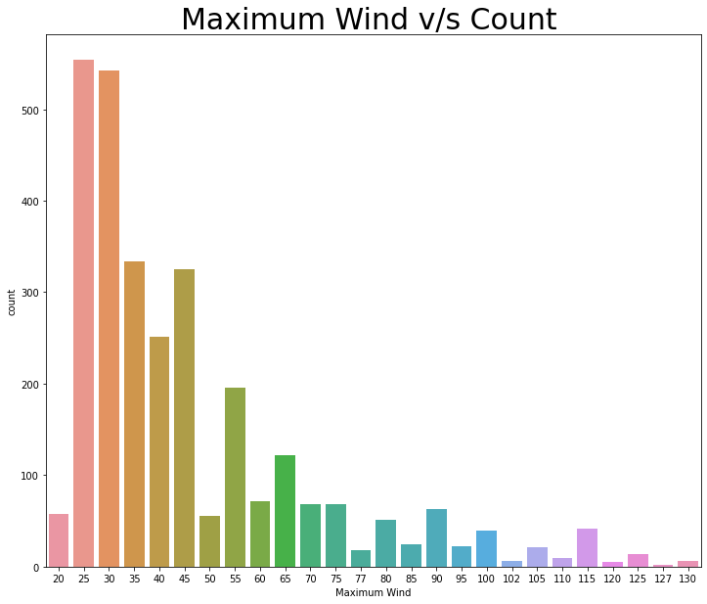

Figure 5. Maximum wind distribtuion

## 

Figure 6. India Meteorological Department TC Intensity Scale

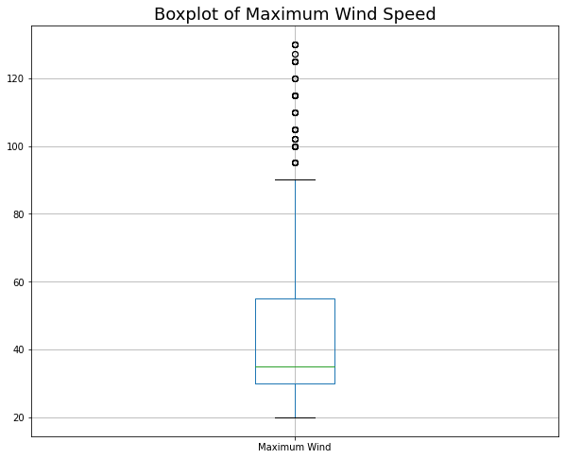

Figure 7. Boxplot of Maximum Wind Speed

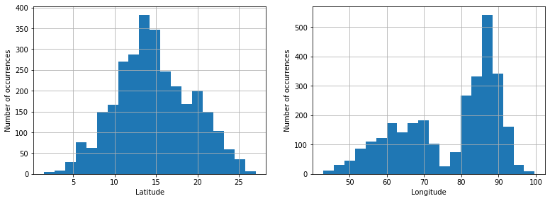

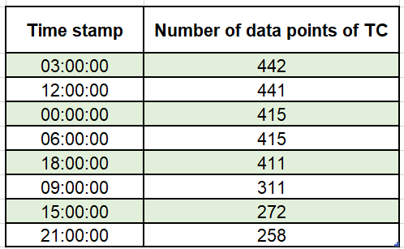 Figure 8. Number of occurrences of Latitude and Longitude

Table 2. Frequency distribution of data points across different timestamps

##### IV. Final Outcome

In past years, there has been enough progress made in the forecasting of tropical cyclones. Our capacity to anticipate and get ready for these potent natural events has been completely transformed by the application of cutting-edge technologies in tropical cyclone prediction. Understanding of cyclone behaviour, track prediction, and intensity forecasts has been efficiently improved by many techniques. Different ML classifiers are used for finding best performing classifier among them. The correlation matrix of all predictors with respect to maximum wind speed is shown in the figure 10. Predictors over the NIO are used for classification. Predictors like MSW etc over the NIO are used for TC classification. Performance of different ML classifiers is seen in figure 9. Both the testing and training accuracy is calculated to understand overfitting and underfitting. This research was performed over NIO with the best track data available on IMD. The best track data of 97 individual storms with 2965 instances are taken for the research. The obtained result show that the TC predictors such as MSW and pressure drop strongly affect the accuracy of the classification. On the other hand, latitude, longitude do not affect the accuracy of the classification. One limitation of this research is that the predictive ML models presented here uses only the best track data. In the future, other predictors like sea surface temperature etc can be used to determine the robustness of the ML classifiers. Random Forest reached the highest accuracy score among the models tested.

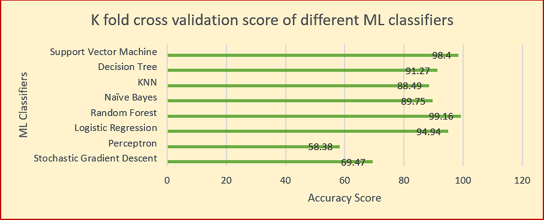

Figure 9. K Fold Cross validation score of ML Classifiers

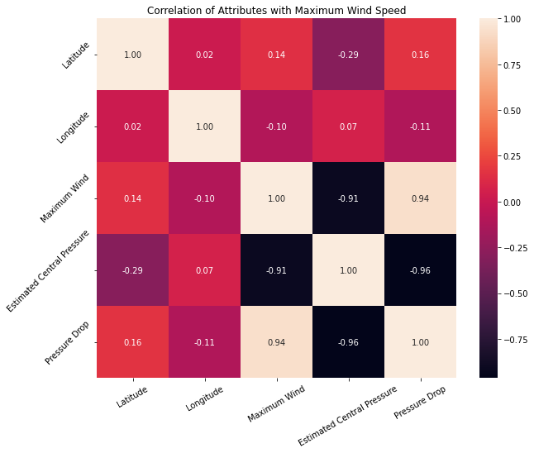

Figure 10. Correlation of predictors with Maximum Wind Speed

##### Acknowledgement

We’re truly grateful to the supervisors Sakshi Aggrawal who took the time to give us such helpful feedback. Their suggestions made our cyclone prediction review way better! Their keen observations significantly strengthened this work, guiding us towards more robust and impactful cyclone prediction research work. The authors extend their thanks to IMD and RSMC for the best track data provided on their website.

##### Abbreviations

The abbreviations present in the whole paper are mentioned below:

TC: Tropical Cyclone

CNN: Convolution Neural Networks

RSMC: Regional Specialized Meteorological Center

ANN: Artificial Neural Networks

SVM: Support Vetor Machine

JTWC: Joint Typhoon Warning Center

DAVT: Deviation Angle Variance Technique

GAN: Generative Adversarial Networks

DCNN: Deep Convolutional Neural Network

RNN: Recurrent Neural Network

NWP: Numerical weather prediction

ML: Machine Learning

AI: Artificial Intelligence

OLR: Optical Layout Recognition

SGD: Stochastic Gradient Descent

GNB: Gaussian Naıve Bayes

LR: Logistic Regression

SSTC: Sea Surface Temperature Cooling

INSAT: Indian National Satellite System

ISRO: Indian Space Research Organisation

MLP: Multi-Layer Perceptron

LSTM: Long Short-term Memory

STF: Short-Term Forecasting

LTF: Long-Term Forecasting

RF: Random Forest

DT: Decision tree

TIROS: Television Infrared Observation Satellite

NOAA: National Oceanic and Atmospheric Administration.

KNN: K-Nearest Neighbours

FY-4: FengYun-4 (FY-4)

SOM: Self-organizing map

FNN: Feedforward Neural Network

MSW: Maximum Sustained Surface Wind Speed

EKF: Extended Kalman Filter

MLNN: Multi-Layer Neural Network

WRF: Weather Research and Forecasting

ESCS: Extremely Severe Cyclonic Storm

VSCS: Very Severe Cyclonic Storm

SCS: Severe Cyclonic Storm

SUCS: Super Cyclonic Storm

NIO: NATIONAL INSTITUTE OF OCEANOGRAPHY

IMD: India Meteorological Department

##### References

[1] Nath, S., Kotal, S. D., & Kundu, P. K. (2016). Seasonal prediction of tropical cyclone activity over the north Indian Ocean using three artificial neural networks. *Meteorology and Atmospheric Physics*, *128*, 751-762.

[2] Dvorak, V.F.: Tropical cyclone intensity analysis and forecasting from satellite imagery. Monthly Weather Review 103(5), 420–430 (1975)

[3] Dvorak, V.F.: Tropical Cyclone Intensity Analysis Using Satellite Data vol. 11. US Department of Commerce, National Oceanic and Atmospheric Administration . . . , ??? (1984)

[4] Olander, T.L., Velden, C.S.: The advanced dvorak technique (adt) for estimating tropical cyclone intensity: Update and new capabilities. Weather and Forecasting 34(4), 905–922 (2019)

[5] Tsai, Y.-L., Wu, T.-R., Lin, C.-Y., Lin, S.C., Yen, E., Lin, C.-W.: Discrepancies on storm surge predictions by parametric wind model and numerical weather prediction model in a semi-enclosed bay: Case study of typhoon haiyan. Water 12(12), 3326 (2020)

[6] Yamaguchi, M., Ishida, J., Sato, H., Nakagawa, M.: Wgne intercomparison of tropical cyclone forecasts by operational nwp models: A quarter century and beyond. Bulletin of the American Meteorological Society 98(11), 2337–2349 (2017)

[7] Burton, D., Bernardet, L., Faure, G., Herndon, D., Knaff, J., Li, Y., Mayers, J., Radjab, F., Sampson, C., Waqaicelua, A.: Structure and intensity change: Operational guidance. In: 7th International Workshop on Tropical Cyclones, p. (2010)

[8] Griffin, J.S., Burpee, R.W., Marks, F.D., Franklin, J.L.: Real-time airborne analysis of aircraft data supporting operational hurricane forecasting. Weather and forecasting 7(3), 480–490 (1992)

[9] Lee, R.S., Lin, J.: An elastic contour matching model for tropical cyclone pat- tern recognition. IEEE Transactions on Systems, Man, and Cybernetics, Part B (Cybernetics) 31(3), 413–417 (2001)

[10] Kar, C., Banerjee, S.: Intensity prediction of tropical cyclone using multilayer multi-block local binary pattern and tree-based classifiers over north indian ocean. Computers & Geosciences 154, 104798 (2021)

[11] Kim, M., Park, M.-S., Im, J., Park, S., Lee, M.-I.: Machine learning approaches for detecting tropical cyclone formation using satellite data. Remote Sensing 11(10), 1195 (2019)

[12] Kar, C., Kumar, A., Banerjee, S.: Tropical cyclone intensity detection by geomet- ric features of cyclone images and multilayer perceptron. SN Applied Sciences 1, 1–7 (2019)

[13] Dutta, I., Banerjee, S.: Elliptic fourier descriptors in the study of cyclone cloud intensity patterns. International Journal of Image Processing 7(4), 402–417 (2013)

[14] Combinido, J.S., Mendoza, J.R., Aborot, J.: A convolutional neural network approach for estimating tropical cyclone intensity using satellite-based infrared images. In: 2018 24th International Conference on Pattern Recognition (ICPR),

pp. 1474–1480 (2018). IEEE

[15] Nasa.Inc: Cyclone Tauktae Strikes India. https://earthobservatory.nasa.gov/ images/148325/cyclone-tauktae-strikes-india

[16] Chong Wang, S.M.X.L.F.Q.X. Gang Zheng: Tropical cyclone intensity estimation from geostationary satellite imagery using deep convolutional neural networks. IEEE Transactions On Geoscience And Remote Sensing, (2021)

[17] K. Balakrishnan, V.G. A. M. Manickavasagam, Ramasamy, V.: Prediction of sub- surface oceanographic parameter using machine learning technique based on long term historical in-situ measurements. OCEANS 2022 (2022)

[18] Ahmed, R., Mohapatra, M., Giri, R.K., Dwivedi, S.: An evaluation of the advanced dvorak technique (9.0) for the tropical cyclones over the north indian ocean. Tropical Cyclone Research and Review 10(4), 201–208 (2021)

[19] al, A.N.: Adeep learning framework for the detection of tropical cyclones from satellite images (2022)

[20] Kalyan Kumar Jena, S.R.N.R.P.a.A.K.B. Sourav Kumar Bhoi: Deep convo- lutional network based machine int elegance model for satellite cloud image classification (2022)

[21] Salzberg, S.L.: C4. 5: Programs for machine learning by j. ross quinlan. morgan kaufmann publishers, inc., 1993. Kluwer Academic Publishers (1994)

[22] Yip, Z.K., Yau, M.: Application of artificial neural networks on north atlantic tropical cyclogenesis potential index in climate change. Journal of Atmospheric and Oceanic Technology 29(9), 1202–1220 (2012)

[23] Bankert, R.L., Tag, P.M.: An automated method to estimate tropical cyclone intensity using ssm/i imagery. Journal of Applied Meteorology 41(5), 461–472 (2002)

[24] Knaff, J.A., Zehr, R.M.: Reexamination of tropical cyclone wind–pressure rela- tionships. Weather and Forecasting 22(1), 71–88 (2007)

[25] Fritz, S., Hubert, L.F., Timchalk, A.: Some inferences from satellite pictures of tropical disturbances. Monthly Weather Review 94(4), 231–236 (1966)

[26] Fletcher, R.D.: Computation of maximum surface winds in hurricanes. Bulletin of the American Meteorological Society 36(6), 247–250 (1955)

[27] Cao, L.J., Keerthi, S.S., Ong, C.J., Zhang, J.Q., Periyathamby, U., Fu, X.J., Lee, H.P.: Parallel sequential minimal optimization for the training of support vector machines. IEEE Trans. Neural Networks 17(4), 1039–1049 (2006)

[28] Mitra, S., Pal, S.K.: Fuzzy multi-layer perceptron, inferencing and rule generation. IEEE Transactions on Neural Networks 6(1), 51–63 (1995)

[29] Mishra, D., Gupta, G.: Estimation of maximum wind speeds in tropical cyclones occurring in indian seas. Mausam 27(3), 285–290 (1976)

[30] Kar, C., Banerjee, S.: Tropical cyclone intensity prediction using best track data over north indian ocean by machine learning classifiers. 2021 IEEE International India Geoscience and Remote Sensing Symposium (InGARSS) (2021)

[31] O. Ogun, G.C.A.T. M. Enoh, Madonna, V.: Enhancing prediction in cyclone separators through computational intelligence (2020)

[32] JieLian, Y.Z.J.P. Pingping Dong, Liu, K.: A novel data-driven tropical cyclone track prediction model based on cnn and gru with multi-dimensional feature selection (2020)

[33] F. Meng, H.S.D.X.S. Q. Tian (ed.): Cyclone identify using two- branch convolu- tional neural network from global forecasting system analysis. IEEE International Geoscience and Remote Sensing Symposium IGARSS (2021)

[34] ZarHsan; MyintMyint Sein, T.: Combining support vect or machine and p olynomial regressing t o p redict tropical cyclone track (2021)

[35] DoraiRangaswamy, D.B.D.: Forecast ing of cyclone using mult i- t temporal change det ected sat ellite images (2014)

[36] A.K.M. Saiful Islam; Mohan Kumar Das; Faruque Abdullah, N.: Assessing t ropical cyclone t racks in the bay of bengal (2022)

[37] Zhou, X.Y.Z.C.G.C.H.Z.J.: A tensor network for tropical cvclone wind speed estimation. IGARSS2019 - 2019 IEEE International Geoscience and Remote Sensing Symposium. (2019)

[38] al., P..X.: Visual prediction of tropical cyclones with deep convolutional generative adversarial networks (2021)

[39] S. K. Suba Raja, R.P..K. D. A. S S L, Selvakumar, J.: Recognition of facial stress system using machine learning with an intelligent alert system (2023)

[40] V. Srikant h, B.J.h.S.S.L.D.A. V. Natarajan, Nageswari, D.: Fruit fly optimisation with deep learning based reactive power optimization model for distributed systems (2022)

[41] Kar, C., Banerjee, S.: Tropical cyclone intensity prediction using best track data over north Indian ocean by machine learning classifiers. In: 2021 IEEE International India Geoscience and Remote Sensing Symposium (InGARSS), pp. 297–300 (2021). IEEE