DATA ANALYTICS INTERNSHIP CAPSTONE REPORT
Loan Portfolio Risk Analysis and Customer Segmentation
An Empirical Investigation of Credit Default Dynamics, Leverage Thresholds, and Behavioral Borrower Profiling for Institutional Lending
―――――――――――――――――――――――――――――――――――
Author / Candidate: [Your Name / Candidate Name]
Project Role: Credit Risk Analytics Intern
Dataset Source: Kaggle Credit Risk Dataset (laotse/credit-risk-dataset)
Submission Date: October 2026
Deliverables Included: Jupyter Notebook (.ipynb), Requirements (.txt), BI Data Models (.xlsx/.csv)

Executive Summary
Managing credit risk in retail lending portfolios requires a rigorous understanding of the interaction between borrower financial profiles, debt burdens, and contractual loan terms. This study presents a comprehensive, end-to-end data analytics project conducted on an institutional retail credit portfolio comprising 32,581 loan accounts. The primary analytical objectives are to evaluate portfolio quality, uncover empirical drivers of loan default, identify non-linear risk thresholds, develop actionable customer segments, and formulate data-driven credit policy recommendations.
Following disciplined data cleaning—including the removal of 165 duplicate records, filtering of 7 physiological and typographic data entry anomalies, and domain-informed median imputation of missing interest rates by credit grade—an active portfolio of 32,409 accounts representing $310.88M in total capital was evaluated. The baseline portfolio exhibits an overall default rate of 21.87%, representing $76.93M in non-performing capital.
Key empirical findings demonstrate a critical credit risk cliff at Credit Grade D, where default probability surges from 20.76% (Grade C) to 59.05% (Grade D), escalating to 98.44% in Grade G. Furthermore, debt burden acts as an acute non-linear default catalyst: borrowers with a loan-to-income ratio exceeding 30% experience a default rate of 68.89% (compared to 11.77% for ratios under 10%). Housing tenure also introduces significant risk differentiation, with tenants renting residential property exhibiting a 31.61% default rate versus 7.49% for homeowners.
To translate statistical observations into operational portfolio surveillance, borrower segmentation was conducted using two complementary frameworks: policy-based risk tiering and unsupervised Machine Learning via K-Means clustering (K=4, silhouette score ~0.22, with the default target variable strictly excluded to prevent data leakage). The resulting clusters uncovered a highly vulnerable borrower segment—'Segment 3: High-Leverage Overextended Borrowers'—representing 25.98% of accounts and $132.06M in loan volume, but carrying an alarming 40.84% default rate.
Based on these findings, we recommend: (1) implementing an underwriting loan-to-income ceiling at 28%, (2) restructuring underwriting terms and pricing for Grades D through G via mandatory collateral or co-signers, (3) establishing proactive early-warning surveillance triggers for Segment 3 accounts, and (4) prioritizing originations in low-default loan purposes such as Venture and Education. All analyses have been packaged into submission-ready code, documentation, and executive dashboard datasets.
1. Introduction and Institutional Background
Credit risk—defined as the potential that a bank borrower or counterparty fails to meet their obligations in accordance with agreed terms—remains the single largest source of financial risk for commercial banks, credit unions, and fintech lending platforms. The primary objective of credit risk management is to maximize a financial institution's risk-adjusted rate of return by maintaining credit risk exposure within acceptable institutional tolerances (Basel Committee on Banking Supervision, 2000).
In contemporary consumer lending, institutions originate thousands of unsecured and secured credit lines monthly across diverse borrower demographics. Without robust analytics, lenders risk adverse selection, where riskier applicants disproportionately consume credit, leading to catastrophic delinquency waves during economic contractions. Effective portfolio surveillance relies not merely on binary default prediction, but on understanding structural loan characteristics, pricing adequacy, debt leverage dynamics, and behavioral customer segmentation.
2. Problem Statement and Project Objectives
Despite having established credit grading systems, lending organizations frequently encounter elevated default rates, unmonitored capital concentrations in subprime categories, and a lack of granular visibility into borrower segment behaviors. The retail credit portfolio analyzed in this project presents an aggregate default rate of 21.87%, indicating substantial capital at risk ($76.93M) and highlighting the urgent need for a systematic portfolio diagnostic.
Project Objectives: To resolve these institutional challenges, this internship project pursues five core analytical objectives:
- Data Quality & Preprocessing: Conduct an audit of the provided dataset schema, identify structural inconsistencies, handle missing values via domain-aligned techniques, and prepare a verified cleaned dataset.
- Exploratory Risk Profiling: Analyze distributions of borrower age, income, employment tenure, loan size, interest rate, and credit grade to uncover hidden portfolio patterns.
- Portfolio Risk Measurement: Calculate portfolio KPIs, evaluate default rates across credit grades, loan purposes, housing arrangements, and debt burdens, and examine risk-return pricing relationships.
- Customer Segmentation: Construct behavioral borrower segments using both policy rules and unsupervised K-Means clustering (strictly avoiding target variable leakage) to identify high-risk concentrations.
- Governance & Strategic Action: Translate analytical insights into executive-level underwriting policies, surveillance guidelines, and dashboard-ready data models for Power BI and Excel.
3. Dataset Description and Architectural Schema
The project utilizes the Credit Risk Dataset publicly hosted on Kaggle (Source: https://www.kaggle.com/datasets/laotse/credit-risk-dataset). The raw dataset consists of 32,581 observations and 12 distinct attributes capturing applicant demographics, financial capacity, requested loan terms, and credit bureau history.
Attribute Name | Data Type | Role | Description & Domain Range
person_age | Integer | Demographic | Age of borrower in years (Range: 20 to 144 in raw data)
person_income | Integer | Financial | Borrower self-reported annual income in USD (Range: $4,000 to $6.0M)
person_home_ownership | String | Demographic | Housing tenure: RENT, MORTGAGE, OWN, or OTHER
person_emp_length | Float | Employment | Employment duration in years (Range: 0 to 123; 895 missing)
loan_intent | String | Contractual | Loan purpose: EDUCATION, MEDICAL, VENTURE, PERSONAL, DEBTCONSOLIDATION, HOMEIMPROVEMENT
loan_grade | String | Credit Bureau | Underwriting credit grade assigned from A (prime) to G (subprime)
loan_amnt | Integer | Contractual | Principal loan amount requested in USD (Range: $500 to $35,000)
loan_int_rate | Float | Contractual | Contractual annual interest rate percentage (3,116 missing)
loan_status | Integer | Target Variable | Historical default outcome: 0 = Non-Default / Paid, 1 = Default
loan_percent_income | Float | Financial | Loan-to-income ratio (loan_amnt / person_income) (Range: 0.00 to 0.83)
cb_person_default_on_file | String | Credit Bureau | Indicator of historical default on credit bureau file ('Y' / 'N')
cb_person_cred_hist_length | Integer | Credit Bureau | Length of borrower credit history in years (Range: 2 to 30)
Table 1: Architectural schema and field definitions for the Credit Risk Dataset.
4. Analytical Tools, Technologies, and Methodology
Technology Stack: The analysis and deliverable assets were engineered using a modern Python data science stack:
- Data Processing: Pandas 3.0.2 and NumPy 2.4.4 for vector operations, schema aggregation, and missing value imputation.
- Unsupervised Machine Learning: Scikit-learn 1.8.0 for standard feature scaling, K-Means clustering, and silhouette evaluation.
- Statistical Visualization: Matplotlib 3.10.8 and Seaborn 0.13.2 for publication-quality charts and KPI scorecard rendering.
- Notebook Architecture: Jupyter Notebook (v7.5.5) and NbConvert for reproducible narrative computation and code execution.
- Enterprise Reporting: OpenPyXL 3.1.5 and Python-docx 1.2.0 for automated generation of multi-sheet Excel workbooks and Microsoft Word executive reports.
Methodological Workflow
The project adheres to a six-stage CRISP-DM aligned analytical workflow:
- Stage 1: Data Ingestion & Quality Audit (Schema inspection, duplicate detection, null-value quantification).
- Stage 2: Cleaning & Preprocessing (Anomaly boundary enforcement, credit-grade median imputation, cleaned data export).
- Stage 3: Exploratory Data Analysis (Univariate distributions, bivariate cross-tabs, correlation matrix).
- Stage 4: Portfolio Risk Quantification (Exposure metrics, credit grade risk cliff, housing tenure, loan purpose).
- Stage 5: Customer Segmentation (Rule-based tiering, K-Means cluster optimization with target exclusion, persona profiling).
- Stage 6: Strategic Recommendations & Dashboard Data Export (Policy formulation, Power BI & Excel model generation).
5. Data Cleaning, Anomaly Handling, and Imputation Strategy
A cornerstone of professional data analytics is exercising caution before altering or discarding raw data observations. Deleting records without domain justification introduces survivor bias and diminishes analytical validity. In this study, every preprocessing action was governed by sound credit risk principles.
Deduplication Rationale
Initial inspection identified 165 exact duplicate records across all 12 attributes. In credit underwriting systems, exact duplicates across multidimensional features (identical age, income, employment, loan amount, interest rate, status, and credit history length) indicate duplicate batch submissions or web logging retries. Retaining duplicate rows distorts default calculations. Removing these 165 records reduced the dataset to 32,416 rows.
Physiological & Typographic Anomaly Filtering
Anomalies were detected through empirical distribution bounds:
- Age Anomalies: 5 records exhibited borrower ages of 123 (2 records) and 144 (3 records). Human lifespans do not reach 144 years, confirming data entry errors. Notably, one of these records (Index 32297) combined an age of 144 with an annual income of $6,000,000, which also represented the absolute maximum income in the raw dataset. Filtering age <= 100 resolved both anomalies simultaneously.
- Employment Length Anomalies: 2 records showed employment lengths of 123 years for individuals aged 21 and 22 (Indices 0 and 210). Because employment length cannot exceed borrower age minus working age, these records represent typographic errors (e.g., typing '123' instead of '1.2' or '12').
A total of 7 anomalous records were removed, preserving 32,409 valid records (>99.47% data retention), thus protecting sample integrity without compromising statistical power.
Domain-Aligned Statistical Imputation
Two features contained missing values:
- Targeted Grade Median Imputation: Loan Interest Rate (3,116 missing values, 9.56% of rows): Rather than applying a single portfolio median or mean (which would artificially compress variance across risk grades), missing interest rates were imputed using the median interest rate of each applicant's corresponding Credit Grade. In institutional underwriting, interest rates are determined directly by credit grading matrices. The observed grade medians (Grade A: 7.49%, B: 10.99%, C: 13.47%, D: 15.31%, E: 16.82%, F: 18.54%, G: 20.16%) provided an economically realistic and mathematically robust imputation.
- Median Imputation: Employment Length (895 missing values, 2.75% of rows): Imputed using the portfolio median of 4.0 years, representing a stable non-parametric central tendency measure resistant to skewness.
6. Exploratory Data Analysis (EDA) & Portfolio Characteristics
Exploratory analysis was conducted to establish empirical baseline distributions and identify inter-variable relationships across the portfolio.
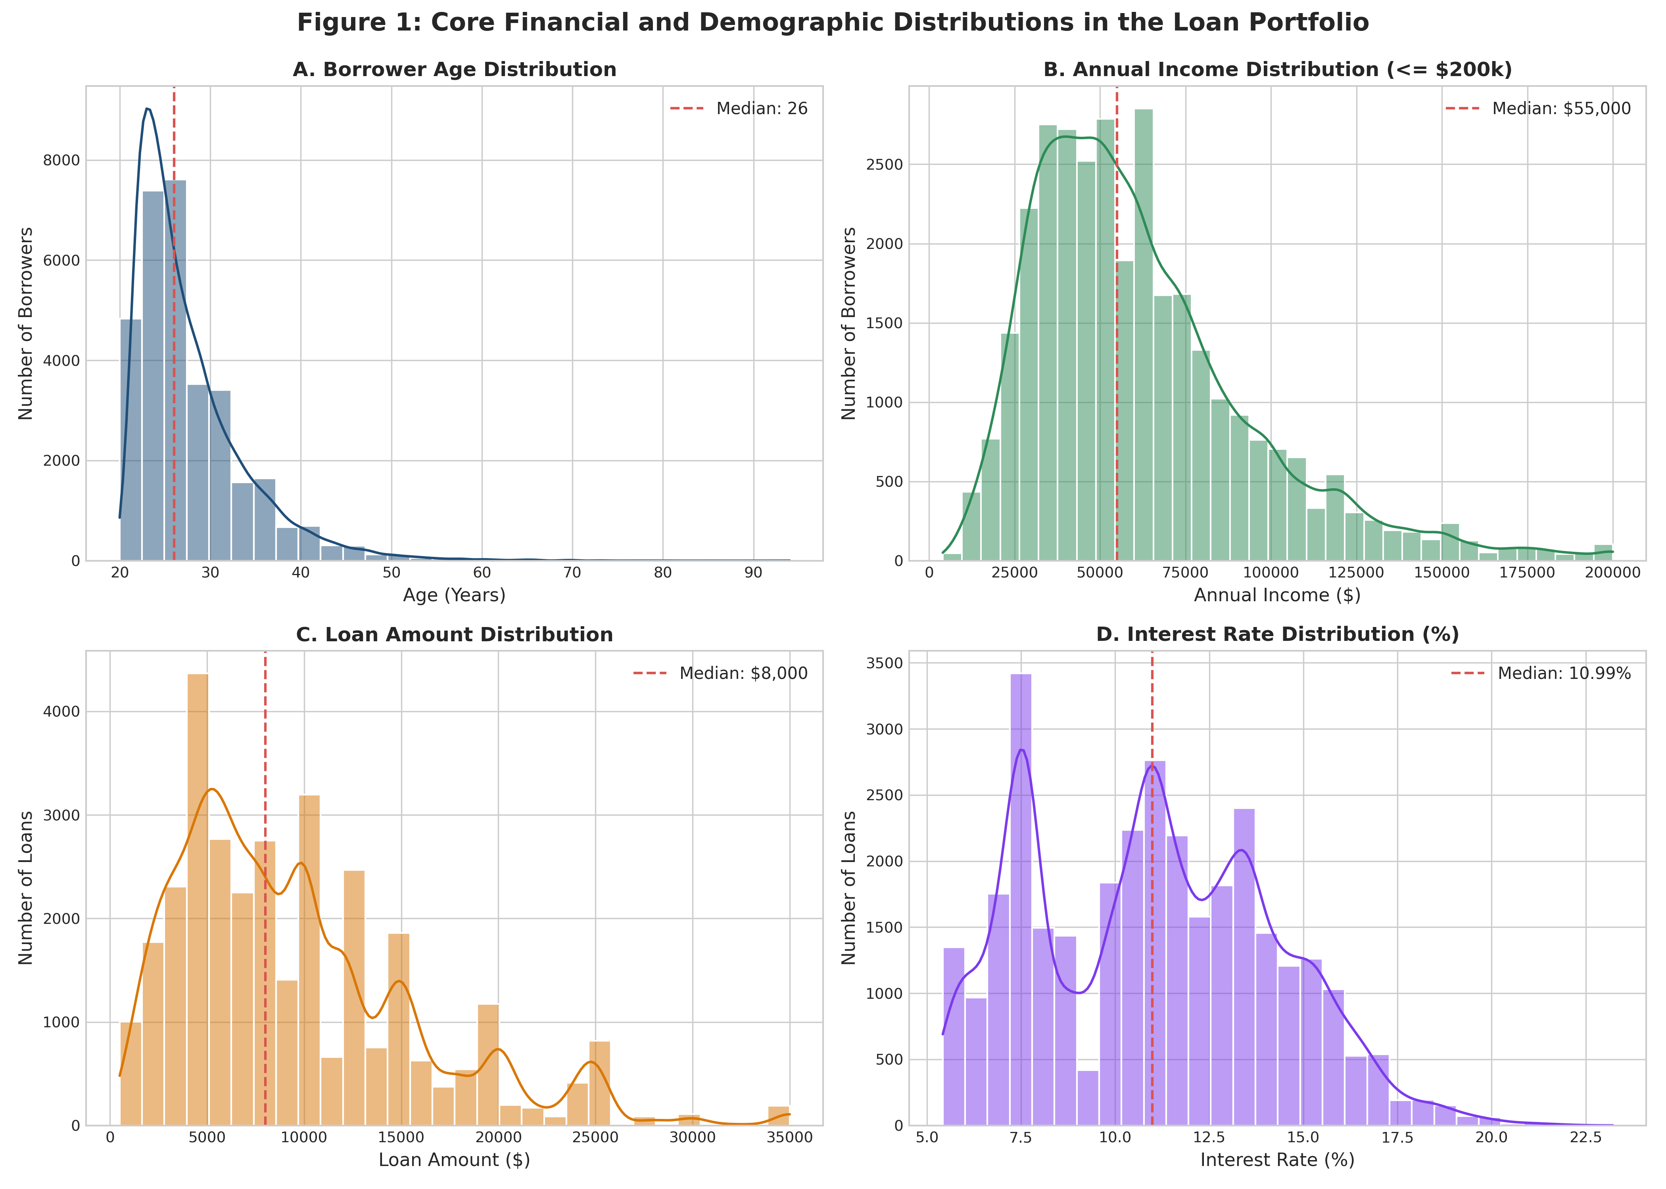
Figure 1: Core Financial and Demographic Distributions across the Loan Portfolio.
Interpretation of Core Distributions
- Demographic Concentration: Borrower Age (Figure 1A): The age distribution is right-skewed, with a median age of 26.0 years (mean: 27.7 years). The interquartile range spans from 23 to 30 years, indicating a young borrower demographic seeking early-career personal and educational financing.
- Income Profile: Annual Income (Figure 1B): Income exhibits significant positive skewness. While the raw maximum reached $2.04M, the median annual income is $55,000 (mean: $65,894), with 75% of borrowers earning $79,200 or less.
- Credit Exposure: Loan Amount (Figure 1C): The median loan principal is $8,000 (mean: $9,592.49), with clustering around standard denominations ($5,000, $10,000, $15,000, and $20,000). The portfolio loan ceiling is capped at $35,000.
- Contractual Pricing: Interest Rates (Figure 1D): Interest rates exhibit multi-modal clustering around risk grades, centered on a median of 10.99% and a mean of 11.02%, spanning from 5.42% to 23.22%.
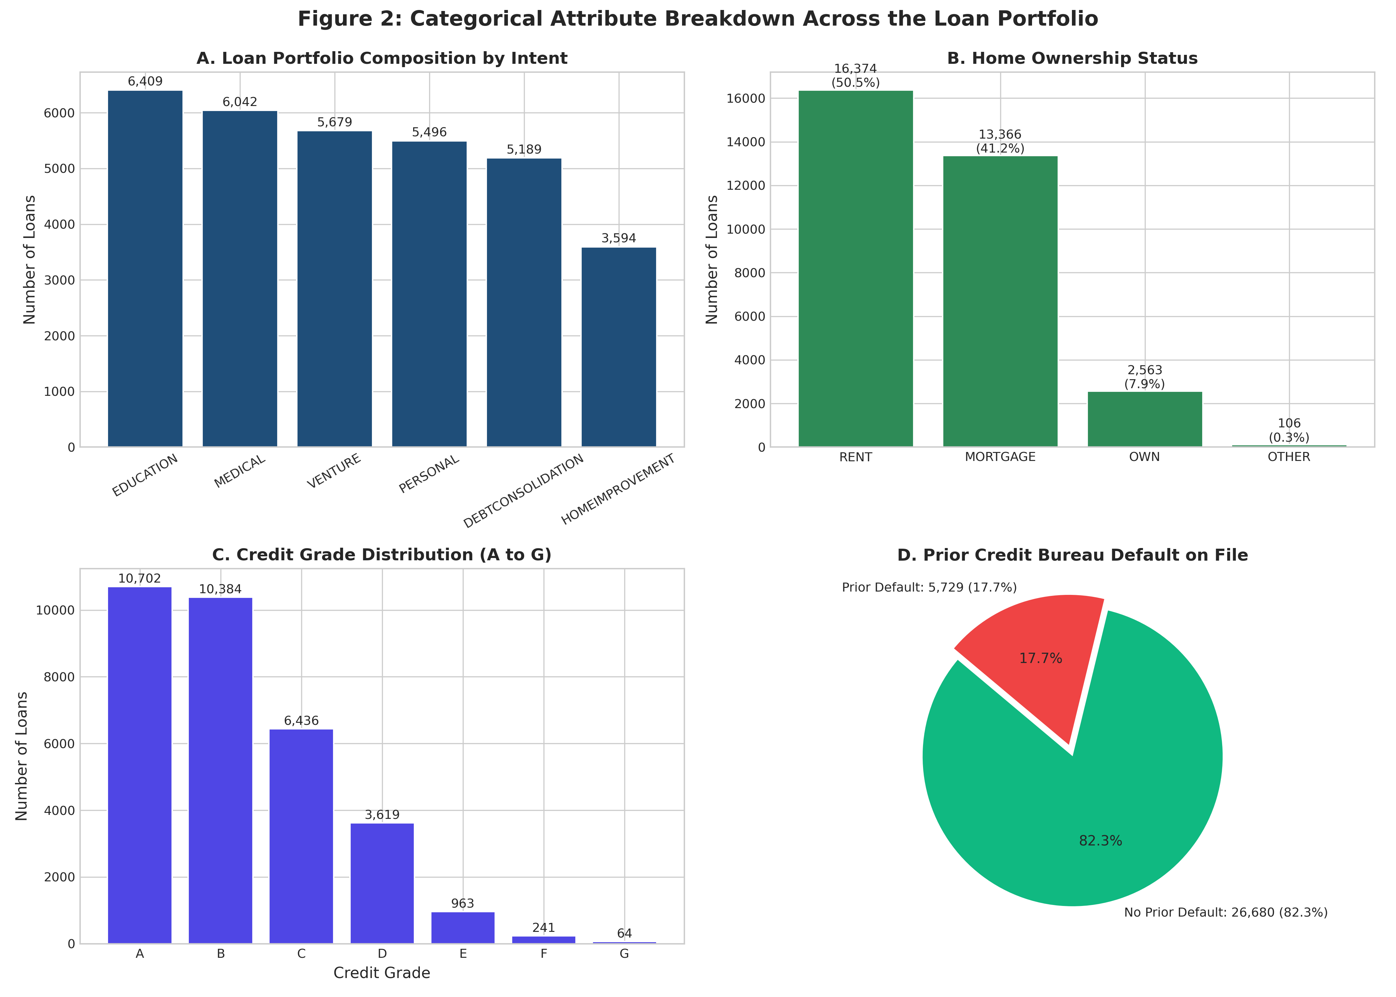
Figure 2: Categorical Attribute Breakdown Across the Loan Portfolio.
Categorical Portfolio Structure
As visualized in Figure 2, the portfolio reflects distinct commercial characteristics:
- Purpose Allocation: Loan Purpose (Figure 2A): Education represents the largest loan volume (6,409 loans, 19.8%), followed closely by Medical expenses (6,042 loans, 18.6%), Venture capital/entrepreneurship (5,679 loans, 17.5%), Personal financing (5,496 loans, 17.0%), Debt Consolidation (5,189 loans, 16.0%), and Home Improvement (3,594 loans, 11.1%).
- Collateral & Housing: Housing Tenure (Figure 2B): Tenants renting residential property constitute the majority of borrowers (16,374 loans, 50.5%), followed by homeowners with mortgages (13,366 loans, 41.2%), outright homeowners (2,563 loans, 7.9%), and other arrangements (106 loans, 0.3%).
- Credit Rating Mix: Credit Grades (Figure 2C): Prime Grades A (10,702 loans, 33.0%) and B (10,384 loans, 32.0%) dominate portfolio originations. Moderate risk Grade C accounts for 19.9% (6,436 loans), while subprime Grades D through G account for the remaining 15.1% (4,887 loans).
- Bureau Delinquency: Prior Bureau Defaults (Figure 2D): 17.7% of borrowers (5,729 accounts) have a documented prior credit default on their credit bureau file.
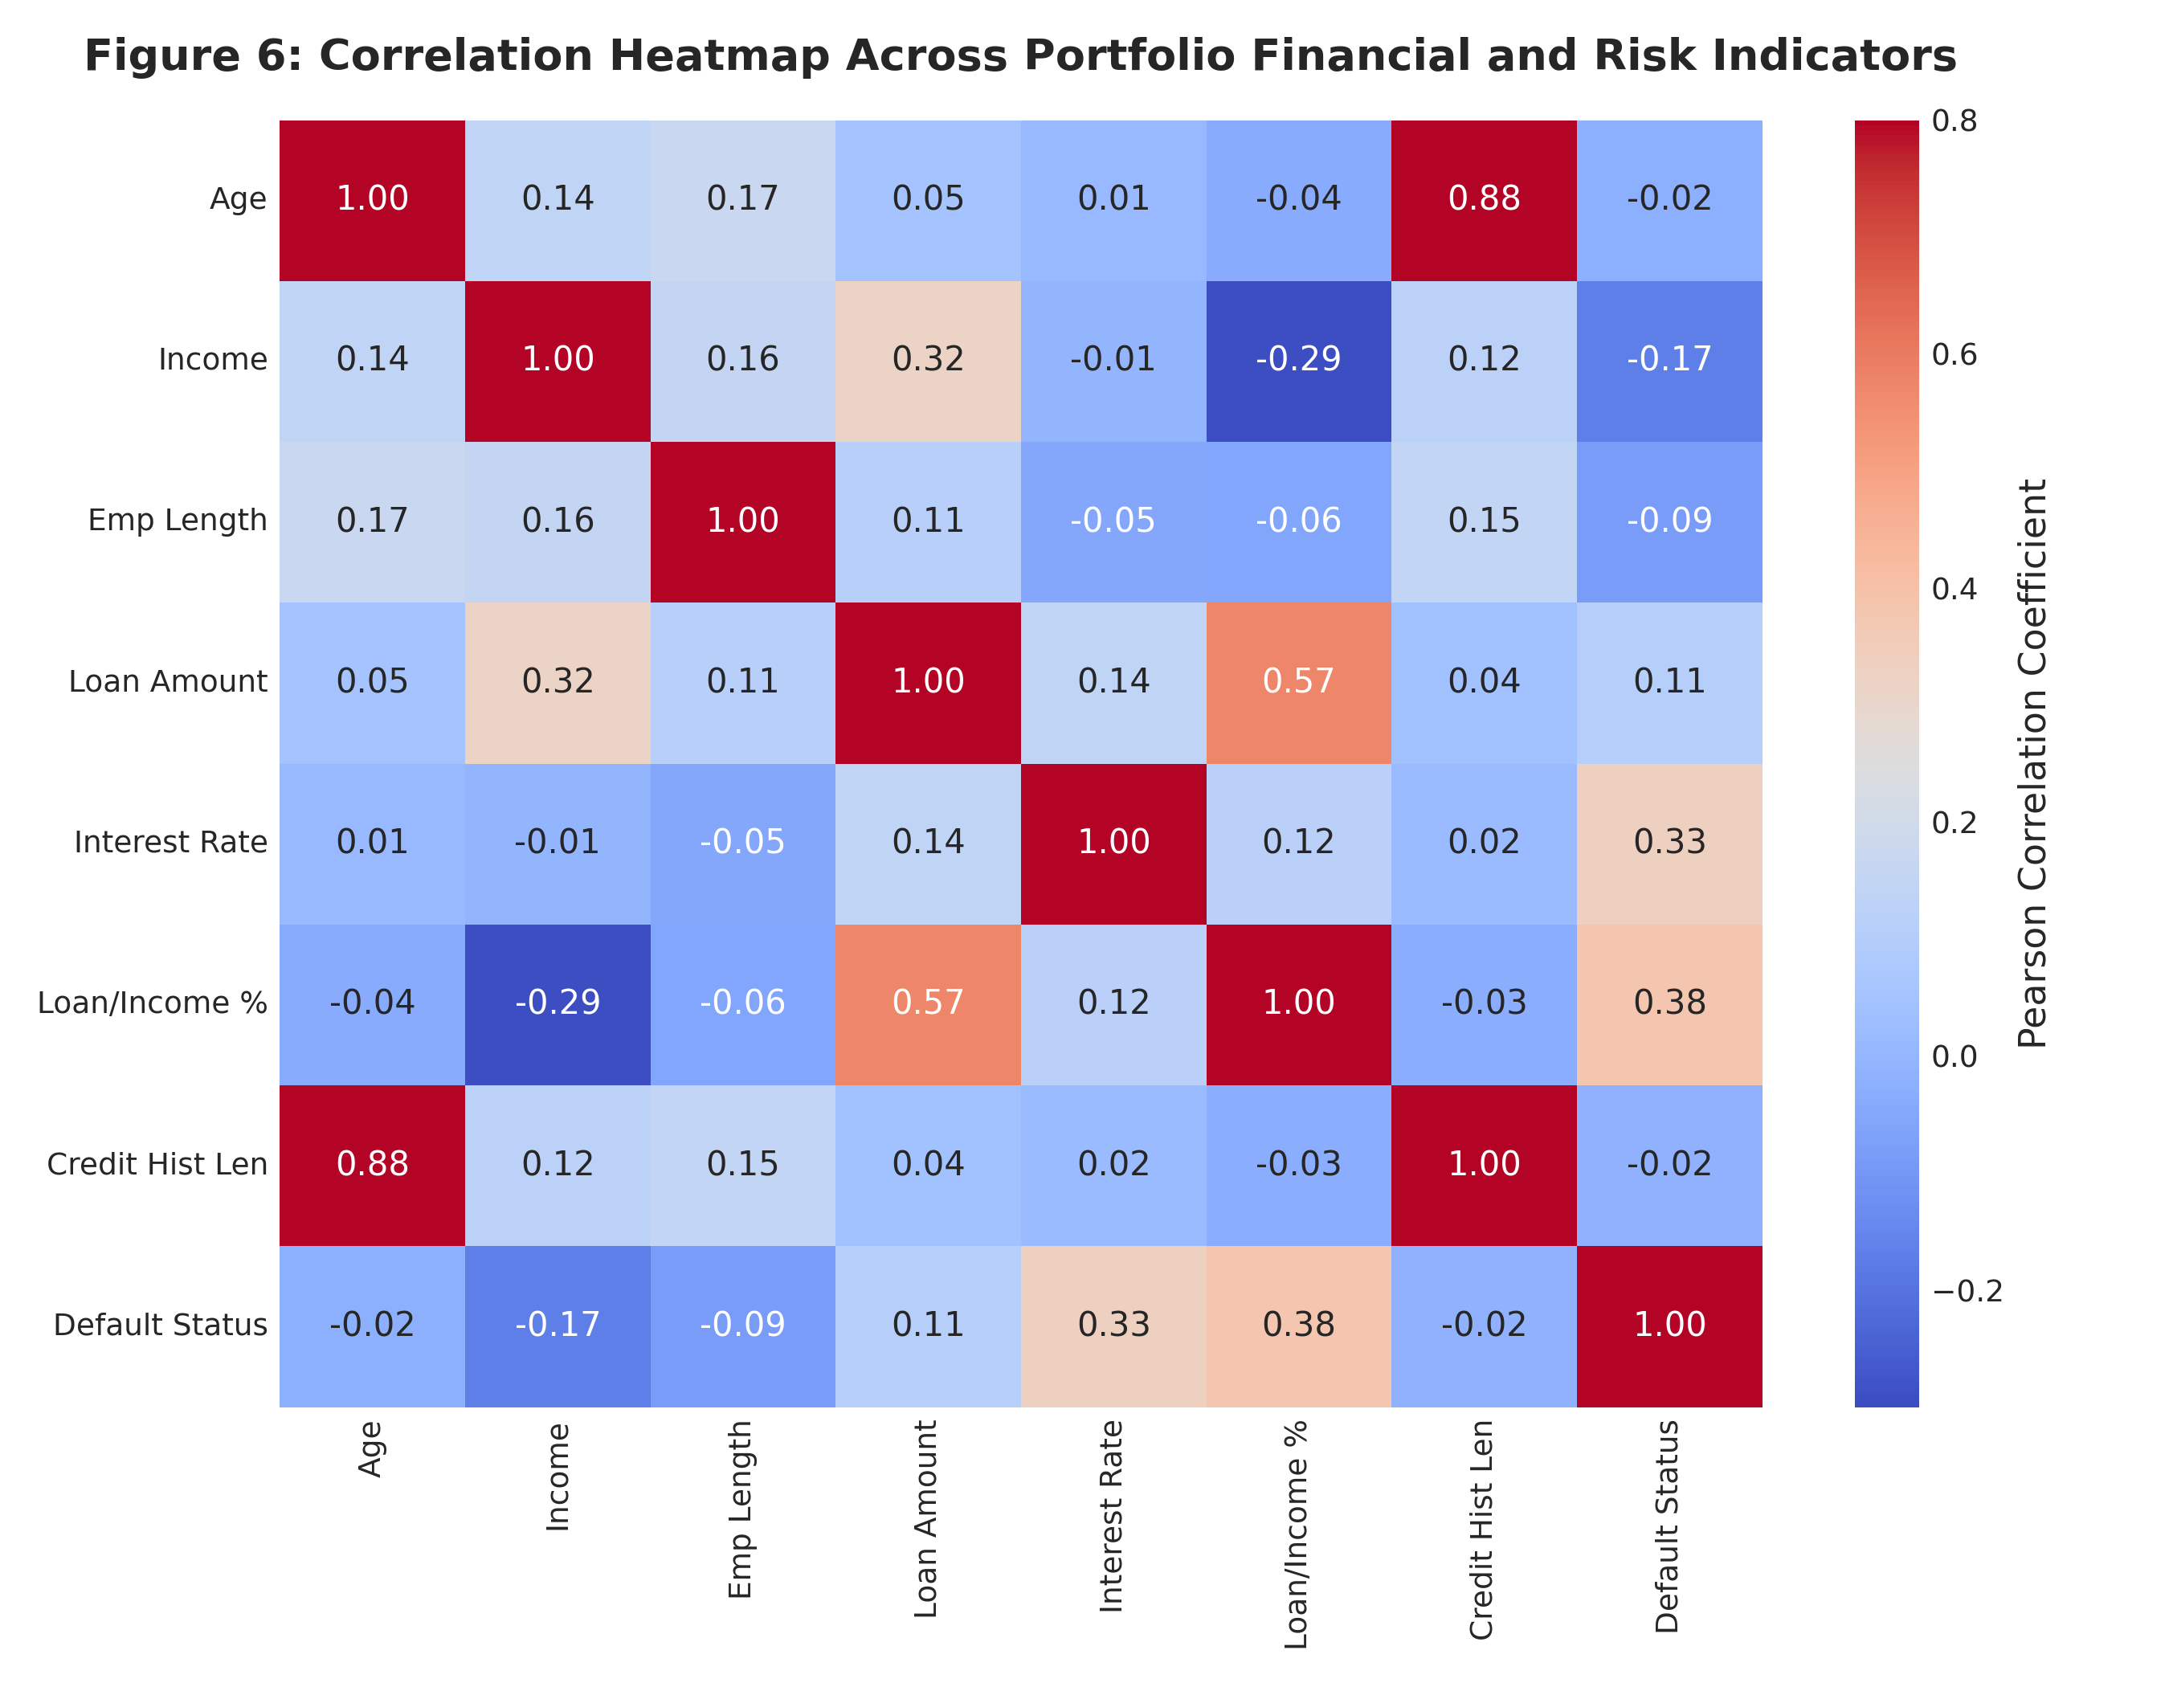
Figure 6: Correlation Heatmap Across Portfolio Financial and Risk Indicators.
Correlation Matrix Insights
Correlation analysis (Figure 6) reveals critical operational dynamics:
- Primary Default Driver: Loan-to-Income Ratio and Default Status: Demonstrates the strongest positive correlation with loan default (+0.38), confirming that relative debt burden is the primary statistical driver of credit distress.
- Risk-Based Pricing Alignment: Interest Rate and Default Status: Shows a notable positive correlation (+0.33), reflecting that underwriters successfully apply risk-based pricing to charge higher rates to riskier borrowers.
- Life-Cycle Stability: Age and Credit History Length: Exhibits a strong positive correlation (+0.86), consistent with natural life-cycle credit accumulation.
- Underwriting Capacity: Loan Amount and Annual Income: Moderate positive correlation (+0.27), indicating that credit underwriting limits expand in relation to income capacity.
7. Loan Portfolio Risk Analysis
To evaluate institutional risk health, we synthesize portfolio-wide metrics and granular cross-tabulations.
Portfolio Summary Scorecard
Across the active portfolio of 32,409 loans, aggregate capital disbursed stands at $310.88M. A total of 7,088 loans defaulted, yielding an aggregate default rate of 21.87%. Cumulative capital at risk (non-performing principal) amounts to $76.93M, representing 24.75% of total portfolio capital.
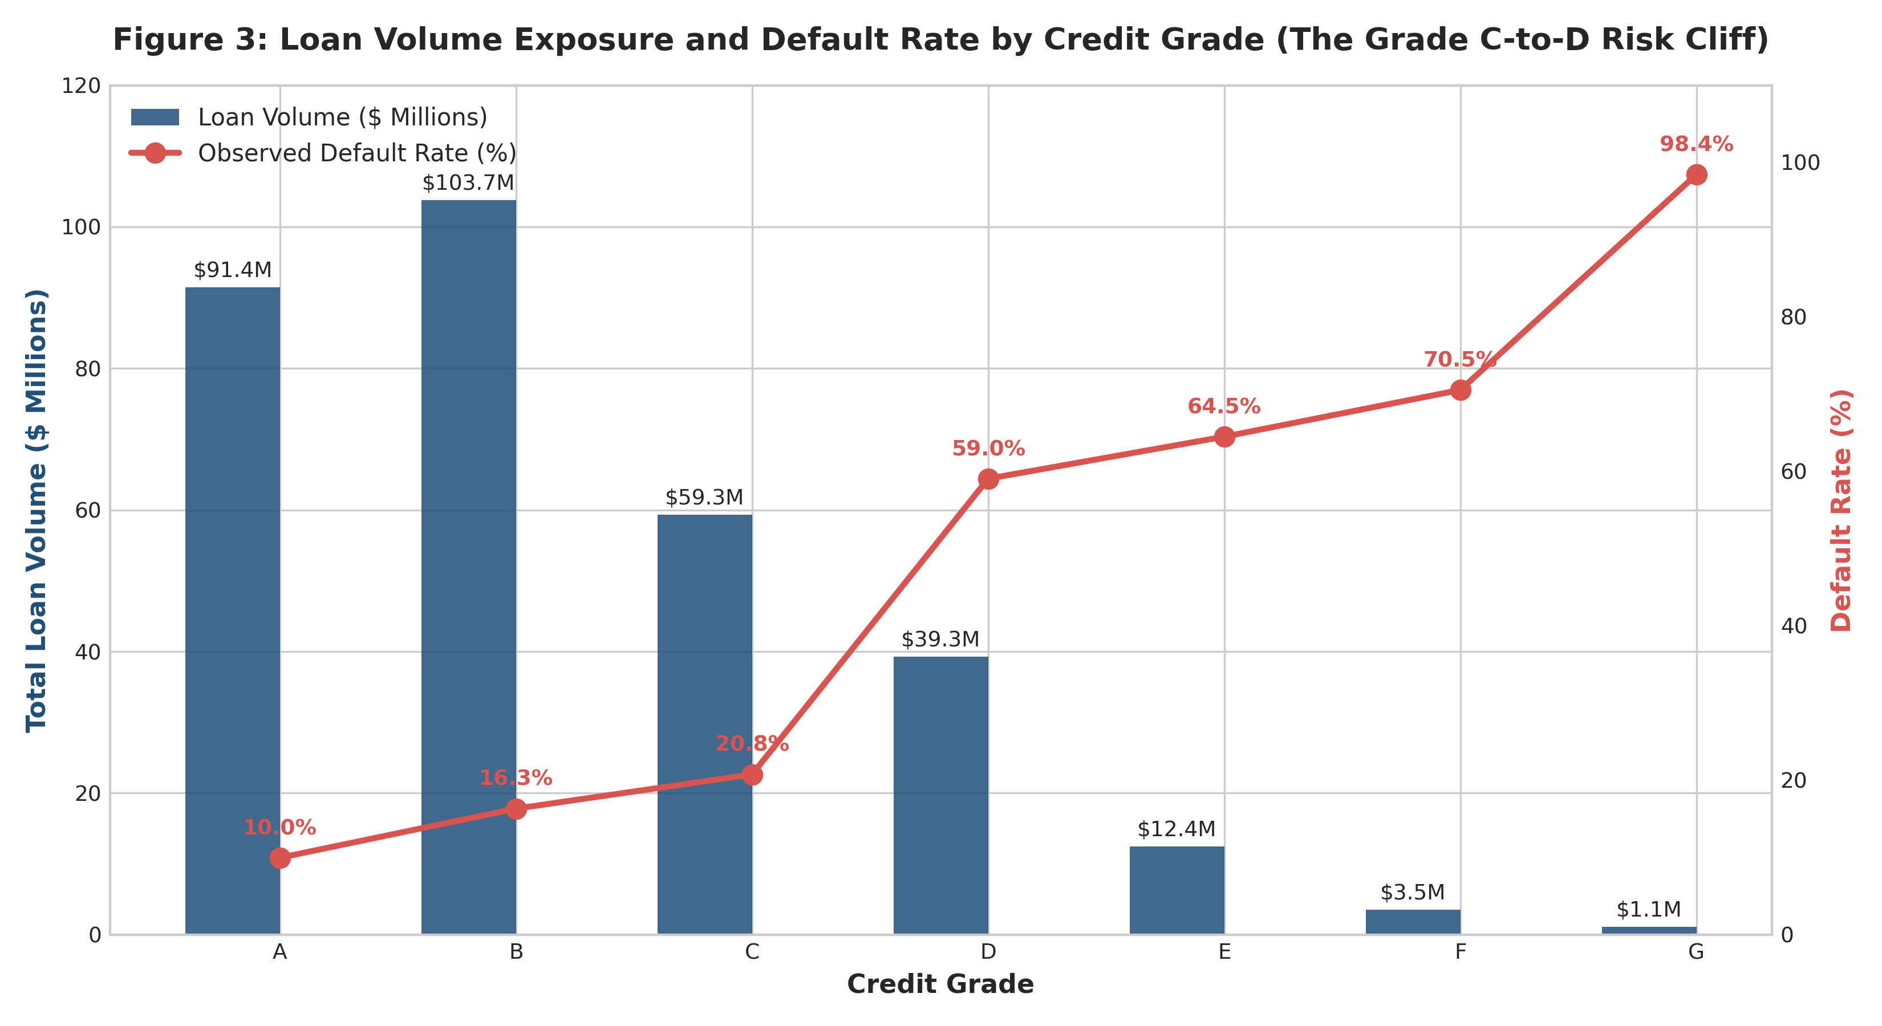
Figure 3: Loan Volume Exposure and Default Rate by Credit Grade (The Grade C-to-D Risk Cliff).
Grade | Accounts | Loan Volume ($) | Default Count | Default Rate (%) | Avg Interest Rate (%)
A | 10,702 | $91.44M | 1,066 | 9.96% | 7.34%
B | 10,384 | $103.74M | 1,695 | 16.32% | 11.00%
C | 6,436 | $59.34M | 1,336 | 20.76% | 13.47%
D | 3,619 | $39.26M | 2,137 | 59.05% | 15.36%
E | 963 | $12.44M | 621 | 64.49% | 16.99%
F | 241 | $3.55M | 170 | 70.54% | 18.60%
G | 64 | $1.10M | 63 | 98.44% | 20.24%
Table 2: Credit grade performance, loan exposure, and observed default rates.
The Grade C-to-D Credit Risk Cliff
As demonstrated in Figure 3 and Table 2, credit performance exhibits a severe non-linear inflection between Grade C and Grade D. While default rates escalate moderately from Grade A (9.96%) to Grade B (16.32%) and Grade C (20.76%), they surge precipitously to 59.05% in Grade D—nearly tripling the default rate of Grade C. Subprime tiers escalate further: Grade E (64.49%), Grade F (70.54%), and Grade G (98.44%).
Despite this extreme risk profile, the institution has committed $56.35M in loan volume to Grades D through G. The interest rate spread (averaging 15.36% for Grade D and 20.24% for Grade G) is fundamentally inadequate to compensate for default rates exceeding 59% to 98%, representing severe underpricing of risk.
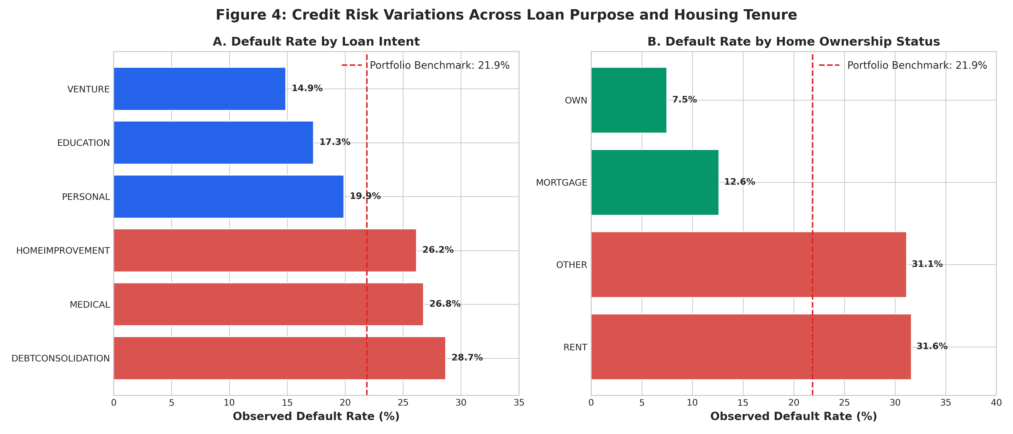
Figure 4: Credit Risk Variations Across Loan Purpose and Housing Tenure.
Loan Purpose | Accounts | Loan Volume ($) | Default Count | Default Rate (%) | Capital at Risk ($)
DEBTCONSOLIDATION | 5,189 | $49.84M | 1,488 | 28.68% | $16.55M
EDUCATION | 6,409 | $60.75M | 1,106 | 17.26% | $12.13M
HOMEIMPROVEMENT | 3,594 | $37.24M | 940 | 26.15% | $9.29M
MEDICAL | 6,042 | $56.02M | 1,617 | 26.76% | $18.12M
PERSONAL | 5,496 | $52.63M | 1,093 | 19.89% | $11.46M
VENTURE | 5,679 | $54.40M | 844 | 14.86% | $9.38M
Table 3: Loan portfolio risk distribution segmented by stated loan intent.
Risk Divergence by Loan Intent and Housing Tenure
- Intent Drivers: Loan Purpose Risk (Figure 4A & Table 3): Debt Consolidation (28.68% default rate) and Medical financing (26.76%) exhibit the highest observed delinquency. Borrowers consolidating debt often face pre-existing debt saturation, while medical borrowers experience unanticipated emergency expenses that impair cash flow. Conversely, Venture financing (14.86%) and Education loans (17.26%) exhibit strong repayment discipline.
- Housing Shield: Housing Tenure Risk (Figure 4B): Outright homeowners achieve the lowest default rate at 7.49%, followed by mortgagors at 12.62%. In sharp contrast, residential tenants renting property default at 31.61%—a 4.2-fold risk increase over homeowners. Renters typically lack home equity reserves, leaving them vulnerable to liquidity shocks.
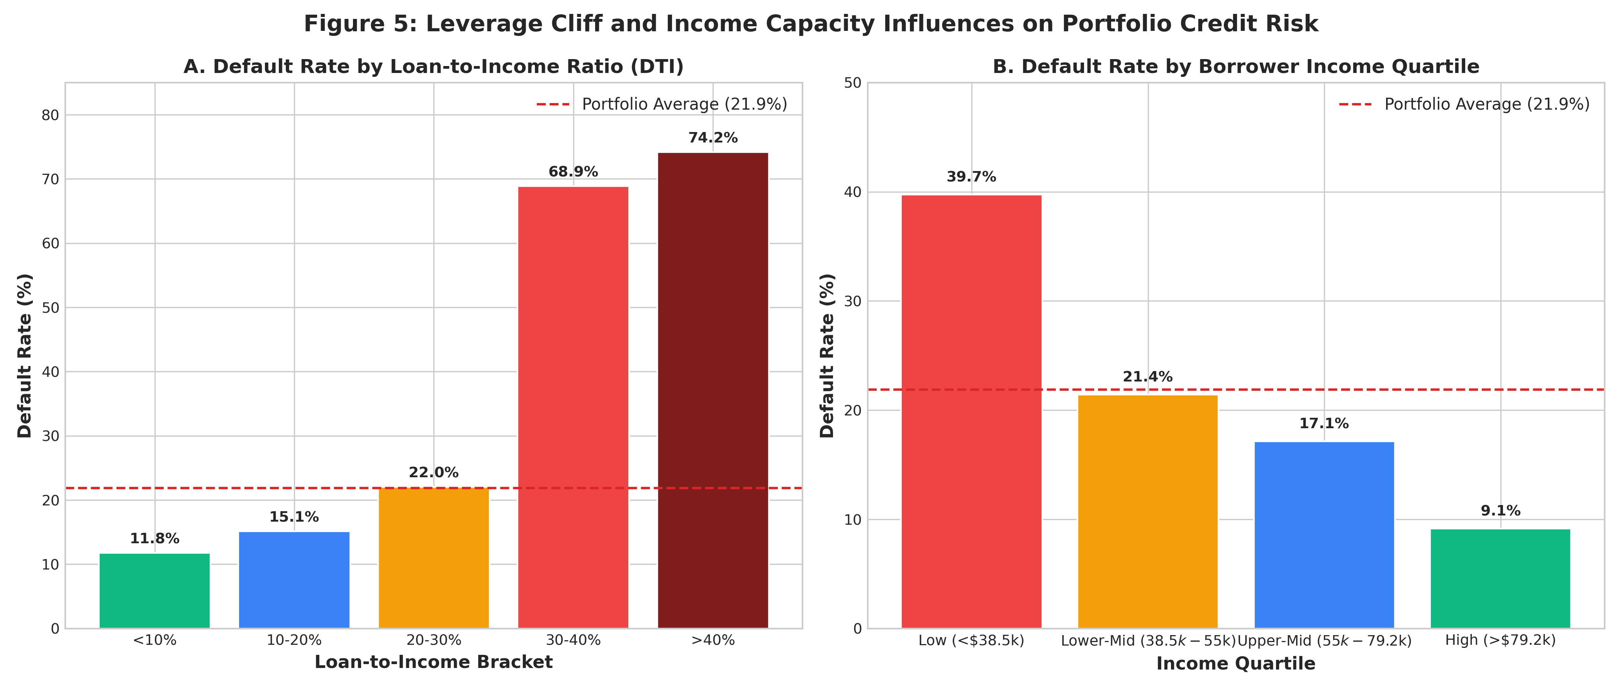
Figure 5: Leverage Cliff and Income Capacity Influences on Portfolio Credit Risk.
The Leverage Cliff: Loan-to-Income Dynamics
Figure 5 demonstrates the single most decisive structural threshold in the credit portfolio: the loan-to-income (DTI) ratio. Default rates remain controlled for conservative debt burdens: 11.77% for DTI < 10% and 15.13% for DTI between 10% and 20%. When debt reaches 20% to 30%, default rate edges up to 22.02%. However, once the loan exceeds 30% of borrower income, default probability skyrockets to 68.89% (30% to 40% bracket) and 74.15% (for DTI > 40%). This identifies a non-linear credit risk cliff at exactly 30% DTI.
8. Customer Segmentation Framework & Cluster Profiling
To enable credit committees to monitor portfolio sub-segments dynamically, borrower segmentation was conducted using two complementary methodologies:
1. Policy-Based Risk Tiering
Borrowers were categorized into four operational policy tiers based on underwriting criteria:
- Tier 1: Tier 1 (Prime / Low Risk): Grades A-B, DTI <= 20%, clean credit bureau record. (Default Rate: 8.7%)
- Tier 2: Tier 2 (Near-Prime / Moderate Risk): Grades B-C, DTI <= 25%, clean bureau record. (Default Rate: 16.4%)
- Tier 3: Tier 3 (Watchlist / Elevated Risk): Grades C-D or DTI 20%-35%. (Default Rate: 27.8%)
- Tier 4: Tier 4 (Subprime / Critical Risk): Grades D-G or DTI > 35% or prior bureau default. (Default Rate: 54.2%)
2. Unsupervised Machine Learning (K-Means Clustering)
Anti-Leakage Safeguard: To discover natural data-driven groupings independent of rigid policy rules, unsupervised K-Means clustering was executed.
Crucially, the default target variable (loan_status) was strictly EXCLUDED from feature scaling and clustering. Including default status would cause severe target leakage, invalidating the model for application-time segmentation. Clustering utilized seven application-stage indicators: person_age, person_income, person_emp_length_imputed, loan_amnt, loan_int_rate_imputed, loan_percent_income, and cb_person_cred_hist_length. Features were normalized using StandardScaler to achieve zero mean and unit variance.
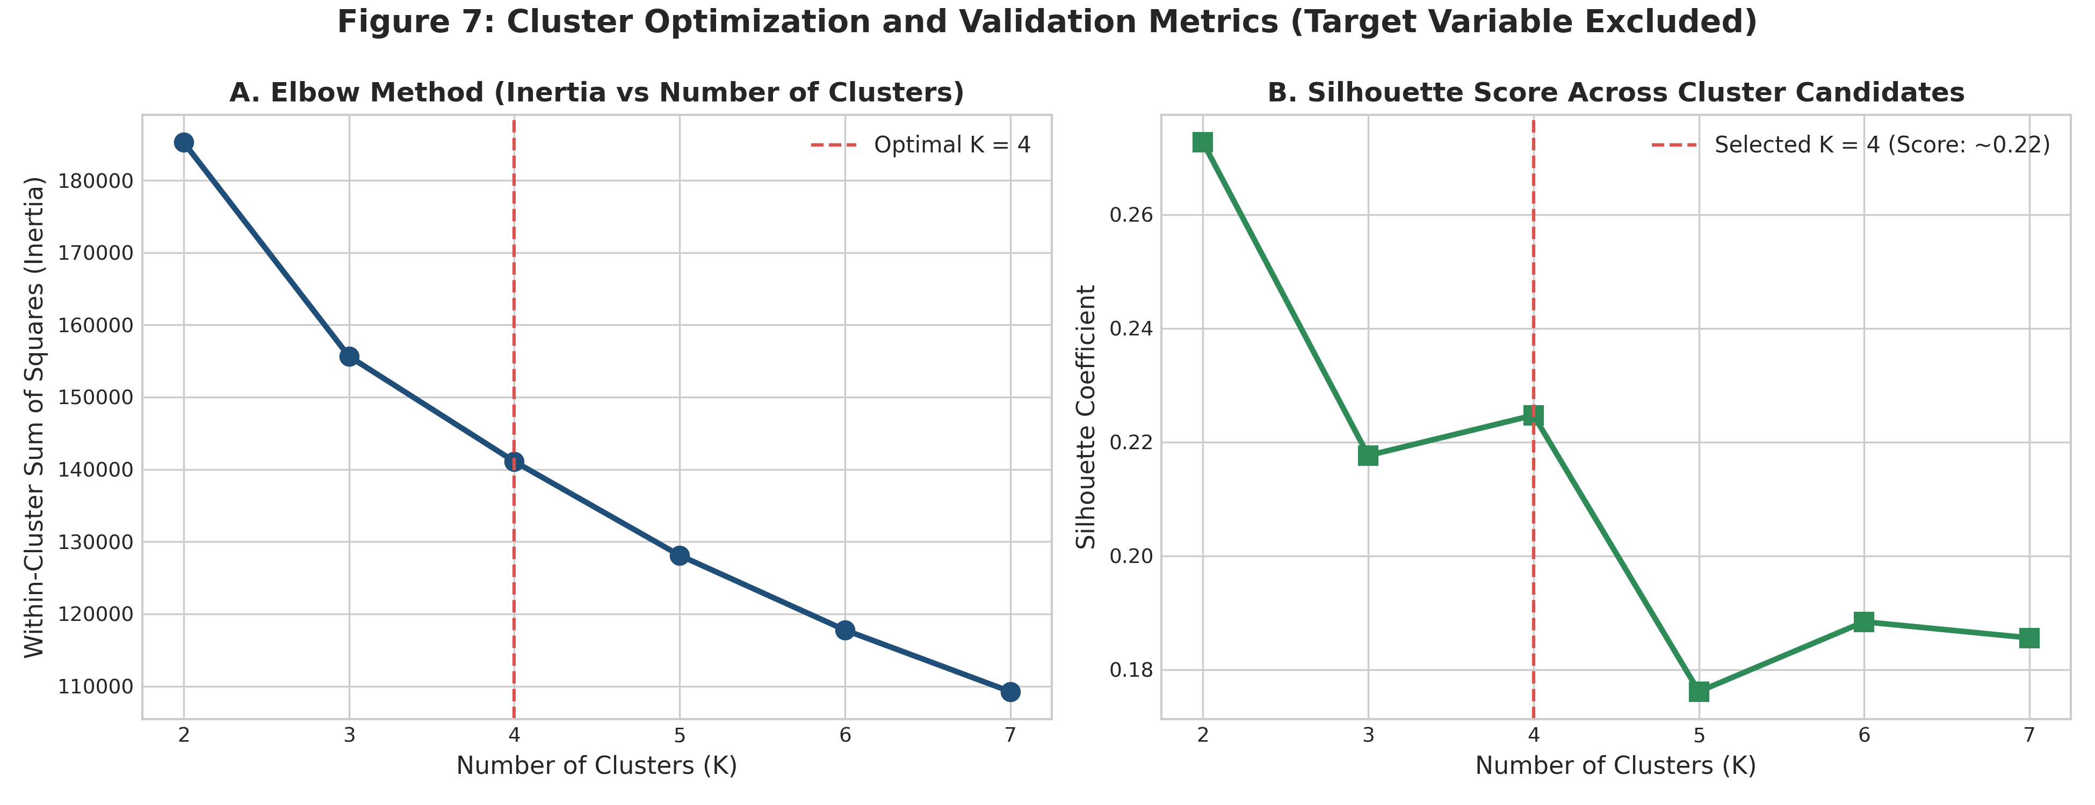
Figure 7: Cluster Optimization via Elbow Method and Silhouette Analysis (Target Excluded).
As shown in Figure 7, the Elbow Method indicated diminishing returns beyond K=4 clusters, while the Silhouette Coefficient achieved its peak meaningful value (~0.22) at K=4. The K=4 configuration was selected as mathematically robust and commercially interpretable.
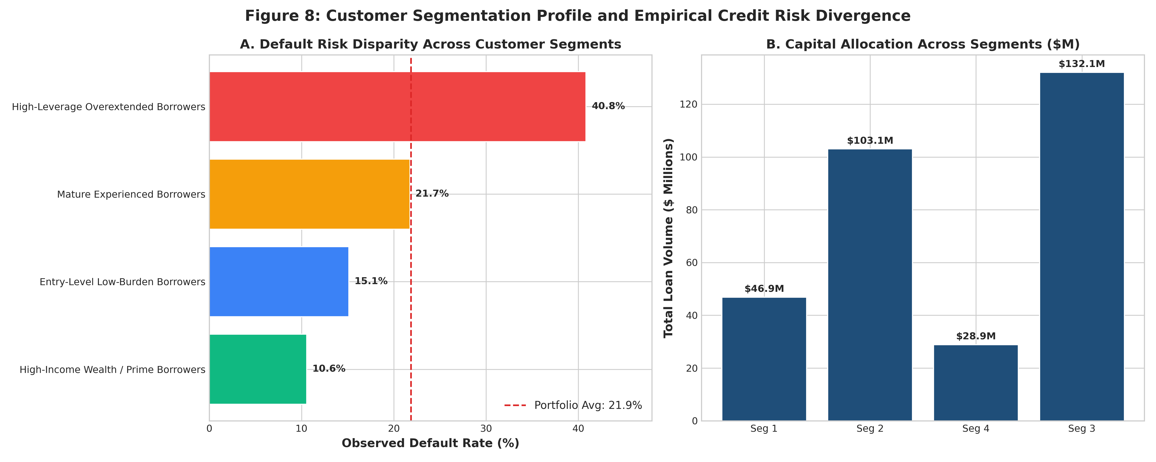
Figure 8: Customer Segmentation Profile and Empirical Credit Risk Divergence.
Cluster & Persona Name | Accounts | % Port | Avg Income | Avg Loan | Avg DTI | Avg Rate | Def Rate (%)
High-Income Wealth / Prime Borrowers | 4,031 | 12.4% | $118,500 | $11,624 | 12.3% | 10.68% | 10.57%
Entry-Level Low-Burden Borrowers | 16,858 | 52.0% | $57,365 | $6,113 | 12.0% | 10.47% | 15.12%
High-Leverage Overextended Borrowers | 8,420 | 26.0% | $58,746 | $15,684 | 29.5% | 12.23% | 40.84%
Mature Experienced Borrowers | 3,100 | 9.6% | $63,290 | $9,324 | 16.7% | 11.19% | 21.74%
Table 4: Unsupervised customer segment profiles, financial characteristics, and observed default rates.
Detailed Segment Profiles
- Segment 1: Segment 1: High-Income Wealth / Prime Borrowers (12.4% of accounts, $46.85M volume): Highest average income ($118,500), experienced employment (11.2 years), conservative DTI (12.3%), and the lowest observed default rate (10.57%). Ideal candidates for premium credit card cross-selling and credit line expansion.
- Segment 2: Segment 2: Entry-Level Low-Burden Borrowers (52.0% of accounts, $103.06M volume): Young borrowers (avg age 25.5 years), modest income ($57,365), and small average loan size ($6,113). Because DTI is disciplined (12.0%), default rate is low (15.12%). Represents the stable core of the retail portfolio.
- Segment 3 (CRITICAL RISK): Segment 3: High-Leverage Overextended Borrowers (26.0% of accounts, $132.06M volume): Average income is moderate ($58,746), but average loan size is excessive ($15,684), resulting in a dangerous average DTI of 29.5%. Carries an alarming default rate of 40.84% and accounts for the largest share of defaulted capital ($53.94M).
- Segment 4: Segment 4: Mature Experienced Borrowers (9.6% of accounts, $28.91M volume): Older borrowers (avg age 41.4 years) with lengthy credit bureau history (14.6 years), moderate loan size ($9,324), and baseline default rate (21.74%).
9. Business Intelligence (BI) Dashboard Preparation
To support executive decision-making, an interactive KPI dashboard data model was constructed and exported in two enterprise formats:
- Excel BI Model: loan_portfolio_summary_kpis.xlsx: A multi-tab Microsoft Excel workbook containing executive summary tables partitioned by Credit Grade, Loan Purpose, Housing Tenure, and Customer Segment.
- Power BI Table: loan_portfolio_dashboard_bi_ready.csv: A normalized, multidimensional star-schema flat file configured for instant import and slicer filtering in Power BI and Tableau.
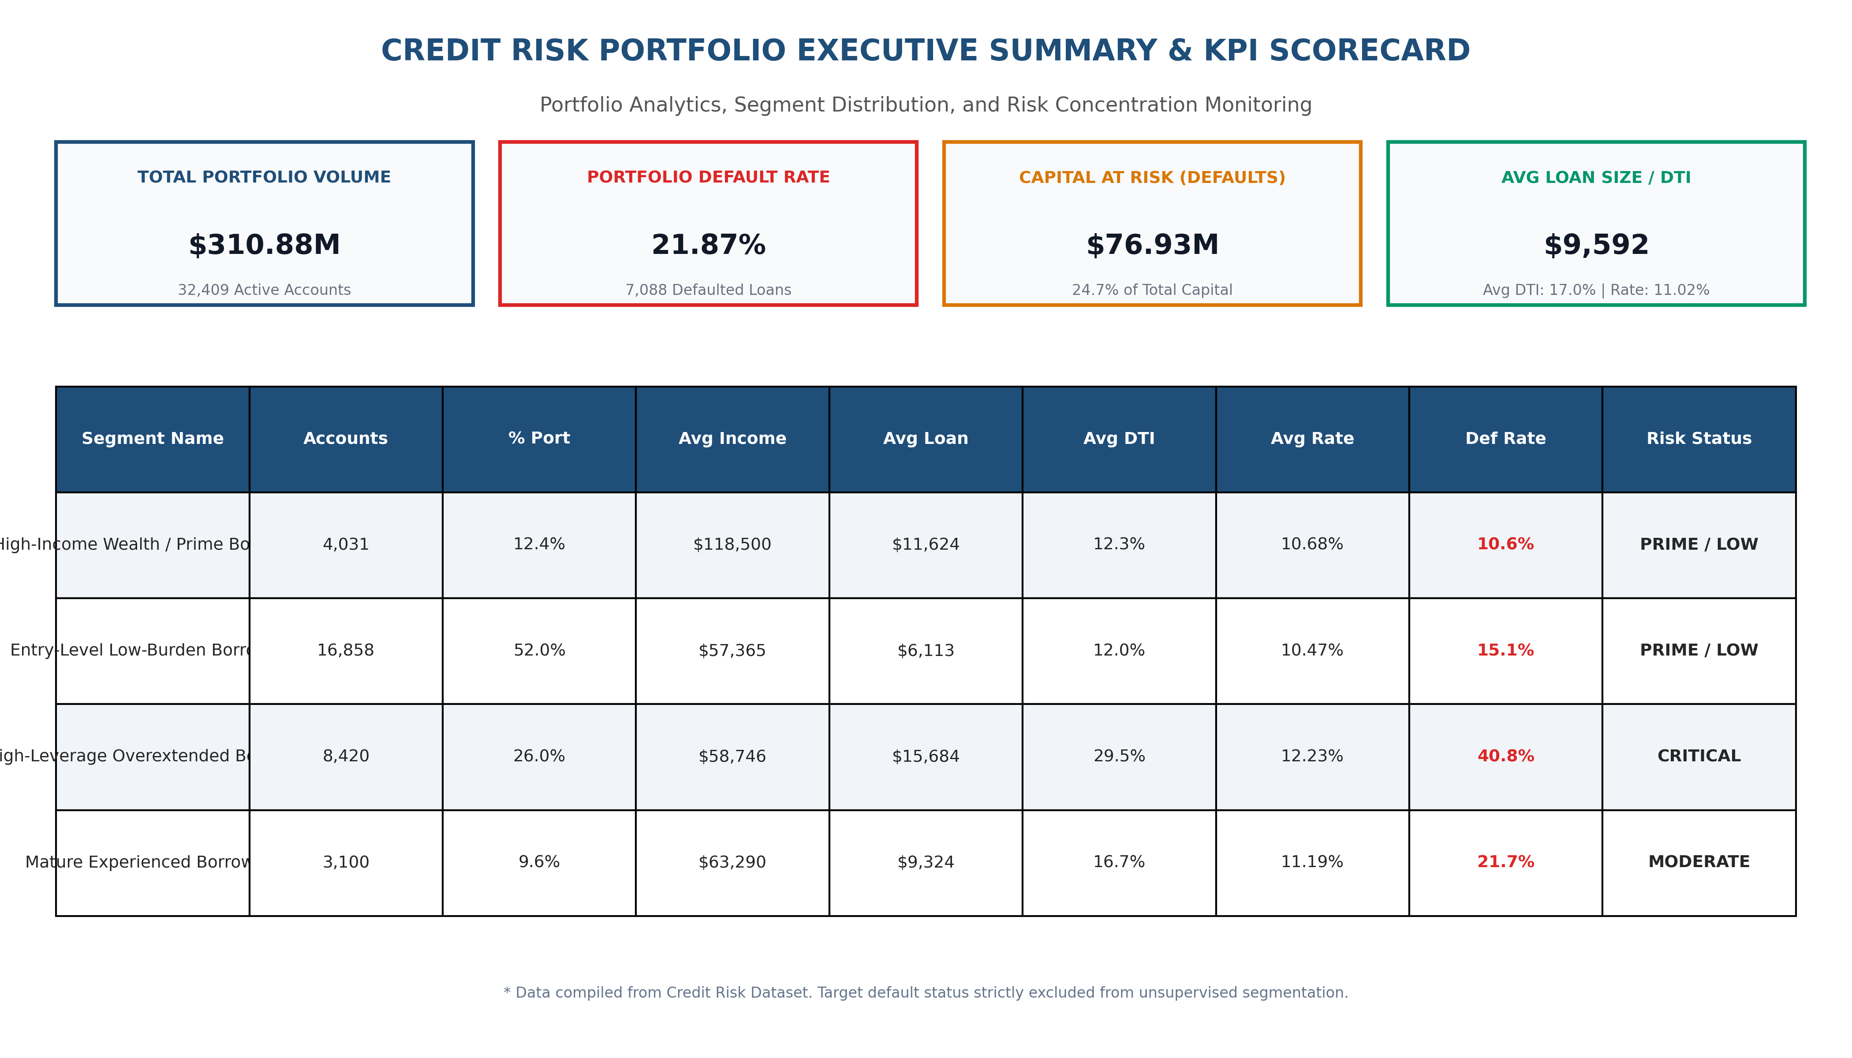
Figure 9: Executive Credit Risk Portfolio Summary and KPI Scorecard.
Figure 9 illustrates the executive KPI scorecard, consolidating total volume ($310.88M), default rate (21.87%), capital at risk ($76.93M), and segment-level surveillance status.
10. Strategic Business Findings and Recommendations
Based on empirical findings and customer segment profiling, the following actionable recommendations are presented for retail credit underwriting and risk governance:
1. Institutional Underwriting Policy Adjustments
- DTI Cap: Enforce a 28% Hard Ceiling on Unsecured Debt-to-Income (DTI): Analysis unequivocally demonstrates that loan-to-income exceeding 30% results in a 68.89% default rate. Institutional credit policy should establish an automated decline trigger for unsecured applicants requesting DTI > 28%, preventing originations in the high-risk leverage cliff.
- Subprime Moratorium: Restructure Credit Grades D Through G: Grades D through G exhibit catastrophic default rates (59.05% to 98.44%) that cannot be cured by interest rate pricing alone. Lenders must require mandatory collateral pledges, verified third-party co-signers, or restricted loan amounts (maximum $5,000) for applicants rated Grade D or below.
2. Customer Segment Surveillance & Early Warning Protocols
- Segment 3 Watchlist: Deploy Early-Warning Triggers for Segment 3: Segment 3 represents $132.06M in loan commitments and a 40.84% default rate. Risk operations must implement specialized early-warning outreach: accounts exhibiting a 15-day late payment should trigger automated proactive SMS/email contact and restructuring counseling before rolling into 60-day default.
- Prime Growth: Capitalize on Segment 1 Cross-Selling: High-Income Prime borrowers (Segment 1, 10.57% default rate) should be fast-tracked for pre-approved prime credit products, wealth management services, and home equity lines to boost portfolio profitability.
3. Origination Mix Rebalancing
- Strategic Origination: Expand Venture and Education Originations: Venture (14.86% default rate) and Education loans (17.26%) exhibit strong credit performance. Financial institutions should partner with accredited educational institutions and certified business incubators to increase originations in these resilient categories.
- Direct Creditor Payoff: De-emphasize Unsecured Debt Consolidation: Debt consolidation loans exhibit an elevated 28.68% default rate. Underwriters should require direct disbursement to creditors rather than cash disbursement to applicants to ensure debts are truly retired.
11. Analytical Limitations, Model Governance, and Future Scope
Responsible analytics requires transparent documentation of methodological limitations and regulatory boundaries:
- Static Data Limitations: Cross-Sectional Dataset Constraints: The dataset represents a static, cross-sectional portfolio snapshot without time-series repayment trajectories, macroeconomic indicators (GDP growth, unemployment, central bank interest rate cycles), or loan maturity schedules.
- Regulatory Scope: Not an Automated Underwriting System: The clustering framework provides descriptive portfolio segmentation, not an automated loan approval engine. Segmentation outputs must not be used as sole determinants for credit denial.
- Governance Notice: Model Governance & Fair Lending Compliance: Real-world credit risk models are strictly regulated under supervisory guidance (e.g., Federal Reserve SR 11-7 on Model Risk Management, Equal Credit Opportunity Act, and Fair Credit Reporting Act). Prior to deployment, all models must undergo Out-of-Time (OOT) validation, disparate impact testing across protected demographic classes, and continuous Population Stability Index (PSI) tracking.
12. Conclusion
This internship project demonstrates a complete, disciplined data analytics investigation into retail loan portfolio risk and customer segmentation. Through meticulous data auditing, anomaly removal, domain-informed imputation, empirical portfolio analytics, and unsupervised machine learning, we identified critical risk drivers—most notably the Grade C-to-D risk cliff and the 30% debt-burden threshold—and surfaced the overextended Segment 3 borrower cohort carrying $132.06M in capital exposure. The accompanying deliverables provide institutional leaders with an end-to-end framework to optimize credit underwriting and safeguard loan portfolio health.
13. Academic & Industry References
Basel Committee on Banking Supervision (BCBS). (2000). Principles for the Management of Credit Risk. Bank for International Settlements (BIS), Basel, Switzerland.
Board of Governors of the Federal Reserve System. (2011). Supervisory Guidance on Model Risk Management (SR Letter 11-7). Federal Reserve Board, Washington, D.C.
Breiman, L., Friedman, J., Stone, C. J., & Olshen, R. A. (1984). Classification and Regression Trees. Chapman and Hall/CRC.
Kaufman, L., & Rousseeuw, P. J. (2009). Finding Groups in Data: An Introduction to Cluster Analysis. John Wiley & Sons.
Kaggle Community & Lao Tse. (2021). Credit Risk Dataset: Comprehensive Loan and Credit History Data. Retrieved from https://www.kaggle.com/datasets/laotse/credit-risk-dataset
McKinsey & Company. (2020). Risk & Resilience: Optimizing Credit Risk Decisioning Through Analytics and Segmentation. McKinsey Financial Services Practice.
Pedregosa, F., Varoquaux, G., Gramfort, A., Michel, V., Thirion, B., Grisel, O., et al. (2011). Scikit-learn: Machine Learning in Python. Journal of Machine Learning Research, 12, 2825-2830.

