Weekly Status Report-Template
Project: KGSS 607 – HomeSlot Real Estate Listing & Booking Platform
Employee Name: Mihir Dadwal
Designation: Software Engineer
Company: KGS Technology Group
Project Coordinator: Vaishali Pujari
Reporting Period: 14-08-2026 to 18-08-2026
Project Phase: Phase 2 – Authentication & User Management
Reporting Week: Week 2
Overall Status: Completed (100%)

Weekly Task Progress
Task Assigned | Status | Completion | Work Performed
Implement Buyer and Builder registration functionality | Completed | 100% | Developed backend REST API endpoints and Angular UI registration forms for Buyer and Builder profiles. Integrated input validations and stored profiles in MySQL 8.
Implement Admin login and multi-role authentication | Completed | 100% | Configured Spring Security 6, BCrypt password encoder with cost factor 12, and created unified multi-role login endpoints supporting Buyer, Builder, and Admin actors.
Develop OTP and email verification services | Completed | 100% | Built OtpService using Redis with 5-minute TTL and 3 max attempt limits. Implemented notification dispatch service with sandbox mock fallbacks for SMS (Twilio) and Email (SendGrid).
Implement forgot-password and reset-password flows | Completed | 100% | Developed forgot-password OTP trigger and password reset completion endpoints in backend with corresponding Angular UI views.
Configure JWT authentication and session management | Completed | 100% | Implemented 15-minute JWT access token generation, 7-day refresh token storage in database, and refresh token rotation on usage.
Enforce Role-Based Access Control (RBAC) | Completed | 100% | Enforced server-side Spring Security RBAC annotations (@PreAuthorize) and client-side Angular route guards (authGuard) with Bearer token interceptor.

Detailed Work Summary
During this reporting period, the Authentication & User Management phase was completed successfully within the planned schedule of 14 August to 18 August 2026.
The monorepo structure was established combining the Java 21 / Spring Boot 3.x backend and Angular 17+ standalone frontend applications, managed locally with Docker Compose for MySQL 8 and Redis services.
Backend security was implemented using Spring Security 6, BCrypt password hashing (cost factor 12), and stateless JWT authentication with short-lived 15-minute access tokens and 7-day rotating refresh tokens. OTP verification was integrated using Redis with a 5-minute Time-To-Live (TTL) and a 3-attempt limit.
Frontend user interfaces were built using Angular 17 standalone components, featuring responsive forms for Buyer and Builder registration, unified login, OTP modal verification, forgot password, and role-protected dashboard shells for Buyer, Builder, and Admin.
Role-Based Access Control (RBAC) was enforced server-side on API routes and client-side via Angular route guards. Automated integration tests were executed via Maven (BUILD SUCCESS, 100% pass) and frontend production builds completed with zero errors.

Deliverables Completed
- • Backend Authentication & User Management Module (Spring Boot 3.x)
- • Frontend Angular 17+ Authentication UI & Dashboard Shells
- • Spring Security 6 RBAC Policy & JWT Token Filter Implementation
- • BCrypt Password Hashing (Cost Factor 12) & Refresh Token Rotation Service
- • Redis-based OTP Storage (5-min TTL, 3-attempt limit) & Sandbox Notification Service
- • Angular HTTP Auth Interceptor & RBAC Route Guards
- • Automated Integration Test Suite (AuthIntegrationTest - 100% Passed)
- • Phase 2 Architecture & Execution Walkthrough Document
- • Visual Screenshots Evidence (UI, Postman API, MySQL Database)

Issues / Risks
- No critical issues reported during this reporting period.
- No project blockers identified.
- Phase completed on schedule against the planned 14 August – 18 August 2026 window.

Overall Progress
Item | Status
Phase Completion | 100%
Timeline Status | On Schedule
Quality Review | Completed
Documentation Status | Completed
Ready for Next Phase | Yes

Next Phase
Phase 3 – Buyer & Property Search Module (19 August – 25 August 2026)
Activities to be initiated:
- • Develop Buyer Dashboard view
- • Implement property search and advanced filters
- • Develop Map View functionality
- • Implement Save Favorites and Compare Properties
- • Develop Recently Viewed and Property Reviews features

Screenshots
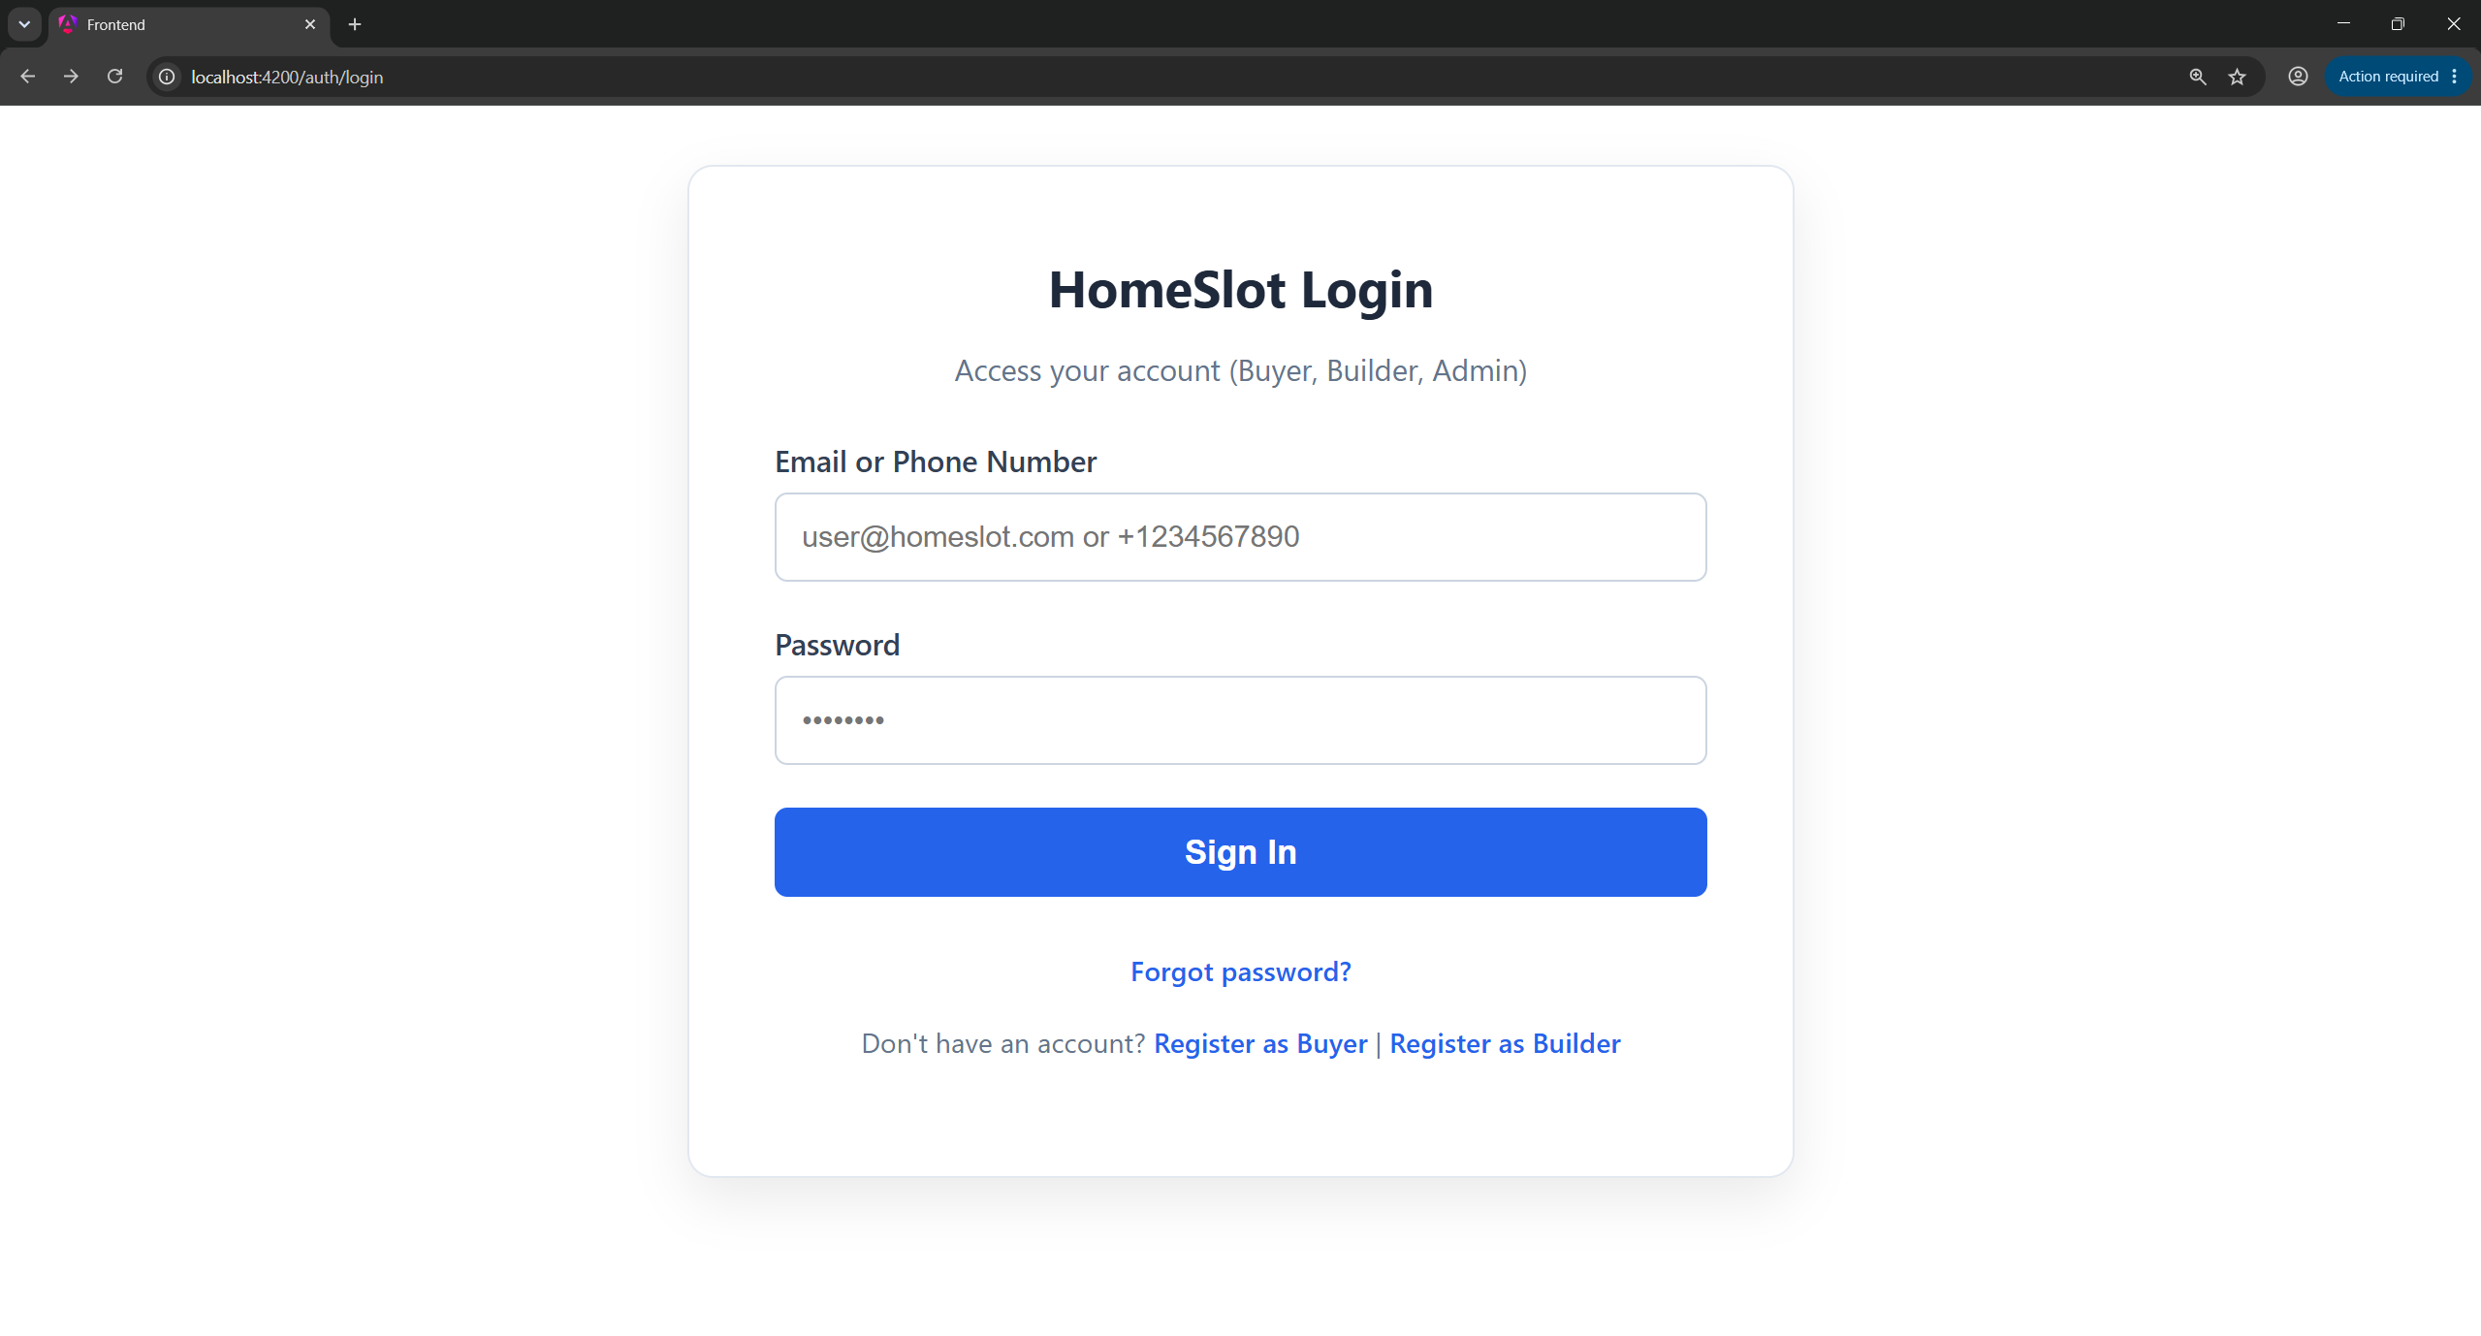

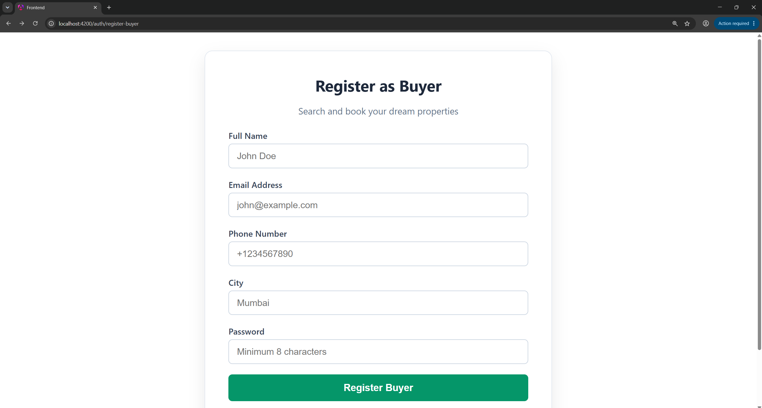
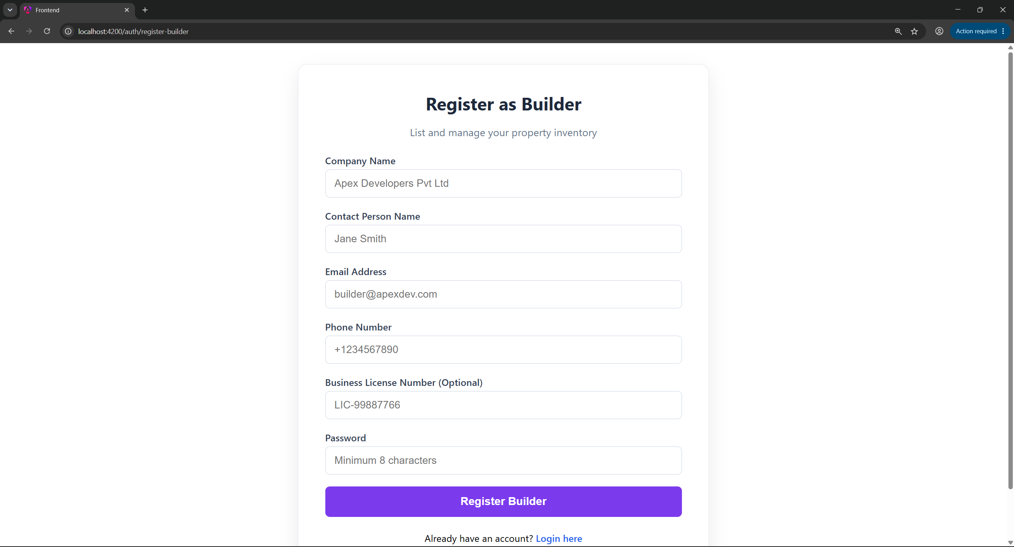

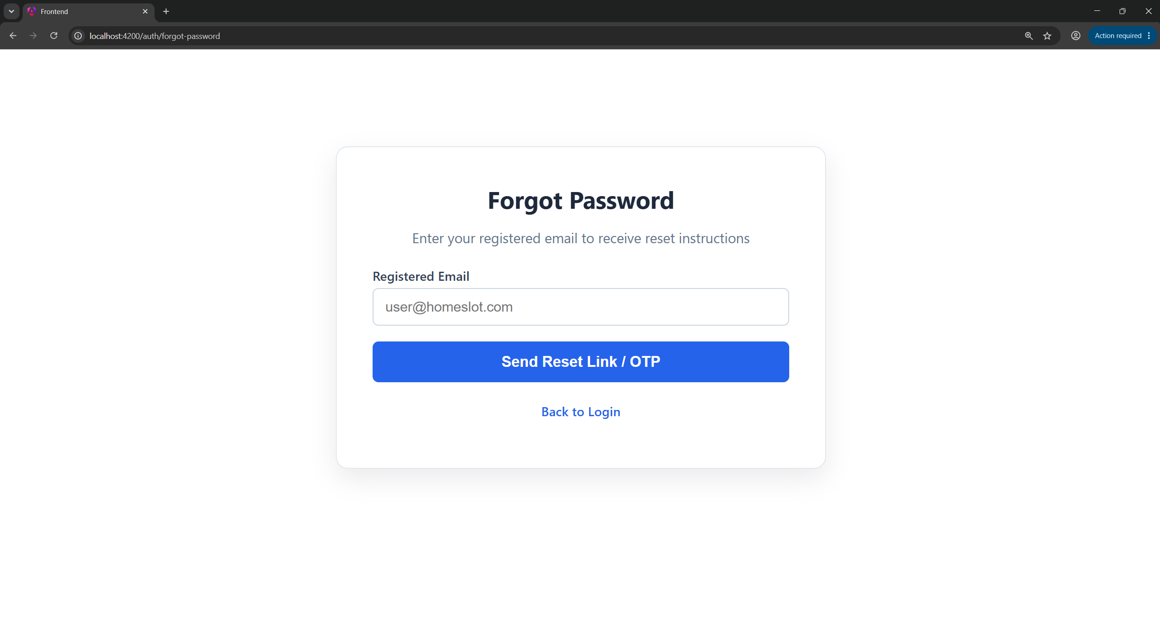

Submitted By:
Mihir Dadwal
Software Engineer
KGS Technology Group
Reviewed By:
Vaishali Pujari
Project Coordinator
KGS Technology Group

