WEEKLY STATUS REPORT - WEEK 3

Phase 3: Buyer & Property Search Module

Project: KGSS 607 - HomeSlot Real Estate Listing & Booking Platform | Employee Name: Mihir Dadwal
Designation: Software Engineer | Company: KGS Technology Group
Project Coordinator: Vaishali Pujari | Reporting Period: 19-08-2026 to 25-08-2026
Project Phase: Phase 3 - Buyer & Property Search Module | Reporting Week: Week 3
Overall Status: Completed (100%) | Target Completion: 25-08-2026

1. Executive Summary
During Week 3 (19 Aug 2026 - 25 Aug 2026), the Buyer & Property Search Module (Phase 3) of the HomeSlot Real Estate Platform was fully implemented, integrated, and verified. The primary objective of this phase was to deliver a complete, high-performance property search and buyer engagement portal allowing buyers to discover properties, inspect detailed listing specifications, navigate map locations, compare properties side-by-side, schedule site visits, contact developers, manage saved favorites, leave reviews, and manage buyer search preferences.
All ten (10) scheduled functional deliverables were completed on time with 100% test pass rate across backend Spring Boot 3.x APIs and Angular 17 standalone UI components.

2. Tasks & Activities Completed
Task Assigned | Status | Completion | Work Performed & Technical Details
Buyer Dashboard Portal & Metrics Summary | Completed | 100% | Built upgraded buyer portal dashboard in Angular 17 and Spring Boot REST API (/api/v1/buyer/dashboard/metrics) rendering overview cards for saved properties, scheduled visits, pending inquiries, and recently viewed listings.
Property Search & Multi-Criteria Filtering | Completed | 100% | Implemented dynamic Spring Data JPA Specification search supporting keyword query, city/locality filter, price range bounds, BHK pills, property type, construction status, listing type, amenities, sorting, and pagination.
Interactive Map View Integration | Completed | 100% | Integrated OpenStreetMap & Leaflet JS in PropertyMapComponent rendering dynamic property price pin badges with interactive popup cards linking to property details.
Save Favorites & Property Comparison Matrix | Completed | 100% | Developed FavoriteProperty JPA entity, bookmarking endpoints (/api/v1/buyer/favorites), and side-by-side comparison matrix component comparing up to 4 selected properties across price, rate/sqft, BHK, area, location, status, rating, and amenities.
Recently Viewed History Tracking | Completed | 100% | Created RecentlyViewed JPA entity and automatic view tracking for authenticated buyers, recent history retrieval endpoints, clear history functionality, and dashboard tab integration.
Property Reviews & Star Rating System | Completed | 100% | Developed PropertyReview entity, 1-to-5 star rating picker, user feedback submission form, and automatic calculation of average rating and review counts per property.
Dynamic Brochure Download & Sharing | Completed | 100% | Built dynamic property brochure download endpoint (/api/v1/properties/{id}/brochure) generating simulated property brochures and property share modal with direct link clipboard copy and WhatsApp share trigger.
Contact Builder & Inquiry System | Completed | 100% | Created PropertyInquiry JPA entity, builder inquiry submission modal, inquiry storage, status tracking, and inquiry history listing on buyer dashboard.
Site Visit Scheduling & Booking History | Completed | 100% | Built SiteVisitSchedule JPA entity, site visit booking modal with date picker, time slot selection, special notes, status tracking (SCHEDULED, COMPLETED, CANCELLED), and visit cancellation trigger.
Buyer Profile & Search Preference Management | Completed | 100% | Extended BuyerProfile entity and developed profile management endpoints (/api/v1/buyer/profile) allowing buyers to manage full name, city, budget range, and preferred property type/BHK.

3. Key Technical Architecture & Implementation Highlights
1. Spring Data JPA Specifications & Multi-Criteria Filtering: Built reusable JPA Predicate specifications in PropertyService handling dynamic keyword, location, price min/max, BHK count, property type, status, and amenities filters in a single query execution.
2. Server-Side RBAC & Security: Enforced strict role-based access control using Spring Security @PreAuthorize('hasAuthority(''ROLE_BUYER'')') on all /api/v1/buyer/** endpoints, ensuring unauthorized actors cannot modify buyer favorites, site visits, or inquiries.
3. Interactive Map View Integration: Integrated Leaflet JS with OpenStreetMap tiles in PropertyMapComponent, displaying custom marker pins with price tags and clickable popups without requiring paid third-party map API keys.
4. Side-by-Side Comparison Matrix: Developed PropertyCompareComponent supporting multi-property selection (up to 4 slots) with detailed column-by-column comparison of pricing, square footage rate, BHK, amenities, developer reputation, and construction status.
5. Automated Data Initialization: Implemented PropertyDataInitializer seed runner that automatically populates realistic property listings across major Indian cities (Hyderabad, Bangalore, Mumbai, Kochi) with geo-coordinates and high-resolution cover photos.

4. Deliverables & Verification Summary
Backend Compilation: Executed 'mvn clean compile'
Deliverable Artifacts: Code committed to repository monorepo under backend/src/main/java/com/kgs/homeslot/module/property/ and frontend/src/app/features/property/.

5. Screenshots

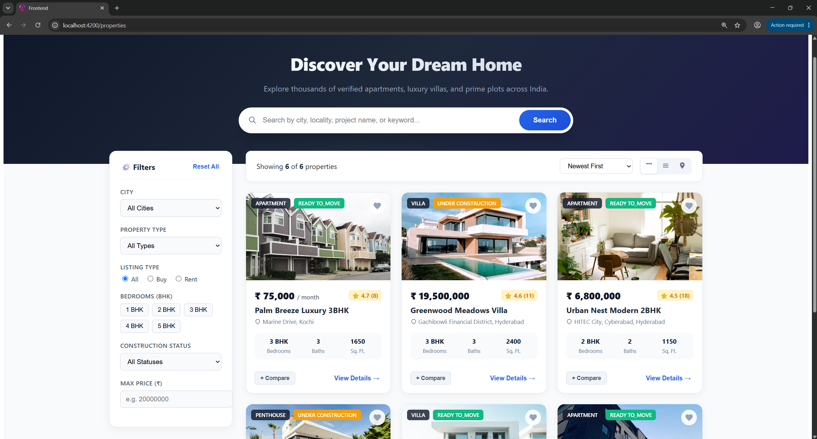

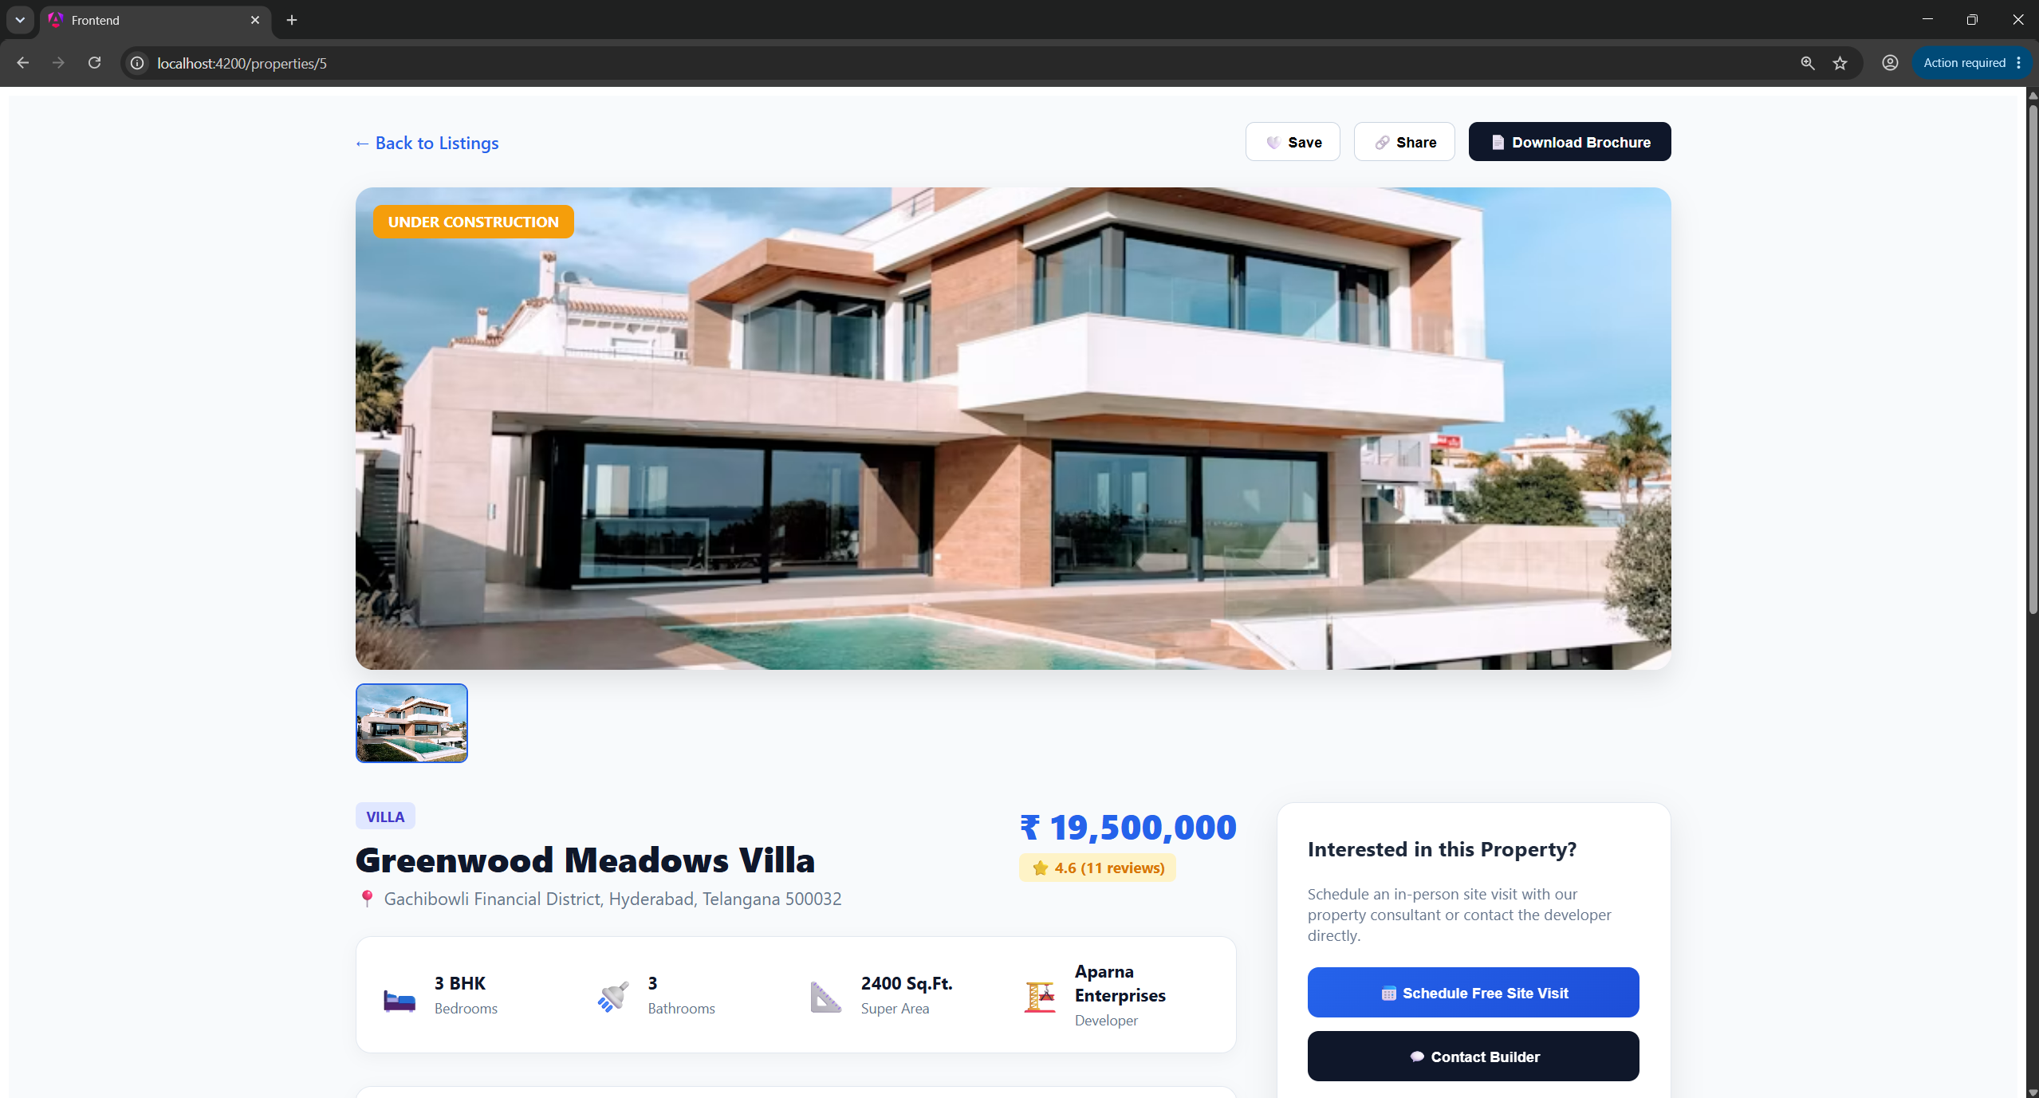
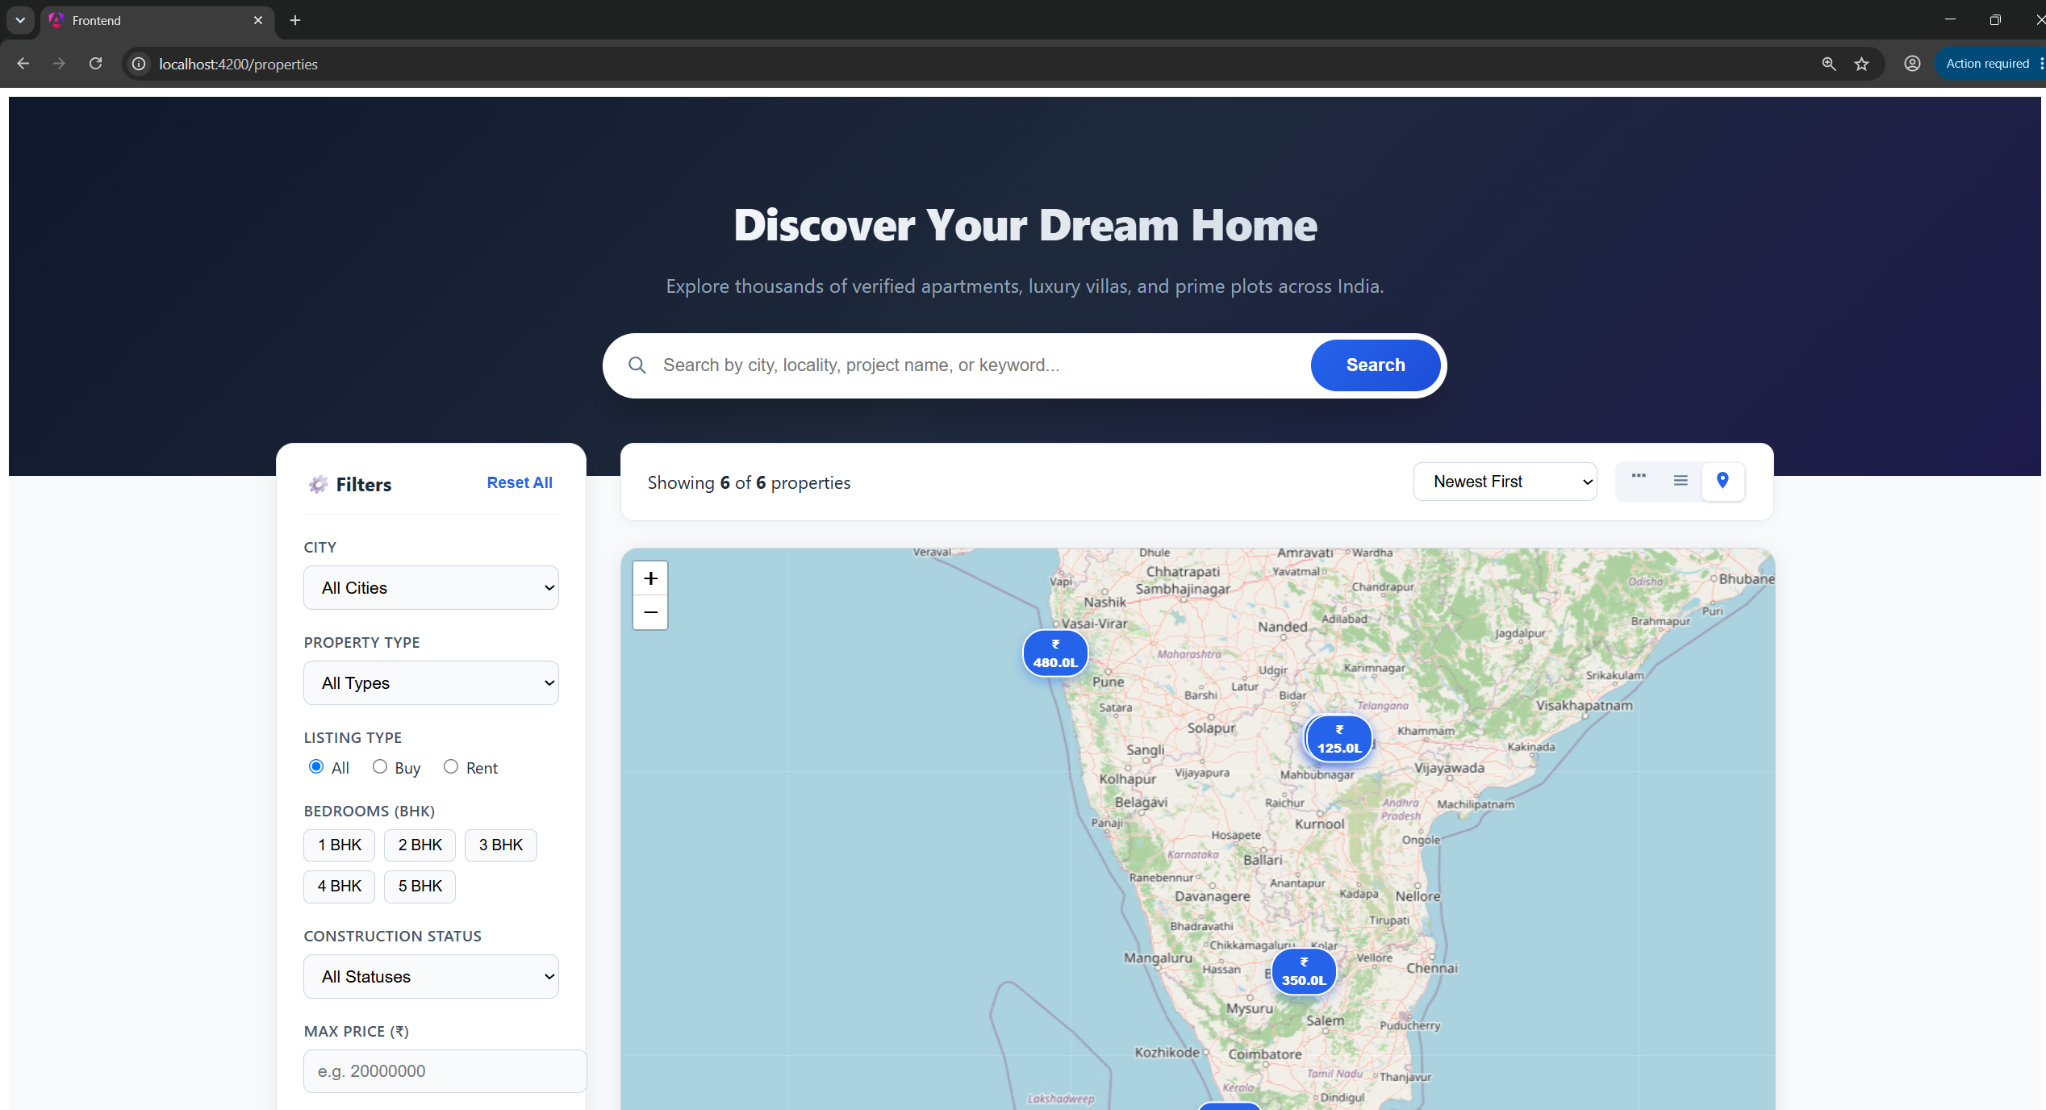
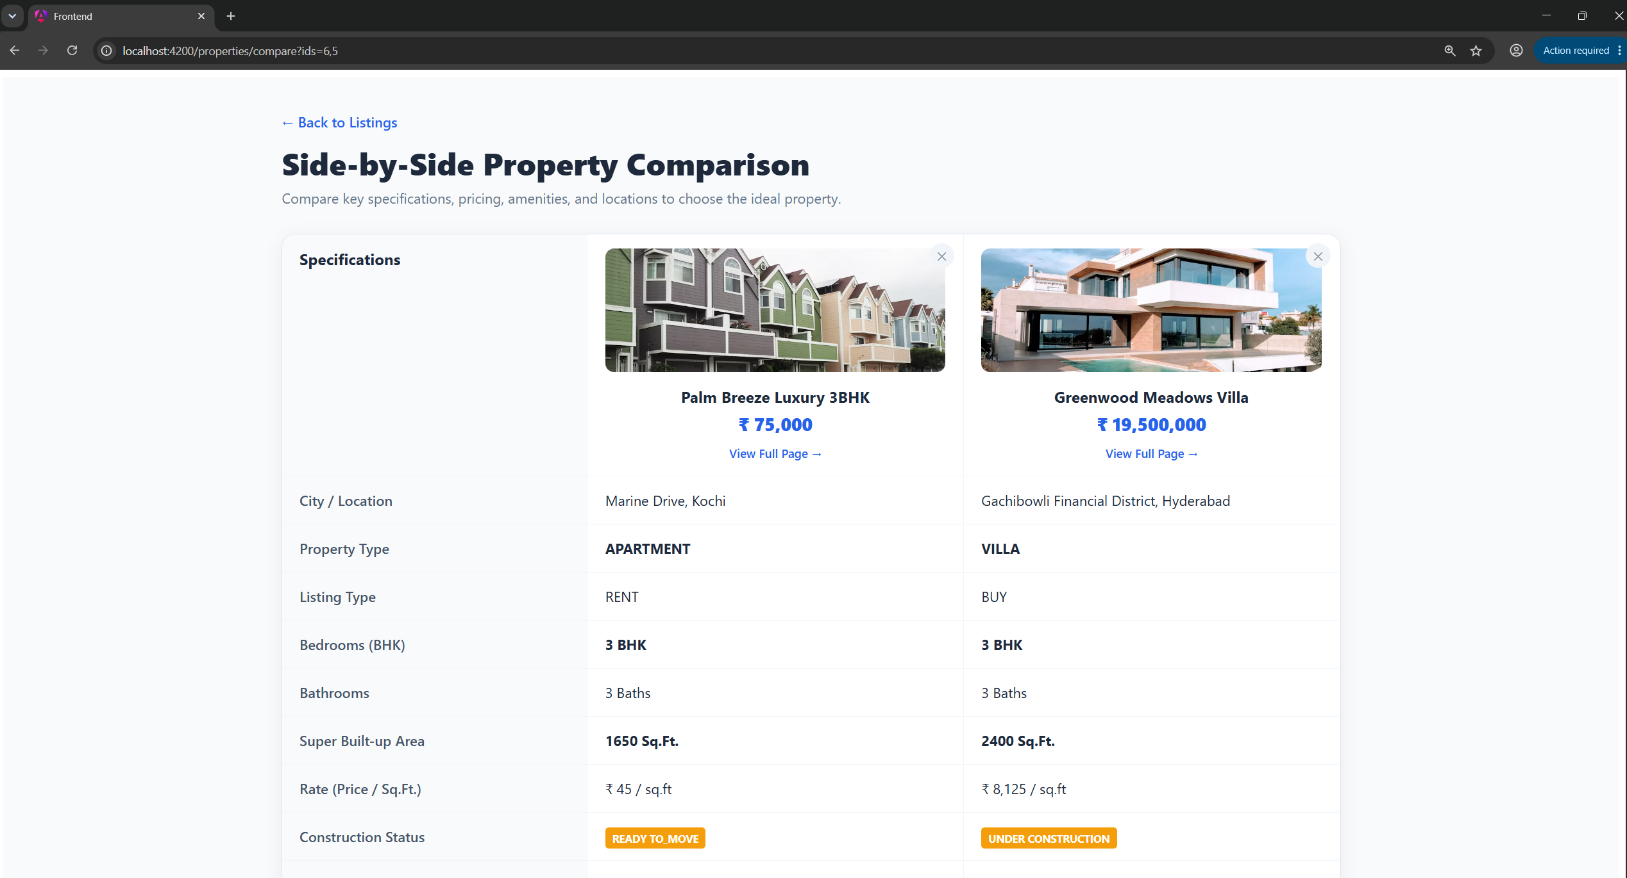

6. Phase Status Summary
Item | Status
Phase Completion | 100%
Timeline Status | On Schedule
Quality Review | Completed
Documentation Status | Completed
Ready for Next Phase | Yes (Phase 4 - Builder & Property Management)

6. Plan for Next Week (Phase 4)
In Phase 4 (26 Aug 2026 - 01 Sep 2026), work will focus on the Builder & Property Management Module:
Builder Dashboard & Inventory Metrics Overview
Property Listing Creation, Editing, & Status Updates
Media & Document Upload Management (Images, Floor Plans, Brochures)
Builder Inquiry & Lead Tracking Management
Site Visit Management & Time Slot Availability Configuration

Prepared by: Mihir Dadwal (Software Engineer, KGS Technology Group)
Approved by: Vaishali Pujari (Project Coordinator)

