1. Create Table in Mysql



1. Access rights on file

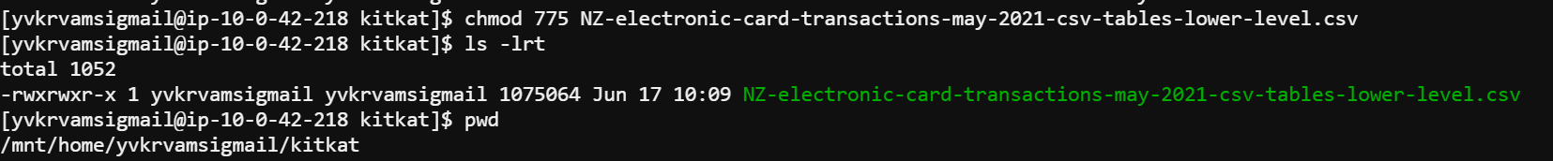

1. Load the file to Mysql

1. Check Loaded data

Hive:

Create table in Hive

SQOOP

1. Sqoop import the mysql data ; please note – in order for Sqoop to import the data, we need to ensure there is a PK column defined in MYSQL Table we are importing, however in this case – deliberately we have avoided having PK. So, to solve this will will ask Sqoop to use String Column for Splitting the data.. . the property for this is as below.

Verify data in HDFS

Validate data in hive table:

