Coupon Management System – CouponWorld

Home Page:

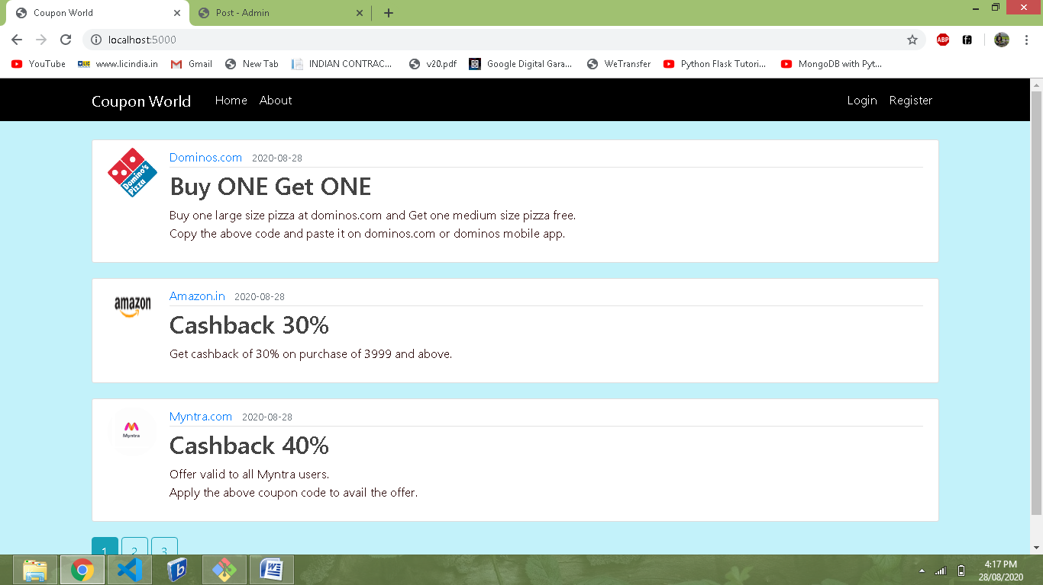

Login Page:

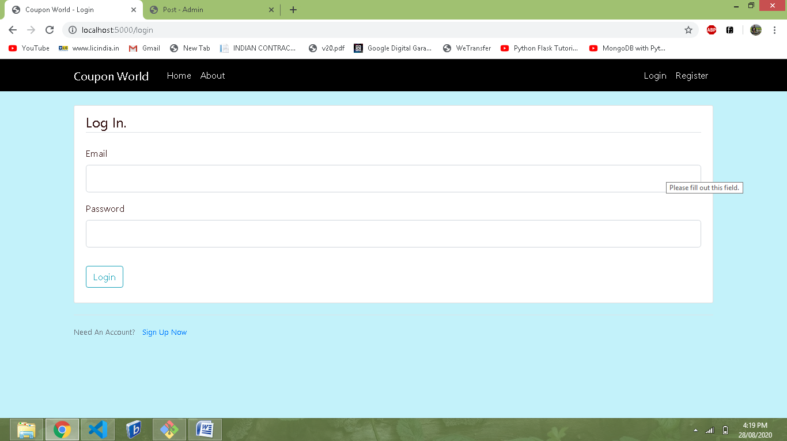

Registration Page:

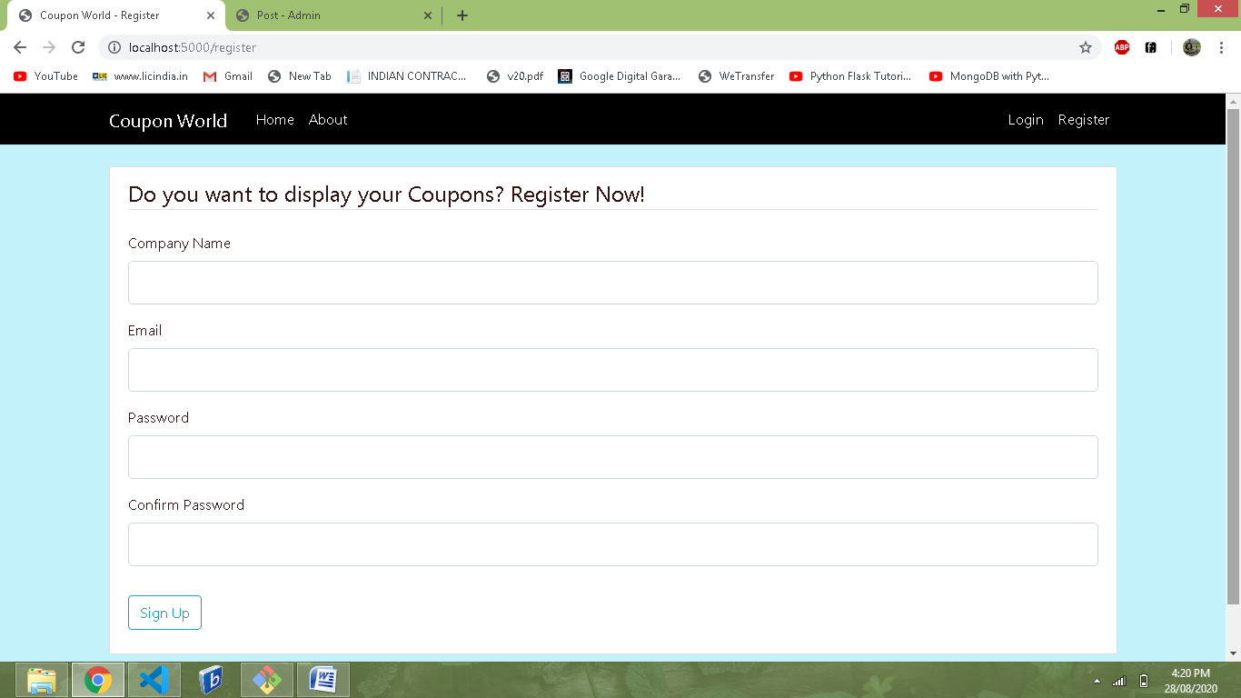

Create Coupon:

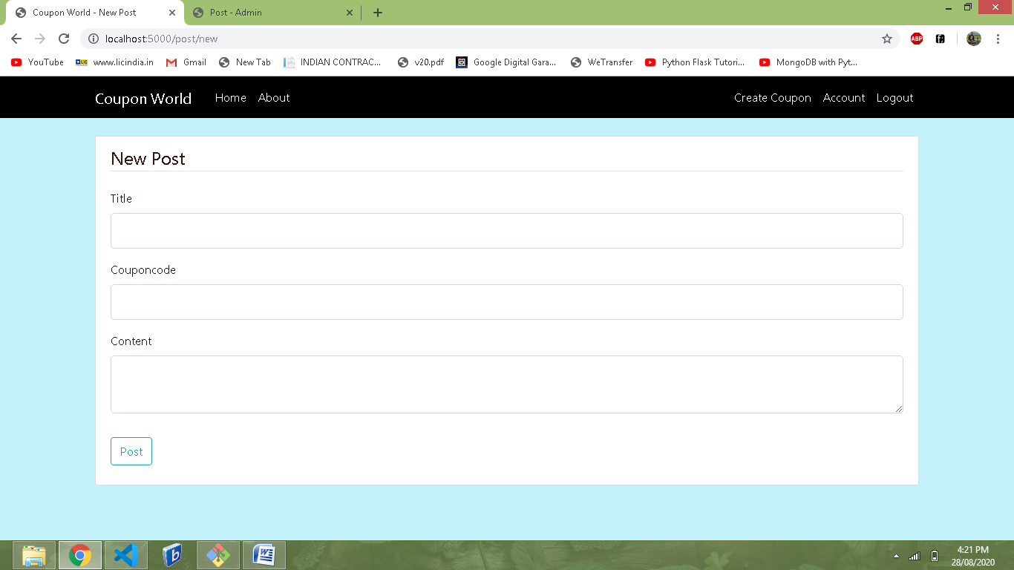

Update Coupon:

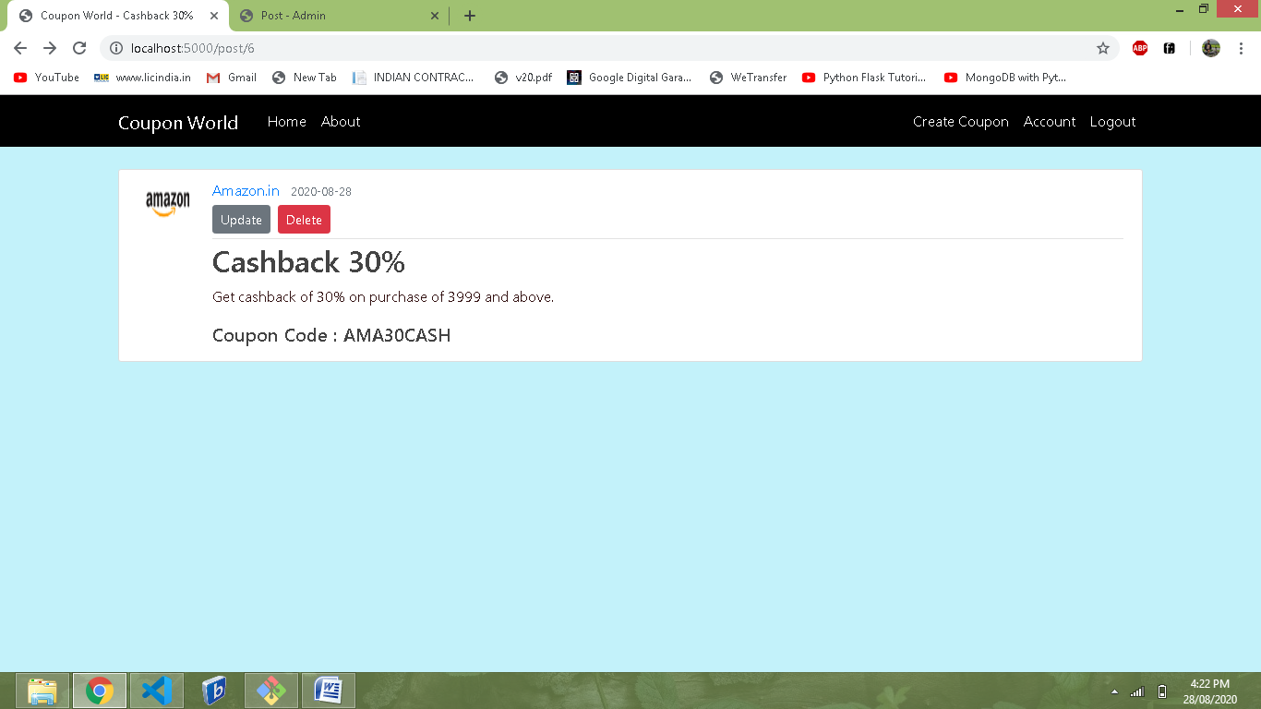

Admin Dashboard:

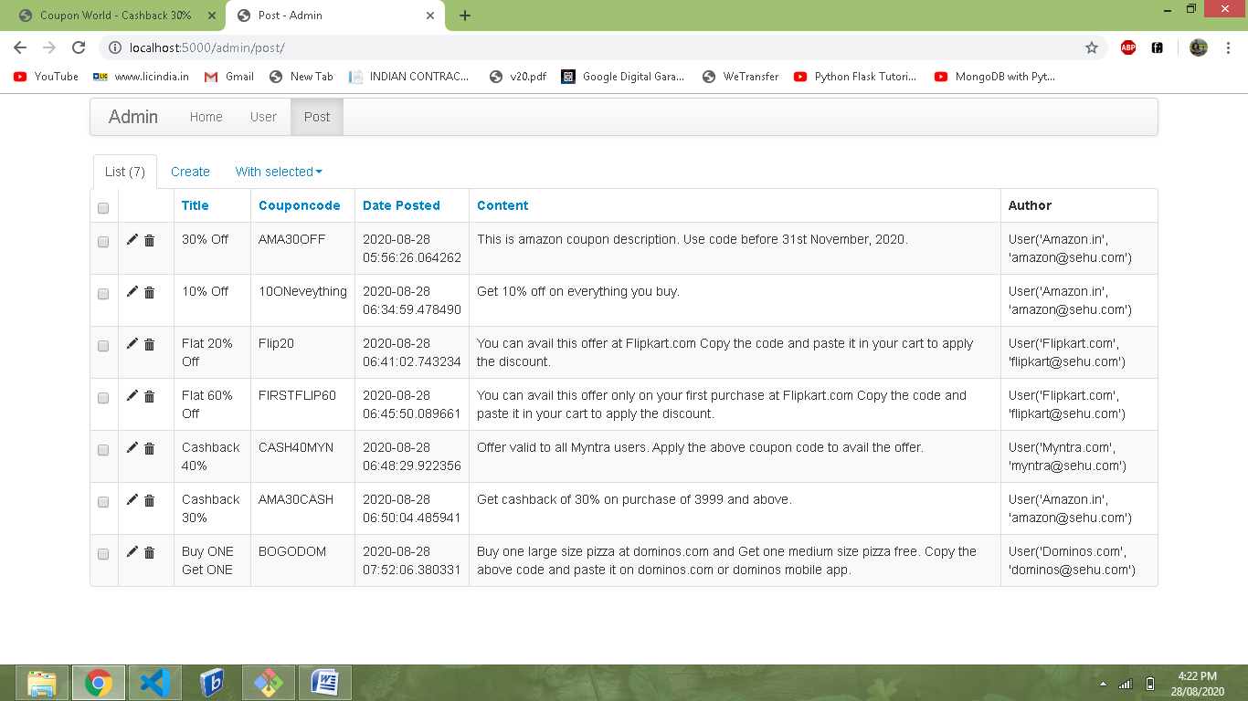

Software Used:

Vs Code - Editor

Python - Backend Programming Language

HTML/CSS – Frontend Programming Language

Flask - Web Application Framework

Jinja - Web Template Engine

SQLAlchemy - Object Relation Mapper (ORM) tool

Sqlite3 - Database

