CS352 – Homework 1

1)

(a (a | d)*) | ( ( _ )+ ( a | d ) (a | d | _ )* )

2)
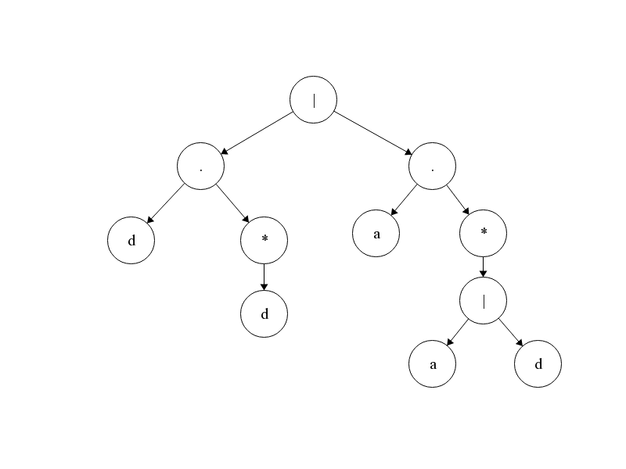

3) (a | b)* a (a | b)

4)
 | Accepting State(Y/N) | a | b
{0} | N | {0,1} | {0}
{0,1} | N | {0,1,2} | {0,2}
{0,1,2} | Y | {0,1,2} | {0,2}
{0,2} | Y | {0,1,2} | {0}

