NAME: MIHIR MAKWANA

ROLL NO: 50 BATCH: D

TECOMPS

**EXPERIMENT NO: 1**

**AIM :** Interface LED matrix , Segment display to ARM-7 LPC 2148 processor and write a Embedded C program to display decimal numbers on the display.

**THEORY :**

**LPC 2148**

LPC2148 microcontroller is based on a 16-bit/32-bit ARM7TDMI-S CPU. This controller is small in size, low on power consumption and has large number of features which make it useful in embedded applications. ARM processors are 32-bit or 64-bit processors based on RISC (Reduced Instruction Set Computer) architecture.

General-purpose input/output (GPIO) is a pin on an IC (Integrated Circuit). It can be either input pin or output pin, whose behaviour can be controlled at the run time. A group of these pins is called a port (Example, Port 0 of LPC2148 has 32 pins).

LPC2148 has two 32-bit General Purpose I/O ports.

1.  **PORT0**

2.  **PORT1**

**PORT0**is a 32-bit port

* Out of these 32 pins, 28 pins can be configured as either general purpose input or output.
* 1 of these 32 pins (P0.31) can be configured as general-purpose output only.
* 3 of these 32 pins (P0.24, P0.26 and P0.27) are reserved. Hence, they are not available for use. Also, these pins are not mentioned in pin diagram.

**PORT1** is also a 32-bit port. Only 16 of these 32 pins (P1.16 – P1.31) are available for use as general-purpose input or output.

Almost every pin of these two ports has some alternate function available. For example, P0.0 can be configured as the TXD pin for UART0 or as PWM1 pin as well. The functionality of each pin can be selected using the **Pin Function Select Registers**.

**Note :**The Port 0 pins do not have built-in pull-up or pull-down resistors. Hence, while using GPIOs on Port 0, in some cases,  we need to connect pull-up or pull-down resistors externally.

**Pin Function Select Registers**

Pin Function Select Registers are 32-bit registers. These registers are used to select or configure specific pin functionality.

There are 3 Pin Function Select Registers in LPC2148:

1.  **PINSEL0 : -**PINSEL0 is used to configure PORT0 pins P0.0 to P0.15.

2.  **PINSEL1 : -**PINSEL1 is used to configure PORT0 pins P0.16 to P0.31.

3.  **PINSEL2 : -**PINSEL2 is used to configure PORT1 pins P1.16 to P1.31.

Let’s see GPIO registers that control the GPIO operations.

Fast and Slow GPIO Registers

There are 5 Fast (also called Enhanced GPIO Features Registers) GPIO Registers and 4 Slow (also called Legacy GPIO Registers) GPIO Registers available to control PORT0 and PORT1.

The Slow Registers allow backward compatibility with earlier family devices using the existing codes.

**Slow GPIO Registers**

There are 4 Slow GPIO registers :

1.  **IOxPIN (GPIO Port Pin value register):**This is a 32-bit wide register. This register is used to read/write the value on Port (PORT0/PORT1). But care should be taken while writing. Masking should be used to ensure write to the desired pin.

2.  **IOxSET (GPIO Port Output Set register) :**This is a 32-bit wide register. This register is used to make pins of Port (PORT0/PORT1) HIGH. Writing one to specific bit makes that pin HIGH. Writing zero has no effect.

3.  **IOxDIR (GPIO Port Direction control register) :**This is a 32-bit wide register. This register individually controls the direction of each port pin. Setting a bit to ‘1’ configures the corresponding pin as an output pin. Setting a bit to ‘0’ configures the corresponding pin as an input pin.

4.  **IOxCLR (GPIO Port Output Clear register) :**This is a 32-bit wide register. This register is used to make pins of Port LOW. Writing one to specific bit makes that pin LOW. Writing zeroes has no effect.

[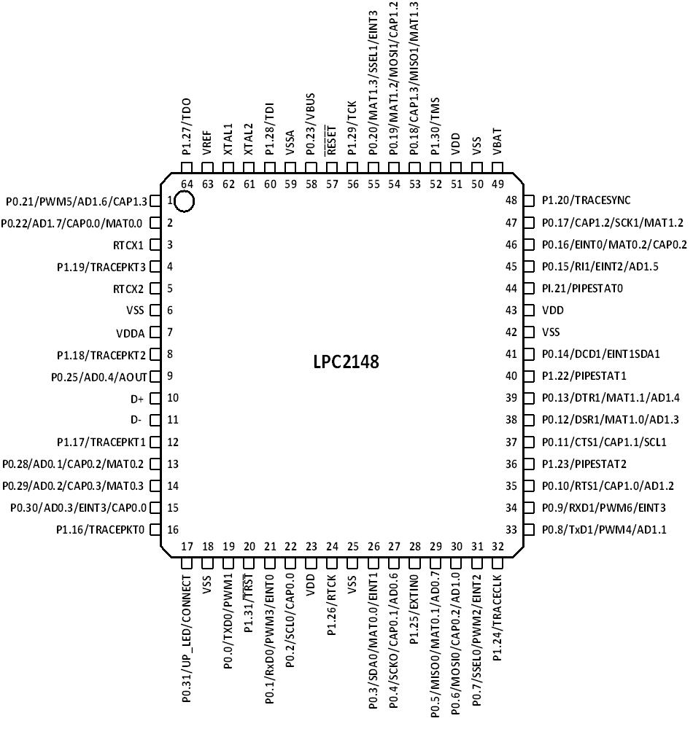](https://www.google.co.in/url?sa=i&rct=j&q=&esrc=s&source=images&cd=&cad=rja&uact=8&ved=2ahUKEwj688TN14PdAhWENI8KHW1ABacQjRx6BAgBEAU&url=https%3A%2F%2Fwww.wikinote.org%2FMain%2FSavitribai-Phule-Pune-University%2FENTC%2FEP-TE%2FUnit-2%2FARM7-LPC2148-Features-and-Architecture%2F&psig=AOvVaw1vay4e5h52GbDKyZh6tFzy&ust=1535131200040298)

Fig: LPC2148 microcontroller pin map

**Seven Segment Display**

A seven segment display is the most basic electronic display device that can display digits from 0-9. The most common configuration has an array of eight LEDs arranged in a special pattern to display these digits.

## Interfacing Seven Segment Display

Below figure shows how to interface the seven segments with microcontroller. A seven segment is generally available in ten pin package. While eight pins correspond to the eight LEDs, the remaining two pins (at middle) are common and internally shorted. These segments come in two configurations, namely, Common cathode (CC) and Common anode (CA).

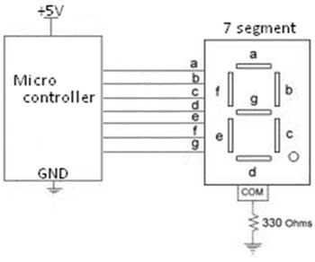

Figure 1: Interfacing with seven segment display

In following table, we convert this 8 pin’s 8 bit binary data into hex code and shows the hex code of displaying digits below.

|  |  |  |  |  |  |  |  |  |
| --- | --- | --- | --- | --- | --- | --- | --- | --- |
| **Digit** | **Hex code** | **A** | **B** | **C** | **D** | **E** | **F** | **G** |
| **0** | 0x3F | 1 | 1 | 1 | 1 | 1 | 1 | 0 |
| **1** | 0x06 | 0 | 1 | 1 | 0 | 0 | 0 | 0 |
| **2** | 0x5B | 1 | 1 | 0 | 1 | 1 | 0 | 1 |
| **3** | 0x4F | 1 | 1 | 1 | 1 | 0 | 0 | 1 |
| **4** | 0x66 | 0 | 1 | 1 | 0 | 0 | 1 | 1 |
| **5** | 0x6D | 1 | 0 | 1 | 1 | 0 | 1 | 1 |
| **6** | 0x7D | 1 | 0 | 1 | 1 | 1 | 1 | 1 |
| **7** | 0x07 | 1 | 1 | 1 | 0 | 0 | 0 | 0 |
| **8** | 0x7F | 1 | 1 | 1 | 1 | 1 | 1 | 1 |
| **9** | 0x6F | 1 | 1 | 1 | 1 | 0 | 1 | 1 |

## Pin Assignment with LPC2138

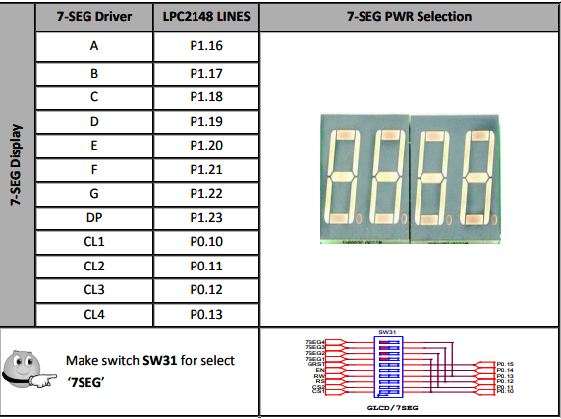

Figure 2: Pin assignment

Here the above diagram shows the pin assignment of Seven segment displays with LPC 2148.

**Circuit Diagram:**

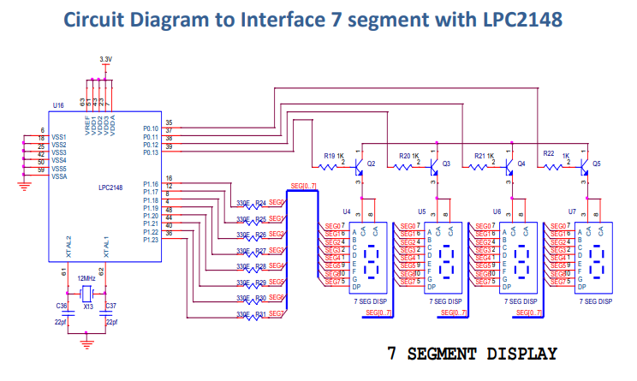

Figure 3 : Circuit Diagram

**Program:**

**//To display 3**

#include <LPC214X.h>

void wait(int count)

{

int j=0,i=0;

for(j=0;j<count;j++)

{

/* At 60Mhz, the below loop introduces

delay of 10 us */

for(i=0;i<35;i++);

}

}

int main()

{

unsigned long i=0;

unsigned long digits[] = { 0x003F0000,0x00060000,0x005B0000,0x004F0000,0x00660000,0x006D0000,0x007D0000,0x00070000,0x007F0000,0x006F0000};

IO1DIR |= 0x00FF0000; // PORT1.16 to PORT1.23 = A,B,C,D,E,F,G,DP

IO0DIR|=((unsigned long)1<<4); // PORT0.2 = Display3 Eanble, PORT0.3 = Display2 Eanble, PORT0.4 = Display1 Eanble,

while(1){

IO0SET=((unsigned long)1<<4); //PORT0.4 = Display1 Eanble,

// Display BCD "3"

for(i=0;i<10;i++)

{

IO1PIN |= digits[i];

wait(100000);

IO1PIN = 0x00000000;

}

}

}

**Conclusion :**

In this experiment we studied about LPC 2148, seven segment display and their interfacing and working. Keil muvision4 software was used for generating hex file and flash magic software was used to load hex file to the microcontroller chip. Seven segment displays are widely use in digital clocks, pricing menu at petrol pump, in metros and electronics meters etc. We can further use this concept to implement in real life scenarios as listed above.