46 – Mihir P. Makwana

**Title of Project:**

Electronic Accessories



**__**

**__**

In-House Project

2022-23

TYBCA - V

Mihir P. Makwana

**Acknowledgement**

I would like to express my profound gratitude to **Ms. Palak Patel** Mam for their contributions to the completion of my project titled **Electronic Accessories Website**. She allowed me to work on this project. I would also want to thank my friends who helped me in finalizing this project within a limited time frame.

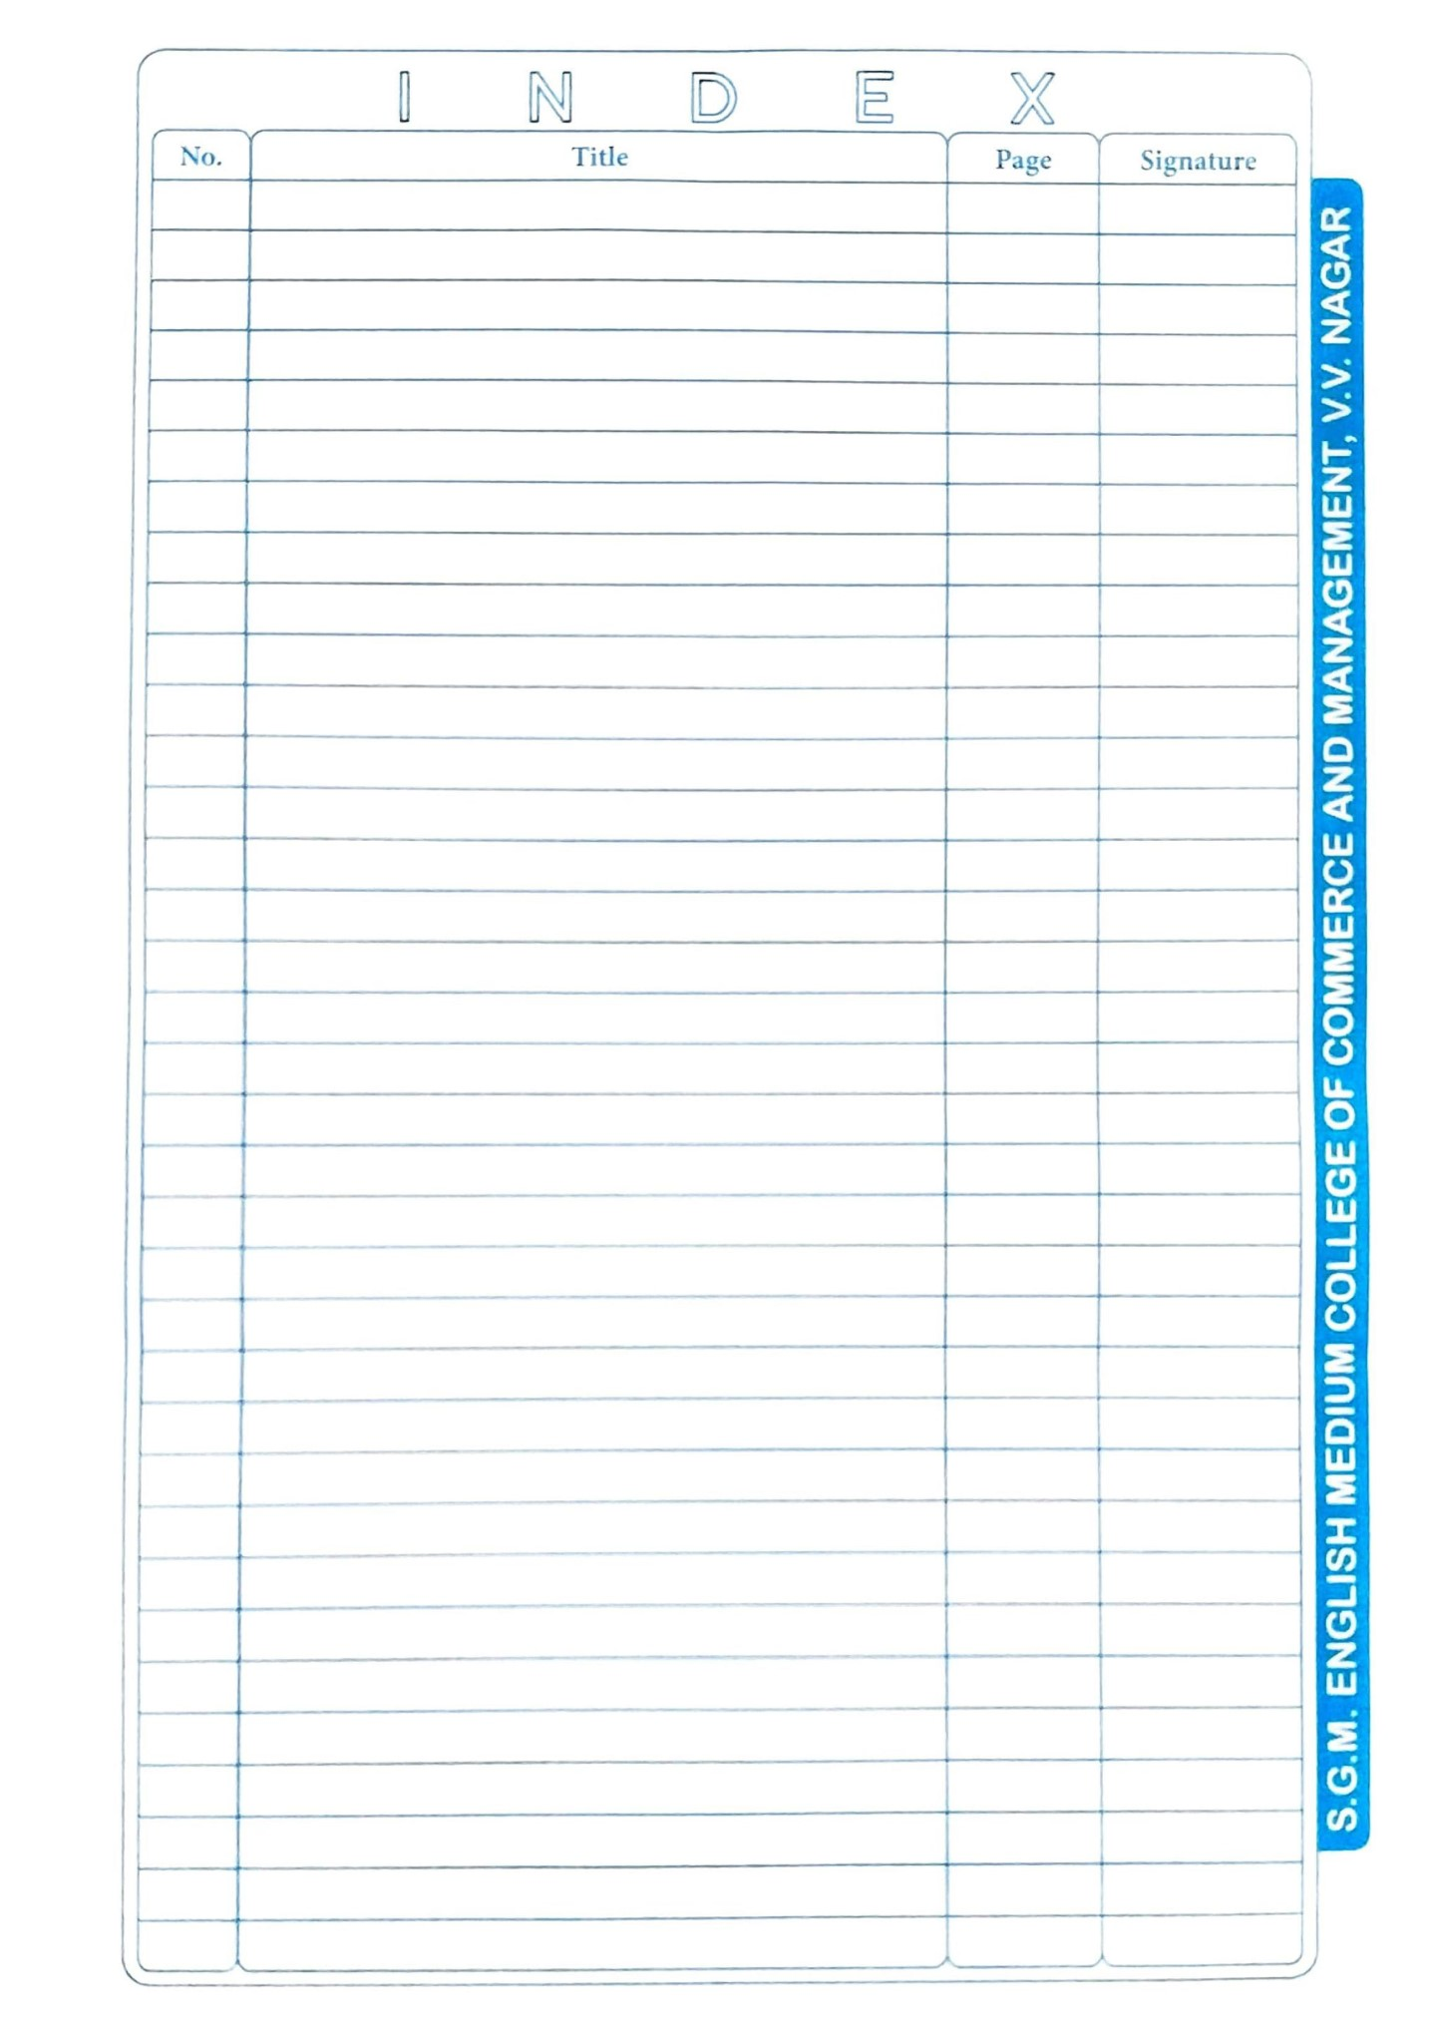

Screens

Data Dictionary

9

8

Data Flow Diagram

An Existing System System

Title Page of Project

7

6

Project Profile

5

Index

4

Acknowledgement

3

College Certificate

2

1

**Project Profile**

Tools:

* HTML
* CSS
* JavaScript
* PHP

Introduction:

This project is built with HTML, CSS, JavaScript and PHP.

In this project there are different webpages like, Home, Products, Contact us, Sign in etc. The HTML, CSS and JavaScript are used in frontend and PHP is used to store user’s data and Products details on the server.

The basic concept of this project is to sell different Electronic Accessories. There are different accessories available in the products section.

The HTML and CSS are mainly used in design of this website. The JavaScript is used in form validation and PHP used to store the data.

The user’s data which stored on the server are using PHP and MySQL via WAMP server. The user’s passwords are encrypted so that even owner of the website is also not able to read the passwords.

In the website if user wants to purchase products than He/she must have to register their selves on the website using Sign In page. If they are already registered than they can easily purchase any products just by login using Mobile No. and Password.

Users also able to add products in the cart so that they can purchase it whenever they want.

For create an account on website user need have to feel following data: Name, Mobile Number, Email (Optional), Address, Pin code, District, State, Password.

Features:

* User-Friendly UI
* Product Description
* Easy to Buy
* Order Tracking
* Personal Data Policy

Needs of project:

* Notepad
* WAMP/XAMPP Server
* Min RAM 512MB
* OS Windows 7/8/10

**An Existing System**

* The existing system Register information required in the system is entered and maintained totally manually. Manually maintain the customer details personal info.
* In this System I created a very user friendly website and user can purchase any item He/she wants.
* When user buy a product the order details will be stored in database and user can kept record of the orders too.
* To buy a product user needs to create an account on the system.

**Data Flow Diagram**

Process Hierarchy:

**Context Level DFD:**

Request for Login Request for Registration

USER

ADMIN

Response Response

**Zero - Level DFD:**

**Data Dictionary:**

**Users Table – Contains details of Users**

|  |  |  |  |  |
| --- | --- | --- | --- | --- |
| **Column Status** | **Attribute** | **Data Type** | **Size** | **Description** |
| Not Null | Name | VARCHAR | 100 | Name of Customer |
| Not Null, Primary Key | Mobile_No | VARCHAR | 10 | Mobile no. of Customer |
| Not Null | Email | VARCHAR | 50 | Email of Customer |
| Not Null | Address | VARCHAR | 200 | Address of Customer |
| Not Null | Pincode | INT | 8 | Pincode of Customer |
| Not Null | District | VARCHAR | 20 | District of Customer |
| Not Null | State | VARCHAR | 20 | State of Customer |
| Not Null | Password | VARCHAR | 20 | Password of Customer |

**Purchase Table – Contains purchase details of Users**

|  |  |  |  |  |
| --- | --- | --- | --- | --- |
| **Column Status** | **Attribute** | **Data Type** | **Size** | **Description** |
| Not Null | Name | VARCHAR | 100 | Name of Customer |
| Not Null, Primary Key | Mobile_No | VARCHAR | 10 | Mobile no. of Customer |
| Not Null | Password | VARCHAR | 20 | Password of Customer |
| Not Null | P_Id | VARCHAR | 5 | Product ID |
| Not Null | Product | INT | 250 | Product Name |
| Not Null | Price | VARCHAR | 20 | Price of Product |

**Contact details Table – Contains contact details and feedback of Users**

|  |  |  |  |  |
| --- | --- | --- | --- | --- |
| **Column Status** | **Attribute** | **Data Type** | **Size** | **Description** |
| Not Null | Name | varchar | 100 | Name of Customer |
| Not Null | Phone | varchar | 10 | Mobile no. of Customer |
| Not Null | Email | varchar | 100 | Email of Customer |
| Not Null | Message | varchar | 500 | Customer Message |

**Screens**

**Home**

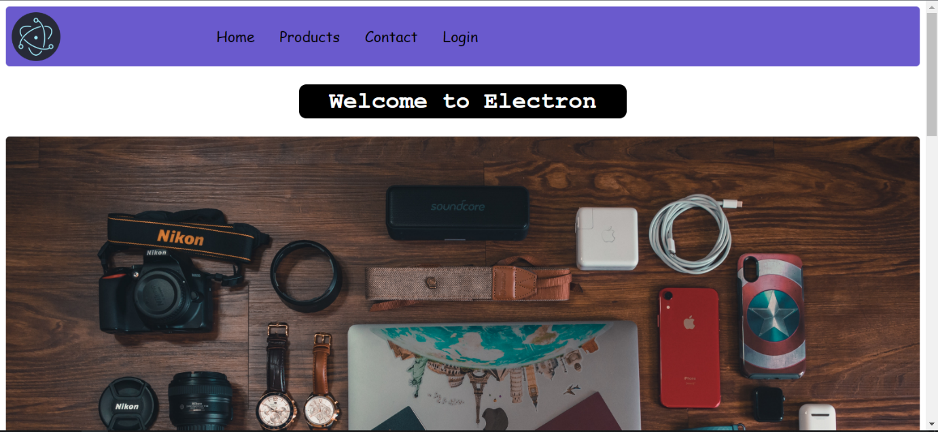

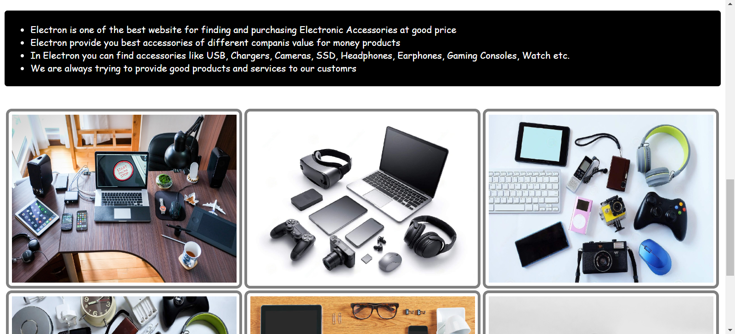

**Products**

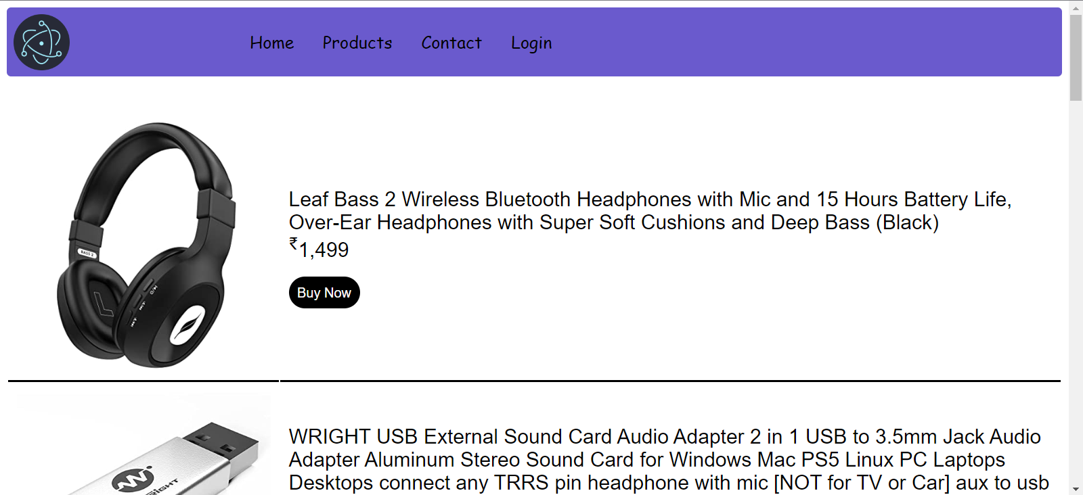

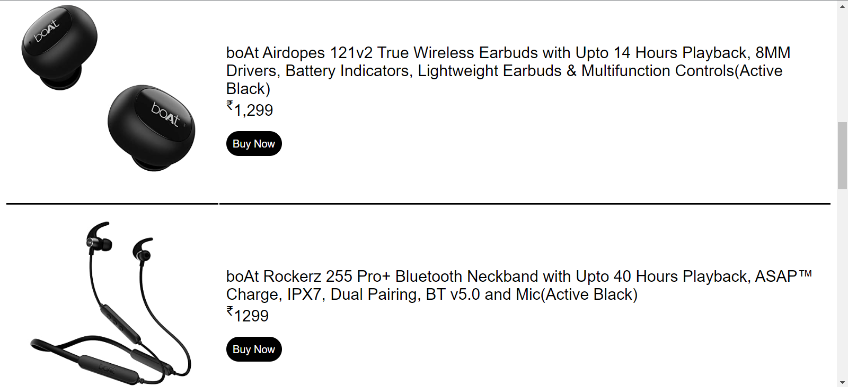

**Contact us**

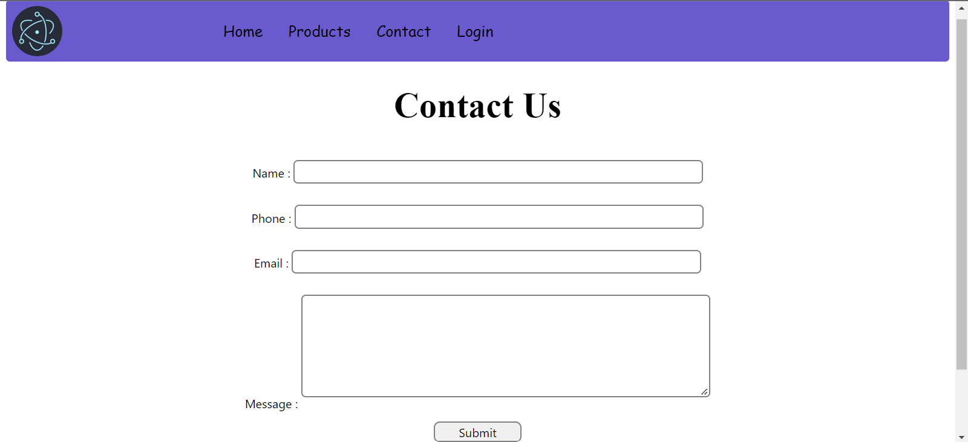

**Sign In**

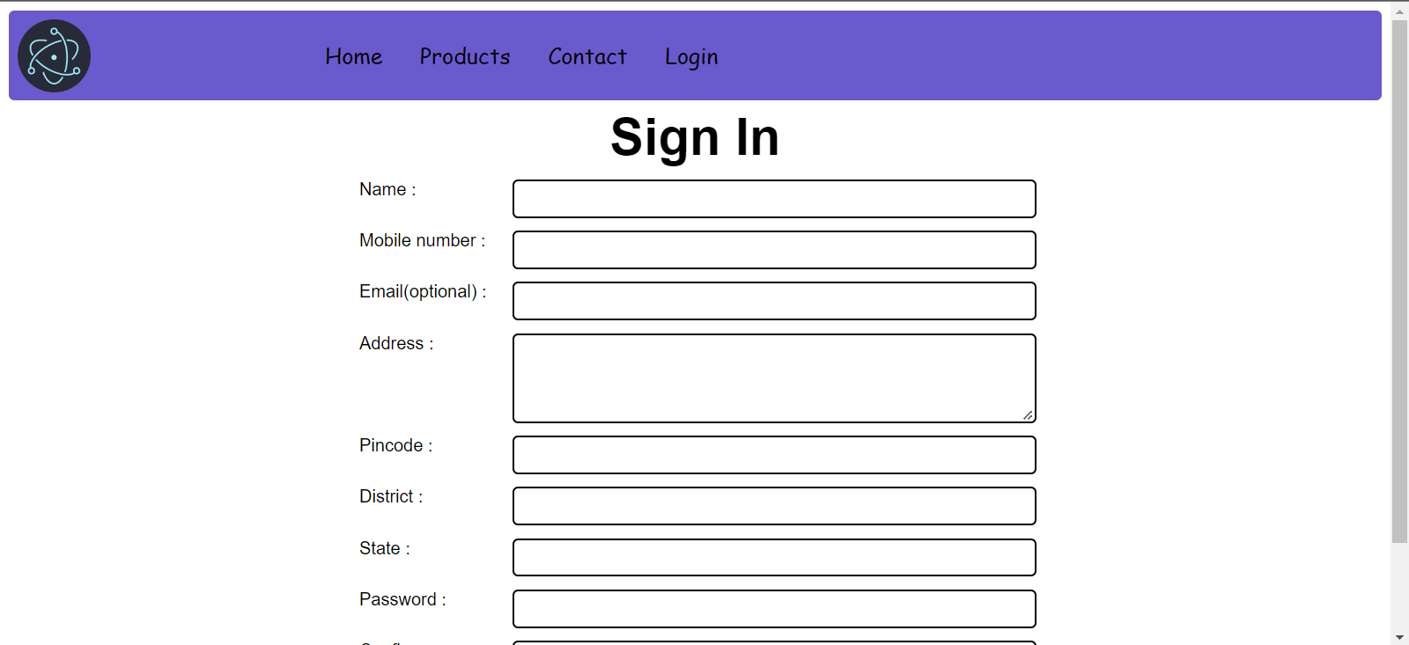

**Log In**

