**ASSIGNMENT 5 – LOGISTIC REGRESSION**

Q 1. Include a clean table of coefficients, t-values, and odds ratio only. I do not want the entire SAS output. Interpret the logistic output explaining AIC/BIC, meaning of coefficients, significance of betas, prediction accuracy (percent concordance), odds-ratios etc.

1. Bayesian Information Criterion:

Our model is outperforming the intercept-only model since we have obtained a lower value for both the Akaike Information Criterion (AIC) and Schwarz Criterion (SC) when compared to the intercept-only model.

Our model also demonstrates a lower -2LogL value compared to the intercept-only model, and this difference has been confirmed by a significant likelihood ratio test. This indicates that our model is performing significantly better than the intercept-only model.

1. Table

   Description automatically generatedGraphical user interface, text, Word, website

   Description automatically generatedConcordance Percentage:

Our model demonstrates a higher concordance percentage of 60.1% in the training set than the intercept-only model (~50%).

1. Coefficients:

The variables listed below have a significant p-value at 95%. Their coefficients can be interpreted as if the independent variable increases by 1 unit, then the log odds will increase by beta (respective coefficient value), for positive coefficients (if the independent variable increases by 1 unit, then the log odds will decrease by beta (respective coefficient value), for negative coefficients). A better interpretation can be given using the odds ratios which is as follows -

1. change_mou – Percentage decrease in Odds of churning for a 1% increase in change of minutes of use is 0%
2. threeway_Mean – Percentage decrease in Odds of churning for a unit increase in threeway calls is 1.7%
3. callwait_Mean – Percentage decrease in Odds of churning for a unit increase in call wait calls is 0.4%
4. mtrcycle – Percentage increase in Odds of churning for customers with motorcycles as compared to customers with no motorcycle is 24.5%
5. eqpdays – Percentage increase in Odds of churning for a 1 day increase in number of days of the current equipment is 0.1%
6. asl_flag_N – Percentage increase in Odds of churning for customers with account spending limits set to 1 as compared to when set to 0 is 38.3%
7. prizm_social_one_C – Percentage increase in Odds of churning for customers with Social Group Letter C as compared to U is 7.4%
8. prizm_social_one_R – Percentage increase in Odds of churning for customers with Social Group Letter C as compared to U is 30.1%
9. prizm_social_one_T – Percentage increase in Odds of churning for customers with Social Group Letter C as compared to U is 17.2%
10. area_CALIFORNIA_NORT – Percentage increase in Odds of churning for customers from California North area as compared to customers from Tennessee area is 13.8%
11. area_NORTH_FLORIDA_AREA – Percentage increase in Odds of churning for customers from North Florida area as compared to customers from Tennessee area is 20.4%
12. area_NORTHWEST_ROCKY_MOUNTAIN_AR – Percentage increase in Odds of churning for customers from Northwest Rocky Mountain area as compared to customers from Tennessee area is 45.4%
13. area_PHILADELPHIA_AREA – Percentage increase in Odds of churning for customers from Philadelphia area as compared to customers from Tennessee area is 19%
14. area_SOUTH_FLORIDA_AREA – Percentage increase in Odds of churning for customers from South Florida area as compared to customers from Tennessee area is 19.9%
15. refurb_new_N – Percentage decrease in Odds of churning for customers with new handsets as compared to customers with refurbished handsets is 27.7%
16. marital_A – Percentage decrease in Odds of churning for customers with marital status A as compared to customers with marital status U is 11.8%
17. marital_M – Percentage decrease in Odds of churning for customers with marital status M as compared to customers with marital status U is 13.5%
18. marital_S – Percentage decrease in Odds of churning for customers with marital status S as compared to customers with marital status U is 12.2%
19. ethnic_B – Percentage increase in Odds of churning for customers with ethnicity roll-up code B as compared to customers with ethnicity roll-up code Z is 57.9%
20. ethnic_D – Percentage increase in Odds of churning for customers with ethnicity roll-up code D as compared to customers with ethnicity roll-up code Z is 52.8%
21. ethnic_F – Percentage increase in Odds of churning for customers with ethnicity roll-up code F as compared to customers with ethnicity roll-up code Z is 39.7%
22. ethnic_G – Percentage increase in Odds of churning for customers with ethnicity roll-up code G as compared to customers with ethnicity roll-up code Z is 39.8%
23. ethnic_H – Percentage increase in Odds of churning for customers with ethnicity roll-up code H as compared to customers with ethnicity roll-up code Z is 50.1%
24. ethnic_I – Percentage increase in Odds of churning for customers with ethnicity roll-up code I as compared to customers with ethnicity roll-up code Z is 44.7%
25. ethnic_J – Percentage increase in Odds of churning for customers with ethnicity roll-up code J as compared to customers with ethnicity roll-up code Z is 33.2%
26. ethnic_M – Percentage increase in Odds of churning for customers with ethnicity roll-up code M as compared to customers with ethnicity roll-up code Z is 67.2%
27. ethnic_N – Percentage increase in Odds of churning for customers with ethnicity roll-up code N as compared to customers with ethnicity roll-up code Z is 31.8%
28. ethnic_O – Percentage increase in Odds of churning for customers with ethnicity roll-up code O as compared to customers with ethnicity roll-up code Z is 87.3%
29. ethnic_R – Percentage increase in Odds of churning for customers with ethnicity roll-up code R as compared to customers with ethnicity roll-up code Z is 70.3%
30. ethnic_S – Percentage increase in Odds of churning for customers with ethnicity roll-up code S as compared to customers with ethnicity roll-up code Z is 36.7%
31. ethnic_U – Percentage increase in Odds of churning for customers with ethnicity roll-up code U as compared to customers with ethnicity roll-up code Z is 34.7%
32. kid0_2_U – Percentage decrease in Odds of churning for customers with unknown number of kids aged 0-2 years in the household as compared to customers with no kids aged 0-2 years in the household is 9.6%
33. creditcd_N – Percentage increase in Odds of churning for customers with credit card indicator set to 0 as compared to customers with credit card indicator set to 1 is 8.3%

Remaining variables* are not significant, therefore no relationship with churn.

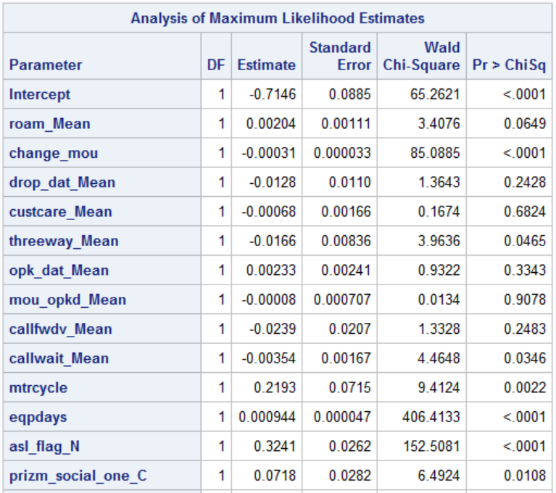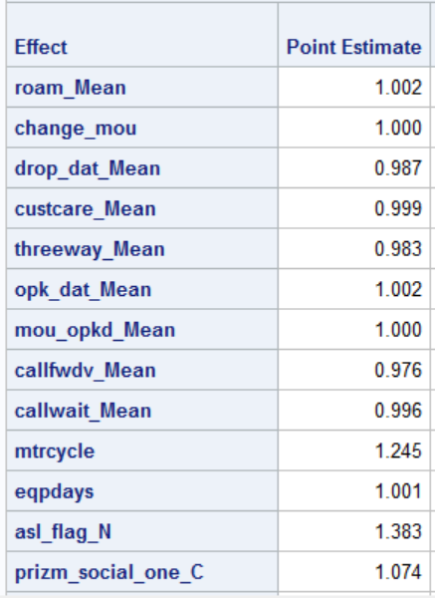

* roam_Mean, drop_dat_Mean, custcare_Mean, opk_dat_Mean, mou_opkd_Mean, callfwdv_Mean, prizm_social_one_S, area_ATLANTIC_SOUTH, area_CENTRAL_SOUTH_T, area_CHICAGO_AREA, area_DALLAS_AREA, area_DC_MARYLAND_VIR, area_GREAT_LAKES_AREA, area_HOUSTON_AREA, area_LOS_ANGELES_AREA, area_MIDWEST_AREA, area_NEW_ENGLAND_AREA, area_NEW_YORK_CITY_AREA, area_OHIO_AREA, area_SOUTHWEST_AREA, dualband_N, dualband_T, dualband_U, hnd_webcap_UNKW, hnd_webcap_WC, marital_B, ethnic_C, ethnic_P, ethnic_X, car_buy_New

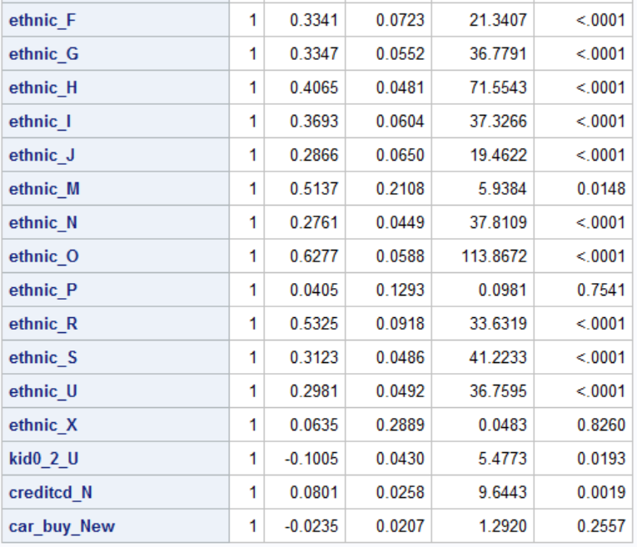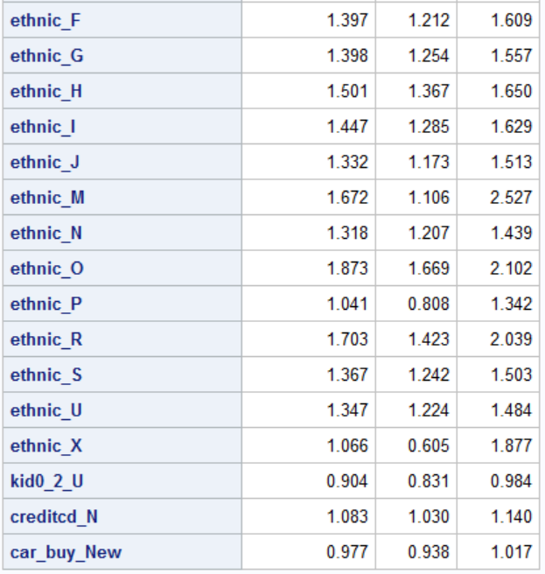

Q2. Which are the top three factors that affect churn in your model and what is their effect size?

Using the standardised beta values, we can say that are the top three factors that affect churn in our model are eqpdays, ethnic_H, and ethnic_N.