RESPONSIVE PRODUCT CARD
Testing & Evaluation Report

1. Objective
The objective of this test was to evaluate how the wireless headphones product card renders at mobile, tablet, and desktop viewport widths using Chrome Developer Tools. The review focused on the card layout, image placement, product information, and overall consistency.

2. Testing Method
- Opened the local product-card webpage in Google Chrome.
- Enabled the device toolbar in Chrome Developer Tools.
- Set the responsive viewport to 600 px, 900 px, and 1200 px in turn.
- Inspected the card at each width and captured a screenshot for evidence.

3. Results Summary
Viewport | Observed layout | Result
Mobile — 600 px | Vertical card; image above product details. | Visible; layout remains vertical.
Tablet — 900 px | Compact, centered card; vertical content flow. | Consistent with mobile layout.
Desktop — 1200 px | Compact, centered card; image above details. | No major layout change observed.
Note: The screenshots show the product card retaining a similar vertical layout at all three tested widths. The viewport widths reported here match the values visible in the supplied screenshots.

4. Screenshot Evidence
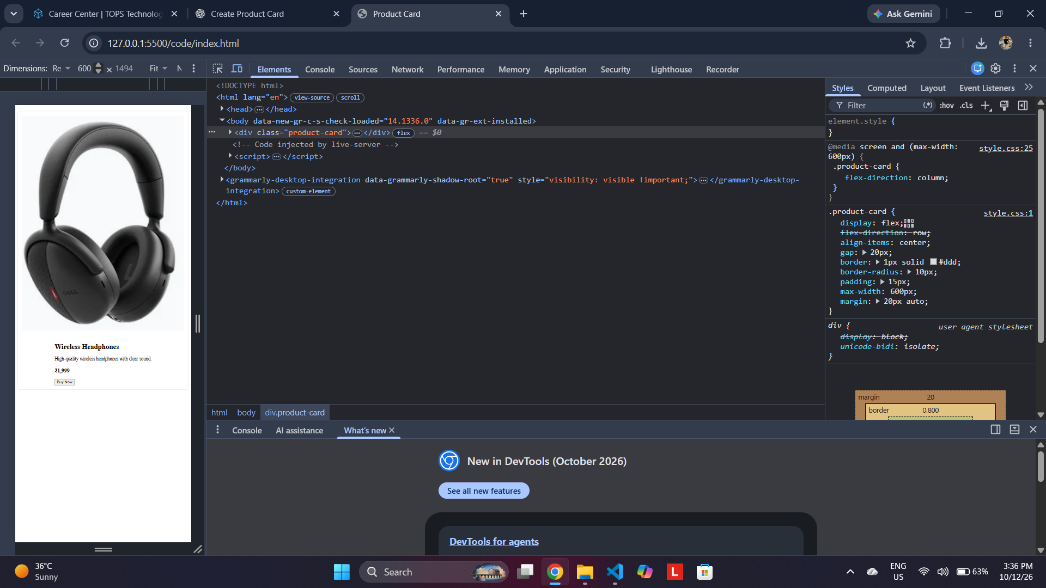
Figure 1. Mobile viewport — 600 px

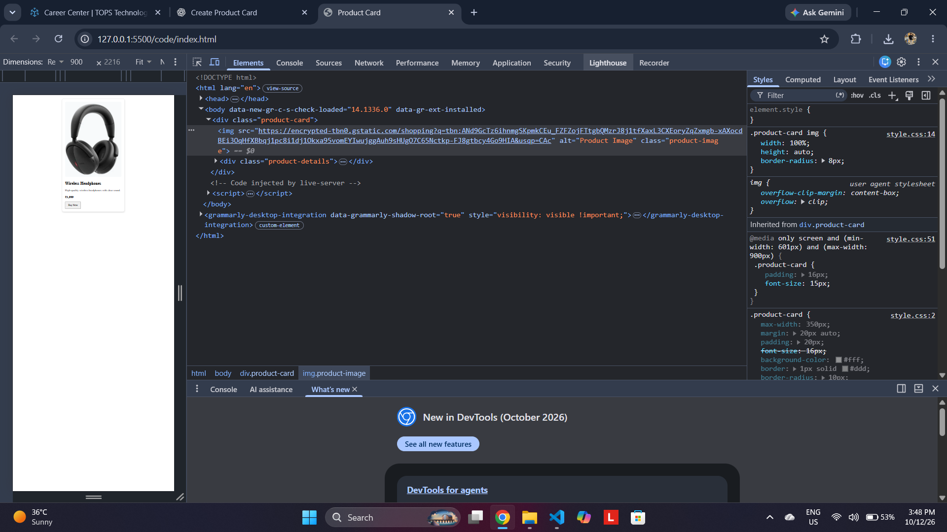

Figure 2. Tablet viewport — 900 px

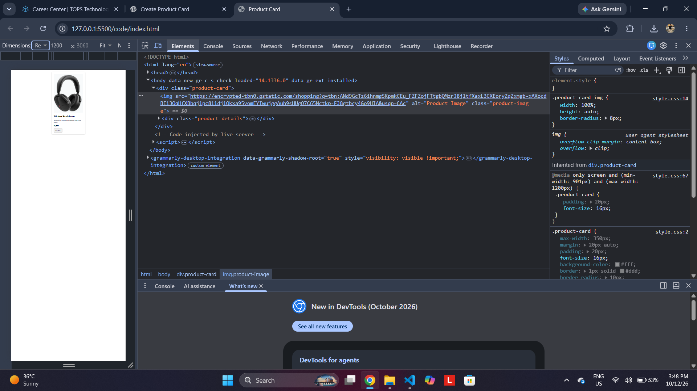

Figure 3. Desktop viewport — 1200 px

5. Conclusion
The product card was successfully reviewed at the three supplied viewport widths. The card remained visible and preserved its vertical content arrangement in the captured results. The screenshots provide evidence of the layout at each width. For a more complete responsive review, it is recommended to verify text readability, button usability, and the absence of horizontal scrolling directly at each viewport.

6. Submission Checklist
☒ Mobile screenshot included (600 px)
☒ Tablet screenshot included (900 px)
☒ Desktop screenshot included (1200 px)
☒ Testing method and observations documented

