Task 1: DNS Lookup Using nslookup
Practical Activity Report

1. Objective
To use the Windows nslookup command to query the Domain Name System (DNS) for www.flipkart.com and identify the IP address(es) returned for the website.
2. Procedure
- Opened Windows Command Prompt.
- Entered the command: nslookup www.flipkart.com
- Pressed Enter to send the DNS lookup request.
- Recorded the DNS server used and the IP address(es) returned.
- Captured a screenshot of the command output as evidence of the practical activity.
3. Command Used
nslookup www.flipkart.com
4. Observed Results
Parameter | Observed Result
DNS Server | jiofiber.local.html
DNS Server IP | 192.168.31.1
Response Type | Non-authoritative answer
Returned DNS Name | e348826.dsca.akamaiedge.net
IP Address 1 | 49.44.140.176
IP Address 2 | 49.44.140.209
IP Address 3 | 49.44.140.232
IP Address 4 | 49.44.140.152
Alias | www.flipkart.com
Additional Alias | www.flipkart.com.edgekey.net
5. Interpretation
The nslookup command successfully queried the DNS system for www.flipkart.com. The computer used the local DNS server at 192.168.31.1. The response shows that www.flipkart.com is associated with the Akamai Edge hostname e348826.dsca.akamaiedge.net and returned multiple IPv4 addresses. Multiple addresses can be used to distribute traffic and improve availability and performance. The response is marked as non-authoritative because the local DNS resolver supplied the cached/forwarded DNS information rather than being the authoritative DNS server for the domain.

6. Screenshot Evidence
The following screenshot shows the exact nslookup command and the DNS response obtained during the practical activity.
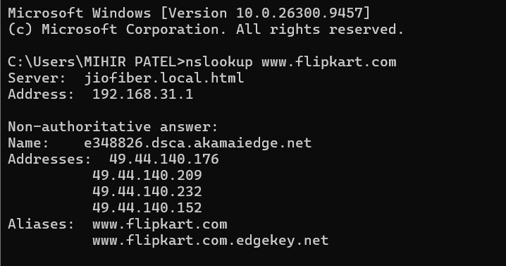
7. Conclusion
The DNS lookup was completed successfully. The activity demonstrated how a domain name such as www.flipkart.com is resolved through DNS into IP addresses that can be used by a computer to locate the relevant web infrastructure. The result also demonstrated that a website may use aliases and multiple IP addresses as part of its hosting and content delivery infrastructure.
8. Learning Outcome
This task provided practical understanding of the relationship between a domain name, DNS, and IP addresses, which is a fundamental concept in how the Internet works.

