PRACTICAL REPORT
Task 2 – Creating and Running an HTML File Using XAMPP
1. Objective
To create a simple HTML profile webpage, place the HTML file inside the XAMPP htdocs directory, run it through the Apache web server, and access the webpage using the localhost address in a web browser.
2. Software and Requirements
- XAMPP Control Panel with Apache enabled.
- A text editor such as Notepad or Visual Studio Code.
- A web browser such as Google Chrome, Microsoft Edge, or Firefox.
- A Windows computer with XAMPP installed.
3. Procedure / Steps Followed
1. Start XAMPP: Opened the XAMPP Control Panel and started the Apache service. The Apache service must be running before accessing the local webpage.
2. Open the htdocs folder: Navigated to the XAMPP installation directory and opened C:\xampp\htdocs.
3. Create the HTML file: Created a new file named myprofile.html inside the htdocs folder.
4. Write the HTML code: Added the HTML structure containing a page title, profile heading, about-me section, hobbies, and skills.
5. Save the file: Saved the file with the .html extension, ensuring it was not saved as myprofile.html.txt.
6. Open the webpage: Opened a web browser and entered http://localhost/myprofile.html.
7. Verify the result: Confirmed that Apache served the HTML file and that the profile webpage was displayed correctly in the browser.
4. HTML Source Code
<!DOCTYPE html>
<html>
<head>
<title>My Profile</title>
</head>
<body>
<h1>My Profile</h1>
<h2>About Me</h2>
<p>Hello! My name is Mihir.</p>
<h2>My Hobbies</h2>
<p>I enjoy learning about technology and the Internet.</p>
<h2>My Skills</h2>
<ul>
<li>HTML</li>
<li>Computer Networking</li>
<li>Web Development</li>
</ul>
</body>
</html>
5. Working Principle
When the browser requests http://localhost/myprofile.html, the request is handled by the Apache web server running through XAMPP. Apache looks for myprofile.html in the htdocs directory and returns the file to the browser. The browser then interprets the HTML code and displays it as a webpage. The use of localhost means that the website is being hosted on the student's own computer and is not publicly available on the Internet.
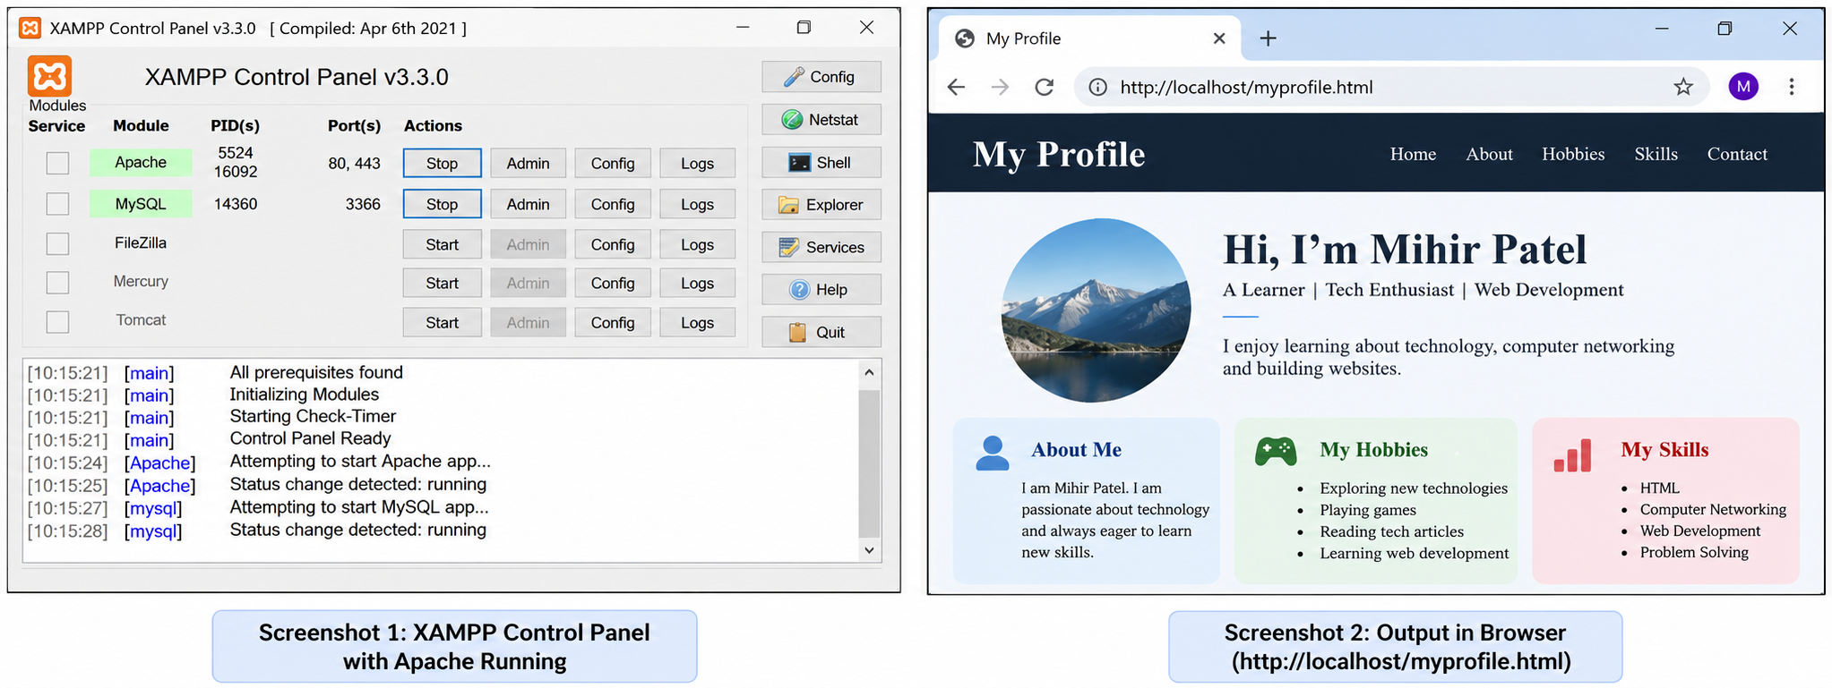
6. Screenshot of Working Webpage

7. Result
The HTML file myprofile.html was successfully created, stored in the XAMPP htdocs directory, and accessed through the Apache local web server using localhost.
8. Conclusion
This task demonstrated the basic process of hosting and accessing a website locally using XAMPP. It provided practical understanding of the relationship between an HTML file, the Apache web server, the htdocs directory, and a web browser. The task also introduced the concept of localhost as a local development environment before deploying a website to a public hosting server.

