Task 3: How a Browser Finds and Loads a website
Practical Training Report

1. Objective
To understand the basic process by which a web browser locates and loads a website when a user enters a domain name in the address bar, with particular focus on DNS, IP addresses, and web servers.

2. Procedure
- Open a web browser such as Google Chrome or Microsoft Edge.
- Enter www.zomato.com in the address bar and press Enter.
- The browser uses the Domain Name System (DNS) to resolve the domain name to the corresponding IP address.
- Using the resolved IP address, the browser establishes a connection with the appropriate web server.
- The web server processes the request and sends the required website resources back to the browser.
- The browser processes the received resources and displays the Zomato website to the user.

3. Explanation
When I type www.zomato.com into the browser's address bar, the browser uses the DNS (Domain Name System) to find the IP address associated with the domain name. The browser then uses this IP address to connect to the web server hosting the Zomato website. The web server receives the request and sends the required website files and data back to the browser. Finally, the browser processes these files and displays the Zomato website on the screen.

4. Practical Screenshot
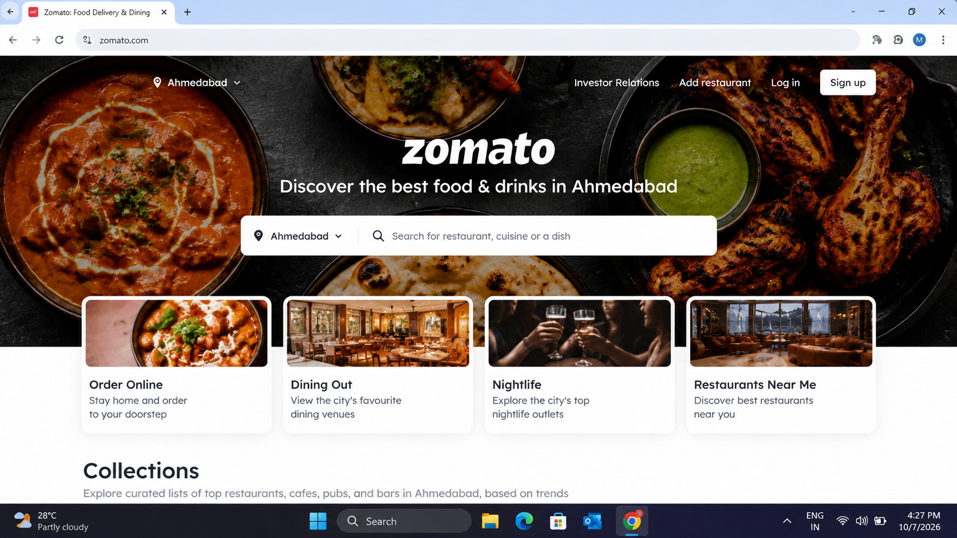

Figure 1: Zomato website opened in a web browser.

5. Key Concepts
Concept | Description
DNS | Converts a human-readable domain name such as www.zomato.com into an IP address.
IP Address | A numerical network address used to identify and communicate with the destination server.
Web Server | A server that receives HTTP/HTTPS requests and delivers website resources to the browser.
Web Browser | Software such as Chrome or Edge that requests, receives, and displays web content.

6. Conclusion
This task demonstrated how a browser loads a website using the DNS, IP address, and web server. DNS resolves the domain name into an IP address, the browser communicates with the web server using that address, and the server returns the resources required to display the website. This process enables users to access websites using easy-to-remember domain names instead of numerical IP addresses.

7. Result
Successfully understood and documented the basic client-server process involved in loading www.zomato.com.

