TASK 4: LOCAL SERVER (XAMPP) VS. REAL HOSTING SERVER
Professional Practical Report
1. Objective
To understand the main differences between running a website on a local server using XAMPP and publishing a website on a real hosting server connected to the Internet.
2. Introduction
XAMPP provides a local web server environment that allows developers and students to create, test, and run websites on their own computer. A real hosting server stores website files on an Internet-connected server, allowing users to access the website through a domain name.
3. Comparison Table
Feature | Local Server (XAMPP) | Real Hosting Server
Accessibility | The website is normally accessible only from the local computer. | The website can be accessed from anywhere through the Internet.
Domain Name | Usually accessed using localhost, for example: http://localhost/myprofile.html | Can use a registered domain name, for example: https://www.example.com
Who Can View It? | Primarily the computer owner; it may also be shared within a local network if configured. | Anyone with Internet access can view the website when it is publicly hosted.
Internet Requirement | Internet access is not required to run a basic local website. | An Internet connection is required for users to access the hosted website.
Cost | XAMPP is free to install and use. | Hosting generally requires payment, and a domain name may also have a registration cost.
Purpose | Mainly used for website development, learning, and testing. | Used to publish a website for real users and public access.

4. Key Observations
- XAMPP is suitable for local development and testing before a website is published.
- A hosted website is available to users over the Internet.
- A public website can use a registered domain name, while a local XAMPP website commonly uses localhost.

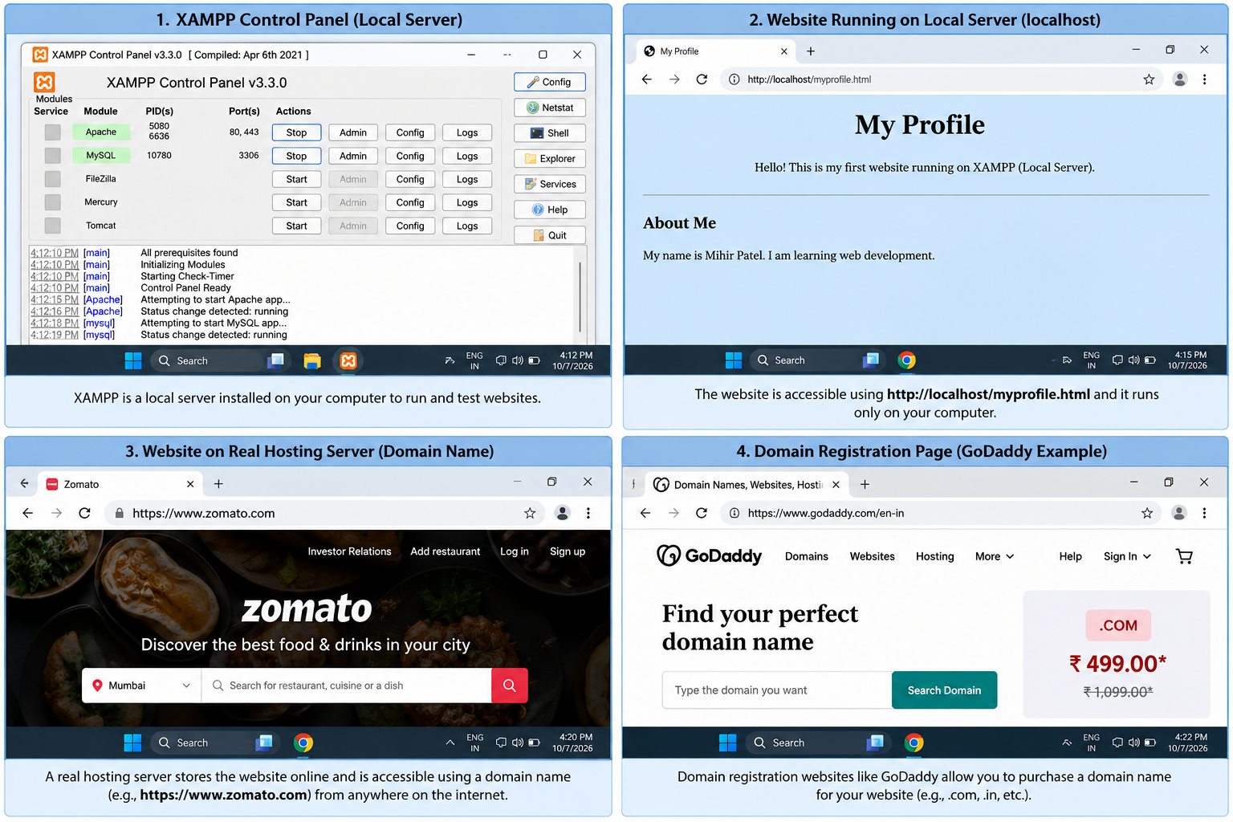
5. Screenshot

6. Conclusion
XAMPP and real hosting servers serve different purposes. XAMPP is mainly used to develop and test websites locally, while real hosting makes a website available to users through the Internet. The major differences include accessibility, domain names, audience, Internet requirements, cost, and purpose.

