TASK 5: DOMAIN REGISTRATION & AVAILABILITY CHECK
Professional Practical Report
1. Objective
To understand the purpose of a domain name, use a domain registration website to search for a domain related to a name or hobby, and record the available domain extensions and registration prices.
2. Tool / Website Used
Website: GoDaddy Domain Search
Official website: https://www.godaddy.com/en-in/domains
3. Procedure
1. Open a web browser such as Google Chrome or Microsoft Edge.
2. Open the GoDaddy domain search page.
3. Enter a domain idea related to your name or hobby. Example: mihirpatel.
4. Click the Search button.
5. Review the suggested domain extensions such as .com, .in, .net and .org.
6. Record whether the domain is available and note the price displayed for each relevant extension.
7. Take a screenshot of the search results showing the domain name, availability and price.
8. Do not purchase the domain; this task only requires a search and observation.
4. Example Search
For this report, the example search term is “mihirpatel”. Replace it with your own name or hobby if your trainer requires a different domain.
Domain | Extension | Availability | Price
mihirpatel.com | .com | Check live | Record live price
mihirpatel.in | .in | Check live | Record live price
mihirpatel.net | .net | Check live | Record live price
mihirpatel.org | .org | Check live | Record live price

Current GoDaddy India pricing reference: the official GoDaddy India domain page currently advertises promotional starting prices for some extensions, including .com and .in. These offers can have eligibility, term, and renewal conditions, so the price shown during the live search should be recorded in the practical.

5. Screenshot – Step 1: Domain Search
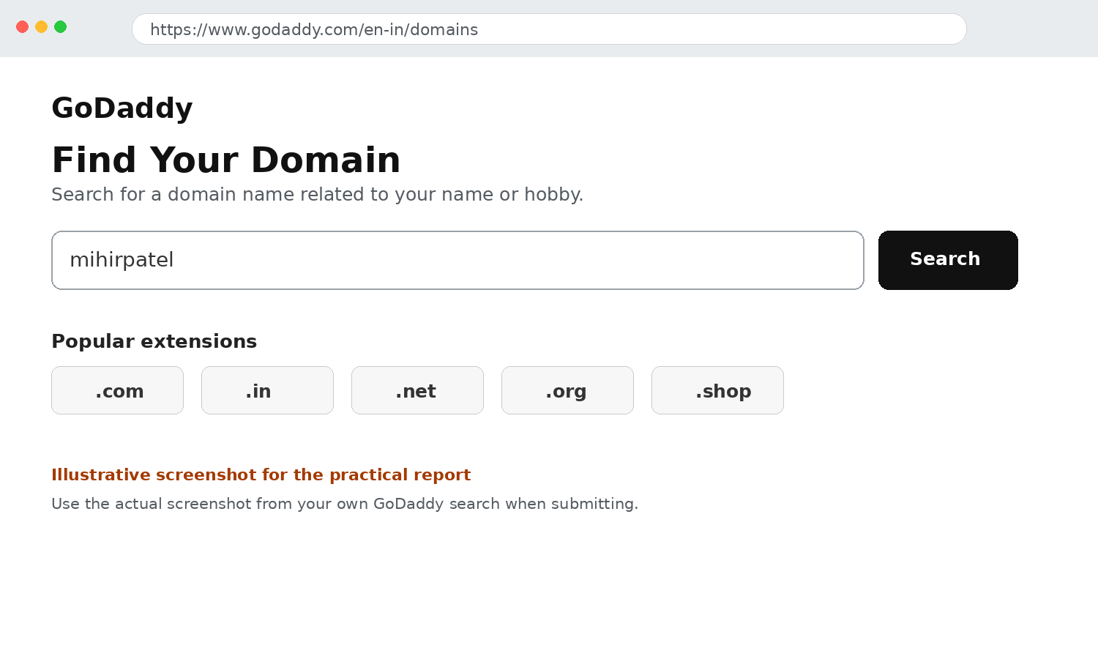
Figure 1. Illustrative GoDaddy domain-search screen. Replace with your actual screenshot before submission.
6. Screenshot – Step 2: Domain Results
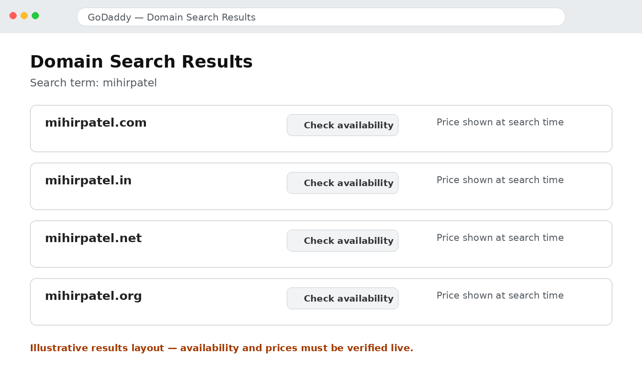
Figure 2. Illustrative domain-results layout. Verify availability and price live on GoDaddy.
7. Result
The domain registration website was accessed and the process of searching for a domain name and checking its extensions, availability and price was understood. Domain extensions such as .com, .in, .net and .org represent different choices for publishing a website on the Internet.
8. Conclusion
This task demonstrated how a domain name can be searched through a domain registrar. The activity helped in understanding that a domain name is registered through a registrar and that different extensions may have different availability and prices. The domain does not need to be purchased for this practical exercise.
9. Source
GoDaddy Domain Search: https://www.godaddy.com/en-in/domains

