PROFESSIONAL TASK REPORT
Semantic HTML5 Homepage — IPL Live Cricket Score App

1. Task Overview
The objective of this task is to create a simple mock homepage for a cricket score application inspired by IPL Live. The webpage is built using semantic HTML5 elements to organize its content in a meaningful, accessible, and maintainable structure.

2. Objectives
- Create an index.html file in the project folder.
- Use the semantic elements <header>, <nav>, <main>, <section>, and <footer>.
- Display sample live-match information and upcoming fixtures.
- Include an About section and basic navigation links.
- Open the file in a web browser to verify the output.

3. Tools and Technologies
• Operating system: Windows 11 (or another desktop operating system)
• Code editor: Notepad or Visual Studio Code
• Technology: HTML5
• Browser: Chrome, Edge, Firefox, or another modern browser

4. Implementation Procedure
- Create the project folder: Create a folder named cricket-score-app.
- Create the HTML file: Create and save a file named index.html. Ensure the extension is .html, not .txt.
- Add the page structure: Write a valid HTML document and include the semantic HTML5 elements.
- Add homepage content: Add the app title, navigation links, sample match score, upcoming matches, and About information.
- Save and preview: Save the file and open it in a browser by double-clicking index.html.

5. Semantic Elements Used
Element | Purpose
<header> | Shows the app name and introductory text.
<nav> | Groups navigation links to page sections.
<main> | Contains the primary content of the page.
<section> | Groups related content, including live scores, upcoming matches, and About information.
<footer> | Displays copyright information at the bottom of the page.

6. Expected Output
The browser displays a basic cricket score homepage with the heading “IPL Live,” a navigation menu, a sample live-match section, a list of upcoming matches, an About section, and a copyright footer. The HTML content is organized using semantic elements.
Note: Match scores and fixtures used in the practice page are fictional sample content and are not live IPL data.

7. Testing and Verification
- Confirmed that index.html is saved in the correct project folder.
- Checked that all five required semantic elements are included.
- Opened the file in a browser and reviewed the displayed content.
- Checked that the navigation links point to matching section IDs.

8. Project Structure
cricket-score-app/
└── index.html

9. Result
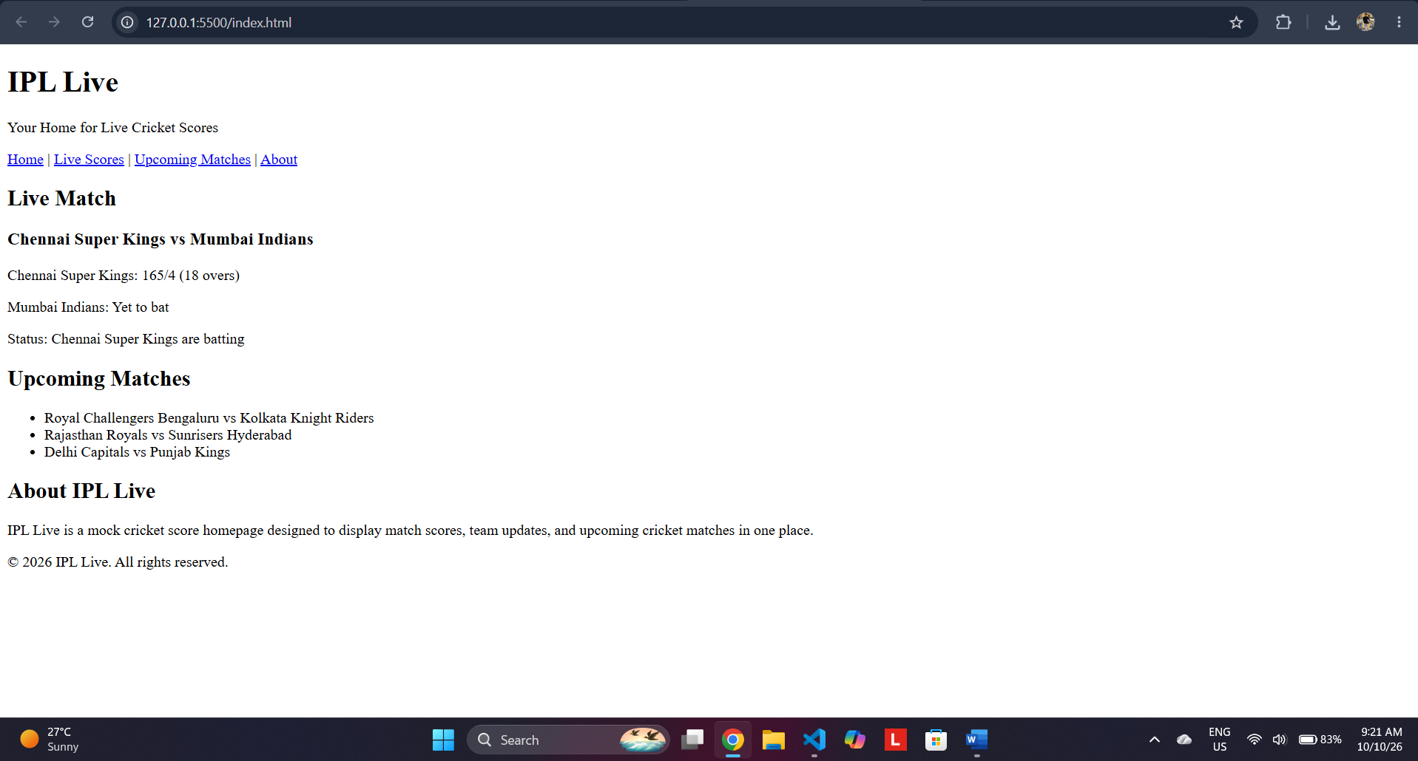
A simple mock cricket score homepage was prepared using semantic HTML5 tags. The task demonstrates basic page structure, content grouping, navigation, and browser preview.

10. Conclusion
This task provides practical experience with semantic HTML5 and the structure of a basic webpage. Possible future improvements include adding CSS styling, responsive layouts, team logos, and a real cricket scores API.

