TASK 1
Analyzing Network Requests and Browser Cache Using Chrome DevTools
Example Website: Myntra

1. Objective
The objective of this task is to understand how a web browser communicates with a web server when a user opens a website and clicks on a product. Myntra is used as an example, and Chrome DevTools' Network panel is used to observe the requests made when a product page is opened.
The main objectives are:
- Understand how a browser communicates with a web server.
- Observe network requests generated when a product is opened.
- Identify resources such as HTML, CSS, JavaScript, images, fonts, and API/fetch requests.
- Understand the difference between resources loaded from the server/network and resources loaded from the browser cache.
- Learn how Chrome DevTools can be used to analyze website performance and network activity.

2. Step-by-Step Procedure
Step 1: Open Google Chrome
Open Google Chrome on a Windows 11 computer and navigate to https://www.myntra.com.
Step 2: Open Chrome Developer Tools
Right-click anywhere on the Myntra webpage and select Inspect. Alternatively, press F12 or Ctrl + Shift + I.
Step 3: Open the Network panel
In Chrome DevTools, select the Network tab. The Network panel records requests made by the webpage.
Step 4: Enable Preserve log
Enable Preserve log at the top of the Network panel. This keeps requests visible when the browser navigates to the product page.
Step 5: Keep Disable cache turned off
Make sure Disable cache is not selected. This allows normal browser caching behavior to be observed.
Step 6: Clear previous requests
Click the Clear button in the Network panel to remove old requests and start with a clean Network log.
Step 7: Select a product
Return to the Myntra webpage and click any product, such as a shirt, T-shirt, shoe, watch, or bag.
Step 8: Observe the Network requests
After the product page loads, observe the requests in the Network panel. These may include HTML/document, CSS, JavaScript, images, fonts, API/fetch requests, and analytics resources.
Step 9: Identify Server/Network requests
Look at the request details, including Size and Time. Resources downloaded through the network are treated as server/network-loaded resources.
Step 10: Identify cached resources
Look for entries showing messages such as 'from memory cache' or 'from disk cache'. These indicate resources served from the browser cache.
Step 11: Take a screenshot
Use Windows + Shift + S to capture the Chrome window showing the Myntra product page and the Network panel.
Step 12: Label the screenshot
Add labels such as 'Loaded from Server (Network)' and 'Loaded from Cache' with arrows pointing to the appropriate requests.

3. Screenshot – Dark Windows 11 / Myntra / Chrome DevTools
The screenshot for this task should show Windows 11 in dark mode, the Myntra product page, Chrome DevTools with the Network tab open, Preserve log enabled, Disable cache turned off, and clearly labeled Server/Network and Cache requests.
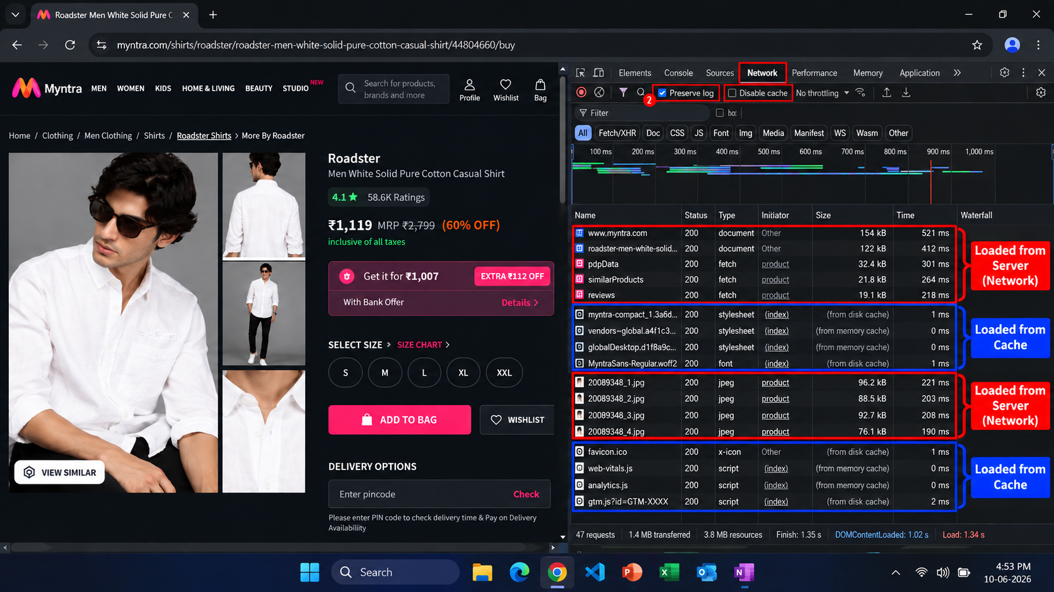
For an academic submission, it is recommended to use a screenshot captured from your own Chrome session so that the displayed network requests are genuinely from your browser.

Figure 1: Myntra product page and Chrome DevTools Network analysis (illustrative).

4. Server (Network) vs Cache Explanation

A. Server / Network
When a browser needs information that is not available in its cache, it sends a request over the network to the website's server or another server/CDN. The server processes the request and sends the required information back to the browser.
Examples include:
- Product information
- Product details
- Product images
- Reviews
- Availability information
- API responses
Typical flow: User clicks product → Browser sends request → Server processes request → Response returns → Product is displayed.

B. Browser Cache
A browser cache is temporary local storage maintained by the browser. When a resource has already been downloaded, the browser may store it locally. If the same resource is required again and the cached copy is valid, the browser can use the local copy instead of downloading it again.
Examples include:
- CSS files
- JavaScript files
- Fonts
- Images
- Icons
- Other reusable website resources
Chrome may indicate cached resources using messages such as 'from memory cache' or 'from disk cache'.

Server / Network vs Browser Cache
Feature | Server / Network | Browser Cache
Location | Remote server/network | User's computer
Internet communication | Usually required | Often not required for the cached copy
Download | Resource is transferred | Existing local copy is used
Speed | Depends on network/server | Usually faster
Examples | Product API, product data | Previously downloaded CSS, fonts, scripts
Purpose | Obtain required/current data | Reuse previously stored resources

Why is caching useful?
Caching improves website performance because it can:
- Reduce network traffic.
- Reduce page loading time.
- Reduce repeated server requests.
- Improve the user experience.
- Make repeated page visits faster.

5. Short Conclusion
This task demonstrated how a browser communicates with a web server when accessing a website such as Myntra. Using Chrome DevTools → Network, different requests made while opening a product page were observed. These requests can include documents, API/fetch requests, images, CSS, JavaScript, fonts, and other resources.
The activity also demonstrated the difference between network/server-loaded resources and cached resources. Server-loaded resources require communication with the network, while cached resources can be retrieved from the browser's local memory or disk cache. Therefore, Chrome DevTools Network is a useful tool for understanding how websites work, how browsers communicate with servers, and how caching improves website performance.

Submission Checklist
- Confirm that the screenshot shows the Myntra product page and Chrome DevTools Network tab.
- Confirm that Preserve log is enabled and Disable cache is turned off.
- Label the relevant requests as Server/Network or Cache.
- Save this document as the Task 1 report.
- Upload the document and/or screenshot to your repository or Google Drive folder and submit the shareable URL in the course portal.

